Neonatal examination:

* **“Head to toe” examination**
  + Wash your hands, ask mother for permission and to expose child (if clothed)
  + **General inspection:**
    - Consciousness (asleep, awake and crying, active movements, irritated, drowsy, toxic looking)
    - Attachment to any IV lines, intubated, face mask, etc.
    - Placed under radiant warmer or not
    - Color (jaundice, cyanosis, pallor)
    - Muscle tone (flexed upper and lower limbs = normal)
    - Signs of respiratory distress (breathing sounds, uses of accessory muscles of respiration)
  + **Vital signs:**
    - Temperature
    - Heart rate
    - RR
    - BP
  + **Take anthropometric measures:**
    - Weight (3 kg)
    - Length (50 cm)
    - Head circumference (35 cm)
      * It must be measured fronto-occipitally (most prominent parts of each)
      * Must go above the eyebrows and NOT include the ears
  + **Head:**
    - Comment on **shape of skull**
      * Abnormal size/shapes include brachycephaly, triogonocephaly and scaphocephaly (all result from cranial synostosis which is early closure of specific sutures)
      * Plagiocephaly, which is positional
      * Microcephaly or macrocephaly (hydrocephalus)
    - **Visible swellings** (chignon, caput succedaneum, cephalhematoma, subgaleal hematoma)
      * All are birth injuries (chignon is due to ventouse delivery)
      * **Caput** = larger, crosses suture line, above periosteum, below epicranial aponeurosis
      * **Cephalhematoma** = doesn’t cross suture line, lies below periosteum, can cause jaundice, anemia and infection
    - **Feel for fontanels** 
      * **Anterior fontanel** opened at birth and closes at 1.5 years
        + Diamond shaped
        + If closure is delayed consider hypothyroidism, osteogenesis imperfecta, hypoparathyroidism, rickets, Down Syndrome, hydrocephalus
      * **Posterior fontanel** should be closed at birth
        + If opened, consider congenital hypothyroidism
    - **Feel the suture lines**
      * Check for overriding sutures (called **cranial molding**)
      * Start by moving forward from anterior fontanel = metopic suture
      * Left and right from anterior fontanel = coronal suture
      * Backwards from the anterior fontanel = sagittal suture
      * From posterior fontanel to sides = lambdoid suture
  + **Face:**
    - General: look for “**dysmorphic features**” & other signs
      * Rashes or **hyperpigmentations** (salmon patches, erythemia toxicum, milia, nevus flammeus of Sturge-Weber which can follow the distribution of any branch of CN5, and for strawberry nevi)
    - **Eyes:**
      * Comment on eyes, whether they are edematous (normal) or if there is line of ointment (topical erythromycin)
      * Check for hypertelorism or hypotelorism
      * Flat nasal bridge (Africans have slightly flat nasal bridge, which is normal)
      * Epicanthal folds (Asians normally epicanthal folds)
      * Upslanting or downslanting palpebral fissures
      * Eyes for brushfield spots or other abnormalities like colobomas (CHARGE syndrome) or heterochromia
      * Perform ophthalmoscopy to check for red reflex
        + If white (leukocoria), it might be RB, cataracts
      * Open the eyes to look for subconjuctival hemorrhages
* **Examine ears for:**
  + - * + Low set ears (draw a line from medial epicanthus to the lateral epicanthus and then from there to the ear – normally 1/3rd of ear should be above)
        + Elasticity, by pulling the ear forward and check for recoil (if there is no recoil, it might indicate prematurity – along with short or absent nails)
        + Check for tags or pits (which is associated with renal anomalies because they develop at the same time in utero ~ BW syndrome)
* **Examine the nose:**
  + - * + Point out if there is nasal flaring or not
        + Look for polyps
        + Check for choanal atresia using “sniff” test in which the metal part of your stethoscope is brought close to one nostril while the other is blocked by your hand – see if there is humidity on the stethoscope – if yes = patent
        + A more definitive sign for choanal atresia is finding resistance upon inserting a nasogastric tube
        + **Jaundice is checked by compressing the nose**
* Examine the **philthrum:**
  + - * + Wide and smooth philthrum seen in fetal alcohol syndrome
        + Identify if there is cleft lip (note that in older children examination, you must identify if there are scars of previous cleft lip or not)
* Examine **the mouth:**
  + - * + Look for signs of cyanosis, and comment on color of mucous membrane (wet and red)
        + Wear a glove and check for **rooting reflex**
        + Insert your little finger into the mouth and check for **suckling reflex**
        + At the same time, feel the hard palate for signs of cleft palate
        + Identify any natal teeth (it need not be removed unless it is loose – in that case it is removed to reduce the risk of aspiration)
        + Look for ebstein’s pearls (white dots, normal)
        + Look underneath the tongue for ankyloglossia (tied tongue – shortened frenulum of tongue) and comment if macroglossia (cretinism, BWS) is present
* Comment on the size of the chin if you are suspecting micrognathia (sign of Pierre-Robin syndrome)
* **Neck:**
  + Pull the baby up and make sure to show that you are examining the neck (hold the baby’s head for support and show the neck)
  + Comment on:
    - Use of neck muscles for respiration
    - Obvious masses and what they could be, including thyroglossal duct cyst, goiter, sternomastoid tumor (torticollis), branchial cleft cysts, cystic hygroma
    - Comment on shape (webbed neck or not)
    - Look at the back and check for excess skin
* **Upper limb:**
  + Follow by palpating the clavicle and noting any “stepping” which might indicate fracture (MC fracture, due to delivery)
  + At this point, comment that there is no suprasternal retractions
  + Point out that the upper limb has **3 divisions** (normal)
  + Identify whether the upper limb is held in any abnormal positions (such as in Erb’s palsy or Klumpke palsy – both can result from brachial plexus injury during birth)
  + Look at the hands for:
    - Acrocyanosis
    - Number of digits (say has 5 digits, with no syndactyly, polydactyly or clinodactyly [Down syndrome])
    - Palmar creases (count how many) – single palmar crease may be a sign of Down syndrome
    - Look at fingers for signs of peripheral cyanosis, nails (stained with meconium or not, short nails [premature])
    - Lastly, check for grasp reflex
* **Chest:**
  + Comment on any **skin findings** (rash, hyperpigmented patches or not)
  + Comment on the **shape of the chest**:
    - State whether there is pectus excavatum or carinatum
    - State whether or not there are intercostal or subcostal retractions
  + Comment on the **spacing between the nipples** and that there are two
    - Widely spaced nipples can be seen in Turner’s
    - Notify if there are **supernumerary nipples** or not
  + Comment if there is any **discharge from the nipples** (Witch’s milk, normal)
  + Inspect the chest for a **precordial bulge** (hyperdynamic circulation)
  + **Palpate the chest for the heart** (one hand over each side of the chest to identify which side the heart is on)
    - If the heart is on the right, it could be dextrocardia alone or part of situs inversus totalis
  + Palpate for the **apex beat** and identify its location with 1 finger and then in relation to the intercostal space (5th ICS) and position (MCL)
  + **Auscultate the chest** for:
    - **Breathing** (bilaterally adequate and equal air entry with no added sounds)
    - **Heart sounds** (check for S1, S2 any additional heart sounds + any murmurs on all 4 sites)
* **Abdomen:**
  + **General** (rashes, distension, masses, pigmentations, visible peristalsis)
  + Comment on whether or not there is an **umbilical hernia** (it may be normal) or signs of:
    - Gastroschisis (not covered by amnion, not central)
    - Omphalocele (covered by amnion, central)
    - Recti diastasis (no associated morbidity or mortality, it is only because the the recti abdominis muscle’s aponeurosis is not fully developed, so they appear widely split)
    - Prune-belly syndrome (absent abdominal muscles showing wrinkly folds of skin over abdomen, usually associated with other abnormalities of kidneys and other organs)
  + Look at the **umbilical cord** that is clamped (the umbilical cord falls off on its own **by 1-2 weeks**)
    - She said try to look for the “happy face” in which the **umbilical arteries** are the two small circular eyes and the **umbilical vein** is elongated and looks like a smile)
    - **Omphalitis** (inflammation of cord) and delayed separation is seen in leukocyte adhesion deficiency (LAD)
  + **Auscultate the abdomen** for bowel sounds
    - Absent bowel sounds 🡪 paralytic bowels?
    - High-pitched tinkling sound = intestinal obstruction
  + **Palpate the abdomen** gently (no need to do it twice – do superficial and deep palpation at the same time)
    - Comment any masses
  + **Palpate for the liver and spleen** (state whether there is hepatosplenomegaly or not)
    - The liver may normally be palpable in newborns
* **Genetalia and anus:**
  + Expose the genetalia and comment on:
    - Presence of **scrotum** with darkened wrinkled skin
    - Presence of **penis** (uncircumcised) or **labia**
    - **Note whether there is any ambiguity of the genitalia**
    - Whitish discharge from vagina is normal
  + **Feel the scrotum**
    - **Make sure the two testes are descended**
    - Make sure there is **no enlargement** that might indicate hydrocele (if there is, transillumination test can be done?)
  + **Look at the penis** for:
    - **External urethral meatus** – which should be central
    - Comment if there is hypospadias or epispadius
  + **Look at the anus**:
    - Externally see if it is patent or not (= imperforate anus)
    - Comment whether they are passing meconium or stool
* **Lower limbs:**
  + Feel for **femoral pulses** (midpoint)
    - If impalpable, consider coarctation of the aorta
  + Perform **Ortolani** then **Barlow tests** to check for **developmental dysplasia of the hip** (it is *not* congenital, but developmental)
    - Ortolani is RELOCATION test, so you are going to place your hands on the thigh with the fingers on the greater trochanter and the thumb on the lesser trochanter – slowly abduct the hips – and note whether there is a click or clung. Try to check for both hips at once.
    - Barlow is the DISLOCATION test, so you are going to move the hip out of its socket, and hips get displaced POSTERIORLY, so you are going to bring the knees forward and place your hand similar to as in Ortolani, but this time you push downwards and outwards (if there is no sound heard – negative)
  + **Go down to the feet:**
    - Comment on their position and shape:
      * **Rocker-bottom feet** 🡪 trisomy **18** and **13**
      * **Talipes equinovarus** or other positions
    - Look for **palmar creases**
    - Comment on the number of digits and if there is any syndactyly, polydactyly
    - Comment if there is an increased space between big toe and other toes (may indicate Down)
    - Check for solar reflex and **Babinski sign**
  + **Perform other reflexes:**
    - You MUST do **moro reflex**, make sure you do it safely by supporting the infants head
      * You flex and extend, he extends then flexes (limbs)
      * Moro is present at birth, and **disappears by 4 months** (“the first go to is Moro”)
      * **Absent Moro on one side** can be **fracture of clavicle** or **erb’s palsy** on that side or **dislocated shoulder**
      * **Absent moro on both sides** can be fracture of both clavicles or due to **CNS depression** (narcotics, anesthetics, anoxia and ICH) or **due to prematurity** (<28 weeks)
      * **Moro that persists** – causes include **cerebral palsy** (and MR)
      * **Sluggish moro** = early kernicterus; **exaggerated moro** = late kernicterus
    - **Stepping reflex** 
      * Put both feet on a surface and one feet will lift up as to walk
    - **Placing reflex:**
      * Putting the plantar surface of one foot underneath a table surface and the other foot on the table 🡪 the baby will pull the lower leg back and up and on the table
* **Check the back:**
  + Hold the baby in the air with support on the chest and NOT too close to the neck, so as to not obstruct breathing
  + Comment on any skin findings including Mongolian spots (normal), hyperpigmented skin (café au lait?), rashes (erythema toxicum)
  + Look at the lower back for signs of spina bifida occulta, including:
    - Dimple
    - Tuft of hair that is thick (looks abnormal)
    - Lipoma
  + 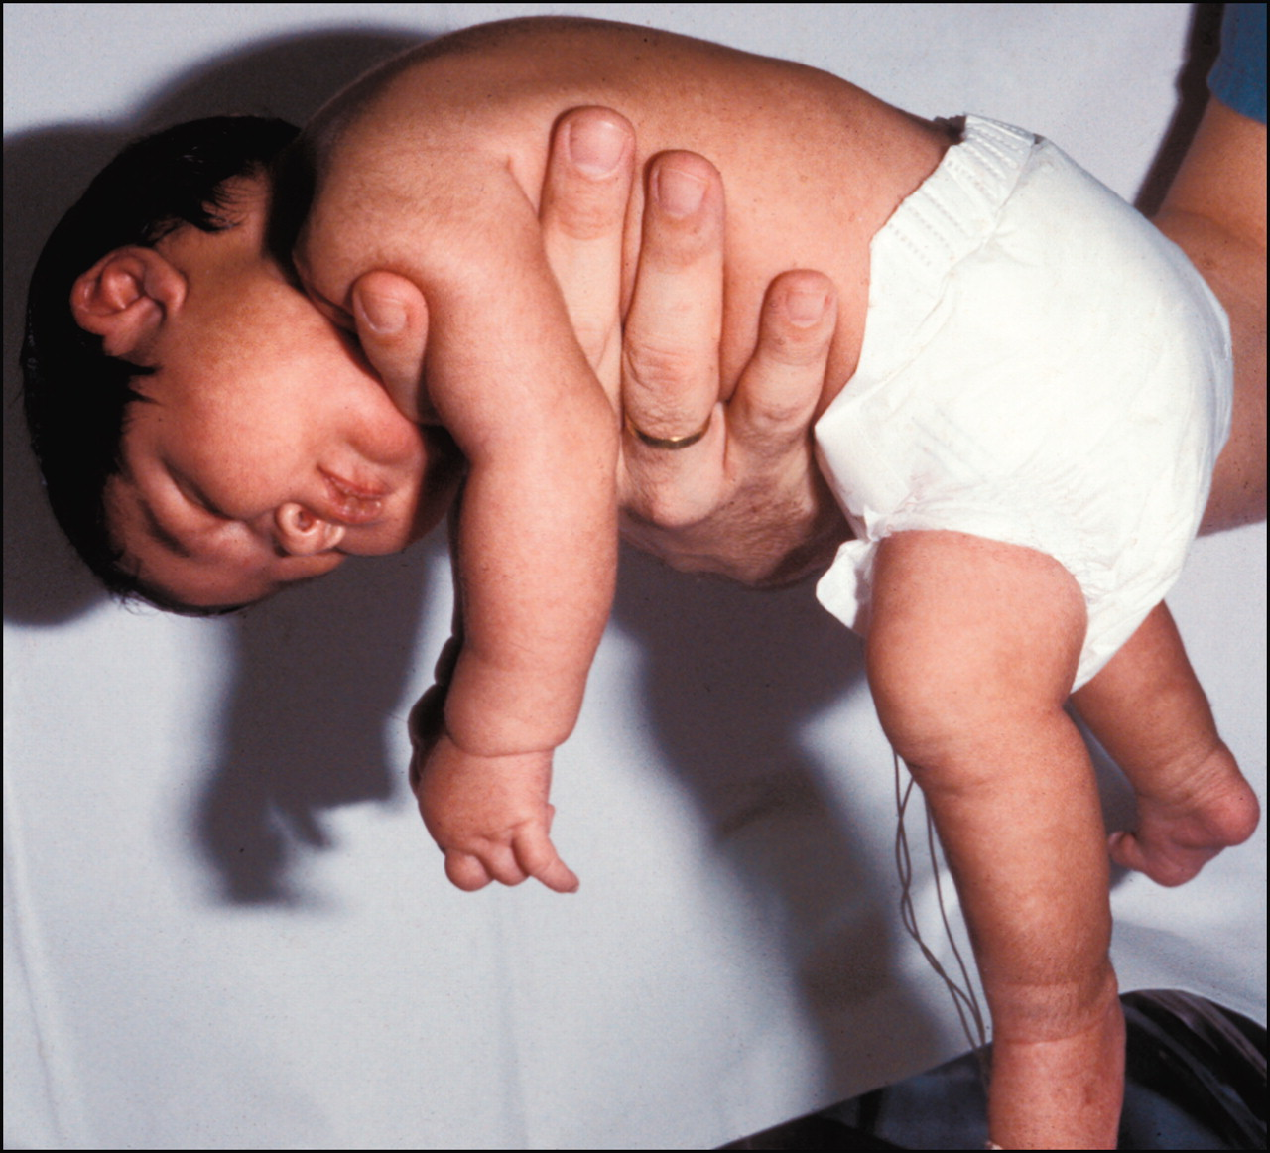Feel the spine and check for any deviations
  + You can comment on the neonate’s tone (floppy baby don’t resist gravity AT ALL… their neck is down)
* Put the baby back on radiant warmer and incubator, and cover him up