Hematology:

* General concepts:
  + Anemia = reduction in RBC count or Hb level > 2 SD below mean
  + **Hemoglobin and age**:
    - **Hb is HIGH AT BIRTH** (>14 g/dL ~ around 15 – 20) because of low O2 tension, resulting in high EPO
    - Then it declines to its **nadir** between **2 – 3 months of age** in TERM infants ~ <10 g/dL (in preterm infants, this happens earlier, at ages of 1 – 2 months and at lower values)
    - 1 – 12 years old: Hb < 11 g/dL
    - It is raised to the **normal adult values** **after puberty**
    - By 6 months of age, HbA (α2ß2) becomes the predominant form of Hb (instead of HbF ~ α2γ2) – defects in beta globulin chain will manifest > 6 months of age (but enzymatic defects in RBCs such as G6PD deficiency and pyruvate kinase deficiency + structural defects like hereditary spherocytosis can all manifest BEFORE 6 months of age)
  + **Corrected reticulocyte count:**
    - Corrected RC% = (measured HCT/45) x RC
    - Further correction for polychromasia means dividing the above value by 2 (>6% = high; <1% = low)
* **Microcytic, hypochromic anemia**
  + Causes:
    - IDA, thalassemia, sideroblastic anemia, lead toxicity, ACD
  + **IDA:**
    - Manifest commonly in those **aged 9 – 24 months** (when iron stores are depleted + when weaning is begun with iron poor foods + **cow’s milk is iron poor**) AND in **adolescent girls** (rapid growth, loss of iron in menstrual blood)
    - Causes may also include **occult blood loss** from: *juvenile polyp*, *meckel’s diverticulum*, *IBD*, *PUD* and *early ingestion of cow’s milk* (< 1 year of age) and *cow milk’s allergy*
    - Also seen in **premature infants (accentuated nadir)** and **twins**
    - Clinical features to note:
      * **Pallor occurs early** (mild disease)
      * **Moderate** anemia will show weakness, fatigue, **headache**, **tachycardia** (sometimes with **ejection systolic murmur**), tachypnea, exercise intolerance, **pica**, anorexia
      * **Severe** anemia can lead to CHF, SOB, HSmegaly
      * Attention is diminished; spoon-shaped nails = **koilonychia** may also occur
    - Labs:
      * **Low serum ferritin** (**early** finding) – but it is an acute phase reactant, so it can be high in inflammation
      * **Low serum iron**
      * **High TIBC, but low %saturation**
      * **High FEP**, **high RDW**
      * Hemoglobin low with normal to high RC
      * **Peripheral smear** will show hypochromic, microcytic RBCs
    - Management:
      * **Dietary counseling** (**increased organic iron intake** from foods) – adequate supply of iron to pregnant female, making **powdered formula fortified with iron**, prophylactic iron therapy to premature infants, proper weaning with iron containing food (meat, liver, green veggies)
      * **Treat the underlying cause** if there is one
      * **Elemental iron** [**ferrous sulfate**/gluconate] (dose = 4 – 6 mg/kg/day) – given orally, with **vitamin C** (juice especially) to enhance absorption – ***RARELY NEEDED***
      * Severe cases may require **IV iron dextran** or **packed RBC transfusion** (only in **heart failure cases**)
      * Don’t forget, earliest response to treatment is seen in **reticulocyte count** (peaking **5 – 7 days** after)
      * **Don’t stop treatment if Hb is normal** (usually by 1 month), as **iron stores need to be replenished** (takes 1 -3 months)
  + **Thalassemia:**
    - **Alpha thalassemia:**
      * **Deletion** mutation of alpha globulin chain of Hb (**affects HbF and HbA**)
      * If ¼ of alpha gene loci deleted 🡪 silent carrier (asymptomatic)

**Hydrops fetalis**:

Collection of fluid **in ≥ 2 serosal surfaces**  (pleural effusion, pericardial effusion, ascites) due to severe anemia in utero resulting in heart failure. Classically the infant dies in utero or soon after birth, with **marked edema**.

The causes include **immune** (erythroblastosis fetalis from Rb, ABO and minor group incompatibility; hemolytic anemia like alpha thalassemia with all 4 deleted; parvovirus B19 infection in pregnant mothers) and **non-immune** (severe maternal IDA, mucopolysaccharidoses like Sly syndrome – low beta-glucoronidases)

* + - * If 2/4 of alpha gene loci deleted 🡪 can be cis or trans; cis is more common in Asians and more dangerous than trans; they usually have milder anemia than ¾ or 4/4
      * **¾ deletion** results in **HbH disease**, in which **HbH (ß4)** are formed as well as some **Hb Barts (γ4)**; they have **severe anemia** and **hepatosplenomegaly**
      * If all 4 are deleted 🡪 **Hydrops fetalis** (Hb Barts are mostly formed, and they have severe anemia with unlikely survival during pregnancy)
    - **Beta thalassemia major (homozygous):**
      * **Mutations or deletions** in genes resulting in decreased formation of beta globulin chain
      * Beta thalassemia major = absent or very low beta globulin formation (ß0/ ß0)
      * **Hepatosplenomegaly** (**extramedullary hematopoiesis**), **thalassemia facies** (“chipmunk” facies including widening of cranial and maxillary periosteum, frontal bossing due to medullary expansion + **crew-cut/hair on head appearance on head X-R**) – both **due to raised EPO** as a result of anemia
      * Lab studies show **severe hypochromic, microcytic anemia** (usually w/ severe hemolytic picture), target cells, **elevated unconjugated bilirubin (**w/ **jaundice);** Hb electrophoresis 🡪 **high HbF, low HbA, high HbA2**
      * They require **life long blood transfusions** and **splenectomy**. BMT may be useful.
      * **Blood transfusions are given to keep Hb > 10 g/dL** and allow **proper growth** and **prevent bone deformation and organomegaly**
      * Complications of transfusions include **2ndary hemochromatosis,** primarily resulting in **dilated cardiomyopathy, liver cirrhosis, diabetes, delayed growth and sexual maturity** [deposited in pituitary gland] and **hyperpigmentation of skin (bronzing)**
      * **Minor complications** of transfusion includes antibody formation, infections, and venous access problems
      * They should be put on **chelation therapy** using **deferoxamine/desferrioxamine SQ** or **deferasirox (OD)/deferiprone (TID) orally**
      * Those compliant with this therapy can live up to their 40s in 90% of cases
      * Expectant mothers who are carriers and whose husbands are too should be offered genetic counseling including CVS DNA analysis
    - **Beta thalassemia minor/trait/heterozygous**:
      * Mild, mostly asymptomatic, anemia with slightly lower Hb levels than normal range
      * Easily **misdiagnosed as IDA** (but in this case, iron is normal, SO **MEASURE SERUM IRON** in these patients, so that you don’t give iron therapy for no reason)
      * Lab studies: peripheral smear may show microcytosis and/or hypochromasia; **Hb electrophoresis may show raised HbA2**
  + **Sideroblastic anemia**
    - Ringed sideroblasts in bone marrow (accumulation of iron in mitochondria of RBC precursors)
    - May be inherited or due to drugs/toxins (INH, alcohol, lead poisoning, chloramphenicol)
    - Condition improves with vitamin B6 therapy
  + **Lead poisoning** (characteristic **basophilic stippling**)
  + Anemia of chronic disease
* **Macrocytic (megaloblastic) anemia**
  + Don’t forget, characteristic smear findings **include hypersegmented neutrophils, macro-ovalocytes**, possibility of cytopenias; bone marrow findings include **megaloblasts**
  + Folate deficiency
    - Decreased intake or decreased absorption of folate
      * **Diet lacking vegetables**
      * Exclusive **goat milk feeding**
      * **Celiac disease, CD**, medications (**anticonvulsants** such as **phenytoin**)
    - May present with FTT
    - Diagnosis = low serum folic acid
    - Management = increase dietary folic acid/treat underlying cause
  + **Vitamin B12 deficiency** 
    - Causes include **decreased dietary intake** (**vegan diet**) or inherited inability to secrete intrinsic factor (**juveline pernicious anemia**) or **inability to absorb B12** (CD)
    - Features include **smooth red tongue** and **neurological manifestations** (ataxia, upgoing plantar reflex/ Babinski sign… Subacute combined degeneration of spinal cord)
    - Diagnosis = low serum B12
    - Tx = monthly IM vitamin B12
* Normocytic, normochromic anemias:
  + Can be divided based on reticulocyte count:
    - **High reticulocyte count (>2%)** – bone marrow reaction
      * Hemolytic anemia (extravascular, intravascular)
      * Blood loss
    - **Low reticulocyte count (<2%)** – bone marrow failure
      * Red cell aplasias
      * Pancytopenias
      * Malignancies
* Hemolytic anemia:
  + **Intrinsic RBC defects:**
    - **RBC membrane disorders**
      * Hereditary spherocytosis
      * Hereditary elliptocytosis
    - **RBC enzyme disorders**
      * Pyruvate kinase deficiency
      * G6PD deficiency
    - RBC hemoglobinopathies:
      * Sickle cell anemia
  + **Extrinsic RBC defects:**
    - AIHA (primary, secondary)
    - Alloimmune hemolytic anemia
    - MAHA
* **Hereditary spherocytosis:**
  + Northern European ancestry; **autosomal dominant** inheritance
  + Defect in membrane structure due to abnormal/absent **spectrin** (or ankyrin)
  + Increased extravascular hemolysis in spleen because of abnormal shape (spherocytes) 🡪 splenomegaly (congestive) at 2 - 3 years of age
  + **Splenomegaly**, pallor, **bilirubin gallstones, aplastic crises** (parvovirus B19)
  + Infants may present with **jaundice (neonatal too) and anemia**
  + Lab tests:
    - CBC shows picture of hemolytic anemia with high reticulocyte count, some nucleated RBCs
    - Peripheral smear shows spherocytes, some nucleated RBCs
    - Osmotic fragility testing (early hemolysis)
  + Tx:
    - RBC transfusion if necessary
    - **Cholecystectomy** may be needed
    - **Splenectomy** cures the condition (by age 6 it is done)
    - Complications of splenectomy:
      * Increased risk of infection by encapsulated bacteria (pneumococcus, meningococcus, Hib, salmonella)
      * Target cells may be seen after
    - Splenectomy care:
      * Before splenectomy 🡪 vaccinations (Hib, PCV, meningo)
      * After 🡪 long acting penicillin prophylaxis till age of 8
* **Hereditary elliptocytosis (AD)**
  + Defect in spectrin; majority are asymptomatic (may develop jaundice at birth, and splenomegaly, gallstones later in childhood)
  + Elliptical RBCs are seen on peripheral smear
  + Splenectomy may be done for those presenting with symptoms of hemolysis
* **Pyruvate kinase deficiency (AR)**
  + No pyruvate kinase = low ATP (final step in glycolysis) 🡪 decreased RBC survival
  + Pallor, jaundice, splenomegaly; kernicterus may occur
  + Labs: varying degree of anemia; blood smear 🡪 polychromatic RBCs
  + Diagnosis: decreased PK activity in RBCs
  + 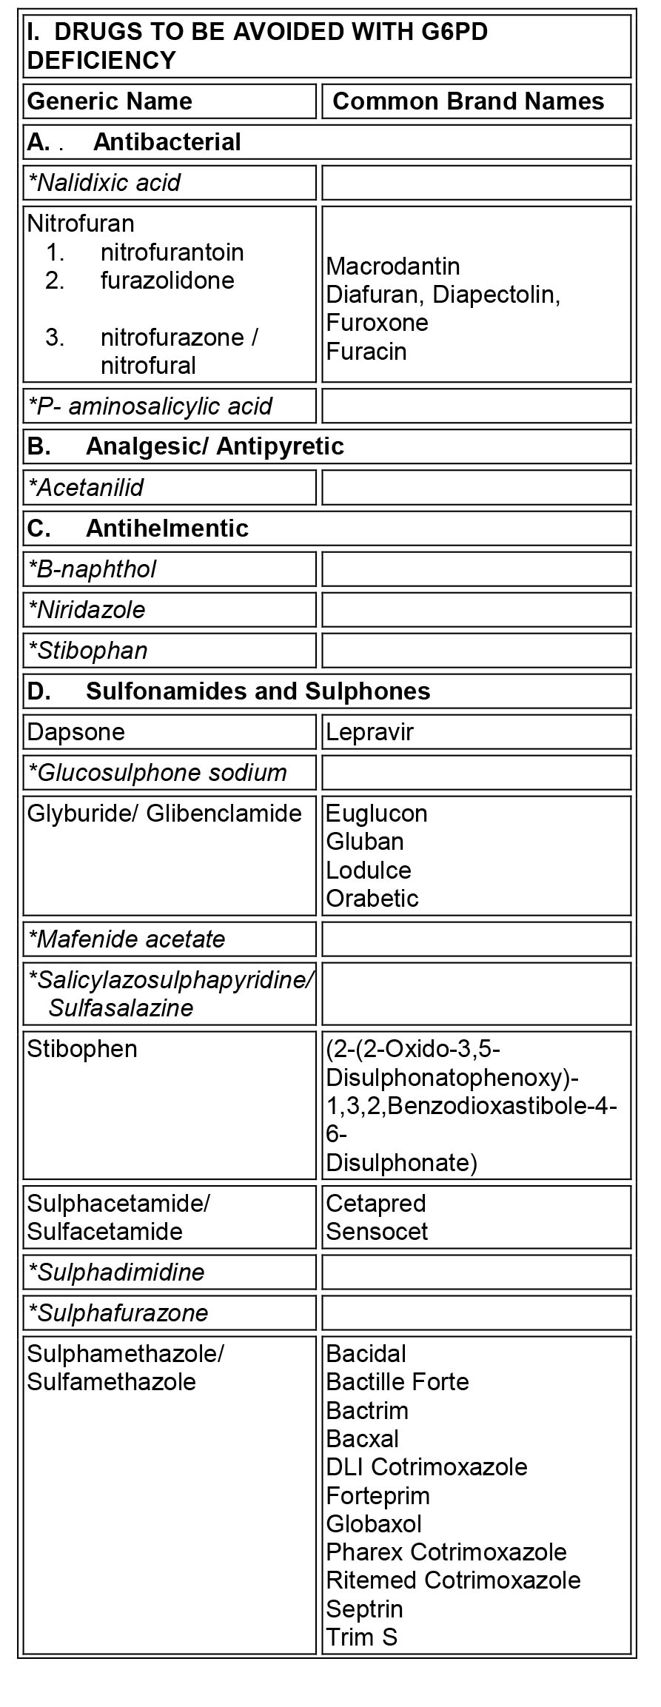Tx: transfusion, splenectomy

Although it is XLR and affects males mostly, females can get affected in cases of X-inactivation (also called **“Lyonization”)**

* **G6PD deficiency (X-linked recessive):**
  + Most common RBC enzymatic defect
    - G6PD is necessary to form NADPH, which acts as a reducing agent for anti-oxidants that reduce oxidative stress within RBCs
    - No NADPH = high reactive oxygen species 🡪 damaging of membranes (oxidized cellular membranes) 🡪 **Heinz bodies**
    - RBCs containing Heinz bodies are damaged in the spleen to form **bite cells**, which can be destroyed intravascularly (mostly intravascular hemolysis)
  + May occur as acute hemolytic disease (medications, infection-induced) or as a chronic hemolytic disease
  + **Triggers of hemolysis** (substances that increase oxidative stress/oxidants):
    - **Fava beans**, **infections**, **drugs** (**sulfa drugs** [including COX-2 NSAIDs like celecoxib], **antimalarial drugs** like chloroquine, quinine, salicylic acid, sulfonamides), **mothballs**, **Henna**
  + Clinical features:
    - 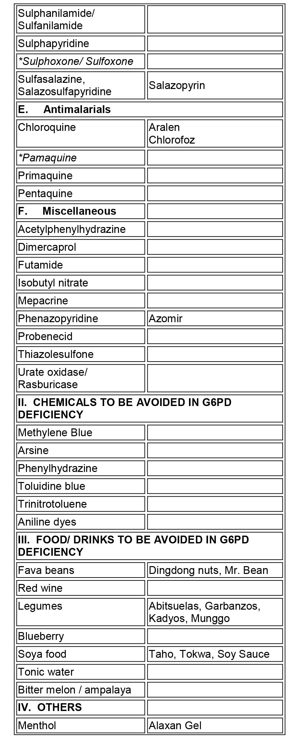Neonatal jaundice (day 3-5, severe, may need transfusion)
    - 24-48 hours post-exposure of oxidant 🡪 hemolytic picture with abdominal pain, vomiting/diarrhea, fever, pallor, jaundice, hemoglobinuria (acute dark color urine)
  + Lab findings, diagnosis:
    - Intravascular hemolysis picture:
      * Blood smear: Heinz bodies, bite cells, reticulocytes
      * CBC and RBC profile: Low haptoglobin, high LDH, high reticulocyte count, high unconjugated bilirubin
      * Urinalysis: hemosiderinuria, hemoglobinuria, urobilinogen
      * G6PD enzyme activity (done AFTER 2 weeks of acute attack, because immediately after hemolysis BM releases new RBCs and reticulocytes with normal enzyme levels 🡪 inaccurate results) – low activity
    - Classification based on enzyme activity:
      * I - very severe (**<10%** enzyme activity, but **chronic HA**)
      * II- severe (<10% enzyme activity, but **acute HA**)
      * III – moderate (10 – 60%; acute HA with stressors only)
      * IV – mild to none (60 – 150% enzyme activity, normal)
      * V – none (>150% enzyme activity, normal)
  + Tx:
    - Immediate blood transfusion (packed RBCs 10 ml/kg) in severe hemolysis
    - Prevention: list of drugs and foods to avoid must be offered
* NOTE: CAUSES OF ACUTE HEMOLYSIS:
  + G6PD D.
  + Hemolytic crisis of CHA (HS, thalassemia, SCD)
  + AIHA (drug intake, infection history; arthritis, rash; coomb’s +ve)
  + HUS (history of gastroenteritis and acute renal failure S&S)
  + Infection (malaria, babesia, look for pattern of fever, travel and blood smear)
  + Sepsis (toxic patient, purpuric eruption, leukocytosis and left shift)
  + Metabolic (Wilson’s disease; kayser-flescher rings, copper & ceruloplasmin)
  + Rh & ABO incompatibility (blood transfusion history, rash, fever, coomb’s, blood grouping)
* **Extrinsic Defects of RBCs (AIHA)**
  + Autoimmune hemolytic anemia (AIHA)
    - Primary AIHA (idiopathic)
    - Secondary AIHA (lymphoma, SLE, immunodeficiency)
  + Cold and Warm type AIHA:
    - Warm and cold refer to triggers of the AIHA
    - Warm type is Ig**G** mediated (think **G** for **G**irl), extravascular hemolysis usually seen in SLE (girls > boys) and methyldopa (think pregnancy ~ girls)
    - Cold type is Ig**M** mediated (think **M** for **m**en), intravascular hemolysis, usually seen in infectious **m**ononucleosis and **m**ycoplasma pneumoniae infection (cold agglutinins)
    - CLL can cause both warm and cold type AIHA
  + An acute type AIHA usually follows a respiratory infection and results in pallor, jaundice, hemoglobinuria (intravascular hemolysis picture) and splenomegaly (source of auto-Ab usually) 🡪 complete recovery
  + Prolonged type AIHA 🡪 high mortality
  + **Lab findings:**
    - CBC with differential showing severe anemia, raised reticulocyte count; raised WBC?
    - Smear will show spherocytes, reticulocytes, leukocytosis; may also show agglutinins (helpful in diagnosis of mycoplasma)
    - +ve direct Coomb’s test
  + Tx:
    - Blood transfusion only provides transient relief
    - Corticosteroids – prednisolone (acute form responds well to this)
* **Alloimmune hemolytic anemia:**
  + **Rh hemolytic disease; ABO hemolytic disease**
* **Macroangiopathic hemolytic anemia**
  + Anemia resulting from mechanical damage to RBCs when passing thru **prosthetic valves** and **aortic stenosis** (**schistocytes** are seen)
* **Microangiopathic hemolytic anemia (MAHA):**
  + Anemia resulting from mechanical damage to RBCs by passage through an **injured vascular endothelium**
  + Seen in: **DIC, HUS, TTP, giant hemangioma, malignant hypertension**
  + Clinical features:
    - Hemolytic anemia picture
    - Thrombocytopenia can result in S&S (purpuric skin lesions, bleeding tendency)
    - Depending on cause: DIC may show a wide variety of S&S (very dangerous); HUS is accompanied by anuria and other signs of acute kidney injury; TTP is accompanied by fever, neurological S&S
  + Labs:
    - Peripheral smear: schistocytes (helmet cells), target cells and burr cells, thrombocytopenia
  + Tx:
    - Supportive care, antibiotics are not given in HUS; cryoprecipitate may be given in DIC

**SICKLE CELL DISEASE/ANEMIA:**

* Common in African Americans, Middle-Eastern people
* Presents after 6 months of age (or when HbF begins to be replaced by HbA as the predominant Hb form)
* Due to **single nucleotide polymorphism/mutation** of **GTG 🡪 GAG** (**glutamic acid** [soluble] 🡪 **valine** [less soluble]) in **position 6** of **chromosome 11**, resulting in an **abnormal beta globin chain**
* The mutation is **autosomal recessive** in form, with increased risk in **consangious marriages** (if both parents are carriers, 25% risk of homozygous child, 50% of carrier child, 25% normal)
* The resulting Hb is called HbS; Homozygous individuals are HbSS, heterozygous individuals are HbAS or carriers/SC trait
  + HbS in SCD (homo) is > 50% (and HbA <50%), HbF is raised
  + HbS in SCT (hetero) is < 50%, but >0%, and HbA > 50%
  + SC***T*** confers immunity to falciparum malaria (similar distribution in sub-Sahara Africa, along with G6PD D. and thalassemia; ***not SCD***!!!)
  + HbS may occur alone or with other inherited hemoglobinopathies, including HbC (HbCS; HbC results from same positional mutation, but to lysine – ly”C”ine – not valine; common in Africans milder disease) or with beta thalassemia (HbS/thal; severe anemia, similar to SCD, but lab with show high HbA2 + HbS > 50%, HbA <50%); HbE (asians)
* Individuals with SCT may not have any signs of anemia, but they can present with **hematuria** (susceptible to renal papillary necrosis) or anemia in severe stress
* The HbS, contained in RBCs, under **stressful situations** (**hypoxia, infection, dehydration, acidosis, cold**) begin to **aggregate/polymerize** and produce an **abnormal sickling shape**, which adheres to and blocks small vessels in various locations in the body
  + Initially the sickling is reversible, but with repeated episodes of sickling, it may become permanent
  + The RBCs have distorted shape, **reduced life span** (risk of hemolysis)
* **Diagnosis:**
  + **Neonatal screening** using Hb electrophoresis/HPLC (part of Guthrie)
    - On HPLC, the beta globin will be less negatively charged and will not move as fast as HbA to the anode
    - Order of travel to the anode (C, S, F, A); so HbC is the least negatively charged/soluble
  + **Sickling test** (blood sample exposed to hypoxic conditions sickle)
  + **Peripheral smear** will show sickled cells and reticulocytosis (depends on what the acute condition of admission is)

**Other cells: target cells, Howell-Jolly bodies**

* **Clinical features:**
  + Onset is usually **2nd half of first year of life**
  + The course is less severe than in thalassemia
  + Clinical episodes are called crises (occur suddenly) and can result from triggers
  + **Vaso-occlusive crises (VOC):**
    - **Painful bone crisis** 
      * Most common crisis
      * Subtypes include **acute dactylitis** (**Hand & food syndrome**), which is often the **initial presentation in kids** and usually in the hand & feet/ metacarpals & metatarsals (and may result in digits of varying sizes)

**The five crises of SCD:**

1. **Vaso-occlusive crisis**
2. **Acute chest syndrome**
3. **Sequestration crisis**
4. **Aplastic crisis**
5. **Hemolytic crisis**
   * + - Result of ischemia of bone or **bone marrow**
       - The pain is deep, throbbing, lasting 3 – 7 days
       - In **older people**, the common places of bone crises are **lumbosacral**, **knee,** elbow, shoulder and femur
       - **DDx = osteomyelitis, avascular necrosis, Gaucher**

General management of crises:

* Analgesia
* IV fluids
* Oxygen
* Antibiotics for infections (ACS)
* **Bicarbonate for acidosis**
* Exchange transfusion (ACS, stroke, priapism)
* Blood transfusion (if Hb < 7 g/dL)
* Bed rest
  + - * Management includes:
* **Pain control** (analgesia, morphine)
* **IV fluids** (2x the maintenance)
* Incentive spirometry/O2 to decrease risk of ACS
* **Partial exchange transfusion** (not packed RBCs, because it can increase viscosity of blood and worsen crisis)
* **Acute abdominal crisis**
* Abdominal pain, distension (caused by sickling within **mesenteric artery** and its tiny branches/arcades)
* **DDx: cholecystitis, gallstones, appendicitis, splenic sequestration**
* Management:
* Same as for painful crises, however, you need to do abdominal imaging
* **Stroke (Acute CNS event)**
* Signs of neurological deficits/palsies (dysarthria, hemiplegia); 11% of patients, but can be subclinical
* 60 – 90% recurrence
* Management is the same as painful crisis, but **chronic transfusion program may be considered** (because of **recurrence risk**)
* The **need for exchange transfusion is urgent**
* **HbS must be maintained < 30%** within next 4 years, and then <50% thereafter
* **Priapism (sustained kind = medical emergency)**:
* Painful, sustained erection
* Most commonly occurs during sleep or upon waking up
* Types include short duration (2 – 3 h), prolonged (>24 h), chronic (up to a week!) – risk of impotence
* Same Rx + a-agonists, aspiration of blood, saline irrigation, shunting
* **Acute Chest Syndrome (ACS)**
* **New pulmonary infiltrate** + **acute respiratory symptoms** including cough, shortness of breath, severe chest pain + **fever**
* The picture is **similar to pneumonia** (consolidation on CXR, fever, increased WBCs)
* There is hypoxemia (and respiratory distress will be noticed), V/Q mismatch
* May cause **25% of deaths in patients with SCD**
* Causes include:
* **Infections** (viral, mycoplasma pneumoniae, chlamydia, streptococcus pneumoniae)
* **Sickling**
* **Fat embolism**
* **Painful bone crises involving the overlying ribs**
* **Others** (pulmonary edema, atelectasis)
* Management:
* Key = OXYGEN
* **Supportive measures (O2, IV fluids)**

**3 main things to use exchange transfusion are stroke, ACS and priapism (according to Illustrated)**

* **Ventilation (CPAP)**
* **Analgesia (very painful)**
* **Antibiotics (cefuroxime, azithromycin, penicillins)**
* **Early partial exchange transfusion** (lower to <50% sickles)
* **Sequestration crisis**
* Blood accumulates in spleen (or liver) resulting in **massive splenomegaly (+/- hepatomegaly) in patients < 6 years** (because by that time, auto-splenectomy may have occurred, either ways age 6 is when spelectomy can be performed)
* Abdominal distension (splenomegaly), abdominal pain, SOB, tachycardia, pallor, fatigue, **shock** (blood is being pooled in spleen, so body thinks it doesn’t have enough blood! So EPO increases)
* High risk of mortality
* Labs will show: HIGH RETICULOCYTE COUNT, low Hb and platelets
* Note: **hypersplenism is also associated with splenomegaly, but in that case there is pancytopenia** (very important DDx)
* Management = **supportive** (O2, IV fluids), analgesia
* **RBC transfusion** (make up for lost RBCs)
* **Splenectomy is controversial** (some recommend it because there is a high recurrence risk ~ 50%)
* **Aplastic crisis:**
* RBC aplasia caused by **parvovirus B19** (or other) infection
* Results in anemia picture, but labs will show **LOW RETICULOCYTE** COUNT and low Hb
* Management is supportive (IV fluids), RBC transfusion if Hb is very low, and G-CSF stimulators (Filgrastim)
* Usually lasts for 3-4 weeks but self-resolves
* **Hyper-Hemolytic crisis**
* Rapid hemolysis, usually with people who have **both SCD and G6PD** deficiency
* Severe anemic picture, with jaundice
* Labs show hyperbilirubinemia (unconjugated), low Hb, low haptoglobin, HIGH RETICULOCYTES
* Rx = supportive care, transfusion of RBCs in severe cases
* Other conditions:
* Eyes 🡪 **proliferative retinopathy**, central artery occlusion (needs monitoring/screening)
* **Aseptic necrosis of femoral** **head** or humeral head
* **Autosplenectomy** (splenic infarction) – needs to removed, person needs to be vaccinated against capsulated bacteria
* **Systolic ejection murmur**, S3 (hyper-dynamic circulation, which can result in **high output** **heart failure**)
* **Gallstones (bilirubin stones)** – they get conjugated and oversaturate
* 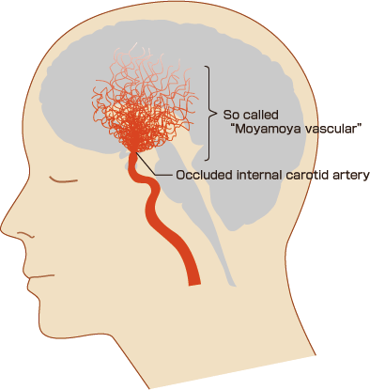**Leg ulcers** (usually in 10 – 20 year olds, not kids) – result of high venous pressure in legs; typical site is over lateral malleoli
* Untreated conditions may show similar facies seen in thalassemia
* **Renal papillary necrosis**
* **Adenotonsillar hypertrophy** and sleep apnea syndrome (trigger)
* **Moyamoya disease**: Japanese for puff of smoke seen on x-ray angiography of the head
* Blocked vessels are bypassed by tiny, weak vessels that are tortuous and easily result in hemorrhage
* It may be congenital (Down, NF-1) or acquired (as in SCD)

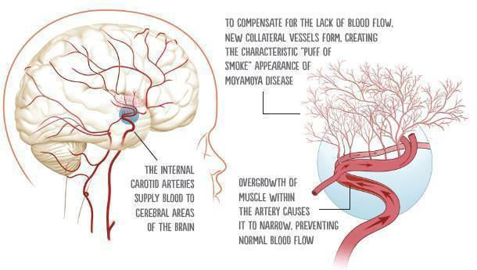

* **Lab findings:**
  + Low Hb (6 – 9 g/dL)
  + Low Hematocrit (18 – 27%)
  + Reticulocyte count is usually raised (hemolytic)
  + WBC count may be high
  + Platelet count often increased
  + Bilirubin is increased (unconjugated)
  + Blood smear may show **sickled cells**, in case of splenic infarction: **target cells** and **Howell-Jolley bodies**
  + BM biopsy may show erythroid hyperplasia
* Management:
  + **Infection = leading cause of death** 
    - 30% develop sepsis/meningitis in first 5 years of life
    - Decreased splenic function results in increased risk of infection by encapsulated bacteria (Hib, S. pneumoniae, salmonella, N. meningitidis)
    - IF YOU SEE FEVER IN SCD PATIENTS, CHECK! Perform blood culture and urine culture, do CXR to rule out pneumonia, and give empirical IV antibiotics just in case
    - **Osteomyelitis in SCD is *often* but *not always* caused by salmonella** (acquired thru GI tract), but the most common causative agents is still **S. aureus.**
  + Preventative care (*besides* genetic counseling):
    - **Hydroxyurea** (increases HbF, which decreases measure of HbS in ratio and results in less vaso-occlusive crises) – usually given if there is recurrent crises and/or stroke, priapism, ACS
    - **Daily oral penicillin prophylaxis** (started early [3 months of age to at least 5 years] and continued throughout childhood, to ensure covering of all pneumococcal subgroups)
    - **Daily folic acid** (increased demand for it due to chronic HA)
    - **Routine immunization** + **yearly influenza**
      * Stress on **meningococcal, pneumococcal, Hib vaccines**

**IV FLUIDS IN SCD:**

If the patient is hypovolemic, normal saline (ie, 0.9 percent saline) is appropriate to maintain hemodynamic stability. If the patient is euvolemic and receiving maintenance intravenous fluids, we use one-quarter or one-half normal saline with or without glucose. Of note, this differs from maintenance fluid replacement in patients without SCD, who often receive normal saline. Patients with SCD may have a decreased ability to excrete sodium and may become hypernatremic from receiving normal saline. Hypernatremia in turn may lead to red blood cell dehydration, which increases sickling.

* + - Serial transcranial Doppler ultrasound or MRA (magnetic resonance angiography)
      * Begin at 2 years, to watch for stroke
      * Moyamoya disease
      * Sinus venous thrombosis
* Other things:
  + Prognosis: 50% may live up to their fifties
  + Long-term complications for kids **include delayed growth and puberty, diminished cognition and school performance**
  + Morphine: risk of dependence in adults
    - Forms of administration include:
      * Bolus (causes surges, high risk of dependence, used only for induction)
      * Continuous IV infusion
      * Patient controlled administration (PCA)
    - Biggest fear = respiratory depression (opioids)
    - Bolus in crises (for spike) and maintain on other forms (to prevent breakthrough pain)
  + Last resort = **BMT** (90% cure rate, but 5% fatality possibility)
  + Future therapies? Gene therapy ☺
* **Red blood cell aplasia** 
  + Characterized by low RBC count, low reticulocytes and low RBC precursors in bone marrow
  + Can be congenital or acquired
  + **Congenital hypoplastic anemia (Diamond-Blackfan anemia)**
    - Anemia develops **rapidly in first year of life** (early)
    - Physical findings are also seen, such as **short stature**, **triphalangeal thumbs** (thumb is like the other fingers), **craniofacial features** (fat-looking), renal and cardiac anomalies
    - Lab findings include low Hb, RBCs, low RC, but HbF may be high; marrow shows low RBC precursors; platelets may also be low
    - Tx = RBC transfusion, corticosteroids (70% respond) and BMT (if no response to steroids)
  + **Acquired red blood cell aplasias:**
    - **Transient erythroblastopenia of childhood (TEC)**
      * Possible post-viral autoimmune reaction
      * Anemia begins **AFTER first year of life**
      * Slow onset
      * Labs: low Hb, RC, normal platelet; marrow shows low RBC precursors
      * Tx: spontaneous recovery in few weeks (no treatment required)
    - **Pure RBC aplasia (infection-associated)**
      * Most common etiology is Parvovirus B19 (can also be EBV, CMV, HIV, and due to drugs like chloramphenicol)
      * If with parvovirus B19, kids may also have fifth disease (slapped cheek disease – red facial cheek rash and URT symptoms, followed by a diffuse red lacey rash)
      * Can occur in SCD (aplastic crisis) or in other hemolytic conditions (hereditary spherocytosis)
      * Labs: low Hb, low RC, normal platelet
      * Tx: spontaneous recovery in 2 weeks; RBC transfusion if severe or in SCD (aplastic crisis)
* **Pancytopenias:**
  + Classification of absolute neutrophil count (ANC):
    - ANC = (PMN%/ 100) x total WBC count
    - > 1,500 = normal
    - 1,000 – 1,500 = mild neutropenia
    - 500 – 1000 = moderate neutropenia
    - <500 cells/mm3 = severe neutropenia
  + Pancytopenia can be congenital or acquired
  + **Congenital aplastic anemia (Fanconi anemia)**
    - **AR** inheritance
    - Features:
      * BM failure ~ 7 years (present with petechia, ecchymosis)
      * **Short stature** (all patients), **absence or hypoplasia of thumb and radius**
      * **Café-au-lait spots** (hyperpigmentation)
      * Renal abnormalities
      * BM transformation to **acute leukemia**
    - Labs:
      * Pancytopenia
      * If RBCs are present, they are macrocytes
      * Low RC count, elevated HbF
      * Bone marrow hypocellularity/fatty infiltration (dry tap)
      * Lymphocyte karyotypes show **increased chromosomal breakage** (like ataxia telangiectasia)
    - Tx:
      * Transfusion of RBCs, platelets
      * Immunosuppressive therapy (corticosteroids), GM-CSF
      * **BMT**
  + **Acquired aplastic anemia**
    - Can be caused by **drugs** (**chloramphenicol** 🡪 gray baby syndrome, sulfonamides, anticonvulsants 🡪 **carbamazepine**)
    - Can be caused by **infections** (HIV, EBV, CMV)
    - Can be caused by **chemicals (benzene)** and **radiation**
    - Features: bruising, petechiae, pallor, serious infections
    - Labs: same as congenital
    - Management: identify and stop causative agent (+ same as congenital)
* Polycythemia
  + HCT > 50% (Hb > 2 SD)
  + Polycythemia can result in **plethoric face, erythromelalgia**
  + **Primary polycythemia = polycythemia vera**
    - It is a malignancy (overgrowth of myeloid precursors due to **JAK2 mutation**), **EPO is LOW**
    - All cells are high, but people always talk about RBCs…
  + **Secondary polycythemia**:
    - Divided into appropriate (in response to hypoxia) and inappropriate (where there is no true hypoxia)
    - In both cases, **EPO is high** (but in appropriate, the O2 saturation is supposedly low)
    - ***Appropriate* secondary polycythemia:**
      * Due to chronic hypoxia as seen in cyanotic heart diseases (MCC in childhood), pulmonary disease, high altitude, sleep apnea
    - ***Inappropriate* secondary polycythemia:**
      * Secondary to **tumors** including **RCC, HCC, VHL, hydronephrosis,** ectopic EPO secretion, ovarian tumors, etc.
      * Secondary to **drugs** (**steroids**, growth hormones)
  + **Relative polycythemia:**
    - RBC count is normal, but concentrated because loss of plasma volume (as in **dehydration, burns**)
  + Tx:
    - **Phlebotomy** is done to keep HCT <60%
    - **Treat underlying cause**
    - Fluid management in relative polycythemia
  + **Complications:**
    - **Thrombosis** (VOC, stroke, MI)
    - Bleeding
* **Hemophilia A**
  + Deficiency in **factor 8,** that is **X-linked recessive** (males are affected, females can be carriers, no male to male transmission, males of carrier mothers have 50% of being affected, females of affected fathers are obligate carriers)
  + Clinical features:
    - **Hemarthrosis** of knees, elbows and ankles
    - **Deep soft tissue bleeding** (such as the iliopsoas, which can go undetected until very late)
    - **Life-threatening hemorrhages** can occur
    - **CNS bleeding = most dreaded complication (head trauma)**
  + **Forms (based on factor 8 activity level):**
    - **Severe** (**spontaneous** bleeding) ~ **<1% activity**
    - **Moderate** (bleeding with **trauma**) ~ **1 – 5% activity**
    - **Mild** (bleeding with **major trauma**, surgeries) ~ **> 5%** activity
    - **Carrier (30 – 60%)**

**IV F8 recombinant concentrate** given to raise F8 level to **30% for minor bleeds,** and for **major/life-threatening bleeds** – **100%** and then **maintained at 30 – 50%** for 2 weeks to **prevent secondary hemorrhage**. Begin home replacement therapy at age 2-3 years… Kids can administer to themselves by age 7 – 8. Keep the baseline >2%. 1 unit of F8 = increase in 1%.

* + - **Normal (>60%)**
  + Lab findings:
    - **Prolonged PTT**
    - Normal PT, bleeding time, platelet count and function assay
    - Low **factor 8 protein activity**
  + Management:
    - Prevent trauma, **avoid aspirin, NSAIDs, IM injections**
    - **Factor 8 replacement therapy (recombinant, IV)**
    - **DDAVP** (desmopressin acetate) may help increase levels of stored F8 (it stimulates VWF release, which carries F8 in blood), used in **mild cases only**
    - **Cryoprecipitate (IV infusion in severe cases)**
  + Complications include **Ab to recombinant factor 8**
* Hemophilia B (Christmas disease, deficiency of F9, X-linked recessive)
* Hemophilia C (AR, low factor 11)
* **VWD:**
  + Most common hereditary bleeding disorder (most forms are **autosomal dominant**)
  + Types:
    - **Type I** (classic type, MC type): **mild, quantitative** deficiency of vWF (and F8, together resulting in prolonged PTT and BT)
    - **Type II** (further divided into subtypes): mostly **qualitative**
    - **Type III** (complete **absence of VWF**, most severe type, may be AR)
  + Features:
    - Most patients (type I especially) have mild-moderate bleeding at **mucocuntaneous sites** (varies from person to person, and may be discovered at an older age):
      * **Epistaxis**
      * **Excessive bleeding following dental extraction or tonsillectomy**
      * Easy bruising
      * **Menorrhagia (pubertal girls)**
    - Hemarthrosis may be seen in type III
  + Labs and treatment:
    - Labs show **prolonged PTT and bleeding time**
    - **Quantitative assay** for vWF & activity (**ristocetin cofactor assay** will be abnormal)
    - Tx:
      * DDAVP (desmopressin) increases vWF release from endothelial cells (used in mild-moderate cases, type I, prophylaxis before surgeries)
      * Cryoprecipitate (contains vWF) may be used for serious bleeding, long surgeries, type III
* **Acquired clotting factor disorders:**
  + **Vitamin K deficiency**
    - Fat-soluble vitamin, needed for liver production of factors 2, 7, 9, 10 + protein C and S
    - Dietary deficiency is unusual (except very early infancy)
    - Malabsorption can lead to ADEK deficiency
    - Medications can interfere too (warfarin)
    - HDN
      * **Classic** form is **within first week**
      * **Early** form is **within 24 hours**
      * **Late** form is **1 – 3 months**
      * Presents as **mucocutaneous bleeding** (hematemesis, **circumcision site**, umbilical cord)
      * Early and late forms may have severe bleeding, including CNS bleeding
    - Labs: prolonged PTT and PT (but PT first)
    - Neonates are given one dose of IM vitamin K postpartum
    - Severe diseases may require FFP (fresh frozen plasma)
  + **Liver disease**
    - Prolonged PT and PTT (causes defect in production of the factors stated above, increased FDPs, thrombocytopenia
    - Give FFP, vitamin K and platelets
  + **DIC:**
    - Secondary phenomenon occurring in response to an environmental factor/systemic factor and local factors – that leads to activation of coagulation system with reduced anticoagulation 🡪 thrombi formation (ischemic picture, earlier, but less obvious) 🡪 platelet consumption, destruction and coagulation factor loss (bleeding picture, later, but more obvious)
    - Causes:
      * Sepsis (meningococcal septicemia, gram –ve, rickettsial, including lyme disease and RMSF)
      * Extensive tissue damage (Burns, trauma)
      * Severe dehydration
      * Hypothermia, hyperthermia
      * Malignancies (acute promyelocytic leukemia/APL, other cancers of lung, breast, etc.)
      * Acute pancreatitis, malignant hypertension,
      * Amniotic fluid embolism, placental abruption
      * HELLP syndrome, eclampsia
      * Large hemangiomas (Kasabach-Merrit syndrome)
      * Heat stroke, snake bites, transplant rejection
    - **Clinical features:**
      * Ischemic findings are the earliest, but hemorrhagic findings are most clinically obvious
        + Ischemic findings include gangrene, acral cyanosis, delirium, infarcts, oliguria, dyspnea, adrenal infarcts
        + Hemorrhagic findings include petechiae, ecchymosis, oozing, ICH, hematuria, hemorrhagic lung, etc.
    - **Lab findings**:
      * Everything’s being used up, so PTT, PT, BT and TT (thrombin and fibrinogen are used up) are prolonged
      * FSPs (fibrin split products, like D-dimer) are high
      * CBC with differentials will show hemolytic anemia (acquired, MAHA) and thrombocytopenia
      * Blood smear 🡪 schistocytes (fragmented RBCs)
    - **Tx:**
      * Treat underlying cause
      * Severe bleeding may need FFP and platelet transfusion
      * Cryoprecipitate is a hard choice (it is considered if fibrinogen levels are low)
      * Don’t give anti-thrombotic or anticoagulants (heparin) 🡪 may increase risk of bleeding
      * Prognosis: 10 – 50% die, >50% if it is associated with sepsis (as in kids)
  + **Blood vessel disorders** (that predispose to bleeding tendency):
    - **Scurvy (vitamin C deficiency):**
      * Results in collagen synthesis defect (so blood vessel wall is weak)
      * Swollen, bleeding gums; bruising, petechiae and poor wound healing, perifollicular and subperiosteal hemorrhages, corkscrew hair
      * Weakened immunity
    - HSP
    - Hereditary hemorrhagic telangiectasia (AD, Osler-Weber Rendu syndrome)
      * Locally dilated and tortuous veins and capillaries of skin and mucous membranes
    - Ehler-danlos syndrome
    - Malnutrition and corticosteroids
* **Classification of thrombocytopenia:**
  + **Normal platelet count:** 150k – 450k/mm3
  + **Mild thrombocytopenia:** 50 – 150k/mm3
  + **Moderate thrombocytopenia:** 20 – 50k/mm3
  + **Severe thrombocytopenia:** <20k/mm3
* Platelet abnormalities
  + **Quantitative** 
    - **Reduced production:**
      * **Congenital** 
        + **Wiskott-Aldrich syndrome (X-LR)**

Thrombocytopenia, eczema, recurrent infections (B & T cell deficiency)

* + - * + **Thrombocytopenia-absent radius syndrome (TAR)**

AR, they have thrombocytopenia, limb abnormalities (absent radius, as name suggests, BUT the THUMB is PRESENT vs. FANCONI ANEMIA, where both thumb and radius may be absent)

* + - * Acquired (same as causes of pancytopenia)
    - **Increased destruction:**
      * ITP (MCC of acquired platelet abnormality in childhood)
      * TTP, HUS
      * Drugs (heparin?), DIC, hypersplenism, large hemangiomas (kasabach-merrit syndrome)
  + **Qualitative**
    - **Congenital**
      * **Glanzmann’s thrombasthenia** (AR, deficiency of Gp2b3a, cannot aggregate)
      * **Bernard-Soulier syndrome** (AR, deficiency of Gp1b, thrombocytopenia is not true, but instead because platelets are large “Big-Suckers”; ristocetin assaying will be abnormal)
    - **Acquired**
      * Drugs (**aspirin, valproate**), **uremia** and severe liver disease
* Specific topics:
  + **Immune thrombocytopenic purpura (ITP)**
    - Types: acute (common in childhood) and chronic (lasts >6 months)
    - Caused by auto-Ab released by spleen that targets platelets resulting in their destruction in the spleen
    - Acute form typically follows an infection (usually viral, usually URTI)
      * Presents as sudden cutaneous bleeding (petechiae, mucous membrane bleeding such as epistaxis, gum bleeding) ~ severe intracranial bleeding is rare
    - Lab findings = isolated thrombocytopenia, and bone marrow biopsy may show increased megakaryocytes
    - Treatment of acute form includes supportive (usually self-limiting), but severe thrombocytopenia may require IVIG or corticosteroids (or both in the worst case, but not recommended, because it increases the risk of future chronic form if given together; best is IVIG alone)
      * Platelet transfusions are useless because they get rapidly destroyed anyway
      * Splenectomy may be beneficial, but generally AVOIDED because of its side effects in kids
    - Prognosis:
      * Most cases resolve spontaneously in months
      * Chronic ITP (usually in adults, > 10 years old) occurs in 10 – 20% - characterized by relapses
  + **Autoimmune (neonatal immune-mediated) thrombocytopenia**
    - Passive form
      * Mother has ITP and her Ab crosses placenta and destroys fetus’s thrombocytes
      * Note: mother has thrombocytopenia
    - Isoimmune form
      * Mother produces Ab against fetus’s platelets (sensitization)
      * Note: mother has normal platelet count
  + **HUS and TTP:**
    - Both characterized with thrombocytopenia
    - TTP is caused by ULVWF release (due to defect in ADAMST13 resulting in not breaking down of ULVWF to small monomers), and characterized by fever, low platelets, MAHA (schistocytes) and neurological > renal manifestations
    - HUS is caused by certain shigella and EHEC enterocolitis (invasive, blood diarrhea, specifically O157:H7, shiga-like toxin) - resulting in same picture as TTP (but no fever) – with renal manifestations (Acute renal failure with anuria) > neurological manifestations
      * The shiga-like toxin damages endothelial cells (blocks ribosome function [60S] and hence protein formation), leading to platelet thrombi formation in vessels, especially renal vessels
      * Antibiotics are contraindicated in EHEC colitis (it can predispose to HUS) and in HUS itself (treatment is supportive)
    - **Atypical HUS:**
      * Drugs (tacrolimus, cyclosporine, oral contraceptives), inherited causes
      * No diarrhea, but severe proteinuria and HTN are seen + chronic relapsing course (“recurrent HUS”)
      * Tx is also supportive, but they have a higher risk of progression to ESRD (than typical shiga-associated HUS)
* **Hypercoagulability**
  + **Protein C deficiency** (protein C is potent anti-coagulant, needs vitamin K and liver)
    - Homozygous individuals are detected soon after birth
    - They have purpura fulminans (non-thrombocytopenic purpura, which can lead to DIC)
    - Heterozygotes present later, usually with dreaded conditions like deep venous or CNS thrombosis
    - Tx: anticoagulants, FFP, protein C concentrates may be given
  + **Protein S deficiency** (same as protein C)
  + **Anti-thrombin III deficiency**
  + **Factor V leiden**
  + **Loss of anti-thrombin III in urine is seen in nephrotic syndrome**
  + **Homocystinuria** (homocysteine is a prothrombotic agent, predisposing to cardiovascular events)
  + Pregnancy and contraceptive uses are major causes of thrombosis
* **Neutropenia (decreased production)**
  + Infection = MCC of neutropenia in childhood
    - HIV, EBV, CMV, parvovirus B19, others
    - Typhus, RMSF, malaria
    - These may suppress bone marrow or exhaust it
  + **Chronic benign neutropenia of childhood (CBN)**
    - <4 years old, variable course of mild infections (otitis media, pharyngitis, cellulitis)
    - Near normal WBC count except low PMNs… Bone marrow will show low PMN precursors
    - Most cases resolve spontaneously
  + **Severe congenital agranulocytosis (Kostmann syndrome)**
    - AR, severe life-threatening pyogenic bacterial infections
    - ANC < 300/mm3
  + **Cyclic neutropenia:**
    - Regular episodes of neutropenia occurs (every 21 days)
  + **Chediak-Higashi syndrome**
    - AR; problem in microtubule transporting function (LYST mutation)
    - Oculocutaneous albinism, large granules in PMNs, neutropenia, blond hair with silver streaks
  + **Cartilage-hair hypoplasia syndrome**
  + **Schwachman-Diamond syndrome**
  + **Drug-induced neutropenia** (clozapine, carbamazepine, PTU/methimazole, colchicine, ganciclovir)
  + Metabolic diseases (Gaucher’s disease, methylmalonic academia)
* **Neutropenia (increased destruction)**
  + Infections (HIV, etc.)
  + Drugs
  + Hypersplenism
  + ANA

Extra Notes:

* Causes of anemia in infants and children:
  + Decreased production
    - RBCs alone (red cell aplasias)
      * Parvovirus B19
      * TEC
      * Diamond-blackfan
    - RBCs with other cells (aplastic anemia)
      * Fanconi anemia
      * Aplastic anemia
      * **Leukemia**
    - Ineffective erythropoiesis:
      * Folic acid and B12 deficiency
      * Chronic inflammation (JIA)
      * Chronic renal failure (low EPO)
      * Myelodysplasia and lead poisoning
  + Increased destruction (hemolysis)
    - Membrane defects (HS)
    - Red cell enzyme disorders (G6PD, PK deficiencies)
    - Hemoglobinopathies (Thalassemia, SCD)
    - Immune (HDN, AIHA, MAHA)
  + Blood loss
    - Fetomaternal transfusion/bleeding
    - Chronic GI blood loss (Meckel’s diverticulum, IBD, cow milk protein allergy)
    - Inherited bleeding disorders
* Burr cells (echinocytes – many spikes) 🡪 ESRD, liver disease, PK deficiency
* Spur cells (acanthocytes - little spikes) 🡪 abetalipoproteinemia, liver disease

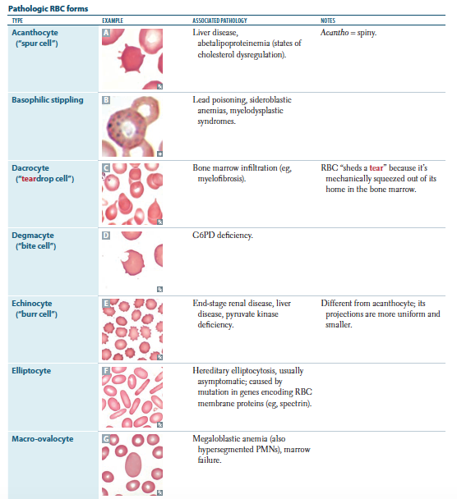

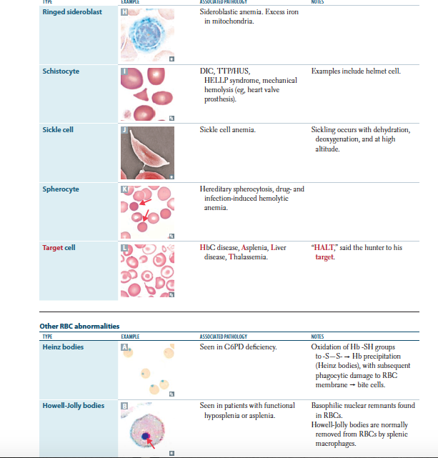

**RESPIRATORY:**

* General information:
  + 26 – 28 gestation 🡪 lungs allow survival (but not enough surfactant)
  + 90% of alveolar development occurs after birth (until age of 8)
  + Infants are at higher risk for respiratory insufficiency:
    - They have smaller air passages that are less compliant but a more compliant chest wall
  + Pulmonary vascular resistance decreases after birth and thus systemic and pulmonary vasculature separate
  + Lung problems are:
    - Obstructive
      * In kids, think asthma, bronchiolitis, foreign body aspiration
    - Restrictive
      * In kids, think pulmonary edema, pulmonary fibrosis, scoliosis, respiratory muscle weakness
  + Chest examination
    - Normal respiratory rate:
      * 40 – 60 bpm in neonates (>60 = tachypnea)
    - The degree of respiratory distress can be stratified in the sense that the increasing severity of distress moves in the pattern from below to above:
      * Subcostal 🡪 intercostal 🡪 supraclavicular 🡪 suprasternal retractions 🡪 nasal flaring
    - Inspiratory stridor 🡪 extrathoracic obstruction:
      * Croup, laryngomalacia (note: the collapse of flabby, soft laryngeal cartilage occurs mainly in supine position)
    - Expiratory wheezing 🡪 intrathoracic obstruction:
      * Bronchiolitis, bronchial asthma
    - Crackles or rales 🡪 parenchymal disease
      * Pneumonia, pulmonary edema
  + Investigations:
    - Imaging (CXR, MRI, V/Q scans, CT)
    - ABG
    - Pulse oximetry
    - PFTs (spirometry)
    - Laryngoscopy and bronchoscopy
* Note:
  + Acute vs. chronic:
    - Arthritis
      * > 6 weeks = chronic
    - Diarrhea
      * > 2 weeks = persistent diarrhea
      * > 1 month = chronic diarrhea
    - Cough
      * Chronic >4 weeks in children
* Indications for tonsillectomy:
  + Recurrent severe tonsillitis (>8 times a year)
  + Peritonsillar abscess development
  + Big enough to cause obstructive sleep apnea (also remove adenoids)
  + NOTE: it will NOT decrease risk of pharyngitis
* Indications for adenoidectomy:
  + Recurrent otitis media with effusion
  + Obstructive sleep apnea

**Bronchiolitis**

* Inflammation of **bronchioles** resulting in inflammatory bronchiolar **obstruction** that is usually viral in etiology:
  + **Respiratory syncytial virus (RSV) = number 1 cause**
    - RSV bronchiolitis is commonly **seasonal** (November - April)
    - Incubation period of 2 -5 days
  + Other causes include **parainfluenza, mycoplasma, human metapneumonia virus (hMPV), adenovirus**
    - hMPV is a common cause of bronchiolitis **OUTSIDE** the RSV season, and produces a **more severe picture**
  + **Human bocavirus** causes a pertussis & bronchiolitis-like syndrome
* **Most common cause of** **LOWER respiratory tract infection** in **first year**
* Age group ~ **< 2 years old** (very important)
  + The earlier the infection, the more severe it is
  + M > F
* **Risk factors**:
  + **Day care** attendance, **multiple siblings**, **smoking** exposure
  + **Prematurity** (with its associated risks, such as respiratory distress, **bronchopulmonary dysplasia**), also SGA, IUGR
  + **No prophylaxis against RSV** using monoclonal Ab (**Palivizumab**)
  + **Congenital heart diseases**
  + Immunodeficiency
  + **Chronic lung diseases** (including cystic fibrosis)
  + **Anatomical anomalies** (TEF, laryngomalacia)
  + Infants < 3 months are increased risk of severe disease
* **Clinical features**:
  + **Gradual onset,** beginning with **URT symptoms** 
    - **Rhinorrhea, nasal congestion, fever and cough**
    - Nasal secretions can be so thick that it can block breathing thru nose (suctioning may be most useful in this case)
    - The initial **vicious secretions** may **block nose**/mouth and cause lungs to develop **negative pressure** and thus cause partial **collapse of immature bronchioles**, producing a **medium for infection to occur**
    - One doctor said that **frequent suctioning** may even be enough to prevent progression
  + **Progression of symptoms:**
    - **Fever, tachypnea,** **fine rales,** **wheezing** (DDx = Asthma)
    - Can be severe enough to cause **respiratory distress**
    - **Hyperinflation** which can **displace liver and spleen downwards** (may appear as hepatosplenomegaly)
  + Normal cases:
    - **Majority of cases recover** within a few days (or **up to 2 weeks**) with no sequelae (it occurs normally, even at home, in most infants) – **50% recurrence** (especially within 1 year)
  + Important details:
    - Can lead to **hypoxemia** (%SPO2 is low… 90% or so) & **cyanosis**
  + **Complications** (up to 7% mortality in severe cases):
    - **Apnea** and **SIDS**
    - **Respiratory distress** and **ARDS**
    - **Dehydration** 
      * **Reduced oral intake** of fluids & feeding due to respiratory distress/difficulty
      * **Tachypnea** causes excess exhaled vapor loss
      * **Insensible losses** in infants (as they have **high surface area** and are more likely to get dehydrated than adults)
    - **Pneumonia (secondary bacterial infection)**
      * Note: serious bacterial infections rarely occur with bronchiolitis
    - **Seizures & encephalopathy**
      * RSV can infect the CNS and lead to neurological symptoms including **seizures** and **SIADH** (result of meningitis)
      * SIADH can cause **dilutional hyponatremia**, which in turn can cause **cerebral edema** and pulmonary edema (“wet lung”) + heart failure
    - **Myocarditis**
    - **Otitis media**
      * Common viral etiology of otitis media is **RSV**
      * Also due to blockage of nasal airways
    - **Bronchiolitis obliterans**
      * If by adenovirus and you use steroids 🡪 risk of this
    - **Asthma** (up to 45% develop asthma)
* **Differential diagnosis:**
  + **Bronchial asthma** (**Recurrent** episodes, **family history** of atopic diseases, **triggering factors**, marked **improvement with nebulizer** or **bronchodilators**)
  + Bronchomalacia
  + Congenital heart disease (CHD)
  + GERD
  + Aspiration
  + Pediatric apnea
  + Cystic fibrosis
* Investigations:
  + **CBC with WBC differential** (look for lymphocytosis)
  + **Blood gases** (check for acidosis)
  + Finding etiological agent (usually not done or indicated only in complicated cases)
    - **Nasopharyngeal swab** or NPA (DAT for RSV)
    - ELISA
  + **Sepsis screen is usually NOT needed** (unless you suspect sepsis)
  + Imaging:
    - **CXR is NOT routinely done** for bronchiolitis and is of **very little value in most cases**
    - It is done if you **suspect a complication** or **associated condition** (pneumonia, pleural effusion, pneumothorax) or they do not respond to oxygen
    - IF CXR WERE TO BE DONE, the findings would include:
      * **Straightened ribs**, **narrow shaped heart**
      * **Hyperinflation** (dark color of lung fields) with flattened diaphragm; **> 14 counted A&P ribs**
      * **Widened intercostal spaces**
  + **Management:**
    - **Supportive treatment**
      * **IV fluid resuscitation** for dehydration
      * **Oxygen**
      * **Monitor vitals** (including SPO2)
    - **Isolation** (highly contagious)
    - **Nil by mouth**/NPO (moderate to severe respiratory distress poses a **risk of aspiration** of oral feeds)
    - **Nebulized bronchodilators** (controversial)
      * Start with **ventolin** (salbutamol) for 15 minutes, if unresponsive, then:
      * **Racemic epinephrine** may be used
      * Hypertonic saline nebulizer (not used here)
    - **Transfer to PICU** if **CO2 retention** is suspected
      * **Continuous positive airway pressure (CPAP)** to keep smaller airways open (used also if apneic)
      * **Heliox** (helium + O2) – less resistance that atmospheric pressure, allowing easier respiration (less effort)
    - **Antibiotics are not usually indicated** unless in cases of 2ndry pneumonia or prophylactically in PICU (because of ventilation assistance related infections)
  + **Guidelines:**
    - **Ribavirin no longer recommended**
    - Diagnosis is clinically made
    - Bronchodilators are no longer recommended, however they made optional to use
    - **NO use of corticosteroids**
    - Admit the patient if he has **low SPO2, tachypnea, risk factors like congenital heart disease and prematurity, associated comorbidities, and if he refuses to eat**
    - Admit into **PICU** if **mental status changes** are seen and if **respiratory distress** develops
* **Bronchial asthma**
  + **Reactive airway disease** that is due **to chronic inflammation** of the airways causing **recurrent episodes** of:
    - Wheezing (usually expiratory musical sound due to air passing through mucus in the blocked airways)
    - Cough
    - Dyspnea
    - Chest tightness
  + The airway obstruction is diffuse, but variable… and must be at least **partially reversible spontaneously or with therapy** (B-agonists)
    - Most common pediatric chronic disease
    - There is **airway hyper-responsiveness** (acutely)
    - Recurrent episodes for years results in airway remodeling
  + When do they present?
    - **20% present by 1 year of age** (and **90% by 5 years of age**)
    - Up to **50% have remission by puberty**
    - Adult onset (non-atopic) asthma (appears later in life)
  + Wheezing – two patterns:
    - **Transient early wheezing**
      * **Virus-associated wheeze**/episodic viral wheeze
      * Small airways are more likely to narrow and obstruct (due to inflammation and aberrant immune response to viral infection... similar to bronchiolitis)
      * **No family history** of asthma or allergy
      * Usually **resolves by 5 years of age** (increase in airway size)
    - **Persistent and recurrent wheezing**
      * **Atopic asthma** (allergy resulting from allergens such as pollens, dust mites, pets… IgE will be elevated)
      * Strongly associated with other atopic diseases (eczema, rhinoconjuctivitis and food allergies) and family history of atopy
    - **DDx of childhood wheeze:**
      * **Acute wheezing:**
        + Asthma
        + Hypersensitivity reactions like **anaphylaxis**
        + **Bronchiolitis**
        + **Pneumonia**
        + **Foreign body aspiration**, gastric aspiration
        + Environmental irritants
      * **Chronic/Recurrent wheezing**:
        + Asthma
        + **Bronchopulmonary dysplasia** or chronic lung disease
        + **Chronic aspiration** (**GERD, TE fistula, un-identified foreign body**)
        + **Congenital anomalies** (**tracheomalacia, bronchomalacia**, lobar emphysema)
        + **Compression of airways** (**tumor, lymph node**, vascular ring, AV malformation?)
        + **Congestive heart failure** or **pulmonary edema**
        + **Hypersensitivity pneumonitis** (type 3/4 HSR)
        + **Cystic fibrosis**
        + **Immotile cilia syndrome** (kartanger syndrome)
        + **α1-AT deficiency**
  + **Predisposing factors:** 
    - Atopy, **family history of asthma**, **exposure to smoke**

While taking history, don’t forget to **ask about** **MEDICATIONS** (as **NSAIDs, beta blockers** may result in exacerbation of asthma)

* + - Infection, pollution and some say diet too
    - **Having one atopic condition increases the risk for others**
    - Most exacerbations are **triggered by URTI** (rhinovirus)
    - 40 – 50% of children who had **RSV bronchiolitis** get asthma
  + **Triggering factors:**
    - **Infection**, **exercise, cold air**, emotions/stress**, allergens**, GER
  + **Pathophysiology:**
    - On secondary exposure of pre-sensitized antigen, **specific IgE on mast cells cross-link** and cause **mast cell degranulation** (immediate reaction) and result in **production of LT** and PG (delayed reaction) 🡪 **hyper-responsiveness** (lasts weeks!)
    - **Smooth muscle bronchoconstriction** with **airway mucosal edema** and increased secretions (due to **type I HSR** to **environmental trigger** with background of **genetic factors**)
    - The secretions begin to block the already narrowed airways and produce **“mucus plugs”**
      * Shed whirly epithelium produces **Curschmann spirals**
      * **Eosinophil recruitment** (eosinophilia) and production of MBP (which disrupts epithelia), produces eosinophilic crystals called **Charcot-Leyden crystal**
    - Eventually, over the years, there is **airway remodeling** in which there is:
      * Smooth muscle hypertrophy/hyperplasia
      * Increased size of submucosal glands
      * Goblet cell metaplasia of airway epithelium
      * Sub-basement membrane fibrosis
  + **Clinical features:**
    - **Wheezing, cough, dyspnea, chest-tightness** during acute attacks
    - Symptoms are **worse at night** and **early in the morning**
    - **Interval symptoms** are based on severity of asthma (but in **most cases they are symptom free**), and there may be:
      * Sleep disturbances
      * Poor school performance due to frequent absences
    - **Long-standing asthma:**
      * Hyperinflation of chest with generalized wheeze and **prolonged expiratory phase**
      * **Harrison sulci** (depressions at base of thorax associated with muscular insertion of diaphragm – also seen in rickets and other COPDs)
      * **Growth abnormalities** (usually normal, but severe cases can result in poor growth)
      * **Finger clubbing, wet cough or poor growth usually indicate cystic fibrosis or bronchiectasis**
  + **Investigations and diagnosis:**
    - **Clinical history** (triggers, family history, social history, recurrence of symptoms, wheezing on examination)
    - Investigations are usually not needed, but include:
      * **CBC with WBC differentials** (eosinophil count)
      * **Serum IgE levels**
      * **Skin-prick allergen testing** (atopy/find allergen)
      * **CXR** (rule out other conditions, but may show **hyperinflation**, **peribronchial thickening**)
    - **PFTs:**
      * **Spirometry** to identify **PEFR, FEV1 and FVC**
      * **FEV1/FVC** and FEV1 predicted (normally ≥ 80%)
      * **Reversibility testing** using beta agonists (increase in ratio by 12% change)
    - **Methacholine challenge test** (no longer used, but the idea is to induce an attack and see if it’s way out of proportion to the expected reaction to this cholinergic drug)
    - **Pulse oximetry** should be **measured in ALL CASES** of children **presenting in hospital** with acute asthma
  + Classification and treatment:
    - **Mild Intermittent**
      * **Daytime symptoms ≤2/week**
      * **Night time symptoms ≤ 2/month**
      * Use inhaled short-acting ß-agonist (salbutamol) for symptomatic relief ONLY (works for 2 – 4 hours)
      * No need for anti-inflammatory agents
    - **Mild persistent**
      * **Daytime symptoms >2/week** (but **not everyday**)
      * **Night time symptoms >2/month** (but **not >1/week**)
      * **FEV1 ≥ 80%** predicted (normal)
      * Use **inhaled short-acting ß-agonists** for **acute attacks**
      * **Daily use** of **LT receptor inhibitors** (montelukast) if < 5 years old or **mast cell stabilizers** (cromoglycate, nedocromil) or **low dose *inhaled*** **corticosteroids**
    - **Moderate persistent**
      * Symptoms occur **daily** (uses short acting inhalers daily)
      * **Night time symptoms >1/week**
      * **FEV1 60 – 80%** of predicted
      * Inhaled short acting beta agonists for acute attacks
      * Between attacks:
        + **Medium dose *inhaled***corticosteroids, **OR**
        + **Long acting beta agonists** (salmeterol, works for 12 hours) + **low dose** ***inhaled*** corticosteroids
    - **Severe persistent:** 
      * **Continuous symptoms** with frequent nighttime symptoms, **limited physical activity**

**KEY:**

**In all acute attacks of this classification, only inhaled beta 2 agonists are given**.

The difference is in the anti-inflammatory regimen given.

* + - * **FEV1 <60%** predicted
      * Attacks 🡪 short acting beta agonists inhaler
      * **High-dose *inhaled*** **corticosteroids** + **long acting beta agonists**
      * May need ***oral* (systemic) corticosteroids**
    - **Notes:**
      * We have drugs to treat acute attacks because they work quickly (**beta 2 agonists** like salbutamol, albuterol, terbutaline + **theophylline** [methylxanthines] + anticholinergic drugs such as ipratropium bromide)

Don’t forget the **ADR of beta agonists** include **tachycardia, tremors, and anxiety.**

* + - * + Usual case is 1-2 puffs as prn
      * And anti-inflammatory drugs that prevents progression of asthma to its airway remodeling phase (corticosteroids, LT inhibitors, mast cell stabilizers, long acting beta 2 agonist)

Mast cell stabilizers need about 2 -4 weeks to become effective.

* + - * **Corticosteroids** are the most effective anti-inflammatory agents for asthma

**Inhaled steroids** can result in **oral candidiasis**; frequent **mouth washing** after use is recommended.

* + - * + ***Inhaled*** types includes **beclomethasone, budesonide, fluticasone**
        + ***Oral*** types include **prednisolone** (usually given on **ALTERNATE days** to minimize the **ADR on HEIGHT** and is required only **for SEVERE PERSISTENT asthma**)
      * Last case scenario = given monoclonal Ab **against IgE** (**omalizumab, IV**)
      * If **theophylline** (and high dose beta 2 agonists) are given, **ECG** should be monitored and blood electrolytes
      * As you will see later, **IV MgSO4** has shown to be helpful in life threatening asthma
    - **Types of inhalers:**
      * **Pressurized meter dose inhaler** (pMDI)
      * **Spacer device** alone if >2 years (or **with face mask if <2 years old)** – **recommended** for children because it **increases drug deposition to the lungs** and in acute cases cuz **poor inspiratory efforts may impair use of inhalers** directly by mouth (too weak to breathe in)
      * **Aerochamber**
      * **Dry powder inhaler** (4+ years, needs good inspiratory flow)
      * **Nebulizer** (given for **any age**, in acute attacks because it **provides O2 along with inhaled drugs** – can be used at home)
      * **Diskus** (different colors for different drugs)
        + Orange are usually steroids (anti-inflammatory)
        + Purple is usually combined steroids + long acting beta 2 agonists
        + Lightish green is combinations
        + The bluish kind of green is usually ventolin (and rarely is the diskus used, usually a metered dose inhaler is used)
      * **Metered dose inhaler** (everything is available, but famously the ventolin bluish green colored one is used by almost everyone!)
  + **In patient management:**
    - **Guide to severity is (from best to poorest):**
      * **Use of accessory muscles** of respirations (from below to above = more severe)
      * **Increased tachycardia** (>130 bpm in children aged 2 – 5 years, >120 bpm if older than 5)
      * **Increased tachypnea and wheezing** (poor guide, but >50 in 2 – 5, >30 in >5 years)
    - Other findings that may be useful:
      * **Pulsus paradoxus** (may also be felt)
      * **Interference with speech** = severe
      * **Cyanosis**, fatigue and **drowsiness** = life-threatening
      * **Silent chest** on auscultation (reduced respiratory effort) = life-threatening (emergency)
      * **SPO2 <92%** on pulse oximetry
    - **Criteria for hospital admission**
      * If after high-dose inhaled bronchodilator therapy, they:
        + **Not responded adequately clinically** (breathlessness, tachypnea, **exhausted**, **cannot speak**, **altered consciousness**)
        + Marked **reduction in their predicted PEFR**
        + **Reduction in O2 saturation** (<92%)
    - **Management:**

BEFORE ANY OF THIS, WHEN MANAGING, ALWAYS **make sure of C,A,Bs as stable:**

* **C**irculation
* **A**irway
* **B**reathing **(GIVE OXYGEN)**

**Tools: bronchodilators + systemic steroids + O2**

**Assess & monitor vitals, SPO2, ABG**

* + - * 3 ACTUAL STEPS:
        + **Assess severity**
        + **Management**
        + **Assess response to treatment and monitor**
      * **Severity Assessment** (note: people with mild don’t come to the hospital)

1- **Short-acting ß2 agonists** via **spacer**, 2-4 puffs (increase puffs by 2 puffs every 2 minutes **up to 10 puffs if required**)

2- Consider **oral** prednisolone

Reassess within 1 hour

* + - * + **Moderate:**

Oxygen saturation >92% (good)

Peak flow >50% predicted or best value

No clinical features of severe asthma

* + - * + **Severe:**

**Too breathless to talk or feed**

1- **Short-acting ß2 agonists** (**spacer or nebulizer**, 10)

2- **Oral** prednisolone or **IV** hydrocortisone (PO or IV)

3- If still poor response 🡪 **nebulized ipratropium**

Repeat bronchodilators every 20 – 30 min

Use of **accessory neck muscles**

Oxygen saturation **SPO2 <92%** (bad)

**RR >50/min** 2- 5 y (or **>30**/min if >5)

**Pulse >130/min** (or >120/min if >5)

**Peak flow <50%** predicted

1- **nebulized ß2 agonists** + **ipratropium** bromide

2 – **IV** hydrocortisone

3 – Consider **transfer to PICU**

Repeat bronchodilators every 20 – 30 min

**NOT RESPONDING:**

1- Take to PICU, check **vitals, CXR, blood gases**

2- **IV salbutamol or aminophylline** (must do **ECG**)

3- Consider bolus of **IV MgSO4**

* + - * + **Life threatening:**

**Silent chest** on auscultation (poor air entry in life-threatening asthma… so **wheezing decreases with severity**, **increases with improved response**)

**Poor respiratory effort** (☹)

**Altered consciousness** (**drowsiness**, impending respiratory failure)

**Cyanosis**

Oxygen saturation **SPO2 <92%**

**Peak flow <33%** predicted

* + - * **Management:**

See boxes

* + - * **Assess response to treatment**:
        + If life-threatening asthma presents to emergency and still does not respond, he should be sent to PICU (look at box)
        + If response seen:

**Continue bronchodilators** (4 hours min)

**Discharge when stable** by 4 h treatment

**Continue oral prednisolone for up to 3 days**

* + - * + **At discharge (patient review and education)**

Review medication and inhaler technique (ask them to show you how they use it)

Provide personalized asthma action plan

Arrange for follow-up

They should make a peak flow diary

They are taught what drugs and for what should they be used + when

Parents should be taught signs to bring their child to the hospital (difficulty in talking, walking, using accessory muscles, no response to dilators)

**DRUGS TO AVOID (NSAIDS, beta blockers)**

* **Cystic Fibrosis (CF)**
  + Multisystem disorder resulting from altered content of **exocrine gland secretion**
  + **Autosomal recessive** inheritance of a **deletion** of phenylalanine at position 508 (**∆508**) of **long arm** (q) of **chromosome 7**
    - Seen in **Caucasians** (**1 in 2,500**) with 5% carrier rate
    - Most common lethal genetic disease in this population
    - They may now live up to their mid-30s (inshalla 40s)
  + **Pathophysiology:**
    - The deletion results in **mutated CFTR** (cystic fibrosis transmembrane conductance regulator) gene, which in turn results in **abnormal ATP-gated chloride-ion transport channel** in epithelial surfaces of GI tract, sweat glands, lungs
    - The mutation produces a product protein that becomes **misfolded** (post-translational modification error) and then retained without transporting to the cell membrane, followed by being broken down by proteasomes
    - The **ATP-Cl- *normally*** functions to:
      * Secrete Cl- into lumen (which allows Na+ and H2O to follow) causing secretions (mucus) to be less viscous – this is seen in the intestines and lungs
      * Exocrine pancreas secretion includes Cl- in exchange for HCO3 in which Cl- is reabsorbed for HCO3 when flow rate is increased
      * Reabsorbed, so that Na+ and H2O can follow to reduce loss of NaCl in sweat, as seen in sweat glands
    - The ***abnormal* ATP-Cl- channel** of cystic fibrosis results in:
      * **Decreased secretion of Cl-** (and **thus water and Na**) into lumen 🡪 **thick, vicious mucus in GI and lungs** (producing plugs and intestinal obstruction, promoting infections)
      * Thick vicious secretions of pancreas, producing plugs that can result in chronic pancreatitis (pancreatic insufficiency)
      * **Excess loss of Na and Cl- in sweat** (basis of chloride sweat test)
  + **Clinical features:**
    - **Chronic sinopulmonary disease:**
      * **Nasal polyps** and **chronic sinusitis (pansinusitis)**
      * **Chronic cough, wheezing and sputum** production
        + Crackles, hyperinflation, dyspnea
        + Decreased respiratory flow rates (obstructive)
        + Decreased lung volumes (restriction)
        + May show hyperinflation on CXR and P/E
        + Progressive **hypoxemia**
        + Intractable asthma, recurrent wheezing bronchiolitis
      * **Mucus plugging**
        + May result in atelectasis (as seen in CXR)
      * **Recurrent pulmonary infection (pneumonia)**
        + Especially with ***Pseudomonas aeruginosa*** (green sputum), ***S. aureus*** and *Burkholderia cepacia*
        + **S. aureus** 🡪 usually seen in **early infancy**
        + **P. aeruginosa** 🡪 usually in **adolescence**
        + Shows pulmonary infiltrates on CXR
      * **Chronic bronchitis** **bronchiectasis** (from recurrent infection and blockage of airways) and **abscess**
        + Bronchiectasis shows **reticulonodular pattern** on CXR
      * They can also develop pulmonary fibrosis, cor pulmonale and respiratory failure
    - **GI abnormalities:**
      * **Meconium ileus** ~ 20% (failure to pass meconium in first 24 hours of life ~ DDx: Hirschsprung’s disease)
      * **Distal intestinal obstruction syndrome**
      * Rectal prolapse
      * **Pancreatic insufficiency** ~ **90%** (chronic pancreatitis, with 2ndry diabetes developing later in 2nd decade) and recurrent pancreatitis
        + **Malabsorption with steatorrhea,** fat-soluble vitamin deficiencies (AKED)
      * **Chronic hepatic disease (abnormal LFTs)**
        + Biliary cirrhosis (rarely) or fatty liver infiltration may occur
        + Gallstones (adults), portal HTN (rare)
      * **Prolonged neonatal jaundice** (blocked intrahepatic bile ducts)
    - **Nutritional:**
      * **Failure to thrive (FTT)**
      * Hypoproteinemia and edema
      * **Fat soluble vitamin deficiencies (ADEK)**
    - **Metabolic abnormalities:**
      * Classic electrolyte picture = **hyponatremia, hypochloremic, hypokalemic metabolic alkalosis**

**Guthrie test:**

Neonatal screening test using **heel-prick blood** used to detect:

- PKU

- SCD

- CF

- MSUD

- MCAD

- TSH (congenital hypothyroidism)

- Galactosemia

* + - * Contraction alkalosis with hypokalemia because of ECF H2O & Na+ losses and renal K+/H+ wasting
    - Other findings:
      * **DIGITAL CLUBBING, Harrison sulcus**
      * **Infertility in men** (congenital **absence of vas deferens**, but spermatogenesis is unaffected)
      * **Subfertility in women** (**thick cervical mucus**)
      * “salty taste” of skin
  + Diagnosis:
    - You need 2 things:
      * 1 or more phenotypic feature **OR** positive **family history** **OR** increased **immunoreactive trypsinogen** on **newborn screening (Guthrie test)**
      * **AND** **laboratory evidence** of abnormal CFTR, either **sweat chloride test >60 mEq/L** **OR** *two* **CF mutations** **OR** characteristic ion transport abnormality across nasal epithelium (**more negative “nasal transepithelial potential difference”** because Na+ is further reabsorbed)
    - Notes:
      * **Sweat chloride test** technique must be done correctly
        + False positives seen in anorexia, hypothyroidism and nephrogenic diabetes insipidus
        + False negatives in edema & hypoproteinemia
      * **CF diagnostic process for screened newborns:**

1. **CF newborn screening using immunoreactive trypsinogen (IRT)** done at 5 – 14 days old of age
2. If positive, **perform sweat chloride test** at 2 -4 weeks
3. **If ≥ 60 mmol/L, diagnosis of CF can be made**
   1. Move on to clinical assessment and begin therapy
4. **If 30 – 59 mmol/L, diagnosis of CF can be made only if 2 CF mutations are found** 
   1. If 0-1 CF mutations found, then there is still a possibility of CF, do other extensive DNA analysis within 1 – 12 months
   2. If no DNA data available, do other extensive DNA analysis
   3. In both cases of a and b, **repeat chloride sweat test in 2 – 6 months**
5. If <30 mmol/L 🡪 CF is very unlikely

* Treatment:
  + **Antibiotics** for pulmonary infections
    - Many recommend prophylactic oral antibiotics (flucloxacillin)
    - Anti-pseudomonal antibiotics for pseudomonas
    - Severe cases may need IV antibiotics
  + **Chest physiotherapy (chest percussion, postural drainage)**
    - At least twice a day, start from diagnosis
    - Older children can use devices for airway clearance
    - **Physical examination is beneficial** and encouraged
    - Also give anti-mucous therapy such as N-acetylcysteine [mucolytic], aerosolized/nebulized dornase alfa (DNAse), hypertonic saline
  + **Bronchodilators (salbutamol)**
  + **Oxygen (as needed for hypoxemia)**
  + **Lung transplantation** is a possibility (rarely required in childhood)
  + **Pancreatic enzyme replacement**
  + **Regular ursodeoxycholic acid** may improve bile flow
  + **Good nutrition** (with fat soluble vitamin supplementation)
  + **Anti-inflammatory therapy** (azithromycin for some reason has beneficial immunomodulatory effect vs. antibiotic effect)
  + **Psychological support** for patients and families
  + Potential future treatment = gene therapy
* Mortality & other notes:
  + **Most common cause of death is respiratory failure** (95%)
  + Failure to pass meconium? **Gastrografin enema < surgery**
  + Intestinal obstruction syndrome? Gastrografin orally
  + Sweating (for the sweat test) can be **stimulated using pilocarpine** iontophoresis
    - The sweat is collected using a special capillary tube or absorbed on a piece of filter paper
  + They can get hemoptysis, pneumothorax, ABPA
* **Lung abscess:**
  + Suppurative destruction of lung parenchyma leading to a cavity with pus
  + Occurs due to:
    - **Aspiration** of foreign body (FB)
    - 2ndary to **pneumonia** (**staph.**, **klebsiella**, pseudomonas or **anaerobic** organisms)
    - **Bronchiectasis**, cystic fibrosis
    - TB
  + Findings:
    - Fever, weight loss, **clubbing** of fingers
    - Cough up of **foul smelling, purulent, copious sputum** +/- hemoptysis
    - Can cause bronchiectasis too (cause and effect)
    - Complications include **rupture (empyema)**
  + Investigations:
    - **CT** > CXR (**shows fluid air level** in lung)
    - **Sputum culture**
  + Treatment:
    - **Broad-spectrum antibiotics** covering staph. for 4 – 6 weeks
    - Chest physiotherapy
    - Surgical resection for chronic cases
* **Bronchiectasis:**
  + Permanent dilation of bronchi, distal to obstruction due to diseases and infections with the accumulation of pus in dependent bronchi
  + May be congenital or acquired due to:
    - **Lung abscess**
    - **Foreign body**
    - **Immotile cilia syndrome**
    - **Cystic fibrosis**
    - Long term GERD
  + Results in distortion of bronchial wall into spherical, fusiform or cylindrical dilated tubes with more stagnation of pus behind thickened bronchial walls (secondary to FB, lung abscess, mucus plug, etc.)
  + Symptoms include **fever**, **clubbing** of fingers, **cough** of **foul smelling**, **purulent and copius** sputum with postural variation +/- hemoptysis
  + On P/E 🡪 **patchy brochial breathing** and **coarse crepitations**
  + CXR 🡪 **honeycomb** or **soap bubble** appearances (confirm with **CT**)
  + Complications include respiratory failure and failure to thrive in prolonged cases
  + Treatment includes:
    - Systemic **broad-spectrum antibiotics** for 4-6 weeks
    - **Postural drainage** and **chest physiotherapy**
    - Symptomatic treatment
    - Surgical resection if needed
* **Empyema:**
  + Pus in pleural **cavity secondary to**:
    - **Pneumonia** (especially **staphylococcal** and pneumococcal)
    - Rupture of **lung abscess**
    - Chest **trauma or surgery**
    - Mediastinitis
  + Clinically, they have **high fever**, difficult breathing, **chest pain** that is **exacerbated with coughing** and **deep breathing** (and **reduced when child lies on affected side**)
    - Inspection = diminished chest movement on affected side
    - Percussion = dullness
    - Auscultation = reduced breath sounds
  + Complications include **bronchopleural fistula** & **pleural fibrosis**
  + Investigations:
    - CXR shows **massive homogenous opacity obliterating** costophrenic angle
    - Thoracocentesis (culture of drained material, also therapeutic)
  + Treatment:
    - **Broad spectrum antibiotics** 4-6 weeks (based on culture and sensitivity it can be changed)
    - **Closed drainage** of pus by an **underwater seal**
    - Surgical “decortication” (remove manually)
* **Choanal atresia (or stenosis)**
  + Congenital problem presenting in neonatal period
  + May be detected on neonatal examination using “sniff” test (where there is no humidity on stethoscope) or nasogastric tube failing to pass through nose
  + Neonates are obligate nose breathers
    - Obstruction of nasal passages = **respiratory distress, especially during feeding**
    - **Crying bypasses it by allowing breathing thru mouth**
  + Confirmed using CT scan or using nasopharnyngoscope
  + Definitive treatment = surgery
* **Larnygomalacia**
  + Exaggerated collapse of glottis structures, particularly of the larynx
  + The laryngeal cartilages are soft and immature, resulting in easy collapse
  + Inspiratory stridor beginning at or shorty after birth raises suspicion
    - Worse when feeding or active
    - Decreased when relaxed or placed prone or when neck is flexed
  + **Most common cause of stridor in infants**
  + Usually does not cause respiratory distress but can affect normal breathing
  + Exacerbated when there is upper airway inflammation (viral)
  + **Resolves on its own** by age **6 – 12 months** (up to 24 months)
    - Observation is needed (Just in case)
    - Family reassurance
  + Flexible nasopharyngoscopy can help assess patency or severity (but generally diagnosed without need of visualization)
* **Pneumomediastinum**
  + Usually mild, self-limiting process
  + Usually due to severe **forceful coughing**, acute asthma exacerbation or **forceful intubation**
  + Crunching noise over sternum
  + **Subcutaneous emphysema** may occur
  + Diagnosis = CXR
* **Bronchopulmonary dysplasia (chronic lung disease)**
  + **Oxygen dependence** **beyond 28 days of life**
  + Causes:
    - **Most cases complication of treatment of RDS** 
      * **Oxygen concentration >40% is toxic** to the neonatal lung
      * Oxygen-mediated injury results from **free radicals which disrupts membrane lipids**
      * High O2 is given for RDS
      * O2 toxicity together with high peak pressures on assisted ventilation
    - Infants that weigh less than 1 kg required mechanical ventilation for respiratory drive (not RDS)
  + Signs = failure of RDS to improve after 2 weeks, **need for prolonged mechanical ventilation**, **oxygen therapy required after 36 weeks** are characteristic
  + Other clinical signs include **hypercapnia, compensatory metabolic alkalosis** and pulmonary hypertension
    - Over time, there is **poor growth** and **RHF (cor pulmonale)**
    - There is an **increased risk of subglottic stenosis**
  + Imaging:
    - CXR shows **cysts** accompanied by areas of overdistention and atelectasis (“**sponge-like appearance**”)
      * Note that there is interstitial edema, atelectasis, necrotizing obliterative bronchiolitis and overdistended alveoli
  + Management:
    - Decrease risk of subglottic stenosis by **tracheotomy**
    - **Reduce barotrauma and oxygen toxicity** by **reducing ventilator settings** to maintain blood gases with slightly **lower PaO2** [50 mm hg] and **higher PaCO2** [50 – 75]
    - **Dexamethasone therapy** (may reduce inflammation and enhances weaning from assisted ventilation) – WE SAW THIS IN THE DROWN PATIENT IN BDF!
  + They are at higher risk for developmental delay, reactive airways, **RSV pneumonia (should receive prophylaxis against RSV), tracheobronchomalacia, and sudden death**
* **Foreign Body Aspiration**
  + Children 3 months – 5 years are at greatest risk
  + Typical objects: seeds, popcorn, hot dogs, candy, grapes, small toy parts
  + Clinical features:
    - History of **choking** (not 100% present)
    - **Laryngotracheal foreign bodies = extrathoracic**
      * Cough, hoarseness, **inspiratory stridor**
    - **Bronchial foreign bodies = intrathoracic**
      * **Right bronchus more common** than left (if it is in the left, suspect situs inversus or right heterotaxy)
      * Localized wheezing, chronic cough, hemoptysis or even persistent pneumonia
      * **Asymmetrical findings on auscultation**
      * Complete obstruction may result in **atelectasis**
      * **Partial ball-valve** obstruction (unilateral emphysema)
      * No obstruction (asymptomatic)
    - **Esophageal foreign body aspiration**
      * May compress the trachea anteriorly producing respiratory symptoms
  + Diagnosis:
    - CHALLENGING, needs HIGH SUSPICION
    - CXR may not always show objects (15% only)
      * They may appear radiopaque
    - Consider inspiratory and expiratory films and bilateral decubitus films or fluoroscopy
  + Management:
    - **Basic life support (C, A, B)**
      * If choking, do what you learned in CPR, which is **5 back slaps** followed by **5 chest compressions** using **2 fingers** on the **lower half of sternum** – do **5 cycles,** then activate ERS
    - **Natural cough** may allow effective expulsion of object
    - If it remains, must be **removed by bronchoscopy**
  + 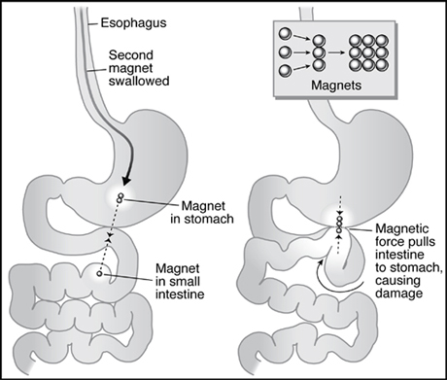**Note: for swallowing of objects like coins, they commonly will pass thru GI without any effects** (but needs observation), however endoscopic removal is necessary for magnets, batteries, sharp objects
    - Magnets can insert the mucosa or whole wall in between each other and cause perforation or obstruction
  + Extra notes from other books:
    - If a child comes in and you suspect foreign body aspiration, you:
      * IV access with maintenance fluids and sedation
      * Bronchoscopy for evaluation (and possible removal) – bronchoscopy is done even if X-rays are normal
      * Child should be kept in NPO until his respiratory distress resolves and his SPO2 should be carefully monitored
    - DDx of such sudden symptoms include anaphylactic response to allergens, but DDx of stridor in this case:
      * Croup
      * Epiglottitis
      * Bacterial tracheitis
      * Retropharyngeal abscess
      * Angioedema
      * Tracheomalacia
      * Extrinsic airway compression (aortic/vascular ring, tumor)
    - Objects lodged in the larynx or trachea 🡪 rapid asphyxia, death (if not dislodged immediately)
    - Objects lodged in the bronchus (more commonly) 🡪 cough, wheezing, decreased breath sounds distal to affected side – about 20% are diagnosed after 1 month!!!
* **Cessation of breathing and complications:**
  + **Normal pediatric apnea** is central and **lasts ≤ 15 seconds**
  + **Periodic breathing:**
    - **Normal** breathing pattern in infants with 3 or more respiratory pauses lasting 3 seconds each with less than 20 seconds of normal respiration in between
  + **Apneas of infancy:**
    - Unexplained cessation of breathing for **≥ 20 seconds** with **bradycardia** (vs. epileptic apnea, which is associated with tachycardia), cyanosis, pallor or hypotonia in full term infants
    - Apnea can be **central** or **obstructive**:
      * Obstructive (effort is useless… e.g. FB or bronchiolitis)
      * Central (no respiratory effort)
    - **Obstructive apnea:**
      * Secondary to **craniofacial anomalies, adenotonsillar hypertrophy, obesity or hypotonia** or **FB**
    - **Apnea of prematurity:**
      * Unexplained cessation for ≥ 20 seconds in premature infants, thought to be due to **immature central respiratory centers**
    - **Note: apnea does not increase the risk of SIDS, and** parents are encouraged to learn CPR
  + **Apparent-life threatening event (ALTE)**
    - **Apnea, color change, change in muscle tone, choking** or gagging in which **recovery occurs only after stimulation or resuscitation**
    - DDx:
      * **Seizure disorder**
      * **GERD**
      * Upper airway obstruction
      * Intracranial mass lesion
      * Sepsis or **other infections** (RSV, pertussis, meningitis)
      * Metabolic changes (electrolyte abnormalities or hypoglycemia)
      * Inborn error of metabolisms
      * Arrhythmias and **LONG QT SYNDROME**
      * Abnormal central control of breathing
      * Munchausen by proxy (mother is basically lying)
      * Non-accidental trauma (shaken baby syndrome)
    - Evaluation involves doing detailed history and P/E + investigations to rule out any causes (hospital observation, sleep study, CXR, Echo, ECG, blood work, pH probe study, imaging of head and neck, metabolic disease work up)
    - Management = **teach parents CPR**
    - Cardiopulmonary monitoring is useful for history of ALTE, clinically significant apnea discovered on sleep study, central hypoventilation conditions, and siblings of SIDS victims, oxygen dependent infants
  + SIDS:
    - **Sudden death of child < 1 year** old that is **unexplained** (even after autopsy, examination of death scene and history)
    - **Apnea is not a risk factor for SIDS**
    - **95% occurs before 6 months of age**
    - Risk factors (* = major)
      * **Prone sleeping position\***
      * **Soft bedding, overbundling, overheating\***
      * **Prematurity\***
      * **Low birth weight\***
      * **Maternal smoking** or **smokers at home\***, prenatal drug abuse (opiates)
      * **Male gender**
      * Recent illness
      * Lack of breastfeeding
      * Young maternal age
      * Being the twin of a sibling who died of SIDS
    - **Prevention:**
      * **Sleep on back** (increased incidence of plagiocephaly)
      * **Firm bedding**, avoid overheating
      * **Smoke-free environment**
      * Early prenatal care and regular well-child care
      * **Breastfeeding**
    - Note: **infanticide should be ruled out**
    - Learning CPR is of little benefit and has not decreased the incidence of SIDS
    - What to do when parents bring an affected child?
      * Inform them that with all the efforts that you could not resuscitate their child, provide them with a room to remain alone
      * The child’s body is taken for **autopsy** (the most common autopsy finding is **INTRATHORACIC PETECHIAE**)
      * **Home is investigated by police** for possible causes

**CARDIOLOGY:**

General notes:

* Rates of common congenital heart lesions:
  + Left-to-right shunts (breathless)
    - VSD (30%) > PDA (12%) > ASD (7%) (FA: ASD>PDA)
  + Right-to-left shunts (blue)
    - ToF = ToGA = 5%
  + Common mixing (breathless and blue)
    - AV septal defect (endocardial cushion defect)
  + Outflow obstruction in a WELL child (asymptomatic + murmur)
    - Pulmonary stenosis > aortic stenosis
  + Outflow obstruction in a SICK NEONATE (collapsed with shock!)
    - Coarctation of Aorta (DDx: sepsis, metabolic disorders)
* Polygenic abnormalities probably explain why having a child with congenital HD doubles the risk for subsequent children + risk is higher if either parent has a congenital HD
* Causes of congenital heart disease that you should be familiar with:
  + Maternal disorders:
    - Congenital rubella syndrome 🡪 PDA, pulmonary stenosis
    - SLE 🡪 neonatal complete heart block (anti-SSA/Ro and SSB/La)
    - Diabetes mellitus 🡪 ToGA
  + Maternal drugs:
    - Warfarin
    - FAS 🡪 ASD, VSD, tetralogy of Fallot (ToF)
    - Lithium 🡪 Ebstein’s anomaly (atrialization of right ventricle)
  + Chromosomal abnormality
    - Down Syndrome 🡪 endocardial cushion defects (ASD, VSDs)
    - Turner syndrome 🡪 coarctation of aorta, aortic valve stenosis (Bicuspid aortic valve)
    - DiGeorge/22q11.2 deletion 🡪 ToF, Truncus arteriosis
    - Williams syndrome 🡪 supravalvular aortic stenosis
    - Noonan syndrome 🡪 ASDs, HCM
  + Marfan syndrome 🡪 MVP, aortic aneurysm and dissection with aortic regurgitation
* Heart murmurs:
  + Most common presentation of congenital HD
  + Innocent “flow” murmurs can be differentiated by being “InnoSent”:
    - aSymptomatic patient
    - Soft blowing murmur
    - Systolic (never diastolic)
    - Present on left Sternal edge
    - Other features: no thrill, radiation and there are NORMAL heart sounds (S1 and S2 with other added sounds)
  + Innocent murmurs are often heard normally during FEVERS and ANEMIA – both due to increased cardiac output
* Heart Failure:
  + Defined as inadequate oxygen delivery by myocardium to meet demands of body
  + The reason is because the heart is weak (“failing”) but the body doesn’t know this and so it tries to help the heart by giving it more work to do, only making things worse!
    - Hypoperfusion of end organs results in release of catecholamines from sympathetic NS + release of renin and resulting activation of RAAS 🡪 fluid and salt retention + increased HR and contractility
  + Causes:
    - In neonates (obstructed + duct-dependent):
      * Hypoplastic left heart syndrome
      * Aortic valve stenosis
      * Coarctation of the aorta
    - In infants (high pulmonary flow)
      * Endocardial cushion defects (ASDs, VSDs)
      * PDA
    - Older children and adolescents
      * Eisenmenger syndrome
      * Rheumatic fever
      * Cardiomyopathy
      * Viral myocarditis (MCC) and other cardiac infections (endocarditis and pericarditis)
    - Other causes
      * Metabolic (hypothyroidism), medications (doxorubicin)
      * Severe anemia (high-output cardiac failure)
      * Rapid infusion of IV fluids in infants
      * Right-sided heart failure causes (cor pulmonale)
  + Presentation:
    - Symptoms:
      * Breathlessness (especially on feeding/exertion)
      * Sweating, poor feeding, recurrent chest infections
      * Diminished urine output
      * Exercise intolerance in older children & adolescents
    - Signs:
      * Tachypnea, tachycardia, wheezing, rales
      * Poor weight gain
      * Heart murmur, gallop rhythm (S3?), cardiomegaly
      * Hepatomegaly and cool peripheries
      * Signs of right heart failure (ankle edema, ascites)
    - CXR may show signs of pulmonary edema
  + Management:
    - Medical:
      * Cardiac glycosides (digoxin) for improved cardiac contractility
      * Severe cases may need other ionotropic agents like dopamine, dobutamine
      * Loop diuretics (furosemide, ethacrynic acid) for pulmonary edema
    - Surgical:
      * Address the underlying cause (e.g. balloon valvulopasty for aortic and pulmonary valve stenosis, surgical repair)
* Cyanosis:
  + Peripheral cyanosis is also seen in hypothermia and vasomotor instability and polycythemia?
  + Central cyanosis occurs when deoxygenated Hb is >5g/dL
    - Causes include pulmonary disease, sepsis, hypoglycemia, polycythemia and neuromuscular disease (can’t breathe)
  + Always check SPO2 using pulse oximetry
  + Cyanosis in a newborn with respiratory distress (RR > 60) may be:
    - Cyanotic congenital HD
    - Respiratory disorders such as NRDS, meconium aspiration, PPHN
    - Infections (sepsis ~ GBBHS)
    - Metabolic (metabolic acidosis, shock)
* Diagnosis of congenital heart diseases:
  + CXR and ECG are usually done, but definitive diagnosis is based on echocardiography and Doppler ultrasound
* ACYANOTIC HEART DISEASES:
  + In all cases, the shunting is left-to-right, but then reverses later in life (with cyanotic features) because of increased PVR and RVH (Eisenmenger syndrome)
  + ASDs:
    - Types:
      * Ostium primum
* Lower portion of atrial septum (endocardial cushion defect, seen in Down syndrome)
* Usually occurs with abnormality of (anterior) mitral valve leaflet 🡪 mitral regurgitation
* Ostium secundum
* Defect in middle portion of septum
* MOST COMMON TYPE
* Sinus venosus
* Defect is high in septum (next to SVC entry)
* Usually occurs with anomalous right pulmonary veins returning into right atrium (vs. left)
* Patent foramen ovale (PFO): failure of normal anatomical closure of foramen ovale, a valve like flap in the atrial wall that allows oxygenated blood to bypass the right heart to enter the left heart without mixing (until ductus arteriosus)
* S&S:
* Usually asymptomatic (in ostium primum type, the symptoms are due to the mitral regurg 🡪 HF S&S)
* P/E:
* Increased right ventricular impulse
* Systolic ejection murmur at pulmonic area (upper left sternal edge, due to increased flow thru that valve)
* Fixed splitting second heart sound
* Of ostium primum with mitral regurg 🡪 apical pansystolic murmr
* Investigations:
* Cardiomegaly, increased pulmonary vascular markings
* ECG will show partial right bundle branch block with right axis deviation (RAD)
* Echo will show the finding and the size
* Management:
* Surgical closure using open heart surgery (for those ASDs that are large enough to cause complications + ostium primum)
* Ostium secundum 🡪 cardiac cathertization with insertion of occlusion device
* VSDs:
* Classified based on location and size:
  + Location = membranous, muscular (trabecular), inlet or outlet
  + Size = small, moderate and large VSDs
    - Important to know because the size will tell you the likelihood that a murmur is heard (the smaller the more likely) and the amount of blood flow and its direction (the larger, the more left-to-right shunting 🡪 more symptomatic)
  + Small VSDs:
    - Usually closes spontaneously
    - Little to no shunting
    - However, **grade 4** high-pitched **holosystolic** murmur with **thrill** at lower left sternal border (high velocity blood squeezing thru tight hole)
  + Moderate VSDs:
    - May have S&S of HF (after 1 wk)
    - Holosystolic murmur heard, but intensity varies
    - They may have a diastolic murmur as a result of the increased left-to-right blood shunting filling the left atria and then left ventricle (mitral filling rumble)
  + Large VSDs:
    - Have S&S of HF
    - Systolic murmur = low-pitched, barely heard
    - Mitral (diastolic) filling rumble may be heard
    - When Eisenmenger syndrome occurs, the mitral filling rumble disappears
* Investigations:
  + As expected, CXR, ECG, Echo
  + CXR may show cardiomegaly, increased pulmonary vascular markings, pulmonary edema
  + ECG may show biventricular hypertrophy (by 2 months of age)
* Management:
  + Drug therapy for heart failure
    - Also, increased pulmonary blood flow is associated with increased risk of chest infections (that’s why I said chest infections in HF)
  + Nutritional support for FTT
  + Surgical closure
    - Done earlier (3- 6 months) if large VSDs (to prevent PHTN and manage FTT)
    - Done later (2- 6 years) if small, mod. VSDs
* PDA:
  + Failure of DA to close after 1 month following EDD
  + Incidence is higher in preterm infants (note: rise of PaO2 from decreased pulmonary resistance results in DA closure)
  + Small PDAs can be asymptomatic, but larger PDAs can produce S&S of HF (left-to-right shunting into pulmonary trunk bifurcation)
  + P/E findings include machinery-like continuous murmur (pan-murmur) at upper left sternal border, mostly infraclavicular
    - Other findings include widened pulse pressure (collapsing or bounding pulse), mitral rumble (same reason as in VSDs)
  + Investigations: Echo is the only one that can distinguish it
  + Management:
    - Indomethacin is used in premature infants to close PDA
    - Surgical closure can be done using coil embolization or ligation

Cyanotic Heart Diseases:

* Right-to-left shunting of blood at discovery (vs. Eisenmenger syndrome)
* It includes the 5Ts:
  + Tetralogy of Fallot (ToF)
  + Transposition of the great arteries (ToGA)
  + Tricuspid atresia
  + Truncus arteriosus (TA)
  + Total Anomalous Pulmonary Venous Return (TAPVR)
* Which ones are associated with increased or decreased pulmonary flow?
  + Decreased? ToF, tricuspid atresia (and pulmonary atresia)
  + Increased? TAVR, TA, ToGA (and single ventricle)
* Things to evaluate:
  + Pulse oximetry, CBC, ABG, ECG, CXR
  + 100% oxygen challenge test or Hyperoxia (nitrogen washout) Test
    - Administer100% O2 for 10 minutes
    - If the PaO2 is still low, then there must be right-to-left shunting of blood either from CHD or from lung disease (PPHN, etc.)
* Other notes (chronic hypoxia results in **clubbing** of fingers and toes)
* Overall management in all cases:
  + C,A,B with artificial ventilation if necessary
  + Start **PGE infusion** (they are duct dependent, key to early survival, but observe potential ADR like **apnea and fever**)
  + Surgical management (each has its own)
* Tetralogy of Fallot:
  + Most common cause of cyanotic congenital heart disease
  + Components:
    - VSD
    - Overriding aorta
    - Pulmonary stenosis (degree = most prognostic feature)
    - Right ventricular hypertrophy
  + The RVOT results in right-to-left shunting of deoxygenated blood thru VSD into left heart, resulting in cyanosis
  + They typically have a PDA that maintains stability
    - PDA closure after birth will result in presentation of cyanosis
  + When do they present?
    - Diagnosed antenatally
    - Diagnosed in 1 – 2 months of life when heart murmur detected and cyanosis is not very obvious
    - Few present with severe cyanosis in first few days of life
  + Findings on P/E?
    - Increased right ventricular impulse (on inspection?)
    - Left parasternal heave (due to RVH)
    - Systolic ejection murmur (pulmonary stenosis)
    - Cyanosis (central?)
  + What are features affecting degree of cyanosis?
    - Decreasing SVR (exercise, vasodilation, hypotension) results in increased R-L shunting and thus more cyanosis
    - Increasing SVR (squatting, valsalva maneuver, bradycardia, volume infusion and HTN) results in decreased R-L shunting and thus less cyanosis
    - Presence of PDA (allows blood to enter pulmonary circulation to be oxygenated)
  + What are tetralogy of Fallot “Tet” or cyanotic spells? How do they compensate for this?
    - Sudden cyanosis with decreased murmur intensity resulting from a trigger that involves increased activity (feeding, exercise, crying)
    - Child becomes irritable and cries more, making more pulmonary resistance, worsening the cyanosis
    - 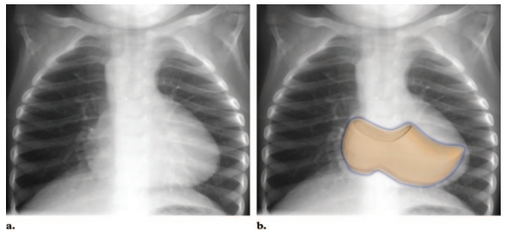Severe hypoxia and acidosis may occur (resulting in alteration of consciousness
    - Child with ToF learns to SQUAT, because it increases SVR and increases VR (decreases right-to-left shunting)
  + Investigations:
    - On CXR:
      * **Boot-shaped heart** (uptilted apex due to RVH)
      * pulmonary artery “bay” (loss of convexity of main pulmonary artery on left heart contour around waist)
      * Right-sided aortic arch
      * Decreased pulmonary vascular markings
    - ECG 🡪 RAD
  + Management:
    - Of Tet spells:
      * Placing in knee-chest position
      * Sedation, pain relief (morphine), O2
      * IV fluids and bicarbonate to correct acidosis
      * IV propranolol (slow HR, reduce contractility)
    - Palliative procedures
      * Blalock-Taussig shunt (the ipsilateral subclavian artery is connected to the ipsilateral pulmonary artery using a graft)
      * Balloon valvuloplasty
    - Complete surgical repair at 6 months of age
* **Transposition of the Great Arteries (ToGA)**
  + Systemic circulation is only oxygenated through a shunt (PDA, PFO, ASD, VSD)
  + **Cyanosis is always present at or shortly after birth** (the more sites of shunting and larger the size, the less cyanosis)
    - Day 2 after birth is usually when PDA closes
  + Auscultation shows **single S2 (no splitting)** because the aortic valve is anterior to the p. valve (masking the sound) and **NO MURMUR**
  + Chest radiograph findings:
    - **Egg-on-string appearance** (or egg on its side)
    - Why? AP positioning of the great vessels (they’re in front of each other now), RVH
    - Increased pulmonary vascular markings (increased flow!)
  + Management:
    - 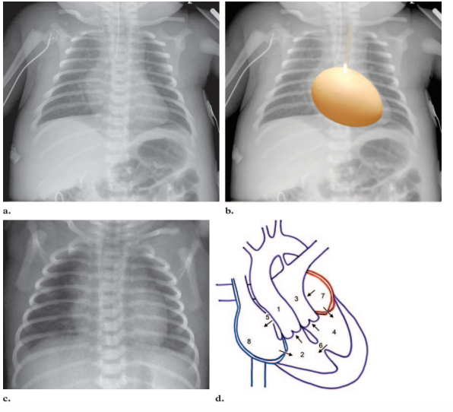**PGE quickly**
    - **Rashkind procedure** (emergent balloon atrial septostomy)
    - **ARTERIAL SWITCH OPERATION** = Definitive repair
      * Great arteries are incised above valves and implanted on opposite roots
      * Coronary arteries are attached to abdominal aorta
* Tricuspid Atresia
  + No tricuspid valve + ASD/PFO always
  + BUT, the direction of blood flow depends on VSD or no VSD
    - VSD = yes 🡪 left-to-right shunt = good
    - VSD = no 🡪 pulmonary atresia also present 🡪 PDA must be present for blood to flow into lungs (once PDA closes 🡪 cyanosis)
  + Those without VSD (+ pulmonary atresia) have no murmur and single S2… Those with VSD have VSD murmur (holosystolic murmur, mitral diastolic rumble)
  + ECG 🡪 LAD, LVH (all the blood goes in the left heart) – the only cause of cyanosis in newborn period with LAD, LVH ☺
  + Management:
    - Glenn Shunt (“Hemi-Fontan”) – 6 months
      * 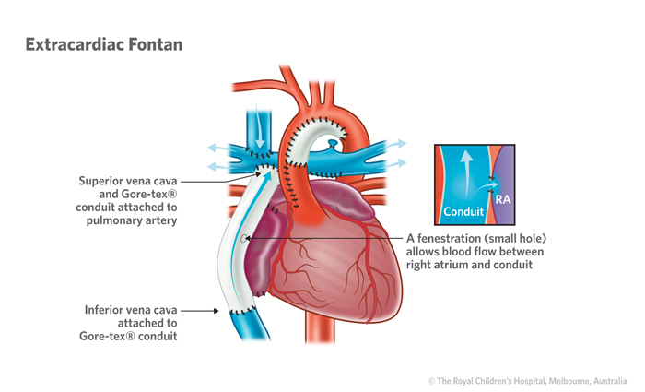Done early
      * SVC is anastomosed to right pulmonary artery
      * Temporary until Fontan procedure
    - Fontan procedure – 6 years (3- 6 y)
      * Basically completes what Glenn shunt started
      * IVC is directed into pulmonary arteries
      * It is also done in hypoplastic right heart syndrome
* Truncus Arteriosus
  + The aorta and pulmonary trunk don’t divide
    - The pulmonary arteries arises from the proximal TA
    - The truncal valve (combined outflow valve) is usually regurgitant or stenotic
    - VSD is almost always present
    - Increased pulmonary blood flow resulting in HF picture
    - Cyanosis is sometimes present but they are only mildly desaturated because the shunting is bi-directional
  + P/E:
    - Systolic ejection murmur at base, single S2 (increased flow through ONE truncal valve), mitral (diastolic) rumble (increased pulmonary flow)
  + Management:
    - HF medications, surgical repair early in infancy
* Total Anomalous Pulmonary Venous Return (TAPVR)
  + Pulmonary veins drain into venous side, either:
    - Supracardiac (into SVC)
    - Cardiac (right atrium or coronary sinus)
    - Infracardiac (portal system)
  + Usually with ASD or PFO (sites that allow shunting)
    - Route: RV 🡪 PA 🡪 lungs 🡪 PV 🡪 RA 🡪 ASD 🡪 LA 🡪 body
    - 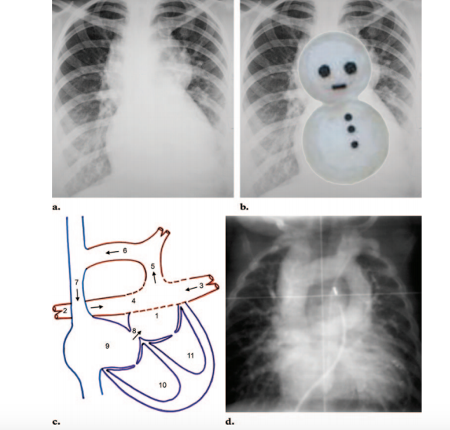Systemic and venous blood mix together, resulting in cyanosis
    - 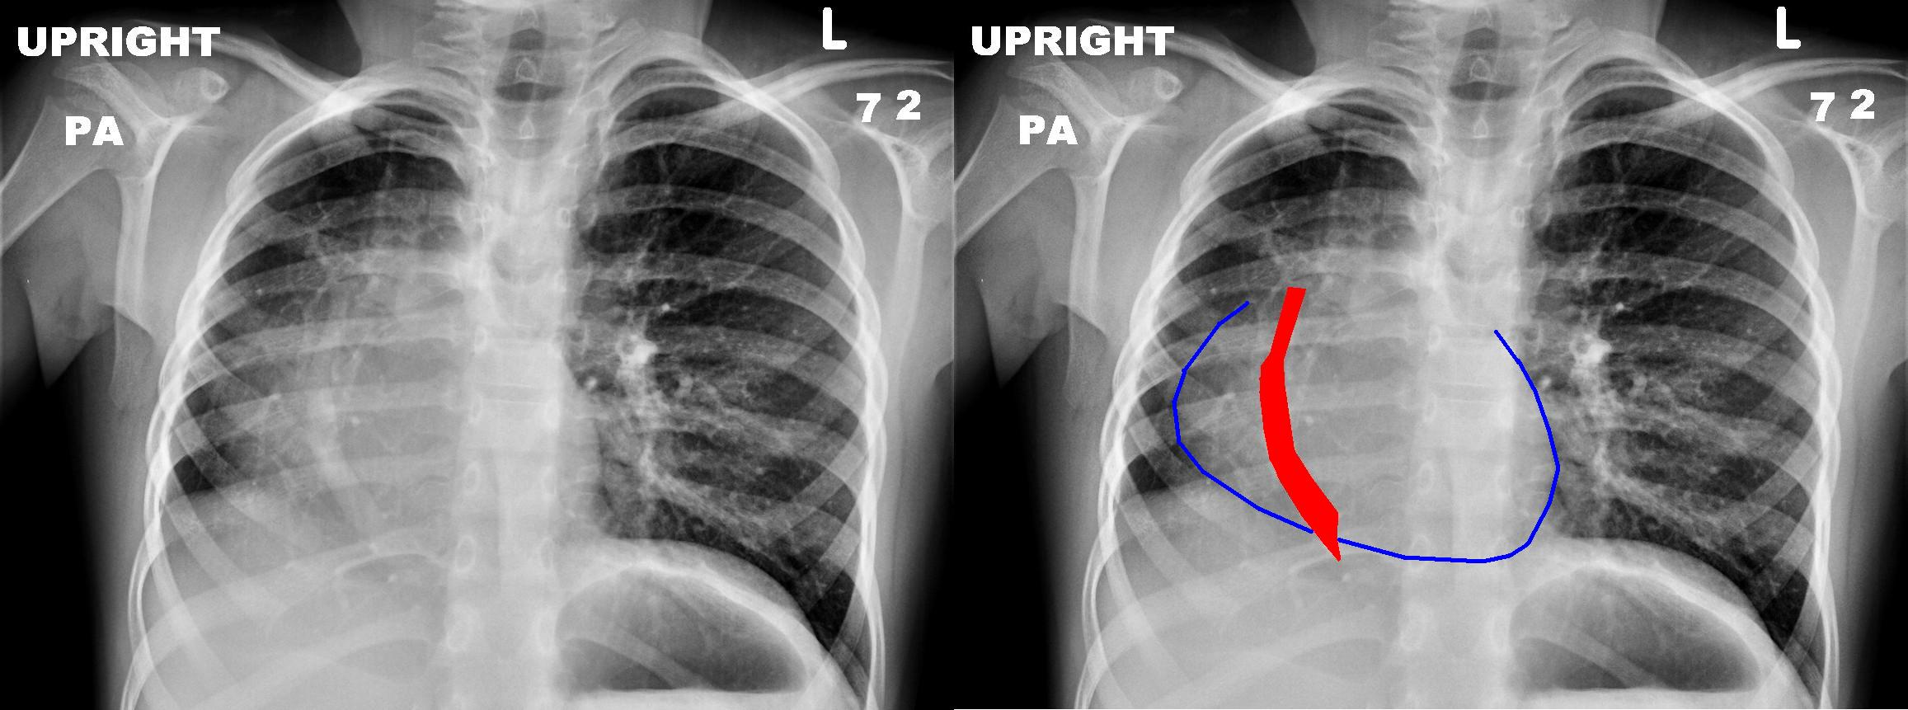The smaller the shunting, the more severe the cyanosis
  + NOTE:
    - There is also PARTIAL anomalous p. venous return (PAPVR)
      * Some (not all) veins drain usually into IVC (infracardiac)
  + P/E 🡪 cyanosis, pulmonary flow murmur (mid-left sternal border)
  + Radiological findings:
    - Type I (supracardiac) TAPVR 🡪 **Snow-man sign**
    - PAPVR 🡪 **Scimitar sign**/syndrome
  + Management 🡪 surgical repair after diagnosis
    - Pulmonary veins are anastomosed to left atrium (☺) and the shunting sites are closed (ASD, PFO)
* **OTHER HEART CONDITIONS:**
  + **Aortic Stenosis**
    - **Commissural fusion** of 3 normal leaflets leading to bicuspid or unicuspid valve OR could be congenital (bicuspid aortic valve, seen in Turner syndrome)
    - There is:
      * Reduced left ventricular output
      * Increased afterload on the left heart
      * Increased oxygen demand on the left heart, which may lead to ischemia
    - Clinical features:
      * ALWAYS check if there are other valvulopathies
      * Younger presentation = “Critical aortic stenosis” (when PDA closes [neonates], blood has no route other than the aortic valve – so there is hypoperfusion of systemic circulation 🡪 S&S of HF)
      * Older presentation = syncope, exercise intolerance, chest pain and sudden death
      * Have ejection systolic crescendo-decrescendo murmur on upper right sternal border, that radiates to the carotids, paradoxical splitting (A2 component closes later than P2 of the S2 heart sound)
      * Slow-rising low volume pulse, bobbing nails and head
      * High resting pressure gradient (across aortic valve)
    - Imaging may show post-stenotic dilation of ascending aorta
    - ECG may show LVH (LAD)
    - Management:
      * Usually if symptomatic or if pressure gradient is high
      * Balloon valvuloplasty (if without insufficiency)
        + Usually reserved for older kids when they become symptomatic
      * Surgery (if with insufficiency)
        + Aortic valve replacement
        + Replace with prosthetic valve
        + Ross procedure (if pulmonic valve is used)
  + Pulmonary Stenosis
    - Most cases are mild/moderate and can be asymptomatic
    - Severe pulmonary stenosis in neonates usually associated with PFO, resulting in a left-to-right shunting (cyanosis)
    - P/E findings include systolic ejection murmur at upper left sternal border with ejection click +/- thrill and heave (RVH), associated with wide splitting of S2 heart sound
    - ECG may show RVH and RAD; CXR 🡪 post-stenotic dilation of pulmonary artery
    - Management:
      * When pressure gradient across pulmonary valve is high
      * Balloon valvuloplasty (treatment of choice in most)
  + Coarctation of Aorta (CoA)
    - Commonly associated with Turner syndrome
      * Commonly associated with bicuspid aortic valve
    - There are two main variants:
      * Preductal (Infantile type) ~ occurs before DA
      * Postductal (Adult type) ~ occurs at or after DA
    - In the preductal type, there is also a PDA that helps establish circulation to the aorta and hence the body
      * If the PDA closes 1-2 days after birth, they develop severe acute circulatory collapse with metabolic acidosis, hypoxia, absent femoral pulses
      * If the PDA remains open for longer, they may remain asymptomatic till S&S of HF develops
    - In the adult type, they typically asymptomatic and only discovered in adolescence:
      * Collateral circulation occurs thru the subclavian 🡪internal thoracic 🡪 retrogradely thru intercostal arteries 🡪 abdominal aorta
    - P/E when discovered in adolescence include:
      * Radio-femoral delay, impalpable femoral pulses
      * Right upper arm HTN
      * Systolic ejection murmur at aortic area (bicuspid aortic valve causes stenosis)
      * Bruit heard at left upper back near scapula
    - Imaging (CXR):
      * Rib notching (due to collateral circulation)
      * 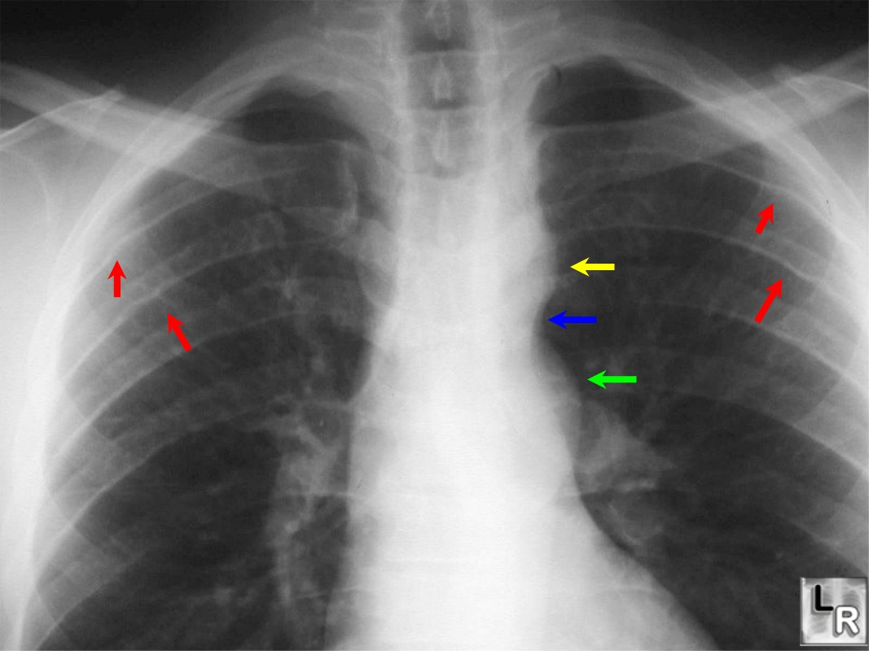**Figure of 3 sign** on **PA view** (pre-stenotic dilation of aortic arch and subclavian artery)
      * **Reverse 3 sign** on **left oblique view** (esophagus indented by the dilation)
    - 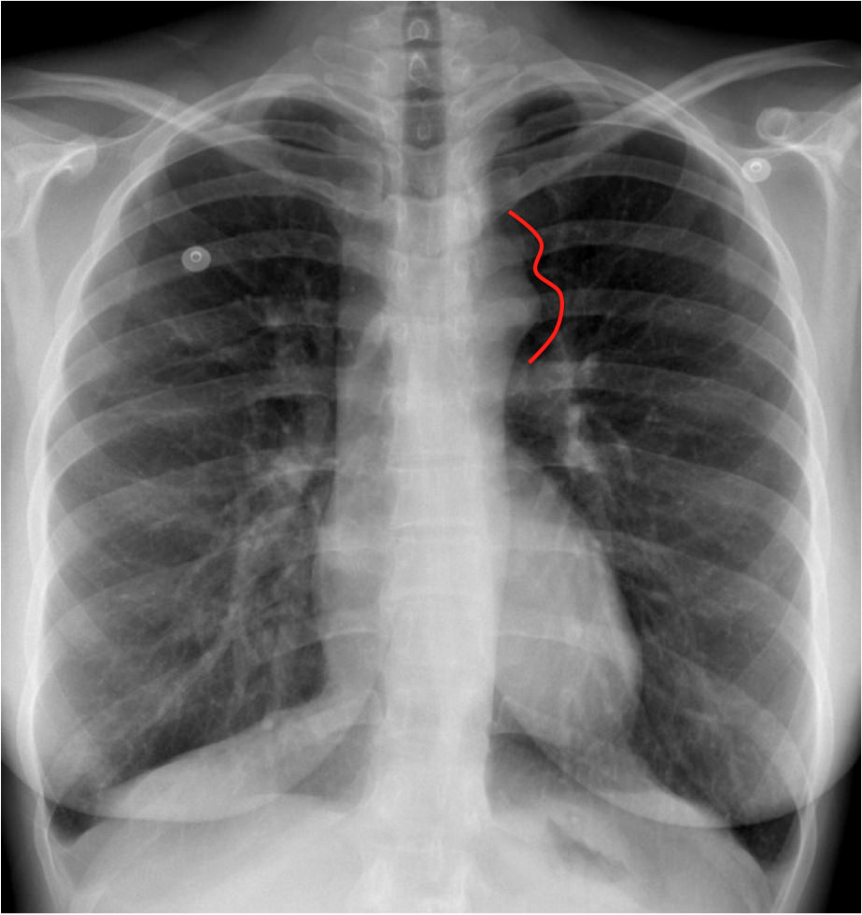Note: **LVH** may occur, found on ECG and Echo
    - Management:
      * Initial management in sick (symptomatic) neonate:
        + Maintain B,A,Cs (give IV fluids, O2 correct acidosis with bicarbonate)
        + IV PGE (to keep PDA open)
        + Inotropic medications
      * Corrective repair:
        + Surgical excision and end-to-end anastomosis, but recurrences of narrowing occurs in 50%!
        + Balloon ANGIOplasty (also therapy of choice for recurrences)
  + Hypoplastic left heart syndrome
    - Associated with small atretic mitral and aortic valve with small ascending aorta
    - Usually detected antenatally by ultrasound screening
    - Present with most severe picture of collapse, acidosis, absence of peripheral pulses
    - Management:
      * Norwood procedure and many other operations
* Acquired Heart Disease
  + Kawasaki disease (coronary aneurysms, MI, carditis, HF, arrhythmias)
    - Low-dose aspirin is given in phase II of the disease (and thereafter) for its anti-thrombotic effect
    - The cardiac features easily regress with treatment
  + Acute Rheumatic Fever
    - Can cause pancarditis (endocarditis, myocarditis, pericarditis)
    - Mitral regurg 🡪 mitral stenosis (same order for aortic)
    - The vegetations are tiny and on the edge, eventually producing a button-hole/fish-mouth valve
  + Infective endocarditis
    - Microbial infection of endocardium (as the name suggests)
    - Most cases (80%) occur on already abnormal valves
      * E.g. ASDs, rheumatic heart valve, bicuspic aortic valve (which is also susceptible to calcification in early age vs. normal calcification of aortic valve occurring in elderly)
    - Commonly occur post cardiac operation (50%)
    - Causes:
      * Viridans streptococci (S. mutans, S. sanguis; alpha hemolytic streptococci)
        + Found in teeth crevices
      * Staphylococci (Staph. aureus, s. epidermidis)
        + S. aureus in IVDUs, right heart valves
        + S. epidermidis usually in prosthetic valves
      * Streptococcus bovis (screen for colon cancer)
      * Gram –ve bacteria (Enterococci, pseudomonas)
      * HACEK group
      * Candida (fungal endocarditis)
      * Non-bacterial causes include Libman sacks endocarditis (SLE, vegetations along both sides of valve)
    - Bacteria are introduced into the blood, usually during an invasive procedure (e.g. dental extraction), where it then infects the already susceptible (damaged) valve
      * Staphylococcus aureus causes subacute endocarditis, which means it can affect NORMAL valves
      * All other bacterial causes affect already abnormal valves
    - The vegetations of infective endocarditis are large, bulky and friable, comprising of fibrin, platelets and causative organisms
    - The vegetations can dislodge and result in septic emboli which can deposit in several tissues resulting in sequelae such as nephropathy, splinter hemorrhages, Roth’s spots, etc.
    - Clinical features include:
      * Fever (most common symptom, common cause of FUO)
      * Non-specific complaints (arthralgia, weight loss, etc.)
      * Murmurs
      * Microscopic or gross hematuria (embolic event)
      * Splinter hemorrhages
      * Retinal hemorrhages and roth’s spots
      * Osler’s painful nodes on fingers, and Janeway painless lesions on palms or soles
      * Splenomegaly
    - Diagnosis:
      * Blood culture (3 times, anaerobic and aerobic)
      * ESR and CRP (but ESR may be distorted if the patient has cyanotic congenital HD – because chronic hypoxia can lead to polycythemia, which reduces ESR)
      * Transesophageal echo > transthoracic echo
    - Management:
      * IV antibiotics (penicillin + AG) for 4 -6 weeks
      * Prophylaxis
        + Good dental hygiene
        + A card to present dentists, surgeons telling them you need antibiotic prophylaxis before invasive procedures because you have a structural heart disease
  + Pericarditis:
    - Always consider it in children with dyspnea and fever, or anyone who has recently underwent cardiac surgery
    - Causes:
      * Viral Infections (MCC, coxsackievirus, echovirus and EBV)
      * Bacterial infections (S. aureus and strep. pneumoniae)
      * SLE, JRA, uremia, rheumatic fever, dressler syndrome, radiation therapy
      * Post-pericardiotomy syndrome (after cardiac surgeries, it can occur)
    - Purulent pericarditis can lead to constrictive pericarditis
    - Clinical features:
      * Fever, dyspnea, chest pain when lying supine and relieved when leaning forward
      * P/E shows pericardial friction rub and distant heart sounds, pulsus paradoxus (>10 mm Hg reduction in systolic BP on deep inspiration) and hepatomegaly
      * Constrictive pericarditis is associated with Kaussmal sign (increasing JVP on inspiration) and pericardial knock
    - Diagnosis:
      * Pericardiocentesis (diagnostic and therapeutic)
      * Elevated ESR
      * Imaging findings on ECG (low voltage) or CXR (enlarged heart shadow sometimes mimicking Ebstein’s anomaly box-shaped heart) or echocardiography
    - Management:
      * Drainage of pericardial effusion
      * Anti-inflammatory agents (steroids) for viral causes and postpericardiotomy syndrome
      * Antibiotics (if necessary)
* Myocarditis
  + Etiology:
    - Enteroviruses (coxsackievirus)
    - Bacteria (C. diphtheria, S. pyogenes, S. aureus, M. tuberculosis, borrelia burgdorferi/lyme disease)
    - Fungi (candida and Cryptococci)
    - Protozoa (trypansoma cruzi, Chagas’ disease)
    - Autoimmune diseases such as SLE, RF, sarcoidosis
    - Kawasaki disease
  + Frequently follows a viral or flu-like illness
  + S&S:
    - Dyspnea, malaise
  + P/E:
    - Resting tachycardia (note: a key sign of myocarditis is tachycardia or HR that is higher than expected for the fever – normally, for each 1C rise, there’s a 10 bpm rise in HR, if it is more than 10, then suspect myocarditis)
    - Muffled heart sounds, gallop heart rhythm (heart failure picture begins?) with hepatomegaly, tachypnea and rales
  + Diagnosis:
    - Elevated ESR, CRP
    - High CKMB
    - Identify causative agent using serology OR PCR of endomyocardial biopsy specimen
    - ECG may help (there are specific changes noted)
    - Echo will show diffuse ventricular dysfunction, there may be pericardial effusion
  + Complications include HF and arrhythmias
  + Management:
    - Supportive (most cases improve spontaneously)
      * Ionotropic agents, diuretics
    - If they develop CHF, they can opt for a cardiac transplant
    - Mortality is high in young infants and those with arrhythmias
* Cardiomyopathy
  + Dilated cardiomyopathy (DCM):
    - Systolic dysfunction (ventricular dilation, reduced cardiac function)
    - Causes:
      * Idiopathic
      * Viral myocarditis (coxsackievirus)
      * Mitochondrial abnormalities
      * Carnitine deficiency
      * Thiamine deficiency (wet beriberi)
      * Hemochromatosis
      * Duchenne muscular dystrophy
      * Chagas’ disease
      * Medications (doxorubicin)
      * Chronic tachydysrhythmias
      * Hypocalcemia
      * Anomalous origin of the left coronary artery from the pulmonary artery (ALCAPA)
    - S&S 🡪 HF picture
    - Diagnosis:
      * Viral serology (rule out viral cause)
      * Serum carnitine levels (rule out CPT or carinitine deficiency, which breaks down FA… and the heart’s major source of energy is FA)
      * ECG (sinus tachycardia and other relevant changes depending on cause)
      * Echo (dilated left ventricle, poor ventricular function)
    - Management:
      * CHF medical management
      * Treat underlying cause if possible (metabolic or nutritional causes, surgical repair of ALCAPA by implanting the left coronary artery into aortic sinus)
      * May require cardiac transplant
  + Hypertrophic cardiomyopathy (HCM):
    - Diastolic dysfunction (cannot fill up)
    - MOST TYPICAL FINDING is asymmetric subaortic stenosis:
      * Asymmetrical septal hypertrophy (with a banana-shaped septum)
    - Causes:
      * Familial, mutation in ß myosin heavy chain gene (AD inheritance)
      * Frederich’s ataxia
      * Transiently seen in infants of diabetic mothers
    - Pathophysiology:
      * Diastolic dysfunction (cannot fill left ventricle)
      * LVOT obstruction (WHY? BECAUSE ANTERIOR MITRAL LEAFLET IS BEING SWEPT INTO SUBAORTIC REGION DURING SYSTOLE)
    - S&S:
      * Many present with syncope and sudden cardiac death, especially those engaging in athletic sports (exercise intolerance, chest pain)
    - P/E will show harsh systolic ejection murmur at apex, accentuated by standing or valsalva (reduce LV volume)
    - Diagnosis:
      * ECG findings (LVH, LAD, deep and wide Q waves in inferior and lateral leads)
      * Echo (shows hypertrophy)
    - Management:
      * Beta blockers or CCBs (reduce LVOT obstruction and diastolic compliance)
      * Surgical myomectomy
      * Anti-arrythmic medications
      * AVOID ATHLETIC SPORTS
  + Restrictive cardiomyopathy (RCM)
    - Stiff ventricular wall impairing diastolic filling
    - Etiology:
      * Amyloidosis
      * Inherited infiltrative disorders (Fabry, Gaucher, hemochromatosis, loeffler syndrome/endomyocardial fibrosis)
    - Features:
      * Exercise intolerance, weakness, dyspnea
      * P/E would show edema, hepatomegaly, ascites, elevated CVP
    - Management:
      * Diuretics (decrease CVP, I think spironolactone?)
      * Improve diastolic compliance with beta blockers, CCBs
* Dysrhythmias
  + Sinus tachycardia:
    - Heart rate < 200 bpm, but there is till P wave and QRS wave that is regular
    - Can be secondary to;
      * Anxiety
      * Fever
      * Anemia
      * Thyrotoxicosis
      * Congestive heart failure
      * Shock
    - Tx: treat underlying cause
  + Supraventricular tachycardia (SVT)
    - A supraventricular source of electricity (that is extra-SA nodal) is passing thru into the ventricle
    - Most common childhood arrhythmia
    - HR is > 240 (250 – 300 bpm)
    - ECG shows narrow QRS tachycardia + no P waves
    - Two types:
      * Atrioventricular re-entrant tachycardia (AVRT) – occurs thru an accessory pathway
      * Atrioventricular node re-enterant tachycardia (ANVRT) – occurs when abnormal conduction arises from AV node
    - An example of AVRT is wolff-parkinson white syndrome (WPW), which results from the accessory bundle of Kent – it can result in sudden cardiac death and ECG changes such as the delta wave (slurring upslope of QRS with short PR interval)
      * Note that WPW can also get atrial fibrillation
      * Giving ABCD (adenosine, beta blockers, calcium channel blockers and dogixin) in WPW can be lethal if they have atrial fibrillation, but helpful if they have SVT
    - SVTs start suddenly and end suddenly
    - It can cause poor cardiac output and pulmonary edema (picture of HF) ~ it is also a cause of hydrops fetalis
    - Symptoms include palpitations, chest pain, dyspnea and sometimes altered level of consciousness
    - Diagnosis is through characteristic ECG changes
    - Management in stable patients:
      * Vagal maneuver (ice pack to pace, carotid massage, placing child upside, orbital pressure)
      * IV adenosine (but not in WPW) and other potential drugs (digoxin, propranolol, procainamide, amiodarone)
    - Management in unstable patients:
      * If conscious 🡪 adenosine, synchronized cardioversion
      * If unconscious 🡪 synchronized cardioversion
    - Radiofrequency ablation of accessory pathways can be used in chronic SVT cases
  + Ventricular tachycardia (VT):
    - Regular, WIDE, QRS only (atrioventricular dissociation)
    - Life-threatening rhythm
    - Treatment of stable patient = IV amiodarone (or lidocaine)
    - Treatment of unstable pt = synchronized cardioversion
  + Ventricular fibrillation (“V-fib”)
    - Cardiac arrest rhythm with chaotic irregular waves
    - Must receive defibrillator (read the name out loud), followed by CPR
  + Heart block:
    - **First degree heart block:**
      * Fixed prolongation of the PR interval (>0.2 seconds… > 5 small boxes)
      * Tx: no treatment required (benign, asymptomatic)
    - **Second degree heart block:**
      * Mobitz 1 = Wenckebach = progressive increasing PR interval till 1 beat is dropped (regularly irregular) ~ usually asymptomatic
      * Mobitz 2 = randomly dropped beats, may progress to 3rd degree, so treat with pacemaker
    - **Third degree heart block**:
      * The atria and ventricles beat independently, so there is an atrial rate and ventricular rate (and the QRS is independent of the P waves… sometimes they overlap!)
      * The atrial rate > ventricular rate
      * Acquired causes: lyme disease, post-surgical AV block
      * Congenital heart block: Neonate of SLE mother (SSA/Ro)
      * S&S: syncope, fatigue, sudden death may occur
      * Treat with pacemaker
  + Long QT syndrome
    - Prolonged QT interval, which predisposes to torsades de pointes ventricular arrhythmia (fatal)
    - Causes include:
      * Jervell-Lange-Neilsen syndrome (AR, sensorineural hearing loss, due to mutation in K+ channels)
      * Romano-Ward (AD, no hearing loss)
      * Hypokalemia and hypomagnesaemia
      * Drugs (A,B,C,D,Es) including:
        + Anti-Arrhythmics (those that prolong action potential, IA and III)
        + Anti-Biotics (Erythromycin)
        + Anti-Cychotics (Haloperidol)
        + Anti-Depressants (TCAs)
        + Anti-Emetics (ondansetron, ~ 5-HT3 blocker)
      * Idiopathic causes
    - Clinical features:
      * Syncope (most commonly), palpitations, sudden cardiac arrest (also seen in HCM, Brugada syndrome)
      * The episodes occur particularly at times of stress, increased emotion
    - Diagnosis:
      * Corrected QT interval (QTc) = QT/√RR interval
      * QTc > 0.44 seconds (or >0.49 s if younger than 6 months) = prolonged
    - Management:
      * Cardiac pacemaker
      * Automated implantable cardiac defibrillator
      * Left stellate ganglionectomy
* Chest pain (DDx):
  + Cardiac causes (pericarditis – MCC, aortic stenosis, HCM, marfan syndrome [aortic dissection])
  + GI causes (esophagitis, PUD, esophageal spasms and perforation, pancreatitis, cholecystitis)
  + Respiratory causes (asthma, pneumonia, pneumothorax, ACS in SCD)
  + Musculoskeletal causes (costochondritis, trauma, VOC in SCD)
  + Psychological causes (anxiety, hyperventilation)

