SURGERY NOTES
All doctors love students who are SYSTEMATIC in their answering.
Hx P/E investigations (lab, imaging, procedures) management (medical, surgical) F/U, prevention
History is the MOST IMPORTANT tool of all in diagnosis; it will guide you.
In these notes my investigations includes the ones to R/O differentials

- Wound healing
  - Stages of wound healing
    - The number of stages differ from source to source, but the process are all explained in the same way
    - 1 = HEMOSTASIS
      - Damage to endothelial lining of vessels expose subendothelial collagen and VWF
      - This initiates primary hemostasis (platelets arrive)
      - This also results in transient vasoconstriction to stop bleeding (endothelin)
      - Secondary hemostasis also occurs (activation of coagulation cascade)
      - IMPAIRED IN?
        - Patients on anti-platelet or anti-coagulants
        - Liver disease and CRF (uremia)
        - Bleeding diasthesis
    - 2 = INFLAMMATION
      - Cytokines released from damaged tissue call for leukocytes
      - PMNs Macrophages (MØ are essential)
      - Role is to clear up cellular debris, foreign body and bacteria to promote wound to heal
      - Presents as the classic signs of inflammation:
        - Rubor (redness, erythema)
        - Callor (heat)
        - Dolor (pain)
        - Tumor (swelling)
        - Loss of function
      - IMPAIRED IN?
        - Patients on immunosuppressants (steroids, calcineurin and MTOR inhibitors, chemotherapy)
        - Patients who are immunocompromised (e.g. AIDS, patients following transplants, etc.)
    - 3 = PROLIFERATION PHASE
      - 4 groups of cell will actively take part:
        - Fibroblasts
        - Endothelial cells
        - Epithelial cells
      - GRANULATION TISSUE FORMATION
        - Growth factors like FGF stimulate nearby fibroblasts to lay down collagen (first type 4 for BM)
        - Growth factors like PDGF, TGF, FGF and VEGF stimulate the nearby damaged vessel endothelium to grow, promoting angiogenesis
        - The result is the GRANULATION TISSUE, a red beefy tissue that fills up the gap of a wound
        - Small, clean wounds that heal with primary intention have minimal granulation tissue and rapid epithelialization
        - Granulation tissue is a good sign of HEALING
      - EPITHELIALIZATION
        - Epithelial cells from the wound edges (and islands) are stimulated to proliferate from the outside in, in essence migrating into the bare granulation tissue to cover it
        - This epithelium will be immature, devoid of appendages (no sebaceous glands, hair follicles)
        - In primary intention, epithelialization occurs rapidly in 48 hours
      - This step is impeded if foreign bodies, infection, necrotic tissue, poor vascularity, hematoma or seromas, too tight or loose suturing, prolonged surgery time or hypothermia is present

    - 4 = WOUND CONTRACTION & REMODELLING
      - Myofibroblasts are activated and contract the wound in order to approximate the edges to promote healing, this is known as wound contraction (≠ scar contraction)
        - Scar contraction is pathological, resulting in limited ROM (an example would be a neck burn scar that results in torticollis)
      - Remodelling occurs over months to years, in which the healed wound starts to regain tensile strength but it will never achieve 100% of its previous strength

  - Types of Wound Healing
    - This refers to how you deal with the wound/cut

    - PRIMARY or FIRST INTENTION
      - Closure of a clean surgical incision or a traumatic laceration using sutures or staples
      - This means you effectively help the tissue to heal by stitching it, cleaning it and covering it with dressing
      - Epithelialization occurs in 48 hours (this is also about the time you change the dressing)

    - SECONDARY INTENTION
      - Wound closure WITHOUT approximating it with sutures or staples
      - This occurs in the setting of:
        - Patient not seeking care
        - An infected wound or very large gaping wound was present
      - Epithelialization occurs late and lots of granulation tissue is present
      - Management involves:
        - Wound irrigation (with saline)
        - Packing the wound
        - Sterile dressing
        - Frequent re-assessment and repeating above steps
    - TERTRIARY or DELAYED PRIMARY INTENTION
      - The wound is left open with appropriate care for 3 – 5 days, when it is then closed by sutures
        - We don’t want infection to occur in a closed wound which will not only delay wound healing but promote abscesses and deep infections to occur
  - FACTORS AFFECTING WOUND HEALING:
    - Patient factors
      - Age (older age = less healing capability)
      - Poor nutrition (vitamin C&A & protein deficiency)
      - Diabetes mellitus (poor immunity, risk of infections)
      - Increased IA pressure (obesity, cough, vomiting, ascites)
      - Chronic renal or liver failure (uremia, bleeding)
      - Bleeding diasthesis or on relevant drugs (coagulopathy)
      - Immunosuppressed (on steroids, chemotherapy)
      - Immunocompromised (AIDs, leukopenia)
      - Poor vascularity (HF, shocked patient)
      - Distal site of infection
    - Local factors
      - Foreign bodies/objections
      - Surgical site infection
      - Necrotic tissue in/around suture
      - Hematoma, seroma in wound
    - Iatrogenic factors
      - Long OT time
      - Cold OT/hospital wards (hypothermia)
      - Tight or loose suturing; excess debridement

  - COMPLICATIONS OF POOR WOUND HEALING:
    - SCARRING
      - Hypertrophic scar
        - Scar is raised above the level of the original wound but NOT beyond the margins
        - May regress within months
      - Keloid scar
        - Scar is raised above and BEYOND the margins of the original wound
        - Often large, deforming, painful and distressing
        - Difficult to Rx and recurs when removed (especially if late), possibly even worse than first time
        - Affects black people and people with family history
        - Common locations: ear lobules, shoulders, parasternal and back
        - Can occur with simple cuts (e.g. following vaccination or piercing of ears)
      - Management:
        - Keloid > hypertrophic scar
        - Intralesional steroids
        - Continuous pressure (using silicone gel sheets)
        - Surgical excision (usually with adjuvant therapy)

    - FASCIAL/WOUND DEHISCENCE
      - Incomplete separation of wound site in that the deeper sutured layers (of the fascia) have opened but the overlying layers are closed by sutures
        - This can preceded by a classic SALMON-COLORED discharge from the wound
        - Can present with its complication, which is visceral evisceration (“burst abdomen” with viscera protruding out!)
      - Risk factors include:
        - To that of poor wound healing in general
        - Inadequate suture TYPE and METHOD
          - Needs non-absorbable suture
          - Requires 1 cm distance between each adjacent suture and 1 cm across the wound (1 x 1 cm) – not too tight, not too loose
        - Patient factors (HIGH IA Pressure & old age)
          - Old age
          - Obesity
          - Ascites
If there is a burst abdomen (evisceration), we DO NOT push all the bowel loops back in at once because this would cause sudden increase in intra-abdominal pressure and result in a vaso-vagal attack/syncope.
          - Coughing and vomiting
      - Management:
        - IV fluid & broad spectrum antibiotics (STAT)
        - Sterile packing (with saline soaked gauzes) & binding (if it is out, cover it with sterile dressing)
        - Call your senior and plan to take him/her to the OT ASAP, especially if evisceration!
  - Complications of wound healing include:
    - Early:
      - Delay in wound healing
      - Infection
      - Fascial dehiscence and evisceration
    - Late:
      - Keloid and hypertrophied scar
      - Incisional hernia
      - Chronic pain

- TYPES OF WOUNDS & RELATED PROBLEMS
  - Non-surgical (traumatic)
    - Closed wounds
      - Contusions (blunt trauma resulting in extravasation of blood from capillaries)
        - May occur in internal organs such as brain and lung = contusion
        - Problem of contusion = edema, especially in closed spaces (e.g. cerebral contusion)
      - Hematoma
        - Excessive internal bleeding that is clotted and slowly reabsorbed
        - Under intact skin, it is called a bruise or ecchymosis
        - A skin hematoma >1 cm = ecchymosis
        - May occur in any wound (and surgical incision)
        - Large hematomas can block wound healing, cause mass effect on structures (e.g. airway in neck), become pulsatile, get infected, or cause jaundice or even consumption of platelets
        - Cerebral hematomas have their own detrimental effect
        - Small hematomas can be aspirated; large ones may need to be surgically evacuated

    - Open wounds
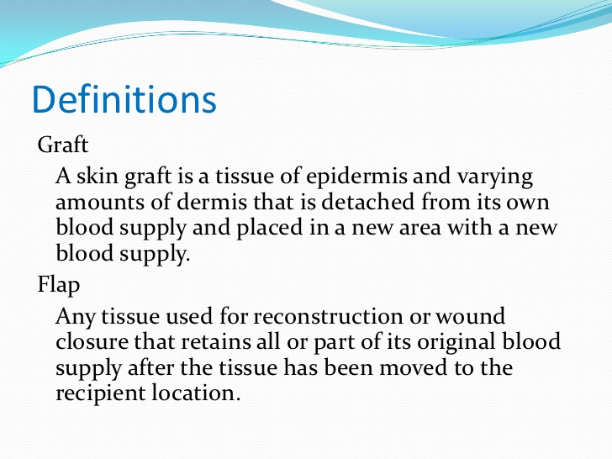
      - Abrasion (scraping of superficial layer of skin due to friction against a hard surface; painful; requires anti-septic cleaning and non-adherent dressing)
      - Laceration (traumatic wounds with irregular, jagged edges; high risk of infection and tissue devitalization)
      - Degloving injury (stripping of skin and SQ from underlying fascia, injuring its blood supply; usually in limbs, but can occur in trunk and face)
        - Replantation, revascularization, skin grafting or using skin flaps or even amputation may be necessary
      - Penetrating wounds (pointed objects or high velocity objects with pointed tip)
        - May have small entry wound, but cause severe damage in viscera and surrounding tissue
        - Comminuted fractures of bone can result from a gunshot
      - Bites (often contaminated)
        - Human bites or hit to teeth eikenella
        - Cat and dog pasteurella (worry about rabies too)
    - Management of open wounds require:
      - ABCs (as always if necessary)
      - Pressure on site of bleeding, if present
      - Assess neurovascular structures (pulses, sensation)
      - Sterile dressing
      - Tetanus Ig and toxoid (Hx helps with need)
      - Prophylactic antibiotics (anaerobic + g+ve/g-ve)
      - Surgical debridement if necessary
      - Contaminated or late wounds are left to heal by secondary or tertiary intention

  - SURGICAL WOUND CLASSIFICATION:
    - CLEAN
      - Surgery that does NOT enter the following systems:
        - RESPIRATORY
        - GIT
        - HEPATOBILIARY
        - UROGENITAL
      - Non-traumatic wound/cut/incision
      - Risk of SSI infection <2%
      - No need for prophylactic antibiotics

      - EXAMPLES OF CLEAN SURGERIES:
        - Herniorraphy
        - Thyroid surgery
        - Breast surgery
        - Vascular surgery
        - Surgery on the head/CNS
      - Example of CLEAN surgery in which you DO give antibiotic prophylaxis?
        - Prosthetic heart valve
        - Arthroplasty (using prosthesis)
        - Hernoiplasty with mesh
    - CLEAN-CONTAMINATED
      - Surgery that DOES enter the respiratory, GIT, HB and GU tract, but it is NOT INFECTED and there is NO SPILLAGE
      - Risk of SSI infection ~ 5%
      - Prophylactic antibiotics are given
      - Example = elective cholecystectomy, colorectal surgery

    - CONTAMINATED
      - Surgery that DOES enter the above systems AND there is an INFECTION in that system or SPILLAGE
      - Risk of SSI infection ~ 15%
      - REQUIRES prophylactic antibiotics
      - E.g. operating on acute cholecystitis in first 24 hours, appendectomy in uncomplicated appendicitis, enterotomy in large bowel obstruction

    - DIRTY
      - Trauma patient with devitalized tissue, perforated viscus and emergency surgery
      - Risk of infection ~ 33%
      - E.g. perforated appendicitis, appendiceal abscess, diverticulitis, exploratory laparotomy for abscess, duodenal ulcer perforation, amputation because of infected ulcer/foot

    - Prophylactic antibiotics:
      - Given 30 minutes prior to operation and once again if surgery lasts >4 hours
      - Choice of antibiotics may vary according to the system, but in general we give:
        - 1st generation cephalosporin (cefazolin)
        - Metronidazole for anaerobic coverage
- Pre-operative evaluation:
  - Goal is to assess whether or not this patient is fit for surgery
    - ASA classification of patients:
      - I – fit for surgery (No problems)
      - II – Mild systemic disease (controlled) or smoker
      - III – Severe disease with morbidity but not incapacitating (i.e. they are alive and well)
      - IV – severe disease that poses threat to life (uncontrolled)
      - V – not expecting to survive even with this surgery
      - VI – brain dead patient/organ donor patient
  - Full history and P/E
    - Obtain details of:
      - Indication for surgery (CC, HOPI)
      - Past medical history (list of medical conditions and their Rx)
      - Past surgical history and anesthesia problems
      - Medication history
      - Drug allergies
      - Social history: smoking, IVDU, alcohol
    - P/E:
      - General inspection (foot of bed):
        - Conscious/awake
        - Oriented to TPP?
        - Mood (relaxed, agitated, irritated?)
        - Obvious distress (e.g. gasping for air) or toxic in appearance
        - Attachments to any IV lines and what for?
        - Appears well-built/emaciated-cachexic/obese
        - Obvious skin manifestations: jaundice, pallor, cyanosed, plethoric
      - General exam with emphasis on:
        - Vitals
        - Signs of anemia
        - Airway patency (look at mouth and assess, usually by anesthetist)
        - Thyroid exam
        - Chest exam
        - Cardiovascular exam
        - Examine for the reason of surgery (e.g. usually abdominal exam, hernia, etc.)
        - LOWER LIMB examination (inspection, peripheral pulses, edema, homan’s sign/calf tenderness, etc.)

  - Pre-operative investigations:
    - Cardiovascular
      - Routine for all = ECG
      - If has cardio Hx or OLD ECG AND Echo
      - We worry about (and do not do surgery until Rx)?
        - Ejection fraction (aortic stenosis)
        - Heart failure
        - Arrhythmias
        - MI within the last 6 months (30% RR post-op)
      - Normal fluid distribution post-op:
        - During OP, we give IV fluids, most of which moves out of intravascular compartment (“3rd spacing”)
        - Post-op day 2, the fluid redistributes back to intravascular compartment
        - In most people this does not cause problems, but in patients with HF this can be detrimental
      - Post-OP MI:
        - Typically SILENT (present with features of HF)
        - Usually post-OP day (POD) 2-3

    - Respiratory evaluation
      - All patients = CXR, coagulation profile (+/-)
      - If Hx or smoker or has chest P/E findings PFTs (FEV)
      - Why do we worry?
        - Most common cause of post-op fever on day 1 is atelectasis
        - Most common cause of post-op death is pulmonary
        - Post-op pneumonia in older age group is associated with 50% mortality
      - High risk patients require?
        - Stop smoking for a period before surgery
        - Incentive spirometry (help recovery)
        - Early post-op ambulation
        - Chest physiotherapy (if necessary)
        - DVT prophylaxis (SQ LMWH, sequential compression device during surgery)

    - Hepatic evaluation:
      - All patients = LFTs (baseline, for anesthesia, some are hepatotoxic)
      - If primary cause/indication is hepatic, assess Child’s score and MELD score
      - Rx underlying conditions if found before surgery (Rx ascites, acute hepatitis)
      - Acute hepatitis is a CI to surgery
      - Pre-op JAUNDICE:
        - Always evaluate for cause (it can be pre-hepatic, hepatic or post-hepatic/cholestatic/obstructive jaundice)
        - We worry about BLEEDING TENDENCY if vitamin K deficiency from malabsorption (secondary to lack of biliary flow)

    - Renal evaluation:
      - All = RFTs (BUN, Cr, electrolyte panel, eGFR using Cockcroft-Gault equation)
      - If patient on or requires dialysis:
        - Dialyze within 24 hours prior to surgery
        - Mortality rate is 5%
      - Any patient with evidence of AKI must manage

    - Hematologic evaluation:
Patient on anticoagulants must have a coagulation profile (check INR, PT and PTT!)
      - All patients = CBC, Cx, BT (this may be the only investigation that is ordered even in the simplest operations, because anesthetists will not work without it!)
SCD to surgery:
FEAR = VOC intra-OP = 80% MR!
Admit for overnight stay
Warm room (hypothermia is a trigger for VOC)
Oxygenation (hypoxia is a trigger)
IV fluids (dehydration is a trigger)
HbS level (electrophoresis)
Simple blood vs exchange transfusion
Prophylactic antibiotics

7 things to say!
      - Anemia is a CI to surgery (postpone the surgery, correct anemia first)
      - Significant thrombocytopenia (<50k) needs to be addressed (may need platelet transfusion)
      - Special populations:
        - Hemophiliac requires F8 to be 100%
        - SCD: NO DAY CASES, HIGH RISK OF VOC (80% MR intra-op); need to stay overnight in a warm room, give oxygen and to be well hydrated with IV fluids, investigated with Hb electrophoresis for HbS levels, simple blood or exchange transfusion prior; antibiotics
Diabetic patients pre-OP and OP day:
Delay surgery if very poorly controlled and HbA1C is high (e.g. >7%)
TRY TO MAKE PATIENT FIRST ON LIST.
If on diet control, no problem, treat as regular patient
If insulin dependent DM, switch to sliding scale insulin with IV fluids on day of surgery (the day before, take all doses as PRN; even give long acting dose the night before)
If taking oral hypoglycemics, take all medications the day before surgery EXCEPT long acting sulfonylureas; on the day of the surgery, you SKIP the morning dose, give it AFTER surgery.
Careful with metformin and IV contrast.

    - Endocrine evaluation:
      - History of diabetes?
        - Glucose levels, HbA1C
        - Needs to be put on SLIDING SCALE (BG is measured at intervals and insulin is given over hours with IV fluids)

      - History of prolonged steroid use?
        - Supplemental steroid doses (surgery is a stressful event for body)
        - Gradual tapering post-op required

      - Thyroid evaluation:
        - History of thyroid disease?
          - TFTs, calcium levels (post-op hypoparathyroidism!)
          - Must be as close to euthyroid as possible before surgery (if hyperthyroid, because of our fear of a thyroid storm intraop high MR (50%!)
          - Laryngoscopy prior to surgery (and during surgery) to study the vocal cords for medico-legal purposes of RLN injury
    - So, all in all, in the most ideal situation you should order:
      - Lab:
        - CBC (+BT, Cx)
        - RFTs (BUN, Cr, electrolytes, eGFR)
        - LFTs
        - Coagulation profile
        - +/- BG
      - Imaging/others:
        - CXR
        - ECG
        - Other (of organ/surgery indication)

  - Pre-OP preparation:
    - CONSENT
    - NPO (no water or food, at least 6 – 8 hours)
      - If GI surgery, will be told to undergo “bowel prep” to clear the bowels of feces, a day before by drinking only clear fluids and taking oral antibiotics (neomycin, metronidazole)
      - Our fear of incomplete bowel evacuation is inability to perform anastomosis, risk of leakage/spillage! So we have to a temporary colostomy and a revised surgery later -_-
    - IV cannulation
    - DVT prophylaxis (SQ, LMWH, 2 hours pre-op)
    - Antibiotic prophylaxis:
      - Depends on what type of surgery: clean, clean-contaminated, contaminated or dirty
      - Clean surgeries (no need): thyroid, head, extremities, cardio, hernia, breast
      - If not clean, you should give antibiotic prophylaxis, typically 30 minutes prior to surgery, another dose if surgery lasts longer than 4 hours
      - By surgery type:
        - Generally cefazolin
        - GI surgery cefazolin + metronidazole
        - Urologic ciprofloxacin
        - Head and neck cefazolin/clinda + genta
    - WHAT TO DO WITH PATIENT MEDICATIONS?
      - On insulin? Change to sliding scale, half the dose on morning of surgery
      - On aspirin? Stop 5 – 7 days before surgery
      - On warfarin? Measure INR, stop 3 days before, start SQ heparin, continue 2 days after
      - On anti-HTN? Continue (give on morning of surg)
      - On oral hypoglycemic? Avoid the morning dose, give it after the operation
      - On anti-thyroid meds? Continue (give on morning of surg, its ok not to give for a while after that because it takes one week for any effect to occur)
      - On prophylactic antibiotics for IE or has prosthetic valve? Give it!

- POST-OP COMPLICATIONS:
  - Whenever a doctor asks you for the complications of a specific surgery, always say that we divide the complications related to:
    - Anesthesia
    - Surgery
      - General (all surgeries)
        - Immediate
        - Early
        - Late
      - Specific (to the specific procedure being done)
  - Complications of anesthesia:
    - Nausea and vomiting (btw pt should expect throat soreness)
    - Altered mental status/confusion/coma/death!
    - Arrhythmias and MI
    - Jaundice
    - Constipation (opioids/sedatives, ileus)
    - Urinary retention
    - Reactions (e.g. anaphylaxis)
    - Hyperthermia
    - Hypoventilation
  - General complications of surgery:
    - Immediate (Day 1):
      - Primary hemorrhage
        - One that occurs during surgery and continues post-op
        - Requires replacement of blood loss and return to OT for exploration
      - Basal atelectasis
        - MCC of post-op fever in POD1
        - Patient typically short of breath, having difficulty in finishing sentences
        - Dullness on percussion and reduced breath sounds over lung bases
        - Management involves promoting early ambulation, incentive spirometry (device that helps open up the distal alveoli, which can be preventative and therapeutic; they are asked to breathe in/suck air as practice), chest physiotherapy
      - Others:
        - Shock, oliguria
        - Surgical site infection (SSI) ONLY IF caused by streptococci or clostridia (bronze colored exudate will be seen)
    - Early (2 days – 3 weeks):
      - Mental status changes
        - May be tired, confused, delirious
        - 2nd to anesthesia, electrolyte imbalances, dehydration, sepsis
      - Nausea and vomiting (anesthesia)
      - Constipation
The causes of post-OP fever is not always straightforward like the books put it… In reality, it’s basal atelectasis, UTI or pneumonia, early DVT, wound infection (5 – 7 days), DVT again, ...
        - 2nd to sedatives/opioids, paralytic ileus, electrolyte distrubances (high Ca, low K)
        - Return of bowel function: small intestine stomach colon
      - Fever (think of the 5Ws as causes of post-op fever)
        - Wind (atelectasis [day 1] or worse, pneumonia)
        - Water (UTI; day 3 – 5)
        - Wound (SSI; day 5 – 7)
        - Walk (DVT/PE; day 7 – 10)
        - Wonder drugs/Womb in CS (endometritis)
      - Reactive hemorrhage or 2nd hemorrhage
        - Reactive: one that starts when 3rd spaced fluid returns to circulation and increases the BP
        - 2nd: due to infection
      - Wound hematoma
      - Wound seroma
      - Small bowel obstruction (SBO) – from fibrinous adhesions (most will resolve spontaneously)
      - Wound dehiscence (see later, but the first sign is oozing of salmon/pink colored material from SS, high risk of evisceration!)
    - Late (weeks to months)
      - SBO (adhesions are the MCC of SBO)
      - Incisional hernia (hernias are the 2nd MCC of SBO)
      - Poor wound healing/non-healing wound
      - Recurrence for reason of surgery

  - Those related specific to the surgery involved
    - E.g. thyroid surgery:
      - RLN injury unilateral (hoarseness of voice), bilateral (breathing difficulty)
      - Hypoparathyroidism and hypocalcemia
      - Thyroid storm (you should minimize squeezing of gland)
      - Hematoma (very dangerous here, obstructs breathing)
    - Laparoscopic cholecystectomy:
      - E.g. laparoscopy complications as below
      - Introduction injuries (of organ by trochars), visceral trauma
      - Hypotension/HF secondary to compressed IVC, CO₂ embolism, incisional hernia
      - Air irritating diaphragm causes referred shoulder pain (due to phrenic nerve origin, C3, C4 (shoulder), C5)
      - Common bile duct damage/stricture, spillage, bile peritonitis
    - Laparoscopic appendectomy:
      - Laparoscopy complications
      - Spilling, intra-abdominal abscesses, SSI, fistula,…
- POST-OPERATIVE FEVER
  - DDx of post-operative fever = 5Ws
    - Wind = basal atelectasis (day 1), pneumonia
    - Water = UTI (day 3 - 5), urinary retention
    - Wound = SSI (day 5 – 7)
    - Walk = DVT/PE (day 7 – 10, but also early)
    - Wonder drugs/Womb in CS (endometritis)
  - NOTE: A very common cause of post-op mortality (excluding those related to bleeding and sepsis) is acute respiratory failure
    - Probably secondary to aspiration (so related to anesthesia)
  - Basal atelectasis
    - MCC of fever within 24 hours of surgery (POD 1 – 2)
    - P/E decreased breath sounds in bilateral lung bases
    - Management & prevention:
      - Sit upright
      - Early ambulation
      - Incentive spirometry (breath in!)
      - Chest physiotherapy

  - Pneumonia
    - In post-op old patients, has a high mortality rate
    - Symptoms:
      - Fever (typically after POD 2)
      - Productive cough (+/- purulent sputum)
      - Dyspnea
      - Pleuritic chest pain
    - Signs:
      - Is the patient toxic?
      - Increased tactile vocal fremitus
      - Dullness to percussion over affected part
      - Bronchial breathing, increased vocal resonance; whispered pectoriloquy and aegophony
    - Investigation:
      - CBC
      - Sputum gram stain, C&S
      - CXR
      - May need to do blood culture, BUN&Cr, electrolytes
      - CURB-65 stratification (Confusion, BUN > 7 mmol/L, RR > 30, BP of SBP <90 or DBP <60, older than 65)
    - Management:
      - ABC (respiratory support, O2, fluid resuscitation)
      - IV broad spectrum antibiotics until results of culture (beta lactam [penicillin/cephalosporin] + macrolide [azithromycin] OR fluoroquinolone)
      - Frequent monitoring of vitals and patient condition

  - Post-OP respiratory failure
    - DDx:
      - Pulmonary embolism
      - CO₂ narcosis (in COPD patients)
      - Atelectasis
      - Pneumonia (infection, aspiration, chemical [Mendelson])
      - Pulmonary edema (MI, HF, AKI)
      - Pneumothorax (e.g. barotrauma)
      - Narcotic overdose (Respiratory depression)
      - Mucous plug
    - Work up:
      - Lab: ABG, RFTs, cardiac enzymes, coagulation profile (look for PaO₂ and acidosis)
      - Imaging/procedures: CXR, ECG, echo, CT angio if high-risk for PE
    - Management:
      - ABCs (intubation, O₂)
      - Frequent monitoring of vitals (HR, RR, T, BP, SPO₂/PaO₂)
      - Rx underlying cause if possible

  - Pulmonary embolism
    - Symptoms:
      - Acute onset
      - Dyspnea
      - Pleuritic chest pain
      - Hemoptysis
      - Tachypnea and tachycardia
      - Syncope (if massive/saddle embolus)
    - Signs:
      - Respiratory distress, altered mental status, hemodynamic instability (high HR, high RR, low BP)
      - LL may show signs of DVT: erythema, pitting edema, warmth, calf tenderness, Homan’s sign
      - Cardio JVD, loud P2
      - DVT may have fever
    - Well’s criteria:
      - 3 points each for:
        - Signs/symptoms of DVT in LL
        - Alternative diagnosis unlikely
      - 1.5 points each for:
        - Tachycardia
        - Prolonged immobilization (>3 days) or surgery within last month
        - Known history of PE/DVT
      - 1 point each for:
        - Hemoptysis
        - Active malignancy or its Rx
      - Simplified score:
        - <4 low probability start with D-dimer
        - 4 or more high probability start with CT angio w/contrast
    - DDx:
      - Of dyspnea (aspiration, chemical pneumonia, airway obstruction, MI, atelectasis)
      - Of chest pain (MI, pneumothorax)
    - Investigations & management:
      - The usual scenario:
        - Low probability d-dimer if normal, R/O; if high, non-specific, do CTA
        - High probability CTA directly
        - If CTA not possible/fails Leg US for DVT if found, Rx for PE; if not, but still high probability, pulmonary angiography (gold standard) or V/Q scan (now outdated)
        - Patient usually is tachypneic, low PaO₂, low PaCO₂ (respiratory alkalosis, hyperventilating), high A-a gradient
      - Lab:
        - CBC, d-dimer, coagulation profile, cardiac enzymes, ABG
      - Imaging/procedures:
        - CT angio (filling defect in pulmonary arteries)
        - Leg US
        - ECG (R/O MI + findings such as tachycardia, RV strain pattern, new incomplete RBBB, S1Q3T3)
        - CXR (Hampton’s hump, westermark sign)
    - Management:
      - Unstable patient ABCs, resuscitation
      - If stabilizes investigate and Rx as appropriate
      - If does not emergency Rx (e.g. embolectomy)
      - Rx (general) = anticoagulation (IV heparin, 3 -6 months warfarin)
      - Post-op patients are in a tricky business, can’t use thrombolytics (consider embolectomy, IVC filter)
      - Prevention of further emboli is the main goal (early ambulation, graduated compression stockings, pneumatic compression device intra-op, LMWH SQ if high risk patient)

  - Urinary tract infection
    - Post-operative UTI can occur owing to:
      - The placement of a line (Foley’s catheter)
      - Urinary retention
      - Type of surgery/what was done intra-op
    - Progression of the UTI can lead to pyelonephritis, which is horrible
    - Symptoms:
      - Upper UTI: toxic, dehydrated, chills, fever, N&V, abdominal and flank pain, urinary symp
      - Lower UTI: urgency, frequency, dysuria, nocturia
    - Investigations:
      - CBC
      - Urinalysis with microscopic analysis, urine C&S
      - If toxic or suspecting pyelonephritis, RFT, KUB imaging and blood culture
    - Causative agents:
      - E. Coli, staphylococcus saprophyticus, klebsiella, proteus, enterococci (nosocomial), pseudomonas (nosocomial), serratia
    - Management:
      - Asymptomatic bacteriuria and cystitis must be Rx with oral antibiotics (5 – 7 days)
      - ABCs, analgesic, broad spectrum antibiotics for pyelonephritis (IV, fluoroquinolone or 3rd gen cephalo or ampicillin based on hospital history)
    - NOTE: AKI (anuric picture) can develop post-op because of:
      - Pre-renal causes: hemorrhage, HF, NSAID use, dehydration
      - Renal causes: nephrotoxicity from contrast agents, antibiotics, other drugs
      - Post-renal causes: bladder urinary retention, ureter injury intra-op
      - Other causes of low urine output? Kinked catheter! Effect of spinal anesthesia!

  - SURGICAL SITE INFECTION (SSI)
    - Classification:
      - Superficial incisional
      - Deep incisional
      - Organ/space SSI
    - TIMING:
      - MOST SSI occur by POD 5 – 7 days
      - EARLY SSI (within 24 hours) occur with CERTAIN infections
        - Clostridia (bronze-brown weeping wound)
        - Streptococci
    - Causative agents:
      - Staph aureus (20%)
      - E. coli (10%)
      - Enterococcus (10%)
      - Staph epidermidis
      - Pseudomonas
    - Major risk factors:
      - DM
      - Type of surgical wound (e.g. contaminated, dirty)
    - Presentation:
      - POD 5 – 7 fever
      - Incisional site pain
      - Surrounding cellulitis (erythema, warmth, swelling and tenderness)
      - Discharge (may be purulent)
    - Investigations:
      - CBC (leukocytosis)
      - Swab of infected site for C&S and gram staining
      - Further investigations are ordered if you suspect an abscess (high spiking fever, exquisite tenderness, may feel fluctuating mass, contaminated operation)
        - CT imaging
    - Management:
      - Fluid rehydration, pain management
      - Remove skin sutures/staples
      - R/O dehiscence if necessary
      - Wound debridement, drainage (if necessary)
      - Irrigation, packing and sterile dressing
      - Antibiotics
    - Complications:
      - Delayed wound healing dehiscence, hernias
      - Abscess, sepsis, fistula or sinus tract, necrosis/gangrene

  - ABSCESS (VERY HIGH YIELD TOPIC)
    - Abscess = localized suppurative inflammation
      - In its final form, it is a collection of pus surrounded by granulation tissue (and a rim of inflamed tissue)
Components of pus:
Cellular debris
Bacteria (live and dead)
PMNs (live and dead)
      - Pus = cellular debris, bacteria & PMNs/WBCs
    - Etiology:
      - MCC is pyogenic bacteria
      - Staphylococcus aureus (MCC; has coagulase enzyme that helps localize itself)
    - Route:
      - Direct access (wounds, scratches, abrasions, or through ducts that open to the skin like the lactiferous ducts)
      - Local extension from adjacent focus (e.g. osteomyelitis)
      - Lymphatic spread (the lymph node may be infected and itself become an abscess)
      - Hematogenous spread (bacteremia can gain access to tissue such as liver and lung)
    - HOW TO MAKE AN ABSCESS 101:
      - Your ingredients:
        - Pyogenic bacteria
        - Medium good for growing bacteria
        - Pockets or space for it collect
      - STEPS:
        - Infection and inflammation occur at the tissue
        - A painful tender mass is a result, with overlying redness and edema IF SQ (with nearby LN enlarged and systemic symptoms begin to appear such as fever, tachycardia, anorexia, malaise)
        - The central zone of the infection begins to undergo coagulative necrosis then liquefies to produce pus (inflammatory exudate, dead leukocytes, necrotic and dead tissue and living organisms)
        - A pustule may be appreciable in the skin before it drains
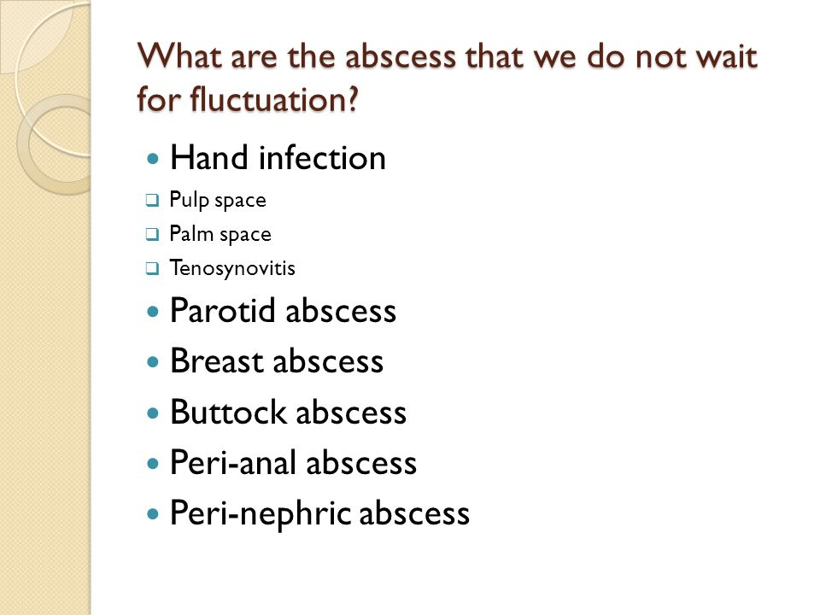
        - When this occurs, the pain becomes THROBBING, the fever become spiking and intermittent, the inflammation becomes localized
        - SQ abscess may demonstrate fluctuation (difficult to appreciate in deep abscess, those covered with strong fascia like parotid abscess or those in the breast); this sign is not liked because it essentially elicits pain in the patient; don’t wait to check for fluctuation in a breast abscess or ano-rectal abscess
    - Risk factors:
      - DM, type of surgical wound, injection sites (especially IVDU), poor hygiene, foreign body, cuts
    - Presentation:
      - Local symptoms:
        - Throbbing pain which steadily gets worse and keeps the patient awake at night
        - Tenderness over site of pain
        - Thickening and hard mass develops at site
        - Discharge (which may relieve symptoms) or a pustule may be seen (if superficial)

      - Systemic symptoms:
        - Fever, which may be high, spiking and intermittent
        - Anorexia, malaise, headache, chills
      - SIGNS:
        - Signs of inflammation (erythema, warmth, swelling, tenderness)
        - Tender, fluctuating mass +/- discharge
        - Regional tender lymphadenopathy
How do you test for fluctuation?
The best way is to put a finger on each opposing side of the lump and then press the center of the lump to see if it pushes against the two fingers on the side. Otherwise, only 2 fingers and one finger pushes while the other feels. You must do it twice, once for each plane; e.g. right to left, up to down.
      - In exam, for a superficial mass/lump, make sure you:
        - Inspect: site, size, shape, surface, skin overlying, surrounding tissue, special characters (abdominal mass? Make sure it’s not a hernia! Check for cough impulse)
        - Palpate: warmth, tenderness, consistency, mobility, shape/circumscribed or not, special tests (reducible or not? Fluctuating or not?) and regional LN needs to be palpated for
        - Percuss (not often done, but will be dull)
        - Auscultate (no findings)
    - DDx?
      - Cellulitis, furuncle, carbuncle, sebaceous cyst, infected hematoma, soft tissue tumors
      - Depending on where the abscess is (e.g. might consider inflammatory breast cancer, infective or congestive mastitis in breast; lung cancer in lung; appendicular mass if RLQ, etc.)
    - Investigations:
      - CLINICAL diagnosis if superficial
      - If deep seated or not obvious imaging may be required (US, CT)
      - CBC (leukocytosis, left shift)
      - Discharge swab C&S (usually intra-op)
    - Management:
      - Incision and drainage (I&D)
        - Patient should be given appropriate sedation, analgesia
        - It is done thru a skin incision in the OT (surgical drainage)
        - Done over the point of dependence
        - The loculi inside the abscess must be broken down to ensure adequate free drainage (ideally by hemostat, but many doctors use their gloved finger)
        - A cruciate incision is done in large abscesses or those in special locations (e.g. anorectal abscess)
        - A rubber (penrose) drain may be used in large abscesses to continue draining pus until none is retrieved
      - DEEP ABSCESS US/CT guided percutaneous drainage
        - The abscess or its drained contents may be in dependent areas of the peritoneum
        - Large or multi-loculated pockets may require surgical drainage thru laparotomy/laparoscopy
      - Role of antibiotics depends on many factors
        - Some say a bigger abscess needs antibiotics
        - Antibiotics MUST be given to those who are IMMUNOCOMPROMISED (e.g. diabetics) and in deep seated abscess (e.g. intraperitoneal)
      - What next?
        - The cavity is usually irrigated, left opened (and in big cavities, we pack them) and then covered by dry gauze and bandage
        - Clinical improvement in 3 or so days indicates an adequate drainage
        - It is re-evaluated in 24 – 48 hours, with the dressing change
    - Complications of abscess:
      - Septicemia
      - Fistula or sinus formation
      - Rupture and drainage into body cavities
      - Related to organs surrounding it or being involved (e.g. infects nearby organ, airway obstruction, etc.)

- CELLULITIS:
  - Infection of the deep dermis and SQ tissue (vs. erysipelas, which involves the upper superficial dermis; impetigo = epidermis)
  - Although infected tissue is abundant in PMN, there is usually no pus
  - Etiology:
    - GABHS (strep. pyogenes)
      - Erysipelas is also caused chiefly by GABHS
    - Staphylococcus aureus
  - Source of entry:
    - Usually not identified or trivial (scratch or prick)
  - Clinical features:
    - Local:
      - Erythema that is NOT well demarcated (vs erysipelas)
      - Pain, tenderness, warmth
      - Enlarged regional lymph nodes
Don’t forget to:
Inspect front and back of affected limb
Feel temperature
Palpate for pulses
Check for edema
Examine the regional lymph nodes
Check for calf tenderness
Assess ROM
      - Usually affects LOWER LIMBS > face
      - Usually non-purulent or no pustules, but may be (may indicate abscess with surrounding cellulitis)
    - Systemic:
      - Moderate to high fever
      - Toxic features (chills, N&V, altered mental status, tachycardia)
  - DDx:
    - More severe forms of infection (abscess, necrotizing fasciitis)
    - Deep vein thrombosis & ruptured baker cyst (in LL)
    - Dermatitis
    - Chemical irritation/inflammation at site of drug injection (e.g. silicone)
    - Bone or joint infection (if over joint) or primary bone cancer
    - Coalesced erythema nodosum
    - Insect bite reaction
  - INVESTIGATIONS
    - Diagnosis is CLINICAL
    - Investigations may be ordered if patient has severe systemic symptoms:
      - CBC
      - Imaging (especially if pain out of proportion!) – US/MRI
  - Management:
    - Minimal systemic symptoms PO antibiotics (amoxicillin or anti-staph antibiotics), 7 – 10 days
Although not as common, it’s important to know about necrotizing fasciitis, gas gangrene, and fournier’s gangrene.
Necrotizing fasciitis is a deep tissue/fascia infection. It can gain access to these tissues through a puncture wound (e.g. RTA) or in a surgical wound (especially if immunocompromised or DM). The infection spreads rapidly through tissue planes, causing necrosis and gas within them, however the superficial tissues may appear less affected. This results in the hallmark feature: pain out of proportion of P/E findings. As the infection becomes more necrotizing, the superficial tissue begins to die. Hemorrhagic bullae may form, necrosis may be obvious on the skin. Consider this in patients in conditions where local inflammatory signs increase, spread or do not respond to weaker antibiotics. The patient is usually toxic and there may be a crepitus felt on P/E. Imaging such as CT may show gas in the deep fascia. The cause is usually polymicrobial.
IV broad-spectrum antibiotics and wide surgical debridement are necessary ASAP, as sepsis may develop and there is a HIGH FATALITY RATE. Amputation may be necessary.
When a similar picture develops by anaerobic clostridium perfringes, it is known as gas gangrene myonecrosis. It is usually 2nd to open wounds that have been closed off completely by occlusive dressing (good medium for anaerobes). There is gangrene with surrounding greenish/black discoloration, crepitus and a foul-smelling discharge. Clinda and metro are necessary.
    - Systemic symptoms present (1 or more SIRS features) IV antibiotics (same as above), change to oral when symptoms subside
    - Rapidly progressing or severe systemic symptoms or no response in 48 hours
      - There may be resistance (e.g. MRSA) OR there could be an abscess that needs to be drained OR incorrect diagnosis
      - IV broad spectrum antibiotics (IV vancomycin + meropenem or piperacillin/ticarcillin)
      - If MRSA suspected, IV vancomycin or linezolid or daptomycin,
      - R/O necrotizing fasciitis especially if pain out of proportion, signs of crepitus and imaging shows air in deep tissue planes (surgical debridement may be warranted before any investigations to save time)
FOURNIER’S GANGRENE: In diabetic patients, necrotizing fasciitis may occur insidiously in the PERINEUM. This can spread very rapidly and is very detrimental. Surgical debridement can leave the patient without a scrotum !
In all these 3 conditions, ABC, IV antibiotics (covering anaerobes and G+ve) and surgical debridement is necessary. Hyperbaric oxygen therapy has also been used (stops anaerobes from growing!)
- Other complications to worry about:
  - Aspiration pneumonia
    - It is the aspiration of OROPHARYNGEAL flora
    - It is not exactly the same as chemical pneumonitis as a result of aspiration of gastric contents (Mendelson syndrome)
    - Which lobe is affected (in all aspiration cases)?
      - RIGHT LUNG almost always
      - When supine/prone posterior segment of upper lobe
      - When upright upper segment of lower lobe
    - What are some risk factors?
      - Being unconscious (e.g. GA, peri-op, comatosed)
      - Absent gag reflex (stroke, MS, etc.)
      - Seizures
    - Problems?
      - In chemical pneumonitis ARDS, abscess
      - In aspiration pneumonia difficult to Rx pneumonia, lung abscess
    - Management?
      - ABCs (O₂ respiratory support)
      - IV broad spectrum antibiotics 7 – 10 days (cover anaerobes, gram –ve and gram +ve: clindamycin, fluoroquinolones and/or beta lactams)
      - If hospital acquired, may want to cover MRSA and pseudomonas (vancomycin, piperacillin/ceftazidime)
      - Antibiotics are given in chemical pneumonitis because they are at high risk of secondary infection
    - Prevention:
      - NPO prior to surgery (6 – 8 hours)
      - Rapid sequence induction for anesthesia

- Central line infections
  - NOTE: we ONLY change central lines when they get infected
    - Remove the line when it is no longer necessary!
  - Presentations:
    - Fever
    - Pus and erythema at central line insertion site
    - Unexplained hyperglycemia
    - Signs of septicemia: altered mental status, tachycardia, low BP, high fevers
  - Risk factors:
    - TPN given thru central line
  - CLABSI = central line associated blood stream infection
    - Central line > 2 days
    - +ve blood culture
    - No other source of infection found
  - Causative agents:
    - Coagulase negative staphylococcus (e.g. staph epidermidis)
    - Staphylococcus aureus
  - Management:
    - REMOVE THE LINE, but send it for C&S!
    - Begin IV antibiotics
    - Place a NEW line at DIFFERENT site (if necessary)

- SURGICAL NUTRITION
  - Total parenteral nutrition (TPN)
    - Indications:
      - NPO > 7 days
      - Enterocutaneous fistulas (to make it a low output fistula to help it close)
      - Short bowel syndrome (initially) and GIT resections (e.g. colectomy)
      - Prolonged ileus
    - Complications:
      - Electrolyte disturbances (Mg, K, Na, Cl, etc.)
      - Refeeding syndrome (refeeding a starved person results in the electrolytes being used up fast: LOW K, Mg and PO₄
      - Central line infection
      - Fatty liver
      - Acalculous cholecystitis
      - Venous thrombosis (in limb using the line)
- SURGICAL INSTRUMENTS TO KNOW ABOUT:
  - For cutting and dissecting
    - Scalpel
      - With different blade sizes (e.g. 10, 11, 12, 15, 23)
      - Number 10 blade MC
    - Scissors
      - Straight and curved scissors
      - Tips may be sharp-sharp, sharp-blunt or blunt-blunt
      - Mayo scissors (curved and straight) – for TOUGH tissue
      - Metzenbaum scissors – for DELICATE tissue (plastic surgery, intestines)
      - Iris scissors (designed for fine detail; thinner than mayo, may be curved or straight)
      - Suture removal scissor (may be straight or angled)
      - Bandage scissor

  - For grasping and holding
    - Hemostat forceps
      - As name implies, used on artery, veins, capillaries (stop bleeding vessels)
      - May be straight or curved
      - Mosquito (Serrations along entire tips)
      - Kelly forceps (serrations along part of tip)
      - NO GROOVES (vs needle holder)
    - Thumb forceps (pick-ups)
      - DeBakey forceps
      - Adson forceps (rat-toothed! For skin)
      - Allis tissue forceps (multi-toothed)
    - Sponge holder/forceps
      - Used to hold surgical gauze
      - Has a hole in each tip
    - Needle holder
      - Has a groove in the surface of its tips (vs hemostat forceps)
      - Used to hold the suture needle
  - For dilating and probing
    - Retractors
      - Used to hook and retract edges of a wound for a better view
      - Manual retractors (below) vs self-retaining retractor (Weitlaner’s retractor)
      - Deaver retractor (looks like a modern prosthetic foot), sweetheart retractor (heart shaped at the end), army-navy retractor and Richardson retractor (both ends are curved)
      - Rib spreader (used for thoracotomy)
    - Hegar dilators
    - Anoscope/protcoscope
  - Suctioning devices (Poole suction for suctioning peritoneal fluid)
  - Electrocautery (diathermy)
    - Two modes: COAG and CUT [higher] mode
    - Two types: monopolar and dipolar
    - It can be placed on a metal instrument to transmit current for cutting or directly used on tissue

- TYPES OF INCISIONS:
  - Kocher incision
    - Right subcostal incision
    - For open cholecystectomy
  - Midline laparotomy
    - Through linea alba
  - Paramedian incision
    - Lateral to midline
  - McBurney’s incision (gridiron incision)
    - Muscle splitting technique is practiced in order to gain access to the appendix
    - It is the slanting one (vs Lanz)
  - Rocky-Davis (aka Lanz incision)
    - Also muscle splitting to gain access to the appendix
    - It is the horizontal one (vs gridiron)
  - Pfannenstiel
    - Low transverse abdominal incision
    - Used for GYNE (Cesarean section, myomectomy)
    - Prostatectomy, cystectomy
  - Roof top incision
  - Groin/inguinal incision (over medial half of inguinal canal)
    - For open inguinal hernia repair
    - For orchidopexy
    - For testicular cancer (we DO NOT do a scrotal incision)
  - Others:
    - McEvedy (for femoral hernia)
    - Transverse incision
    - Morrison
    - To gain access to chest:
      - Lateral thoracotomy
      - Midline thoracotomy (Sternotomy)
      - Mercedes benz incision
      - Chevron incision (/\)

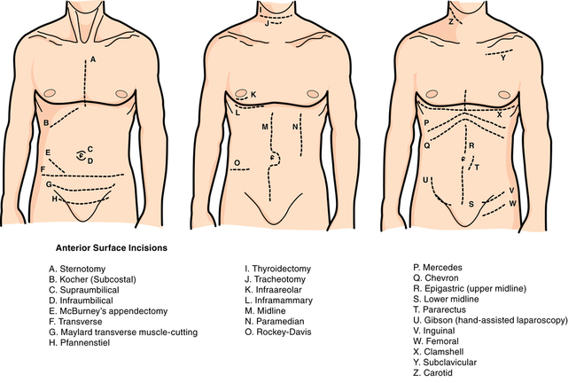

- SUTURING & STITCHING
  - Suture is the material used to approximate tissue or ligate a blood vessel
    - A suture in reality consists of the thread and needle
    - We usually refer to the thread and how it was stitched when referring to “suturing”
    - Size is mentioned as “number + O”
      - The smaller the number, the thicker the diameter/size (1-O > 3-O)
  - Suture material:
    - Divided into:
      - Absorbable or non-absorbable
      - Monofilament or multifilament (braided or twisted)
      - Synthetic or natural
    - Certain key points:
      - Absorbable suture do not need to be removed, they are dissolved by enzymes in the body; often used in deep tissues and tissues that heel rapidly (bowel, stomach, bladder)
      - Non-absorbable (if superficial) needs to be removed and otherwise do not get broken down in order to provide long-term support (as used for tissues that heal slowly like the fascia, tendons)
      - Natural sutures are not man-made: silk and catgut (plain or chromic) are prime examples; catgut is made from collagen fibers of the intestines of healthy cows and sheep! They may provoke a tissue reaction! Useful in securing drains
      - Synthetic sutures are made of man-made material (e.g. PDS, nylon); they are more predictable and evoke less of tissue reaction
      - Monofilament sutures are SINGLE STRANDED: they have a lower risk of infection but are VERY SLIPPERY (you will see doctors frequently applying saline over their gloved fingers when handling them)
      - Multifilament sutures are TWISTED/BRAIDED (not single stranded): higher risk of infection because bugs can collect in between the strands, BUT they are EASIER TO HANDLE, STRONGER and MORE SECURE

  - So let’s meet our friends:
    - ABSORBABLE:
      - Synthetic:
        - Monocryl (monofilament; for subcuticular skin closure)
        - PDS (monofilament; abdominal wall closure; takes 6 months to absorb)
        - Vicryl (multifilament [braided]: bowel anastomosis, SQ tissue closure)
        - Dexon (braided multi)
    - NON-ABSORBABLE:
      - Synthetic:
        - Prolene (mono; for arterial anastomosis)
        - Polyamide/Ethilon (mono; closing skin wounds)
      - Natural:
        - Silk (multi [braided]: securing drains)
        - Cat gut (not used as often)
    - OTHERS:
      - METAL CLIPS and STAPLES (often after steronotomy or skin wounds)

  - When do we remove it?
    - Depends on WHERE you’re suturing
    - Rapidly healing skin surfaces are removed earlier
    - FACE, NECK AND SCALP >5 days
    - Abdominal, proximal limbs and clips >10 days
    - Distal extremities > 14 days
    - If there’s SSI? NOW!

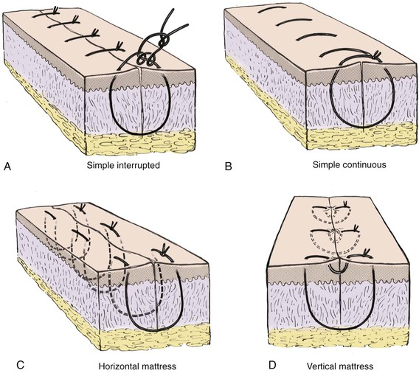
  - Suturing techniques:
    - Simple interrupted (the one we all know)
    - Simple continuous suture (stitches made until the end, then cut)
    - Mattress suture (two times with same stitch)
      - Vertical mattress (perpendicular to wound)
      - Horizontal mattress (parallel to wound)
    - Subcuticular stitch
    - Retention suture (for evisceration/dehiscence)

  - Other instruments to know:
    - Staple removal device
    - GIA (GI anastomosis device)
    - Laparoscopy trocars and laparoscope

- TYPES OF SURGERIES
  - Open surgery (e.g. laparotomy)
  - Minimally invasive surgery (e.g. laparoscopy)
    - Laparoscopy:
      - A minimally invasive surgical technique
      - Involves inflating the peritoneal cavity with CO₂
        - Why CO₂? Because it is LESS VOLATILE (non-combustable), has less solubility in blood (lower risk of gas embolism)
      - Introduction of instruments using a TROCHAR through small incision known as PORTS
        - A laparoscope is inserted into one of the ports in order to provide LIVE VIDEO GUIDANCE
        - Different port locations depend on type of surgery
      - Frequently used for?
        - Cholecystectomy
        - Appendectomy
        - Inguinal and ventral hernias
        - Nissen fundoplication
        - Others (morcellation and then splenectomy; colostomy, bowel resection!)
      - ADVANTAGES:
        - Less invasive
        - Everyone in the OT can see (including us )
        - Shorter duration of surgery and need of anesthesia
        - Shorter post-op stay
        - Smaller incisions with less scarring
Pneumoperiotneum = air under the diaphragm. This is seen ideally on an ERECT CXR, under the right hemidiaphragm. If an erect CXR cannot be done, a left lateral CXR can be used. It is also found incidentally on an erect AXR or a CT. Remember that POST-OP you may NORMALLY find pneumoperitoneum for up to 1 week.
        - Less post-operative pain
      - DISADVANTAGES:
        - Post-op shoulder pain (irritation of diaphragm by the air inflated, refers pain to shoulder thru phrenic nerve)
        - Introduction injuries (trochar may injure the intestines, solid organs like liver)
        - Hernia at trochar sites
        - IVC compression reduced VR and COP hypotension
        - CO₂ embolus (triad is hypotension, low end tidal CO₂ and mill-wheel murmur)
    - ROBOTIC SURGERY MAY BE THE FUTURE!

- Mohamed, for blood transfusion types and reaction, see medicine slides on it
  - Worthy to note: hypocalcemia, hyperkalemia, hypothermia, …
GENERAL SURGERY

ESOPHAGUS

- Anatomy
  - Length
    - From incisor teeth to gastroesophageal junction (GEJ) or Lower esophageal sphincter (LES)
      - 40 cm in males
      - 38 cm in females
    - The esophagus from the upper esophageal sphincter (UES) and LES
      - 25 cm in males
      - 23 cm in females
  - Layers:
    - Mucosa (stratified squamous non-keratizined until LES)
    - Submucosa
    - Muscularis (inner circular, outer longitudinal)
      - Upper 1/3rd mostly skeletal/striated muscle (voluntary)
      - Middle 1/3rd mixed
      - Lower 1/3rd mostly smooth muscles (involuntary)
    - Adventitia/serosa (in posterior mediastinum/retroperitoneal until it enters stomach, which is intraperitoneal)
  - Areas of narrowing:
    - At UES level
      - UES is formed by the cricopharyngeus muscle at the level of C6
    - When it is crossed by the arch of aorta and left main stem bronchus
      - Level of sternal angle/Angle of Louis/T4-T5 level/2nd IC cartilage attachment to sternum
    - At the LES level
      - LES is produced by the esophageal hiatus of the diaphragm
      - VOA: voice of Arabic (T8, T10, T12)
  - Vasculature
    - Arterial
      - Cervical esophagus: inferior thyroid arteries
      - Thoracic esophagus: branches from aorta
      - Lower esophagus shares arterial supply from left gastric artery
    - Venous
      - Follows arterial supply
      - Upper part drains into systemic circulation (azygous)
      - Worthy to note that there is a portosystemic venous system in the lower esophagus (left gastric vein [portal] with azygous and hemiazygous vein)
  - Lymphatic drainage and innervation
    - Lymphatic
      - Cervical cervical lymph nodes
      - Thoracic tracheal, tracheobronchial and posterior mediastinal lymph nodes
      - Lower esophagus left gastric and celiac LN
    - Innervation
      - Cervical esophagus RLN
      - Thoracic esophagus vagus nerve (L, R)
      - Esophagus contains the Meissner (submucosal) and Auerbach (Myenteric) nerve plexus that respond to parasympathetic (i.e. vagus nerve) action
- Some background:
  - Dysphagia is NOT odynophagia
    - Dysphagia means difficulty in swallowing
    - Odynophagia means PAINFUL swallowing
    - In any older patient with dysphagia, always R/O possible esophageal cancer
      - Ask about constitutional symptoms like weight loss
  - Grading dysphagia
    - I = normal (can have solids and liquids)
    - II = liquids ok; needs to drink water with solids
    - III = liquids ok; semi-solids ok
    - IV = liquids ok; no solids
    - V = liquids not ok; solids not ok; can swallow saliva
    - VI = cannot swallow even saliva!!

- Disorders of Motility
  - Mechanical obstruction (usually solids first +/- liquids later)
  - Functional obstruction (usually to solids and liquids from start)
    - Primary
      - Achalasia
      - Diffuse esophageal spasms (DES)
    - Secondary
      - Scleroderma (limited sclerosis [CREST] or diffuse)
      - MCTD

  - ACHALASIA
    - Triad of achalasia:
      - 1 = Increased LES tone
      - 2 = Decreased relaxation of LES
      - 3 = Aperistalsis
    - Damage to the myenteric plexus of nerves in the lower esophagus
      - Primary achalasia ~ unknown cause
      - Secondary achalasia ~ Chagas disease
    - Presentation (40s; M=F)
      - Symptoms:
        - Progressive, chronic symptoms
        - Dysphagia to solids and liquids
        - Regurgitation of food contents, halitosis
    - DDx?
      - Of intrinsic obstruction (esophageal web, stricture, achalasia, zenker’s diverticulum)
      - Of extrinsic obstruction (thyroid goiter)
      - In older patients, of cancers (esophageal cancer, thyroid)
    - Investigations
      - Gold standard test for confirming diagnosis of achalasia is ESOPHAGEAL MANOMETRY, but not done first!
      - IMAGING:
        - Old patient Upper GI endoscopy (R/O cancer and take a biopsy)
        - Younger patients start with CXR (fluid level in esophagus) and barium swallow
        - If barium swallow suggestive of achalasia (Bird beak’s sign) in young patient, do esophageal manometry to confirm diagnosis
        - If barium swallow not suggestive of achalasia, proceed to endoscopy
    - Management:
      - 1 = MEDICAL
        - Lifestyle changes: chew more, elevate trunk, avoid food prior to sleep
        - Medications to relax LES: CCB, nitrates, botox injection
        - Procedures to dilate LES: pneumatic dilation (5% risk of perforation)
      - 2 = SURGICAL
        - Heller’s myotomy +/- Nissen fundoplication (to prevent resultant reflux disease)
        - May be done laparoscopically, transabdominally or transthoracically
    - COMPLICATIONS
      - Aspiration pneumonia, chemical pneumonitis
      - SQUAMOUS CELL CARCINOMA risk (10%, when left for 15 – 25 years
  - Diffuse esophageal spasms (DES):
    - Definition:
      - Aperistaltic
      - Uncoordinated
      - Spontaneous
      - Contractions of the esophageal body
      - At different points
      - At the same time
      - With NORMAL LES tone
    - Presentation:
      - Chest pain, which will often be managed as an acute coronary syndrome
      - Dysphagia to solids and liquids
      - No regurgitation
      - Patient may present with a history of the above, in which case investigations may fail to show the classical signs of DES
    - Investigations:
      - Barium swallow: normal unless having an episode of spasm CORK-SCREW appearance
      - Manometry ~ normal LES tone at rest (R/O achalasia) and during spasm episode will show varying pressure levels across esophagus
      - Endoscopy R/O cancer, no findings
    - Management
      - Medical as with achalasia (not the dilation bit tho)
      - No surgical Rx have been proven to be effective

- Esophageal diverticula
  - Classification
    - True diverticula (contains all layers of the wall of the tubular structure of its origin)
      - Mid-esophageal diverticula (rare)
      - Non-esophageal examples include Meckel’s
    - False diverticula (contains only the mucosa and submucosa protruding thru a defect in the muscular layer of the wall)
      - Zenker’s diverticulum
      - Non-esophageal examples include diverticulosis

  - Zenker’s diverticulum
    - FALSE diverticulum in the upper esophagus
    - Originates from the defect in the cricopharyngeus muscle
    - Presentation:
      - Dysphagia
      - Regurgitation of food contents
      - Halitosis
      - Choking and aspiration
    - Investigations
      - Barium swallow will show collection of contrast in a sac
      - AVOID ENDOSCOPY (risk of perforation)
    - Management:
      - Medical Rx as above (not the dilation bit tho)
      - Surgical Rx is considered if LARGE (>2 cm) or severely symptomatic
        - MYOTOMY (to tighten the defect and prevent it from happening again)
        - Diverticulectomy (if we do this alone, high RR!)

- Esophageal ring/web
  - Schatzki’s ring
    - Lower esophageal circumferential submucosal ring
    - Associated with hiatal hernia
    - Patient has intermittent dysphagia (mostly solids)
    - Rx Pneumatic dilation
  - Plummer Vinson Syndrome (AKA Paterson-Kelly)
    - Long-standing iron deficiency anemia can result in this syndrome
    - Consists of koilonychia, esophageal webs, glossitis and angular stomatitis
    - Rx
      - Treat underyling IDA with iron supplements
      - Pneumatic dilation

- Esophageal caustic injury
  - May be accidental (e.g. in children) or on purpose (e.g. suicide)
  - Ingestion of alkali (lyes) or acids can result in caustic injury
  - ALKALIS ARE WORSE THAN ACIDS, WHY?
    - Alkali result in liquefactive necrosis, which means that it will continue to dissolve the mucosa and the rest of the wall, which can cause esophageal perforation
    - Acids result in coagulative necrosis in the mucosa, to some extent limiting its depth of injury
      - Acids also BURN THE MOUTH, so patients are more likely to NOT SWALLOW!
    - Example of alkali materials include oven and drain cleaners, lyes, KOH, laundry detergents
    - Examples of acidic materials include toilet bowl cleaners, battery fluid and HCl for swimming pools
  - Symptoms
    - Oral/substernal pain
    - Esophageal symptoms: Odynophagia, dysphagia, hypersalivation
    - URT symptoms: hemoptysis, stridor, respiratory distress (causes laryngospasm and laryngoedema)
  - Complications
    - Acute:
      - Esophageal perforation (not necessarily immediate, could take 1 – 7 days!)
      - Respiratory distress, laryngoedema asphyxia
    - Chronic:
      - Strictures (80% within 2 months)
  - Management:
    - ABCs (evaluate airway and intubate if necessary)
    - DO NOT INDUCE VOMITING, DO NOT TRY TO NEUTRALIZE
    - Endoscopy within 24 hours to stratify burn degree
      - You do not advance it thru burn area
    - Degree of management depends on severity
      - Conservative management may be all that is necessary
    - F/U is ESSENTIAL (to assess and Rx for complications)
- Esophageal Perforation
  - SURGICAL EMERGENCY
  - Etiology:
    - IATROGENIC (MCC) ~ endoscopy (usually cervical esophagus)
    - TRAUMA
    - Foreign body or chemical ingestion (Alkali > acids)
    - Boerhaave syndrome
      - Severe retching
      - Mallory-weiss tears are superficial/mucosal linear tears (vs Boerhaave which is deeper and results in esophageal rupture)
      - MC site is left lateral wall (vs. Mallory Weiss which is on posterior lateral right side)
  - Presentation:
    - Symptoms:
      - Chest pain (severe, constant, may be substernal or in upper back)
      - Dyspnea and dysphagia
    - Signs:
      - Unstable patient
      - SQ emphysema
        - Haman’s sign (crunching sound on palpating anterior chest) =/= homan’s sign (DVT)
      - Signs of pneumothorax or pleural effusion may be present (usually on left side)
  - Investigations:
    - We will either know it is perforation given the clinical scenario (he just vomited a lot! We just did endoscopy!) or it is discovered in secondary survey or thereafter when imaging is done
    - IMAGING:
      - CXR:
        - Pneumomediastinum
        - Widened mediastinum
        - Pleural effusion or pneumothorax (usually on left side)
        - SQ emphysema
      - GASTROGRAFIN ESOPHAGOGRAM
        - Gastrografin is a water-soluble contrast
        - Will show extravasation in mediastinum
    - If for whatever reason the pleural effusion is sampled using thoracocentesis, it will demonstrate high amylase, low pH
  - Management:
    - ABCs
    - Peri-operative antibiotics
    - Massive tear needs surgical closure within 24 hours
      - Mediastinum also needs to be drained
    - Smaller, more contained tears can be managed by:
      - NPO
      - IV PPI
      - IV antibiotics
      - Close monitoring

- GERD
  - Inappropriate relaxation of LES resulting in reflux of gastric contents (acid) into the esophagus
    - This may occur secondary to a hiatal hernia
    - Activities that lower LES tone or increase risk of reflux:
      - Caffeine
      - Chocolate
      - Alcohol
      - Smoking
      - Late-night meals
      - Obesity
  - Presentation:
    - In adults, they present with “heartburn”
      - Non-specific term that may be dyspepsia, which can confused with peptic ulcer disease
      - Most people can clearly describe reflux, especially after meals and when in bed
    - Patients may have waterbrash (hypersalivation), sore throat, morning cough, hoarseness of voice and if asthmatic, exacerbation of asthma
      - These result from irritation of the upper esophagus and pharynx by reflux material
  - Investigations
    - CLINICAL DIAGNOSIS
    - BUT the GOLD STANDARD to diagnose GERD is 24 hour pH monitoring
    - In older patients, if there is any complaint of chest pain, we MUST rule out coronary heart disease (e.g. do an ECG)
    - RED FLAGS to INVESTIGATE with ENDOSCOPY in order to R/O cancer:
      - >5 – 10 years of symptoms
      - Weight loss
      - Anemia or +ve guaiac
      - Signs of dysphagia or odynophagia
  - Management algorithm:
    - Clinical diagnosis of GERD (WITHOUT alarming symptoms)
      - Lifestyle changes (avoid precipitants, don’t eat before bed, elevate head when sleeping, lose weight, stop smoking) AND PPI trial (OD, 2 months, 30 minutes before meals)
      - If the above trial fails even with increasing dosage of PPI, then consider investigating (barium swallow, endoscopy)
      - If all else fails, SURGICAL management includes NISSEN FUNDOPLICATION
    - Clinical diagnosis of GERD BUT has ALARMING symptoms
      - Do an endoscopy to R/O cancer
      - If cancer R/O, then Rx as above
  - Complications:
    - Barret’s esophagus (risk of progressing to adenocarcinoma)
    - Pulmonary (chemical pneumonitis, aspiration)

- Barret’s esophagus
  - Chronic GERD (>5 years) may result in intestinal metaplasia of the lower esophagus
    - 0.5 – 1% risk of adenocarcinoma every year
  - It is a HISTOLOGICAL diagnosis made thru ENDOSCOPIC BIOPSY
    - Grossly, on endoscopy there is obvious erythema near LES
    - Histologically, there is eosinophilia and “intestinal” metaplasia to simple columnar epithelium
  - Management:
    - Barret’s esophagus w/o signs of dysplasia
      - Managed as GERD with PPIs and lifestyle changes
      - BUT must be monitored in 2-3 years using endoscopy
    - Patients with dysplasia may require endoscopic ablation (photodynamic, radiofrequency, mucosal resection)

- Esophagitis
  - Causes:
    - Infection
      - Candida (MC)
      - HSV
      - CMV
    - Others
      - Reflux esophagitis (AKA GERD)
      - Eosinophilic esophagitis
      - Chemical esophagitis
      - Drugs (e.g. bisphosphonates = hard to swallow them shits down! YOU NEED TO SIT UPRIGHT FOR UP TO AN HOUR AFTER SWALLOWING!)
  - Details on:
    - Candida esophagitis
      - Always assume an esophagitis to be candidiasis (clinical diagnose)
      - Rx with fluconazole, PO or IV
      - If no response to therapy, THEN you investigate to find alternative diagnosis (i.e. do an endoscopy)
    - HSV esophagitis
      - Consider in immunocompromised patients
      - Diagnosis is supported by endoscopy findings such as a PUNCHED OUT and SMALL ulcer (volcano-like); biopsy will help confirm based on cytopathic findings (e.g. giant cells, cowdry A bodies)
      - Treatment is with acyclovir, PO
    - CMV esophagitis
      - Same as HSV
      - Endoscopy shows large, LINEAR and deeper ulcers
      - Treatment is ganciclovir, IV (poor oral absorption)

- Esophageal cancer
  - Epidemiology
    - Histological types:
      - SCC > Adenocarcinoma in developing world
      - Adenocarcinoma > SCC in developed countries
      - SCC affects upper 1/3rd of esophagus more
      - Adenocarcinoma affects lower 1/3rd more
    - More common in males, African Americans, >50 years old
    - Risk factors:
      - Barrett’s esophagus (Adenocarcinoma)
      - Smoking
      - Alcohol
      - Achalasia (SCC)
      - Radiotherapy
      - Frequent ingestion of hot liquids (SCC)
    - Symptoms:
      - Gradual dysphagia (first to solids, then liquids)
      - Of local invasion (coughing, stridor, hoarseness of voice = RLN involvement!)
      - Constitutional (WEIGHT LOSS, fatigue)
    - Investigations
      - Barium swallow may be done first, but endoscopy needs to be done for biopsy
      - Diagnosis is confirmed by biopsy on endoscopy
      - For STAGING:
        - Endoscopic US (for depth of invasion)
        - CT Chest and abdomen (for metastasis)
    - Management:
      - IF limited to the esophagus:
        - Surgical resection
        - Neoadjuvant or adjuvant radiotherapy or chemotherapy
      - IF advanced (i.e. goes beyond muscle layer, involves local structures or lymph nodes, stage 4):
        - Palliative surgery and/or radiochemotherapy
        - Poor prognosis (15% 5 year survival rate)

- Esophageal varices
  - Background on upper GI bleeding:
    - Any bleeding that originates from a site above the ligament of Trietz is considered UGI bleeding
    - The MC site of GI bleeding in general is UGI, in that:
      - Patients that present with hematemesis, melena, occult blood positive stools, we do an UPPER GI endoscopy before we try to find lower GI causes
      - Brisk bleeding in the upper GI tract can present with hematemesis and hematochezia
    - Bleeding in the upper GI tract is like having a high protein meal (the blood proteins are absorbed by the gut)
      - For this reason, patients with liver failure may develop acute exacerbation of hepatic encephalopathy (high ammonia)

    - DDx of UGI bleeding (more common to least):
      - 1 = Peptic ulcer disease (PUD) [complicated type]
      - 2 = Gastritis
      - 3 = Esophageal varices
      - 4 = Mallory-Weiss tears
      - 5 = Others:
        - Esophagitis
        - Neoplastic
        - Swallowed epistaxis
        - Dieulafoy’s vascular malformation
        - Gastric varices (yes, they occur secondary to SPLENIC VEIN thrombosis, often due to cancer)
      - For the sake of the exam to help you remember it better, you can arrange it from up to bottom (i.e. swallowed epistaxis, Mallory Weiss, esophagitis, varices, cancer, vascular malformation, PUD and gastritis)

  - Esophageal varices occur secondary to portal hypertension
    - The portosystemic venous shunt becomes enlarged and superficial (they are submucosal veins in the lower esophagus, the connection is between the left gastric vein and esophageal veins to the azygous vein)
    - Chronically elevated portal pressure can result from:
      - Liver cirrhosis
      - Schistosomiasis
      - Liver congestion (Budd-chiari syndrome)
      - Portal vein thrombosis
    - 30% fatality rate, but…
      - 50% of bleeding stop spontaneously
      - However, 70% have a rebleeding risk, which is often the cause of death
    - SYMPTOMS:
      - PAINLESS, UNPROVOKED HEMATEMESIS (fresh blood in vomitus, NOT coffee-ground)
    - SIGNS:
      - Hemodynamic instability (tachycardia, low/orthostatic BP, anxious, pale, altered mental status)
      - Stigmata of liver failure (e.g. jaundice, nail clubbing, dupytren’s contracture, astrexis, gynecomastia, ascites, dilated veins, caput medusa, splenomegaly)

  - Management of suspected upper GI bleeding:
    - 1 = ABCs (stabilize the patient)
      - Airway must be protected, O₂ supply
After the initial ABCDE (for all UGIB) and NGT, the following steps will depend on the patient’s history (what is the cause of the UGIB?). In varices, IV octreotide, IV antibiotics, endoscopic bleeding control, balloon tamponade and TIPS will benefit them. For those bleeding from ulcers, IV PPI and endoscopy is necessary.
      - TWO large IV bore cannula lines are inserted into large veins, collecting blood for investigations and rapidly giving IV resuscitation fluids (e.g. RL) and if necessary, blood transfusions (and platelets if low)
      - Blood investigations include CBC (with Hb, Hct, PLT, BT, Cx for PRBCs), BUN & Cr, electrolytes, coagulation profile, LFTs (w/ albumin), ammonia levels
    - 2 = IDENTIFY SOURCE OF BLEEDING & SUCTION
      - Patient is NPO
If Hb < 7 in a healthy patient, transfuse. If Hb < 10/9 in a patient with HF or history of CAD, transfuse. If varices, don’t transfuse over 10 because risk of more bleeding to occur. Platelet transfusion if platelet <50,000 or has platelet dysfunction (on long-term aspirin).
      - NG tube is inserted to suction for blood and to find out if the source is in esophagus
    - 3 = MEDICAL MANAGEMENT
      - IV octreotide + IV PPI + IV antibiotics (ceftriaxone)
      - Continuous monitoring of patient
      - Patients that develop encephalopathic features may benefit from lactulose, neomycin or rifamixin
    - 4 = IF THE BLEEDING DOES NOT STOP or PATIENT STILL UNSTABLE
      - Urgent endoscopy for band ligation/sclerotherapy and to study bleeding source
      - If this fails or not possible and it is varices, BALLOON TAMPONADE can be done using a SENGSTAKEN-BLAKEMORE tube (although there is a risk of perforation)
      - Another option for varices is transjugular intrahepatic portosystemic shunting (TIPPS) but this increases the risk of encephalopathy by bypassing the liver
When stabilized and managed, patient should be monitored in ICU/ward. If it was a minor bleed, this won’t be necessary.
      - Devascularization techniques are also being used
    - 5 = PREVENTION
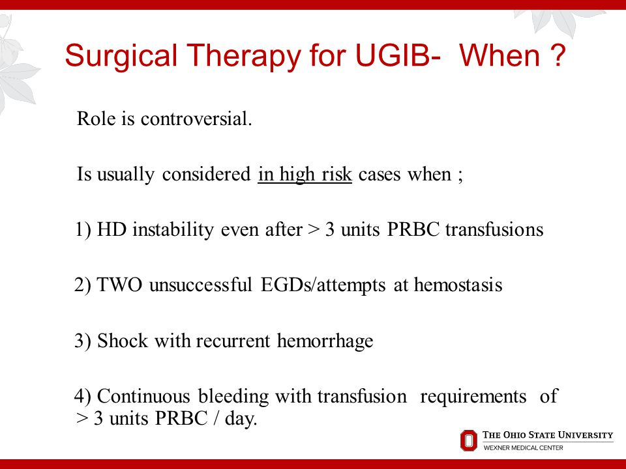
      - Note: all cirrhotic patients need endoscopy when diagnosed and if negative, need to do another in 3 years
      - Following an episode, patients MUST have an endoscopy to ASSESS FOR RISK OF RE-BLEEDING
      - MEDICAL Rx includes PROPRANOLOL (which help venodilate vessels in the liver to reduce portal pressure)
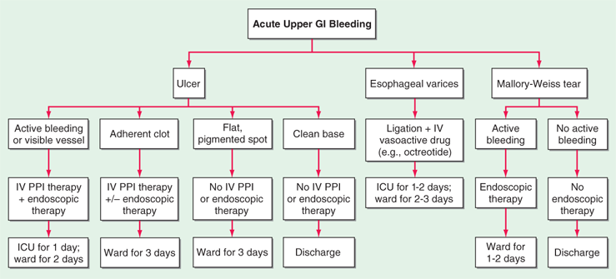
      - LIVER TRANSPLANTATION is another option if appropriate

STOMACH

- Anatomy review
  - Divided into:
    - Cardia (where esophagus enters)
    - Fundus
      - Above the level and to the left of LEJ
      - Source of gastric bubble
    - Body
      - The greater and lesser curvatures are worthy to note
    - Antrum
      - Opens up into the pylorus, which houses the pyloric sphincter
  - Functional anatomy:
    - Body and fundus houses the most parietal and chief cell in gastric glands
      - Parietal cells secrete HCl and intrinsic factor (for B12 absorption in distal ileum)
      - Chief cells contain granules, and secrete pepsinogen, which are activated by acid to pepsin (minutely digesting some protein in meals)
    - The antrum secretes mostly mucus and gastrin
      - Antral mucosa is alkaline (the rest is acidic)
      - G-cells secrete gastrin INTO THE BLOOD, which stimulate the body of the stomach to secrete more acid
      - More acid in antrum less gastrin less acid secretion (negative feedback mechanism)
  - Layers of the wall:
    - Mucosa and submucosa
      - Mucosa is simple columnar epithelium with glands diving down
    - The muscularis layer include:
      - A unique innermost oblique muscle layer
      - The traditional inner circular muscle layer
      - The traditional outer longitudinal muscle layer
    - Serosa
      - It is an intraperitoneal organ
  - Blood supply
    - Arterial
      - Left and right gastric arteries (near lesser curvature and esophagus) ~ left arises directly from celiac trunk
      - Right gastroepiploic artery from gastroduodenal artery branch of hepatic artery
      - Left gastroepiploic artery and short gastric artery arise from the splenic artery, which is a branch of the celiac trunk
      - Gastroduodenal artery runs behind 1st part of duodenum
    - Venous
      - Follow arterial naming
      - Drain into the portal venous system
      - Pre-pyloric vein of mayo is a surgical landmark of the pylorus
  - Lymphatic drainage
    - Follow the arteries, mostly to celiac lymph nodes
  - Innervation
    - Parasympathetic = vagus nerve (CN10)
      - Left and right vagus nerve become the anterior and posterior vagal trunk, respectively
      - The vagal trunks form the nerve of Laterjet, which provide several small branches to the stomach
      - Cutting the vagal trunk = truncal vagotomy (in essence depriving the pylorus of nerve supply: so you NEED a DRAINAGE surgery which involves a pyloroPLASTY OR antrectomy with gastroduodenal anastomosis (Bilroth I) OR a more advanced technique (e.g. Bilroth II)
      - Cutting only the fine branches of the nerve of laterjet = highly selective vagotomy
    - Sympathetic
      - From greater splanchnic nerve

- Quick review of DUODENUM anatomy
  - 4 parts:
    - First part of duodenum is 2 inches long, the first inch is the duodenal cap area and it is the only part that is intraperitoneal
    - The rest of the duodenum is retroperitoneal
    - The second part is 3 inches long and is also where the ampulla of vater enters: it marks the division between the foregut and midgut
    - The third part is 4 inches long and crosses to the left, being overrun by the superior mesenteric vessels
    - The 4th part is 1 inch long, ascends to join the jejunum, where it takes a sharp turn due to the ligament of Trietz
    - Bleeding before the ligament of Trietz is UGI bleeding and beyond it is lower GI bleeding

  - Blood supply
    - The main supply is by:
      - A&P superior pancreatoduodenal artery (from gastroduodenal artery of hepatic artery of celiac)
      - A&P inferior pancreatoduodenal artery (from superior mesenteric artery)
  - Gastric mucosal barrier concepts
    - Protective factors that keep mucosal surfaces safe:
      - Mucus secretion
      - Bicarbonate secretion
      - Prostaglandins (inhibit acid secretion)
    - Destructive factors
      - NSAIDS
      - H. pylori (secrete urease, which takes up H+ and NH3 from urea to produce NH4, neutralizing the acidity)
      - Uremia
      - Bile reflux
      - Irritation (alcohol, smoking, spicy foods)
- Epigastric pain DDx
  - Acute coronary syndrome (especially inferior wall MI) – old age
  - Peptic ulcer disease and its complications
    - E.g. Perforated DU
  - Non-ulcer dyspepsia
  - Pancreatitis
  - AAA complications
  - Acute mesenteric ischemia
  - Cholecystitis and other hepatobiliary disease
  - Right lower lobe pneumonia

- Non-ulcer dyspepsia
  - MCC of epigastric pain
  - Further investigations reveal no findings
  - For this reason, in most cases, patients with DYSPEPSIA and NO ALARMING FEATURES can be started on a trial of PPIs:
    - Alarming features:
      - Age > 55
      - Severe pain
      - Hematemesis (coffee-ground) or melena
      - Weight loss
      - Sign/symptoms of anemia (e.g. pallor, palpitations, tachycardia, fatigue)
      - Chronic symptoms
      - Intractable symptoms
    - Patients that don’t respond to PPI trial are warranted a full investigation to identify peptic ulcers, H. pylori and R/O malignancy of the stomach and esophagus, using:
      - CBC and stool occult blood
      - Endoscopy with biopsy (especially in older patients)
      - Urea breath test/serology/stool Ag
    - Medical management is warranted if peptic ulcer disease is the definitive diagnosis
      - Avoid smoking, alcohol, NSAIDs
      - Use of antacids to relieve symptoms
      - PPI for isolated ulcers (no H pylori)
      - H. pylori +ve triple therapy (PPI + amoxicillin + clarithromycin) or quadruple therapy (PPI + tetra + metro + bismuth)
    - Surgical management is only indicated in PUD if “ICHOP”:
      - Intractable to medical Rx
      - Cancer possibility (in gastric ulcers)
      - Hemorrhagic features
      - Outlet obstruction (GOB)
      - Perforated peptic ulcer (usually duodenal)

- Peptic ulcer disease
  - Acute ulcer disease (usually secondary to gastritis)
    - NSAIDs use (hemorrhagic gastritis)
    - Stress ulcers (in ICU patients, shocked patients)
    - Cushing ulcers (in increased ICP, probably increased vagal tone)
    - Curling ulcers (in burn patients)

  - Chronic ulcer disease (classic peptic ulcer disease)
    - Risk factors:
Risk factor of ulcers: the ‘S’s
Smoking
Spirits (alcohol consumption)
Steroids (and NSAIDs)
‘Sepsis’ (H. pylori infection)
Stress (physiological > psycho)
Spicy food

Also uremia (CRF)
      - Family history
      - Smoking and alcohol use
      - Age (DU occurs at age 40s-50s; GU later ages)
      - H. pylori infection
      - Chronic NSAIDs use
      - Chronic steroid use
    - Possible causes to consider:
      - Hypercalcemia (hyperparathyroidism)
      - Zollinger-Ellison syndrome (suspected when intractable and on endoscopy many ulcers are seen, even in jejunum; gastrin levels are >1000 pg/mL = pathognomonic)

    - DUODENAL ULCERS
      - Pathophysiology?
        - 70-90% associated with H. pylori
        - H. pylori infection of antrum of stomach, results in excess H⁺ secretion that irritates the duodenal mucosa
        - Acid production is usually high
      - There is no increased risk of cancer (vs GU)
      - Presentation (uncomplicated)
        - 40s-50s patient (younger than GU)
        - Epigastric pain that is worse when fasting (post-meals and at night, waking him up)
        - Pain is relieved by eating
        - Patients are well-fed/overweight
        - Periodicity (pain is episodic)
      - Diagnosis is CLINICAL
        - Urea breath test may be ordered to initiate triple therapy
      - Always investigate if patient has alarming S&S (e.g. risk factor or complication) or refractory to PPI alone
        - ENDOSCOPY + BIOPSY (one is enough)
        - Biopsy urease test to detect H. pylori
      - Ulcer findings:
        - Posterior DU: MC, more likely to BLEED (gastroduodenal artery); panceatitis
        - Anterior DU: more likely to perforate
        - Kissing ulcer: anterior and posterior ulcers
        - Indurated/inflamed ulcers gastric outlet obstruction visible peristalsis, succussion

    - GASTRIC ULCERS
      - Pathophysiology?
        - Less likely to be associated with H. pylori
        - Normal to low acid production
        - Loss of mucosal barrier (e.g. NSAIDs use)
      - MUST R/O malignancy (3% risk)
      - Presentation (uncomplicated)
        - Older patients (>50s)
        - Epigastric pain when EATING
        - Patient avoids eating WEIGHT LOSS (alarming sign, must investigate!)
        - May develop nausea and vomiting
      - INVESTIGATIONS
        - You MUST investigate if you suspect it
        - ENDOSCOPY (multiple biopsies to R/O cancer)
        - Ulcer findings:
          - MC site is lesser curvature
          - Posterior wall GU may result in pancreatitis and bleeding (splenic a)
          - Anterior wall GU may perforate
          - Type I = in lesser curvature (MC site)
          - Type II = type I + duodenal ulcer
          - Type III = prepyloric
          - Type IV = near LES
          - Certain findings may indicate malignant potential: raised, nodular edges, non-radiating gastric folds
  - Complications and their management
    - Hemorrhage (bleeding)
      - Bleeding may be ACUTE/ACTIVE or CHRONIC
      - Acute bleeding
        - Coffee ground vomitus (usually GU; had time to be digested in the stomach)
        - Melena (DU and GU; dark-tarry stool)
        - Hematemesis (MCC of hematemesis) = massive bleeding
        - Hematochezia = brisk bleeding
      - Chronic bleeding
        - Occult blood (+ve stool guiuac)
      - Management:
        - Acute bleeding as below; chronic bleeding requires CBC, endoscopy as in uncomplicated cases
        - Most acute bleeding stops spontaneously due to clot formation
        - Patient is admitted, ABCs (protect airway, 2 large IV bore needles, blood drawn, fluids & blood if necessary), NPO, NGT for suctioning and identifying level, IV PPI, IV antibiotics, careful monitoring of vitals and urine output
        - If bleeding CONTROLLED & patient stable plan for endoscopy within 24 hours to assess risk of rebleeding and management
        - If bleeding UNCONTROLLED & patient unstable urgent endoscopy for hemostasis using laser coagulation (spurting blood will be seen)
        - Rebleeding risk based on ulcer base findings on endoscopy (from highest to lowest):
          - Visible vessel (pulsating?)
          - Clot
          - Pinpoint bleeding
          - Clean base
        - Ulcers with high rebleeding risk surgical Rx
          - Hemostasis with sutures
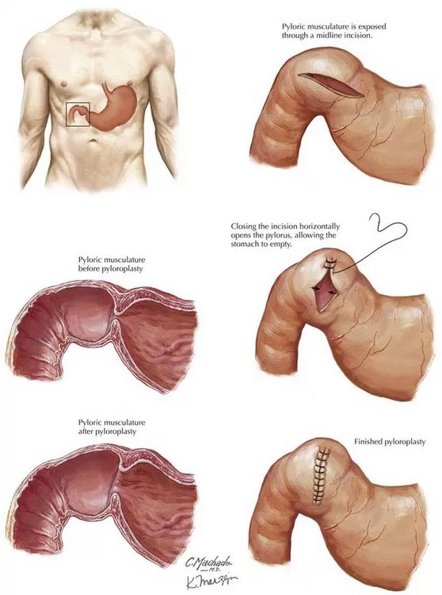
          - Pyloroplasty (longitudinal incision, horizontal suturing)
    - Gastric outlet obstruction (GOO)
      - Occur mainly in duodenal ulcers
On P/E there is epigastric distention, a succussion splash (when shaking abdomen) and +/- visible peristalsis.
        - DDx?
      - Presentation:
        - Early satiety
        - GERD
        - Abdominal distention
        - Late symptoms include weight loss, non-bilious vomiting and dehydration
      - ABG findings of hypochloremic, hypokalemic, metabolic alkalosis
      - Management:
        - ABCs (IV fluid and electrolyte correction)
        - NG decompression, NPO
        - Surgical Rx (pyloroplasty)
    - Perforation
      - Occur in anterior duodenal ulcers, gastric ulcers
      - Presentation = acute abdomen
        - Onset of severe, constant epigastric pain
Perforation examination:
Inspection: patient looks ill, lying still, appears to be in pain, respiration is shallow but rapid, abdominal movements are reduced; tachycardic
Auscultation: absent bowel sounds may be noted
Palpation: there may be initially exquisite epigastric tenderness and guarding, however, patients may have diffuse pain, board-like rigidity or involuntary guarding.
Percussion: painful
        - May become diffuse abdominal pain
        - Pain worsened by movement and respiration (prefers to sit still)
        - Pain may develop in RLQ if draining fluid tracks down the right paracolic gutter (Valentino’s sign; misdiagnosed as acute appendicitis)
        - P/E unstable patient, tachycardia, epigastric tenderness, rigidity, involuntary guarding
      - DDx of acute epigastric pain:
        - MI (especially inferior wall MI), RLL pneumonia
        - PUD (perforated?)
        - Acute pancreatitis
        - Acute cholecystitis, cholangitis
        - AAA rupture/expansion
HOW TO CHECK FOR AIR UNDER DIAPHRAGM (pnuemoperitoneum)?

If patients are able to stand, PLAIN ERECT CXR is the BEST TOOL to look for AIR UNDER DIAPHRAGM on the RIGHT HEMIDIAPHRAGM (because the gastric bubble can distort it on the left side).
If they CANNOT stand, the BEST ALTERNATIVE WAY is to do a LEFT LATERAL DECUBITUS CXR.
        - Acute mesenteric ischemia
      - Investigations
        - NOT required if signs of peritonitis is present or (if CXR > AXR done) air under diaphragm emergency laparotomy

        - Acute abdomen labs and imaging:
          - CBC + BT + Cx
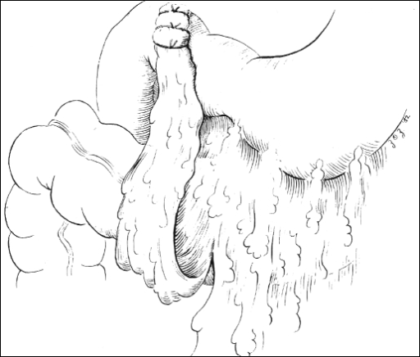
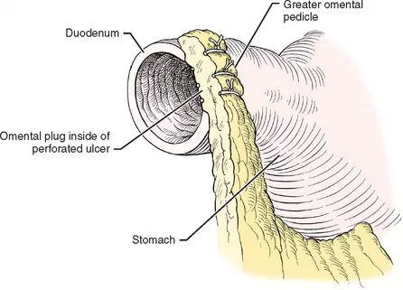
          - BUN, Cr, electrolytes
          - Beta-HCG in childbearing age women
          - Amylase/lipase
          - Coagulation profile
          - LFTs
          - Cardiac enzymes
          - Biochemistry (glucose, lactate)
          - CXR, plain erect and supine AXR
          - ECG
Why do we do graham patching using omentum? The edges of the perforated ulcer are necrotic and very friable; primary suturing will be useless because the edges are too friable. That’s why we overlay the omentum over the perforation and suture further away from the edges over the omentum.

      - Management:
        - ABCs (airway, IV fluids, blood collection)
        - IV antibiotics (+PPI?)
        - Emergency laparotomy:
          - GRAHAM PATCHING (close perforation using piece of omentum)
          - PERITONEAL TOILETING/IRRIGATION
          - Close abdomen with drain inserted

  - Management:
    - Uncomplicated
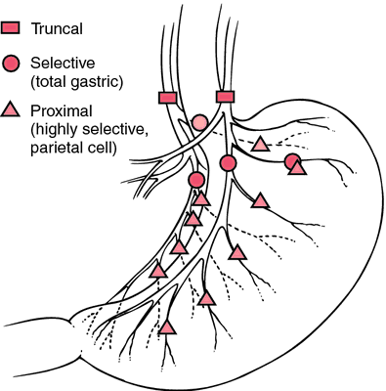
      - 1 = Medical Rx (usually successful)
        - Avoid NSAIDs
        - PPI +/- triple therapy if applicable
      - 2= Surgical Rx (rare)
        - Indicated if intractable (in uncomplicated cases)
          - 12 weeks of failed medical Rx
        - General indications for surgery = “ICHOP”
          - Intractable
          - Cancer (in GU)
          - Hemorrhage (chronic)
          - Outlet obstruction (in DU)
          - Perforation
        - Duodenal ulcers
Note: It’s easy to confuse Billroth II with roux-en-Y. Roux-en-Y is not a specific operation (but most people use it to refer to Kasai operation of biliary atresia or gastric bypass), but a principle. The principle is you cut part of a tube, bring the distal segment to attach to wherever you want to drain (e.g. portal triad) and connect the proximal segment to the distal segment. In essence, you are making a Y.
          - Highly selective vagotomy (no need for drainage procedures, but high RR)
          - Ulcer excision
        - Gastric ulcers
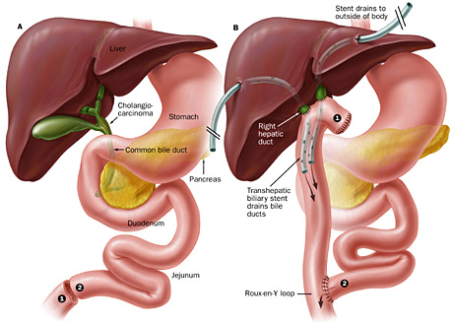
          - I ulcer excision + Bilroth I (distal gastrectomy + gastroduodenostomy)
          - II & III ulcer excision + truncal vagotomy + pyloroplasty (drainage)
          - IV ulcer excision + Bilroth II (distal gastrectomy + gastrojejunostomy)
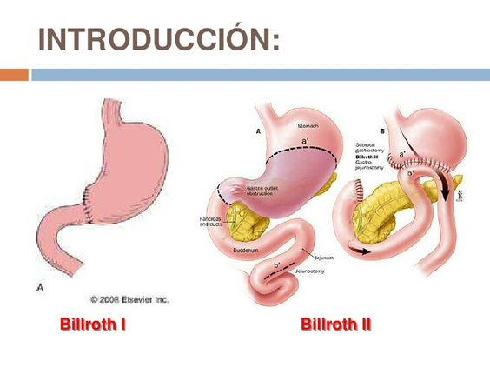
          - Only II and III need truncal vagotomy because they are associated with acid hypersecretion (think of the fact they have a duodenal ulcer)
    - Complications of surgery:
      - Nutritional disturbances (especially B12, iron)
      - Marginal ulcer
        - Ulcers that occur on stumps/anastomosis
        - Probably related to incomplete vagotomy
        - Patient develops PUD symptoms again
        - Endscopy will confirm
        - PPI + re-operation considered
      - Postvagotomy diarrhea
        - Occurs in many patients
        - Condition improves with time
      - Dumping syndrome
        - Unregulated movement of gastric contents from stomach to small intestines (occur too rapidly, hyperosmolar solution enters small bowel)
        - Clinical features:
          - May be early (5-15 minutes post-prandial) or late (2 – 4 hours)
          - GI symptoms: Nausea and vomiting, diarrhea, flatus/belching
          - Vasomotor symptoms: tachycardia, palpitations, flushing, diaphoresis, dizziness, syncope
          - Late = hypoglycemia
        - Management:
          - Dietary modification: small, more frequent meals, low in carbs and high in proteins, avoid fluids with meals
      - Afferent (or efferent) loop syndrome
        - Afferent limb of a Bilroth II gets obstructed or dilated for any reason (kinking, angulation, volvulus, adhesions)
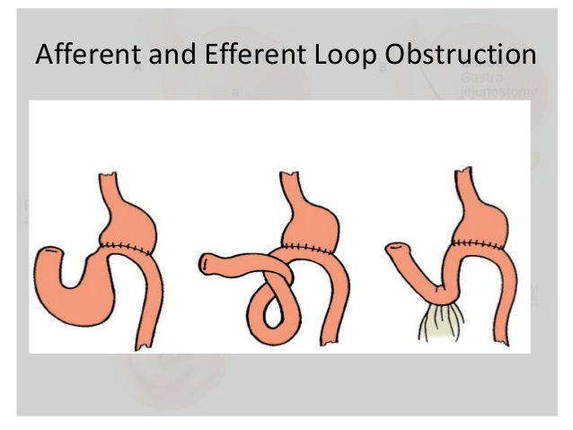
        - Clinical features:
          - Post-prandial RUQ pain
          - Abdominal fullness
          - Bilious vomiting that alleviates symptoms
          - Steatorrhea
        - Investigations:
          - US (shows dilated afferent loop)
          - UGI series (barium enters the afferent loop)
        - Management:
          - Surgical revision of loop (e.g. Bilroth II Bilroth I or roux-en-Y)
      - Biliary gastritis (reflux gastritis)
        - Bile enters stomach and irritates mucosa
        - Bilious vomiting with gastritis symptoms result
        - Diagnosed by endoscopy
        - Revision surgery is necessary
      - Gastric cancer -_-

- GASTRIC VARICES
  - As previously mentioned, consider splenic vein thrombosis as a possible cause
    - This may occur secondary to pancreatitis, pancreatic malignancy

- BARIATRIC SURGERY (A short word)
  - Indications:
    - BMI ≥ 40 in any case
    - BMI > 35 + comorbidity
  - Perquisites:
    - Unsuccessful SUPERVISED dietary program (of course nobody follows this rule because they want to make money)
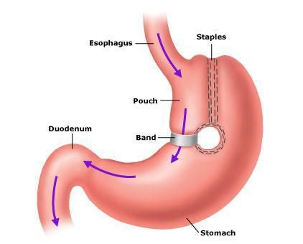
  - Types (not mutually exclusive):
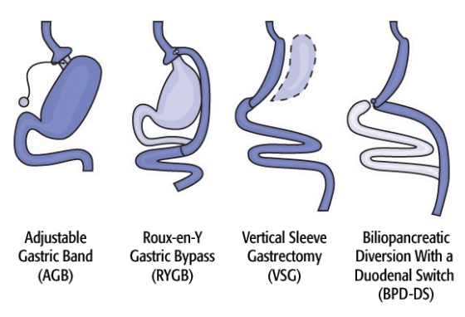
    - RESTRICTIVE:
      - Gastric sleeve (vertical, with gastrectomy)
      - Vertical band gastroplasty
      - Adjustable banding
      - Gastric balloon
    - MALABSORPTIVE:
      - Roux-en-Y gastric bypass

- GASTRIC CANCER
  - Histological types:
    - Adenocarcinoma (95%)
    - Lymphoma (4%)
    - GIST (1%)
  - Gross types:
    - Polypoid
    - Ulcerative (25 – 50%) – sharp nodular margins, non-radiating gastric folds
    - Superficial spreading (best prognosis)
    - Linitis plastic (thick wall, lack of gastric folds)
- Adenocarcinoma of the stomach
  - Risk factors:
    - Age (>60 Y)
    - M>F
    - H. pylori infection (6x!)
    - Smoking
    - Familial adenomatous polyposis (FAP)
    - Pernicious anemia (the one with auto-Ab against IF/parietal cells)
    - Diets high in smoked foods (nitrites)

  - Presentation:
    - Patients often present LATE with:
      - Constitutional symptoms (anorexia, weight loss)
      - Bleeding related symptoms (melena, hematemesis, anemia related)
    - Or with present with metastatic features:
      - Hard left supraclavicular LN (Virchow node)
      - Sister Mary Joseph nodule (periumbilical metastatic nodule)
      - Krukenburg tumor (metastasis to bilateral ovaries resulting in large ovarian cyst mass)
      - Seborrheic keratosis on back (Lesar-Trelat sign)
      - Pseudomyxoma peritonei (Malignant ascites)
      - Blumer’s shelf (DRE exam shows mass in pouch of douglas or recto-vesical pouch)
  - Investigations:
    - Lab:
      - CBC (other baseline for mets)
      - Tumor markers (CEA, CA-19-9)
    - Imaging/procedures:
      - Endoscopy with biopsies
      - Abdopelvic CT scan (for staging)

  - Management:
    - Early radical subtotal gastrectomy
    - Late Chemotherapy, palliative surgery
- Others
  - Gastric lymphoma (MALToma)
    - MC site of lymphoma in gut
    - Usually Non-hodgkin lymphoma (NHL), B-cell type
    - Risk factors:
      - H. pylori infection (triple therapy has preventative role)
    - Low grade MALToma may respond to triple therapy

- DDx of abdominal pain
  - Concept of acute abdomen
    - Definition
      - Any sudden, spontaneous, non-traumatic, severe abdominal pain, of <24 hours duration
    - Importance
      - Conditions that require RAPID diagnosis because they require RAPID management (which MAY be surgical)
      - Emergency laparotomy is indicated in the case of:
        - Generalized peritonitis
          - Patient is unwell, lying still, vitals are unstable
Exploratory laparotomy in?
1. Generalized peritonitis on P/E
2. Bowel strangulation suspected
3. Evidence of sepsis, clinical deterioration, failure of medical Rx
4. Perforation (radiological evidence of air under the diaphragm)
5. ALL penetrating abdominal trauma
6. FAST or DPL +ve
7. Uncontrolled massive LGIB (despite all efforts!)
          - Abdominal examination shows involuntary guarding with board-like rigidity, diffuse abdominal rebound tenderness
          - Peritonitis results from a ruptured viscus no matter the cause (ruptured appendix in appendicitis; perforated DU; strangulated and necrotic hernias or bowel obstruction or mesenteric ischemia; diverticulitis; ruptured ectopic pregnancy)
        - Signs of advanced/non-improving bowel obstruction (which may progress to ischemic necrosis)
          - Unstable patient
          - Abdominal distention
          - Vomiting & obstipation (no pooping or farting)
        - Radiological evidence of pneumoperitoneum (air under the diaphragm on CXR or CT scan)
        - Uncontrolled (massive or ongoing) bleeding from GIT
  - Types of pain
    - Visceral vs. somatic (parietal)
      - When an abdominal viscus is dilated the pain is vague/dull and felt in the midline depending from where it is derived embryologically:
Visceral pain occurs when a viscus is stretched/dilated or when contracting against an obstruction (in some locations, this produces a colicky sort of pain). When the organ is distended enough to irritate the parietal pleura of the abdominal wall, the pain becomes somatic.
      - Foregut epigastric; midgut periumbilical or hindgut infraumbilical
      - Irritation of the parietal pleura will produce pain over the location in which the irritation occurred; the pain will be more sharp, well-localized and have rebound tenderness
    - Quality/character of pain
      - Gradual and steady pain
        - Acute cholecystitis
        - Acute cholangitis
        - Hepatic abscess
        - Diverticulitis
      - Intermittent and colicky - grabs their abdo
        - Small bowel obstruction (SBO)
        - Inflammatory bowel disease (IBD)
        - Biliary colic (not true, they always feel some sort of background pain)
      - Abrupt & excruciating
        - Perforated ulcer
        - Ruptured AAA
        - Urteric colic (can’t sit still, also colicky)
      - Rapid-onset, severe and constant - patient lies still!
        - Acute appendicitis
        - Acute pancreatitis
        - Mesenteric ischemia (hallmark = out of proportion of P/E)
        - Strangulated bowel
        - Ruptured ectopic pregnancy
        - Testicular/ovarian torsion

    - Special characters:
      - Referred pain (connected by origin/nerves)
        - Biliary tract/right hemidiaphragm irritation right scapula or right shoulder pain
        - Splenic rupture/left hemidiaphragm irritation left shoulder pain (Kehr sign)
      - Radiating pain (connected by anatomic tract)
        - Acute pancreatitis upper back
        - Ureteric colic loin to groin (following urinary tract)
      - Migrating pain (as in acute appendicitis)

  - DDx of diffuse abdominal pain
    - GI:
      - SBO, LBO
      - Peritonitis (ruptured viscus/appendicitis, PUD, diverticulitis)
      - Mesenteric ischemia (but may be LUQ, epigastric)
      - Gastroenteritis
    - Genitourinary:
      - Ruptured ectopic pregnancy
    - Cardiovascular:
      - AAA rupture
    - Endocrine:
      - DKA
      - Addisonian crisis
    - Hematologic:
      - Sickle cell crisis (abdominal crisis)
      - Porphyria
    - Others:
      - Blackwidow spider bite
      - Lead poisoning
  - DDx of pain by quadrant:
EPIGASTRIC pain

Cardio:
MI (inferior wall)
AAA rupture/acute expansion, AA dissection

GI:
Perforated DU/GU, acute pancreatitis, acute mesenteric ischemia, GE

Hepatobiliary:
acute cholecystitis/cholangitis
Hepatic abscess/hemorrhage into hepatic cyst

RUQ pain
Hepatobiliary:
Biliary colic, acute cholecystitis, cholangitis, CBD obstruction, hepatitis, hepatic abscess
GI:
Perforated DU, appendicitis in pregnancy, mesenteric ischemia
GU:
Nephrolithiasis, urolithiasis, pyelonephritis
Others:
Right lower lobe pneumonia (RLL)

NOTE: include DDx of RIGHT SIDED abdominal pain (so include below)

LUQ pain

GI:
Splenic rupture
PUD perforation
Acute mesenteric ischemia
Diverticulitis
Ulcerative colitis

GU:
Pyelonephritis, kidney stones,

HYPOGASTRIC pain

Peri-umbilical:
Acute appendicitis, acute pancreatitis, AAA, mesenteric ischemia, gastroenteritis, IBS, etc.

Suprapubic area:
GI: Acute appendicitis, sigmoid diverticulitis, incarcerated groin hernia
GU: ectopic pregnancy rupture, mid-cycle pain (mittelschmerz), uterine pathology (e.g. red necrosis of leiomyoma), TOA, cystitis may cause discomfort, acute retention
RLQ pain
GI:
Acute appendicitis, crohn’s disease, meckel’s diverticulitis, hernia strangulation, mesenteric adenitis (e.g. Yersinia), intussusception, cecal volvulus, abdominal TB

GU:
Ovarian cyst torsion
Testicular torsion (look at scrotum!)
Ectopic pregnancy rupture
TOA/PID, fibroid red necrosis, abortion, mittelschmerz
LLQ pain

GI:
Diverticulitis
Acute mesenteric ischemia
Sigmoid volvulus
Ulcerative colitis
Pseudomembranous colitis
Fecal impaction
Strangulated inguinal hernia

GU:
Ovarian cyst torsion
Testicular torsion (look at scrotum!)
Ectopic pregnancy rupture
TOA/PID

- What to ask about in history:
Pain SOCRATES + OCD
Site, onset (when did it start), character (intermittent or continuous; sharp or vague; rapidly increasing or steady, change over time), radiation (or referred pain; to back or to shoulder or scapula), timing (with specific meals? Fatty meals?), exacerbating and relieving factors (lying still or coughing or moving); scoring (1- 10)
In this case we must add? Recent Hx of MIGRATION of pain
  - Demographics (age, M/F, occupation)
  - CC + duration
  - HOPI:
GI symptoms to ask:
- Pain
- Distention
- N&V
- Anorexia
- Change in bowel movements (diarrhea or constipation, passes gas? Color change?)
Ask about urinary (dysuria, urgency, frequency, dribbling, etc.) and HB symptoms (jaundice, change in stool or urine color, itchiness, bleeding)
In females, you must ask about menstrual/obstetric history; in males about testicular pain.

    - SOCRATES, OCD (onset, course, duration)
    - Symptoms associated with system involved (e.g. all GI symptoms including anorexia!) or its DDx
    - Constitutional symptoms (fever, weight loss, anorexia)
    - History of trauma
    - Previous personal history (is this your first time?)
    - Hospital course
  - PMH:
    - Medical conditions and their Rx
    - OPERATIONS (very important) & problems with anesthesia
    - F&D allergies
    - Medications
    - F menstrual and obstetric history
  - FH & SH:
    - FH of CRC, …
    - Diet/recent food intake

- What to do in P/E:
  - General exam (foot of bed first)
    - General inspection (Mental status, toxic? Sick-looking? In pain? Anxious? Prefer to lie still or move around? Obvious pallor or jaundiced? Lines attached?)
    - Vitals (unstable? Temperature, pulse, BP important)
  - GI examination:
    - Exposure is from 5th ICS (dome of diaphragm is at this level; you can say level of nipple but nipple position is variable) to ideally mid-thigh (to examine the pelvis if necessary)
    - Inspection (type of breathing; scaphoid or distended abdomen? Visible pulsations/peristalsis/dilated veins or caput? Hair distribution? Umbilicus position? Masses (comment on it with the Ses)? COUGH TEST/COUGH IMPULSE? If applicable, inspect scrotum
    - Auscultation for bowel sounds (e.g. absent? High pitched?)
    - Palpation (start with least painful area: note tenderness, rebound tenderness, guarding, rigidity; special signs: Murphy’s sign, rebound tenderness at McBurney’s point [indicates BASE of appendix, which is FIXED], Rovsing, etc.)
    - Ideally, DRE and pelvic exam

- Special Hx & P/E findings to keep in mind:
  - Sudden onset of epigastric pain, now diffuse pain and rigid abdomen perforated DU
  - Peri-umbilical pain to RLQ pain in about 1-2 days AND anorexia (+/- rebound tenderness at RLQ, Rovsing sign and possibly other special signs) acute appendicitis
  - Pain out of proportion to P/E acute mesenteric ischemia
  - Colicky pain, abdominal distention, vomiting and obstipation bowel obstruction
  - Epigastric boring pain radiating to back, patient leaning forward acute pancreatitis

- Investigations to order in acute abdomen:
  - NOTE: they should not delay emergency surgery if Hx & P/E has clear indications
  - LAB investigations:
    - CBC + BT + Cx
    - BUN & Cr + electrolytes
    - Biochemistry (glucose and lactate)
    - LFT
    - Coagulation profile (pre-op)
    - Amylase and lipase (both for pancreatitis, amylase can be used for perforation too)
    - Cardiac markers (R/O MI)
    - ß-HCG in all women in childbearing age
  - IMAGING/procedures:
    - CXR (to r/o chest + air under diaphragm)
    - Supine and erect AXR
    - ECG

- Management:
  - All cases:
    - 1 = ABCs (protect airway, oxygenate, IV fluid resuscitation, monitor)
    - Next step depends on cause (e.g. NGT decompression)

INTESTINES

- Anatomy:
  - Primitive gut (endoderm)
    - Foregut: gives rise to esophagus, stomach and duodenum up to the ampulla of vater opening (sphincter of Oddi); also gives rise to the accessory organs such as the pancreas, liver and gallbladder as well as the spleen
    - Midgut: from 2nd part of duodenum till the 2/3rd of the transverse colon
    - Hindgut: from the above point to the dentate line (Pectinate line)
    - The ectoderm beyond the pectinate line gives rise to the anal canal’s stratified squamous non-keratinized epithelium (up to the white line of Hilton/anal verge where the epithelium becomes keratinized)
    - The midgut loops around the long axis of SMA while in utero
      - This looping occurs outside the abdominal cavity
      - Total looping is 270 degrees counterclockwise
      - Malrotation and omphalocele may be associated with abnormal completion or incompletion of midgut looping
      - Vitelline duct proximal remnant results in Meckel’s diverticulum
  - Small intestines
    - Duodenum
      - 4 parts as previously mentioned
FUNCTION OF INTESTINES:
The job of the small intestines is absorption of nutrients. The job of the large intestines include water and electrolyte absorption to form stool (right side) and housing fecal matter with mucous secretion (left side).
      - Receives pancreatic secretions necessary for absorption
      - Histologically characterized by having villi and submucosal (Brunner’s glands)
    - Jejunum:
      - Grossly:
        - Larger caliber (vs ileum)
        - Less mesenteric fat (vs ileum)
        - Long vasa recta, short arterial arcades (vs)
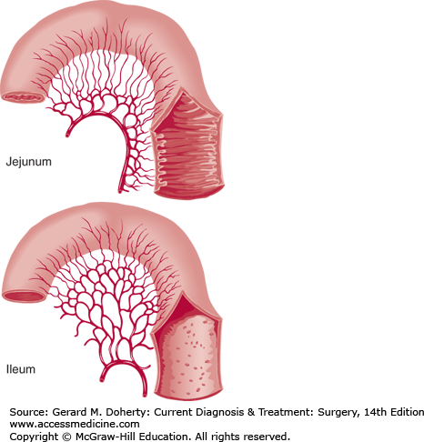
        - More frequent plicae circularis (radiologically called valvulae conniventes or stack of coins appearance)
      - Histologically characterized by having ONLY villi (with glands)
    - Ileum (longest part):
      - Grossly:
        - Smaller caliber (vs jejunum)
        - More mesenteric fat (vs jejunum)
        - SHORT vasa recta, MORE arterial arcades (vs jej)
        - Less frequent plicae circularis
      - Histologically characterized by having villi + peyer’s patches (and M cells)
        - Peyer patches are lymphoid nodules in the ileum which hypertrophy in response to gut bacteria or viral infection
        - They may enlarge and become a nidus for acute appendicitis intussusception in kids (example is rota virus and its vaccine, which reports claim may predispose kids to intussusception)
      - Ends by joining the cecum through the ileocecal valve
    - Radiologically, the small intestines are:
      - Centrally distributed (supine AXR)
      - Differentiated by their small caliber, high number of loops and vulvae conniventes
  - Large intestines (colon)
    - Colon vs. small intestines:
      - Much larger caliber
      - Haustrations (externally visible curvatures due to contracted tenia coli)
      - Tenia coli (outer longitudinal layer of muscle in colon is divided into 3 columns of muscles that meet at the base of the appendix; the tenia coli helps form the haustrations and when loosen straightens the colon)
      - Fat appendages (epiploic appendix)
      - Radiologically identified by its:
        - Large caliber (filled with air/feces) and peripheral location
ODE TO THE GREAT OMENTUM:
It is known as the policeman of the abdomen because during inflammation and perforation, the omentum adheres to the area to contain it as to protect the peritoneum. It has an important role in Rx perforated DU (Graham patch). In the pediatric age group, the omentum is not as efficient in its job, so they may develop complications earlier (e.g. acute appendicitis).
        - Haustrations (semilunar folds)
        - Air in the rectum can be seen centrally above the level of the pubic symphysis (important to look for in an AXR, because its absent signifies a proximal obstruction)
      - Histologically has no villi, only glands
    - The ascending and descending colon are retroperitoneal
    - The transverse and sigmoid colon are intraperitoneal
      - The sigmoid colon’s mesentery is S shaped and long and predisposes this part of the colon to volvulus
    - The cecum is large and mobile, lies in the RIF area but is not actually intraperitoneal (predisposes to cecal volvulus in kids)
    - The appendix is a mobile appendage arising from the cecum at a fixed point known as the base of the appendix
      - The base of the appendix is at McBurney’s point (1/3rd the way from right ASIS to umbilicus) and is the sight of rebound tenderness in acute appendicitis
      - The base of the appendix is identified intra-operatively as the point at which all 3 tinea coli unite
      - The position of the appendix differs from person to person (see later)
      - Histologically it is very lymphoid in nature
  - Layering of wall
    - Mucosa (all simple columnar epithelium with goblet cells that increase in number as you go along the intestines)
    - Submucosa
      - Contains submucosal (Meissner) plexus of nerves
    - Muscularis layers
      - Inner circular
      - Middle myenteric (Auerbach) plexus of nerves
      - Outer longitudinal
    - Serosa or adventitia depending on whether it is intra or retroperitoneal
  - Vascular supply:
    - SMA
      - Gives rise to right colic artery, middle colic artery and ileocolic artery
      - The ileocolic artery, which supplies the cecum and ileum, gives its terminal branch to the appendix (known as the appendicular artery)
      - Main supply is for the midgut organs (SI, colon till 2/3rd of transverse), however all the arteries meet in the mesentery as arterial arcades and form a large marginal artery that combine with the arcades of the IMA
      - Yet, the most “watershed” zone is still the splenic flexure and rectosigmoid colon where IMA and superior rectal artery (from internal iliac artery) meet
    - IMA
      - Gives rise to left colic artery (to descending colon) and sigmoid artery (to sigmoid colon)
  - Lymphatic drainage:
    - Follows the arterial supply through mesenteric lymph nodes to the origin of the major arteries (e.g. SM lymph nodes, IM lymph nodes)
      - Mesenteric adenitis may present as abdominal pain and or mass
  - Innervation:
    - Parasympathetic supply (mainly from vagus nerve [cranio] and S2-S4 to pelvic splanchnic nerve [sacral])
      - The anterior and posterior vagal trunk provides branches to the celiac plexus, which supply the intestines all the way down to the splenic flexure, beyond which is supplied by the pelvic splanchnic nerves
      - The pre-ganglionic nerve fibers are long and reach the surface of the organs to synapse
      - They stimulate peristalsis, secretion and bowel movements
    - Sympathetic supply
      - Thoracolumbar sympathetic nerves leave the lateral horn of the spinal cord, bypassing the sympathetic (para-vertebral ganglion) chain ganglion and then synapses in the pre-vertebral ganglion, which in the abdomen and pelvis is called the greater, lesser and least splanchnic nerves
      - From there the post-ganglionic nerve fibers innervate the organ
      - To note: the only exception to this is the branches to the adrenal medulla, in which the preganglionic nerves reach all the way to the medulla without synapsing (because the medulla itself is made of modified post-ganglionic nerve fibers of neural crest cells origin)
      - The SNS slows down motility and secretions

INFECTIONS OF PERITONEUM
  - Peritonitis
    - Primary (spontaneous) peritonitis
      - AKA: spontaneous bacterial peritonitis (SBP)
      - Occurs in the absence of bowel perforation
      - May occur secondary to hematogenous spread
      - Occur in patients with ascetic fluid that gets infection as in patients with liver failure and renal failure
      - Key feature = ascetic fluid having WBC count >500/µL, with >25% neutrophils + a SAAG score of >1.1 g/dL
      - Rx = IV broad spectrum antibiotics until culture results of ascetic fluid
    - Secondary peritonitis
Familial Mediterranean Fever may present with periodic peritonitis (they have polyserositis) .
      - Causative organisms:
        - E. coli
        - Aerobic and anaerobic streptococci
        - Bacterioids
        - Pneumococci, enterococcus
      - Sources of organisms:
        - Infected organs (appendicitis, diverticulitis, cholecystitis)
        - Leaking organs (perforated DU, perforated typhoid ulcer, leaking anastomosis, extravasated urine, bile peritonitis)
        - Direct entry (from OT wound or traumatic wound)
        - Hematogenous
        - Others (e.g. PID thru fallopian tubes)
      - NOTE: the more DISTAL organs that rupture/perforate = the more likely to cause early fatal infection and peritonitis (e.g. diverticulitis is more dangerous than ruptured appendix vs ruptured DU in terms of bacterial load and severity of infection)
    - Course:
      - Paralytic ileus occurs at first as a reflex to minimize spread, then accentuated by toxic effect of pus formation
      - Fate may be resolution OR:
        - Localization (abscess formation) which may be:
          - At the site of primary infection (e.g. abscess in acute appendicitis)
          - At dependent zones (usually in the case of abrupt onset as in perforations: subphrenic, iliac, pelvic abscess in pouch of douglas/recto-vesical pouch)
        - Flaring up (develops generalized peritonitis)
          - Especially in sudden perforations (peritoneum does not have enough time to mount a defense)
          - Persistent source of infection
          - Immunosuppressed persons
          - Extreme of ages (in children, the omentum is less developed and may not be able to do its job to contain the infection)
        - Septicemia & SIRS, multiple organ failure, septic shock and death
      - Clinical presentation
        - Acute abdomen + septic picture
        - May present with the clinical picture of original cause (e.g. appendicitis or cholecystitis)
        - If condition well established, it may be difficult to establish cause

        - Symptoms:
          - Diffuse abdominal pain, aggravated by movements and coughing (patient prefers to lie still)
          - Vomiting
          - Abdominal distention
          - Obstipation
        - Signs:
          - Unwell, toxic-looking patient, lying still in bed, may have altered mental status (disoriented, anxious)
          - May have “Hippocratic facies” because of dehydration (sunken eyes, anxious or altered mental status)
          - Unstable vitals: high fever, tachycardia low BP
          - Auscultation absent bowel sounds
          - Generalized tenderness with rebound, involuntary guarding, rigidity
          - The site of MAXIMAL tenderness and rigidity may indicate etiology
      - Investigations:
        - Of acute abdomen
          - CBC, BUN&Cr&electrolytes, LFTs, amylase+lipase, coagulation profile, glucose&lactate, B-hCG, may need blood culture
        - Lab investigations (to help you with Dx):
          - CBC (leukocytosis with left shift)
        - Procedures/imaging
          - CXR/AXR air under diaphragm, paralytic ileus
          - Paracentesis/DPL WBC count >200 cells/ µL
        - DELAYED RECOGNITION = HIGH MORTALITY
      - Management:
        - A, B, Cs (IV fluids!)
        - NPO, NGT if necessary to decompress stomach, foley cath to monitor urine output
        - IV analgesia
        - IV broad spectrum antibiotics (vary from source to source but generally we give a cephalosporin with metronidazole to cover anaerobes/ or meropenem)

        - Surgical Rx when patient is stable:
          - Exploratory laparotomy
          - Midline incision
          - Rx underlying lesion (e.g. graham patching of perforation)
          - Peritoneal irrigation/toileting with saline
          - Peritoneal drainage
        - Prognosis ~ mortality rate about 40%! More if more distal causes (E.g. diverticulitis-related peritonitis)

  - Intraperitoneal abscess (localized septic peritonitis)
    - Having a peritoneal abscess is better than generalized peritonitis (it means the body was capable to localize the infection, especially with the help of the omentum!)
    - Abscess occur at the site of primary infection or at dependent peritoneal sites in the case of leakage
      - Subphrenic area (e.g. morrison’s pouch)
      - Right iliac fossa (through right paracolic gutter)
      - In the pelvis (e.g. in Douglas pouch/recto-vesical)
    - Etiology:
      - Right side: acute appendicitis, cholecystitis, perforated DU
      - Left side: perforated diverticulitis, perforated CRC of sigmoid colon; subphrenic abscess (splenectomy)
      - Pelvis in general: female PID (e.g. TOA)
      - Anywhere in the case of generalized peritonitis
    - Presentation:
      - Symptoms:
        - Pain
        - Swelling
        - Hectic, fluctuating high fevers
        - Nausea and vomiting
        - Pelvic abscesses may present with deep pelvic pain, diarrhea, dysuria
        - Shoulder pain (referred) may indicate suphrenic abscess irritating diaphragm
      - Signs:
        - Tenderness and rigidity is maximal at site of abscess
        - Mass may be palpable (classically fluctuating)
        - Overlying skin may show signs of inflammation
        - Pelvic abscess may show DRE tenderness or PV exam tenderness
    - Investigations:
      - Same as always
      - CBC will show very marked leukocytosis (maybe >16k)
      - Imaging (E.g. US or CT) may demonstrate localized abscess
    - Management:
      - ABCs
      - IV analgesia and antibiotics
      - Mainstay = US/CT guided percutaneous drainage
      - If the above is not possible or fails or there are multiple abscess, surgical drainage is indicated
      - We often do not remove the infected organ source (E.g. appendix), but instead do an interval (delayed) removal because it is safer

  - Extra topic: TUBERCULOUS PERITONITIS
    - TB occurring in another source may spread to peritoneum by the way of:
      - Direct spread (TB lymphadenitis, enteritis)
      - Hematogenously (pulmonary TB/miliary TB)
      - Lymphatic spread (from pleura or bowel)
    - Encountered types of TB peritonitis:
      - Miliary type (studded everywhere!)
      - Caseous type (cold abscess form)
      - Ascitic type (the ascetic fluid is thickened, fibrosing the omentum into a DOUGHY MASS
      - Others (adhesive, encysted)
    - Clinical features:
      - Suspect in migrants
      - There are constitutional symptoms of TB (e.g. night sweats, fever)
      - Palpation: doughy abdomen or abdominal masses (may be LN or omentum or tuberculomas)
    - Investigate as TB:
      - Lab: CBC, ESR/CRP
      - Imaging: CXR, abdominal US or paracentesis
      - Procedures: TST if applicable, laparoscopic biopsy
    - Rx as TB!

  - Extra topic: Mesenteric cyst
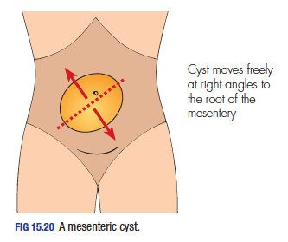
    - Dr Jafar Al Khuzaie may as well ask you about this
    - Usually near the umbilicus
    - Key CLINICAL P/E feature = MOVES ONLY PERPENDICULAR TO ROOT OF MESENTERY (So it can move up and down, but not left to right)
SMALL INTESTINES

  - Small bowel obstruction (SBO)
    - Most common causes:
      - Adhesions (MCC)
      - Incarcerated hernia (2nd MCC)
      - Malignancy/cancer (3rd MCC)
    - All etiology can be divided into:
      - MECHANICAL
        - Intraluminal (inside):
          - Bezoars (e.g. trichobezoar)
          - Foreign bodies
          - Gallstone (gallstone ileus)
          - Intussusception
Types of bezoars:
Trichobezoars (hair)
Phytobezoars (veggies)
Pharmacobezoars (meds)
Lactobezoars (concentrated milk formula, neonate)
        - Intramural (wall):
          - Crohn’s disease
          - Malignancy/cancers (3rd MCC)
          - Radiation stricture (yes!)
        - Extraluminal (external):
          - Adhesions (MCC) – especially from previous operations
          - Incarcerated small bowel hernias (2nd MCC)
          - Volvulus (cecal)
          - Peritoneal carcinomatosis

      - FUNCTIONAL
        - Paralytic ileus
          - Peritonitis
          - Post-OP
          - Electrolyte disturbances (hyperCa, hypoK)
          - Opioids related
        - Don’t say Ogilvie syndrome, because it is pseudo-LBO (not SBO)

    - Types of obstruction:
      - Incomplete (partial):
        - Only a portion of lumen is occluded
        - Patient can pass gas and some fluid
      - Complete obstruction:
        - Lumen is completely occluded
        - Progresses faster, no passage at all
      - Closed loop obstruction:
        - Obstruction occurs at two points (proximal and distal)
Cause of bowel obstruction (in general) by age:
Neonate: congenital (duodenal atresia, NE, midgut volvulus, imperforate anus)
3 weeks: pyloric stenosis
6 – 9 months: intussusception
>1 year: Hirschsprung’s
Teenager/young adult: appendicitis, hernia, CD
Middle age: adhesions, appendicitis
Older adult: hernia, cancer, sigmoid volvulus and fecal impaction
        - Requires emergency surgery
        - Occurs in incarcerated hernias, torsion, adhesions, volvulus

    - Pathophysiology:
      - Obstruction results in proximal air-fluid collection and distal decompression
      - Increased intestinal activity (peristalsis) to overcome the obstruction (contracting against a blocked tube) results in colicky pain (early)
      - Bowel wall edema and increased intraluminal contents and pressure
      - Disruption of venous and then arterial circulation
      - Ischemia (strangulation) and then necrosis occurs
      - Perforation peritonitis, septicemia & shock & death

    - Risk factors:
      - Previous abdominal operations (MC RF)
      - Hernia
      - Inflammatory bowel disease (especially CD stricture SBO)
“Virgin” abdomen
concept of SBO without hx of previous operations. Consider need of emergency surgery.
      - Ingested foreign body
      - Hx of cholecystitis/cholelithiasis (risk to develop gallstone ileus)

    - Presentation:
Higher obstructions are more likely to present with vomiting than lower at first. Lower obstructions (e.g. colon) are more likely to present with obstipation than upper.

Why does pain occur in SBO? Contraction (peristalsis) against the obstruction causes the pain.
      - Symptoms:
        - Colicky abdominal pain (diffuse/central)
        - Abdominal distention
        - N&V (proximal obstruction produce more vomiting; +/- bilious & feculent odor)
        - Constipation: does not pass stools but may pass gas
        - Obstipation: does not pass stool or gas (more likely to be complete)
      - Signs:
        - Unstable patient (patient appears unwell, altered mental status, dehydrated, tachycardic +/- fever, BP drop)
        - Abdominal distention, visible peristalsis, previous operation scars
        - Hyperactive bowel sounds on auscultation (high pitched tinkling sounds)
        - Abdominal tenderness, rigidity, guarding can indicate strangulation and/or peritonitis
        - DRE shows empty rectal vault
    - GOALS:
      - 1 = is this LBO or SBO?
      - 2 = is it complete or incomplete?
      - 3 = is it mechanical or functional? (what is the cause?)
      - 4 = is it simple or complicated? (signs of ischemia)

    - Investigations:
      - Lab:
        - CBC + BT + Cx
        - BUN & Cr, electrolyte panel
        - Amylase + lipase
        - Blood glucose, lactate
      - Imaging/procedures:
        - Plain CXR (for air under diaphragm)
        - Supine and erect plain AXR
          - Erect AXR to look for air-fluid levels (step-ladder appearance) and cut-off point
Valvulae conniventus crosses from one side of lumen to the other (looks like stack of coins). Semilunar folds of colon and haustrations do not cross the whole lumen.

Acute gastric dilation is painful and warrants an NGT gastric decompression!
          - Supine AXR to look for location (SBO will show dilated bowel loops centrally that have characteristic valvulae conniventes that cross one side of the lumen to the other; absent air in colon/distal to obstruction)
          - In the case of paralytic ileus, the whole SI and LI will be filled with air
        - CT abdo/pelvis
          - Useful in showing transition point, possible cause and above findings
        - Pneumobilia:
          - Air in biliary tree
          - Gallstone ileus (you may find the gallstone stuck at ileocecal valve; >2 cm stones block the valve)
    - Management:
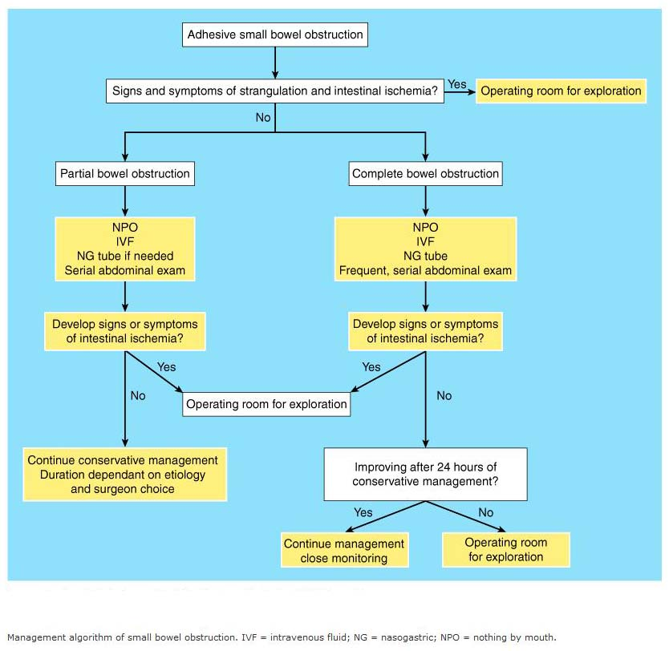
      - ABCs (e.g. IV fluid resuscitation, foley’s catheter to monitor urine output)
      - NPO
      - NGT for gastric decompression
      - IV analgesia
      - IV antibiotics (metronidazole + cephalosporin)

      - EMERGENCY SURGERY INDICATIONS:
        - P/E + imaging findings of strangulation or complete SBO or perforation/peritonitis

      - Trial of conservative management if adhesions suspected:
        - Patient with recent history of abdominopelvic surgery (it may occur as an early or late complication)
        - >50% of adhesions resolve spontaneously
        - 48 hours of surveillance of vitals, symptoms, labs, imaging
        - If condition deteriorates or he/she develops complications urgent surgery
      - If intussusception is suspected (classical symptoms and sign, imaging) non-surgical reduction using air/hydrostatic enema

      - Surgical Rx:
        - Exploratory laparotomy > laparoscopy
          - Usually midline incision
          - If hernia strangulation, we do incision over the hernia site NOT a laparotomy

        - JOBS TO DO:
          - 1 = Exploration & rx underlying cause
          - 2 = Assess involved bowel’s viability & excision if non-viable
          - 3= others (toileting/irrigation if peritonitis)
        - Adhesions Lysis of adhesions (LOA) or adhesiolysis
        - Hernia herniotomy, herniorraphy
        - CD stricturoplasty
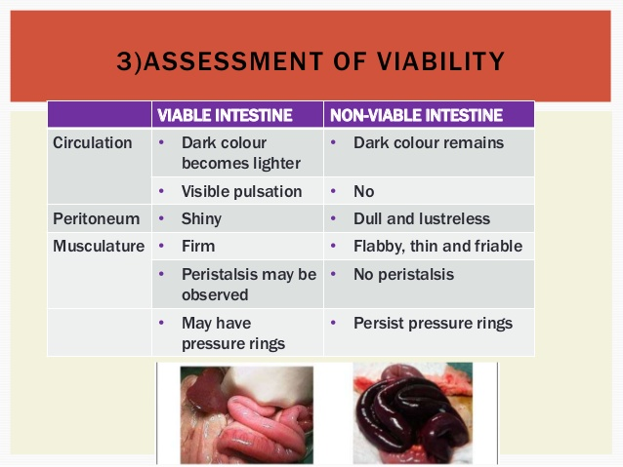
        - Bezoars and gallstone ileus removal
        - Volvulus reduce

        - Bowel non-viability factors & Rx:
          - COLOR (blackish = necrotic; purplish ~ may be viable; pink/red ~ viable)
          - Mesenteric pulsations (present = good)
          - Peristalsis (if it has = good)
          - Bleeding on cut surface (if it does = good)
          - IV fluorescein assessment of bowel under Wood’s lamp (fluoresces = good)
          - Doppler assessment of arterial flow
          - “Second look” in 24 hours if still questionable (we really don’t want to resect bowel)
          - Non-viable bowel = resection + end-to-end primary anastomosis

  - INFLAMMATORY BOWEL DISEASE (IBD)
    - Doctor’s favorite question is DEFINITION of IBD:
Diarrhea vs hyperdefecation?
ALWAYS ask about the patient’s NORMAL bowel habits before the disturbances. In general, it is said that 3/day to 3/week is normal, but this SHOULD NOT stop you from asking the patient what THEIR normal bowel movements are like. Always ask about the volume, components, consistency of the stool, because “diarrhea” may be confused with frequent evacuations.
If a person normally shits 1/day, shitting 3/day might concern them, but not concern you if you follow that shit rule. Use your shit brain.
Make sure you also ask about blood (and its form: streaks, frank, tarry) AND mucus.
      - Idiopathic chronic systemic inflammatory condition associated with autoimmune, environmental and genetic factors whose effects mainly fall on the GI tract
        - Is it a short-lived/temporary? No.
        - Do we know an exact cause? NO.
        - Does it only affect the intestines? NO! (think CD)
        - Does it only affect the GIT? NOO!!
        - Are there a well-established exact autoimmune, infectious, dietary and genetic cause? NOOOO!!!!
        - But are they FACTORS that do play a role? Yes
      - So now, go up and re-read the definition and say it out loud, dividing each part so it makes sense to you for the rest of your life
    - COMPONENTS OF IBD:
      - Crohn’s disease (CD)
      - Ulcerative colitis (UC)
      - Intermediate colitis (somewhere in the middle)
SIMPLY PUT:
HOW IS THE DIAGNOSIS OF IBD MADE?
BY BIOPSY THRU COLONOSCOPY

CAN I MAKE THE DIAGNOSIS INTRA-OP WHEN I THOUGHT IT WAS APPENDICITIS, I TAKE A SAMPLE OF THE ILEUM FOR BIOPSY OK YES NO PROBLEM, PLEASE?
NO, NO AND NO.

As you will see later, CD maybe misdiagnosed as acute appendicitis and intra-OP the appendix may appear normal. You STILL remove the appendix (to prevent diagnostic confusion in the future) UNLESS the base of the appendix is involved with CD. IF the appendix is normal you MUST EXPLORE the area for potential causes. This is when the intra-op findings of CD-affected bowel is noted. DON’T TOUCH IT, CLOSE UP!
According to Dr. Rami, opening a CD abdomen increases risk of fistula anyway, so remove the appendix even if it involves the base, because it will also help alleviate future diagnostic confusion.
Sometimes terminal ileitis is seen, however the patient doesn’t have CD. This could also be the patient’s FIRST presentation!
    - Risk factors to consider:
      - Family history
      - Smoking (thought to correlate with worse CD and better UC)
      - In general, M=F risk
    - CROHN’S DISEASE
      - Affects ANY part of the GIT, but LOVES to start/affect the ILEOCECUM (don’t say terminal ileum alone, although 1/3rd have terminal ileitis alone)
      - Age group is 15-30 + 60-80
      - GI presentation:
        - Chronic diarrhea [>4 weeks] (not bloody as often as UC, but it can be)
        - Abdominal pain (RIF pain may be misdiagnosed as acute appendicitis)
        - Recurrent oral ulcers
      - Extra-GI presentation:
        - Constitutional (Weight loss, low grade fever and fatigue)
        - Joint symptoms (IBD-associated arthritis is migratory mono-articular and seronegative)
        - Eye symptoms (episcleritis is MC; uveitis)
        - Skin symptoms (Clubbing; erythema nodosum [EN] > PG; anal tags, peri-anal pruritis, recurrent fistula-in-ano or fissure-in-ano [especially if not in the typical posterior midline location])
      - Complications:
        - Malabsorption
What concerns us about CD in surgery?
Fistulas
Strictures w/ SBO
DDx of acute appendicitis
Peri-anal disease
Gallstones
          - Symptoms of megaloblastic anemia (B12 deficiency)
          - Recurrent cholelithiasis (calcium oxalate stones)
          - Malnutrition of fat-soluble vitamins (ADEK)
        - Strictures SBO, perforation
        - Fistula formation enteroenteric, enterovesical, enterocutaneous, enterovaginal
        - Phlegmon/abscess with or without sinus tract
        - Peri-anal disease ano-rectal abscesses, fistulas and fissures
        - Cancer (not as much as UC)

    - ULCERATIVE COLITIS
      - MUST involve the rectum (usually starts here, but may be limited to here)
      - Same age of onset (15-30/40)
      - GI presentation:
        - Chronic diarrhea (more often bloody than CD)
          - Mild disease <4/day
          - Moderate disease 4-6/day
          - Severe disease >6/day (may need BT!)
        - Colicky abdominal pain (usually LLQ)
        - Tenesmus
      - Extra-GI manifestation:
        - Constitutional (weight loss, fever, fatigue)
        - Joint symptoms (as CD) – MOST FREQUENT
        - Eye symptoms (as CD)
        - Skin manifestations (pyoderma gangrenosum [PG] > EN; CLUBBING; no ano-rectal disease)
        - Hepatobiliary (picture of obstructive jaundice due to PRIMARY SCLEROSING CHOLANGITIS [PSC] risk related to p-ANCA)

      - Complications:
What concerns us about UC in surgery?
Massive bleeding
Toxic megacolon
Perforation
CANCER!
        - Massive lower GI bleeding (unstable patient)
        - Chronic bleeding (iron-deficiency anemia, palpitations, etc.)
        - Toxic megacolon and colonic perforation
        - CRC (way higher risk to develop CRC, always R/O if patient had symptoms for 8 – 10 years or has PSC on presentation)
    - DDx to consider
      - CD:
        - UC
        - Irritable bowel syndrome (IBS)
        - If acute RLQ pain, acute appendicitis (often misdiagnosed acutely)
        - Infectious colitis (especially salmonella, shigella, EHEC, Yersinia, clostridium difficile and CMV in immunocompromised patients)
        - Colon/Small intestinal cancer
        - Endometriosis (females)
      - UC:
        - CD
        - Infectious colitis (as above + emphasis on pseudomembranous colitis which can be bloody and last for a long time; consider in patients taking antibiotics for a long time)
        - Diverticular disease (e.g. complicated ones develop bleeding or diverticulitis)
        - Ischemic colitis/chronic mesenteric ischemia
        - CRC
        - Radiation colitis
        - Solitary rectal ulcer syndrome

    - INVESTIGATIONS:
      - If patient presents with acute abdomen, do workup for that
      - For IBD, the diagnosis is MADE only with biopsy on colonoscopy
      - LAB:
        - CBC (look for anemia, WBC count)
        - ESR & CRP
        - Serology (p-ANCA for UC & PSC; some places check for anti-sacchromyces Ab for CD)
        - LFTs
        - Stool analysis (ova, parasite, microscopy, Ag testing, C&S)
      - IMAGING:
        - CT & MRI > contrast studies (classically)
          - Most will order nowadays a CT (MRI is probably more expensive)
          - Identify affected areas, strictures, fibrosis
          - LGI contrast studies historically will show classical signs:
            - String sign in CD
            - Lead-pipe sign in UC (may also show pseudopolyps in mucosa)
        - Of complications (e.g. US for gallstones)
      - ILEOCOLONOSCOPY
        - Used to visualize mucosa and take biopsies essential for diagnosis
        - CROHN’S DISEASE:
          - Affects terminal ileum and cecum (ileocecum)
CLASSICAL INTRA-OP findings of CD:
There is creeping mesenteric fat and fibrosis of the affected segment such that it looks thinner

          - Cobblestone appearance with SKIP LESIONS (& serpentine pattern)
          - Luminal narrowing and strictures may be obvious
          - TRANSMURAL inflammation
          - Non-caseating granulomas
        - ULCERATIVE COLITIS:
          - Distribution includes proctitis, proctosigmoiditis, distal colitis (descending), extensive colitis (transverse), pancolitis (ascending), “backwash” ileitis (includes part of ileum)
          - MUCOSAL inflammation with “pseudopolyps” and is CONTINUOUS
          - Cryptitis and crypt abscesses
    - Management:
      - 1= medical management
        - Acute (for flares) – e.g. steroids (PO, IV)
        - Disease-modifying drugs – e.g. 5-ASA (mesalamine, sulfasalazine), metronidazole, immunosuppressive agents (infliximab)
      - 2 = Surgical management
        - Typically reserved for complications (both CD, UC) to prevent development of cancer (in UC)
        - In CD:
          - Surgical options are feared because of the high recurrence risk + risk of fistulas
          - SBO, strictures stricturoplasty (if viable)
          - Ano-rectal abscess I&D/surgical drainage
CLASSICAL INTRA-OP findings of CD:
There is creeping mesenteric fat and fibrosis of the affected segment such that it looks thinner

          - Fistula-in-ano fistulotomy with seton placement
          - Enteric fistulas NPO, fistulectomy
          - Acute appendicitis DDx appendectomy is done ONLY IF the BASE of the appendix is NOT affected by CD; if the intra-op features suggestive of CD is seen and OTHER potential causes are R/O, the abdomen is closed and the patient are Rx conservatively and colonoscopy is planned to diagnose patient
          - Cancer or severe colonic disease may warrant some surgical options (if patient wishes)
        - In UC:
          - Often done if medical Rx fails or if there are complications or to avoid the high risk of CRC associated with it
          - Responds to surgical Rx (low RR)
          - PROCTO-COLECTOMY with ILEOSTOMY (to nullify the risk of cancer altogether)

- HERNIA
  - Classic question = definition of hernia
    - Protrusion of a viscus or part of a viscus through a defect in a cavity in which it is contained
    - MC it is the protrusion of an abdominal viscus (or a part of it) through a defect in the abdominal wall

  - Anatomy (classic questions)
    - PLEASE, LAYERS OF THE ANTERIOR ABDOMINAL WALL?
      - 1 = Skin
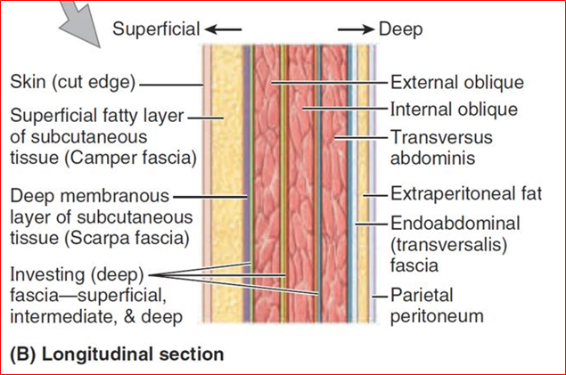
      - 2 = fatty superficial fascia (Camper’s fascia)
      - 3 = deep membranous fascia (Scarpa’s fascia) – becomes Colles fascia in perineum
      - 4 = External oblique muscle/aponeurosis
      - 5 = Internal oblique muscle
      - 6 = Transversalis muscle
      - 7 = Transversalis fascia
      - 8 = Parietal peritoneum
      - 9= HOME FREE!
      - 10 = PARTAY!
If you go a bit down near the groin, we say skin, SQ tissue, EO aponeurosis, transversalis fascia
    - Some interesting points to remember
      - L1 gives rise to:
        - Iliohypogastric nerve
        - Ilioinguinal nerve (we are concerned with this one because it runs along the spermatic cord through the SUPERFICIAL ring but NOT the deep ring, and it does NOT supply any of its contents; innervates the skin at the base of the penis, part of the scrotal high anterior skin and a small part of the medial thigh; in females, the mons pubis and labia majora; it may be injured in hernia repair surgeries resulting in loss of sensation)
        - Both run along the psoas major muscle
      - L2 gives rise to the genitofemoral nerve (pierces through psoas major muscle)
        - Genital branch runs within the spermatic cord, meaning it passes through the deep and superficial ring, supplying the cremasteric muscle (responsible for cremasteric reflex) and part of the skin of the scrotum (F: mons pubis and labia majora)
        - Femoral branch runs beneath inguinal ligament to supply area of skin in the thigh

      - Folds of the transversalis fascia as seen intra-abdominally:
The rectus sheath is formed from the aponeurosis of the oblique muscles towards the midline and they encase the rectus abdominis muscle by either running behind it (below arcuate line, inferiorly) or by sandwiching it (above arcuate line, superiorly). They meet in the center to form the linea alba.
This strong tendon can be separated in a condition called diastasis (divarication) recti, most commonly in multiparous women, but also occur in newborns.
        - Median umbilical fold
          - Contain the median umbilical ligament (remnant of urachus)
        - TWO medial umbilical folds
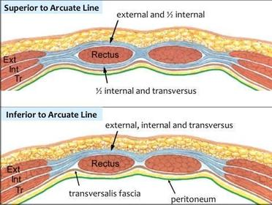
          - Contain the medial umbilical ligaments (remnants of umbilical arteries)
        - TWO lateral umbilical folds
          - Contain the INFERIOR EPIGASTRIC VESSELS that will run medially towards the rectus sheaths
          - This is the KEY ANATOMICAL LANDMARK that differentiates direct and indirect inguinal hernia
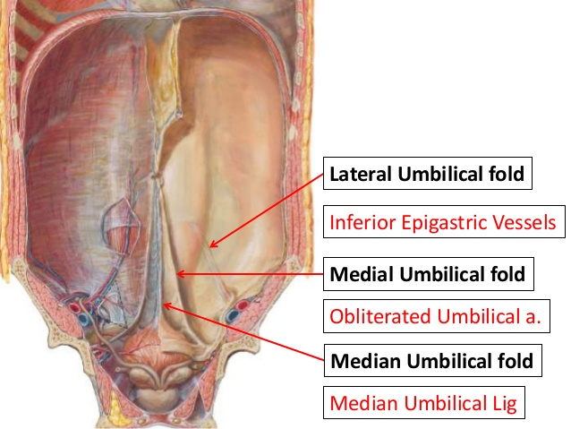
            - If the hernia occurs LATERAL to this fold, it is INDIRECT
            - If it occurs MEDIAL to this fold, it is DIRECT (through Hasselbach triangle)

      - Hasselbach inguinal triangle boundaries:
        - Medially: rectus abdominis muscle
        - Laterally: inferior epigastric vessels
        - Inferiorly: inguinal ligament
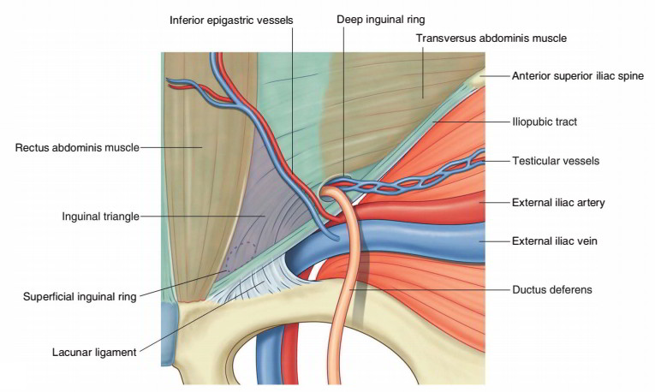
        - Weakness in this un-reinforced wall (from old age usually) makes it the MC site of DIRECT inguinal hernia

    - Important landmarks
      - Inguinal ligament
        - What is it? It is the thickened inferior most part of the anterior oblique aponeurosis, which reflects backwards/inwards
        - Where does stretch from? From ASIS to pubic tubercle (NOT symphysis)
        - What is its importance in the inguinal canal? It forms the floor of the inguinal canal
        - What is its midpoint called and what important landmark structure lies above it? Midpoint of the inguinal ligament (NOT mid-inguinal point) and the deep inguinal ring lies about 1 inch (2 – 2.5 cm) above

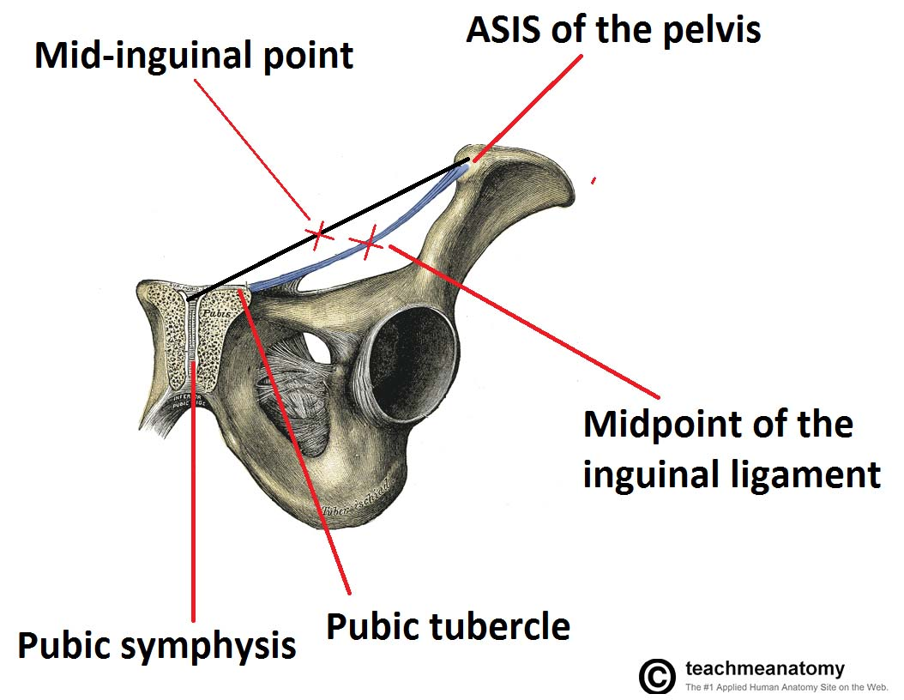
      - Pubic tubercle
        - What lies above it? The superficial inguinal ring
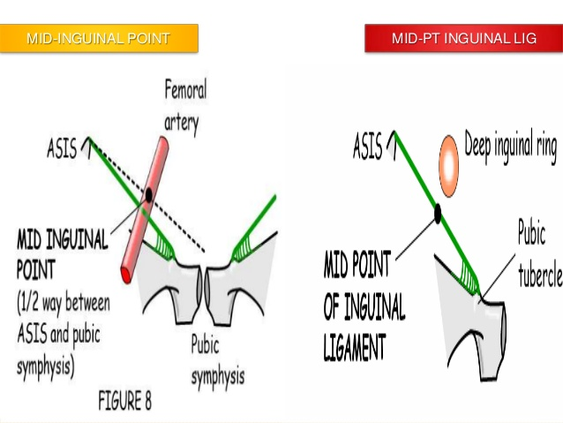
        - How do you identify it clinically? Ask the patient to adduct their thigh against resistance, this is when you follow the adductor longus muscle to its attachment at the pubic tubercle
        - This technique is mainly for obese individuals
      - Mid-inguinal point
        - This is a point halfway in between the ASIS and pubic SYMPHYSIS (NOT tubercle)
        - It is at this point that the FEMORAL ARTERY pulse can be felt
      - Midpoint of the inguinal ligament
        - As previously mentioned, it is the middle of the inguinal ligament which stretches from the ASIS to pubic tubercle
        - Above this point, the deep inguinal ring is present (important in hernia P/E)
    - Inguinal canal
      - It is an oblique canal that runs over the medial half of the inguinal ligament that transmits contents from within the abdomen into the scrotum/labia
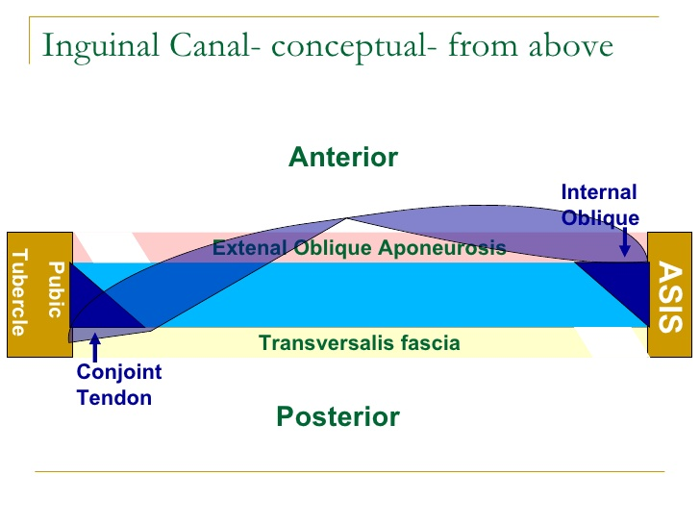
        - It is oblique in two planes; i.e. it runs from inside to outside, from superolateral to inferomedial
        - The best way to imagine its contents is if a fist pushes through the abdominal wall from the inside out
      - Roof: arching fibers of internal oblique and transversus abdominis muscle
      - Floor: inguinal ligament
      - Anterior wall: external oblique aponeurosis mostly
        - Reinforced laterally by internal oblique muscle
      - Posterior wall: transversalis fascia mostly
        - Reinforced medially by conjoint tendon
      - Deep (internal) inguinal ring:
        - It is the internal opening of the canal that begins in the transversalis fascia
        - The transversalis fascia is pulled along the course of the canal to form the internal spermatic fascia
        - Anatomically located 2 cm above the midpoint of the inguinal ligament
        - Directly medial to it are the inferior epigastric vessels
        - All the contents of the spermatic cord enter through here
        - The inguinal branch of ilioinguinal nerve does NOT enter through the deep ring
      - Superficial (external) inguinal ring
        - It is a triangular opening in the external oblique aponeurosis above the pubic tubercle which allows the contents of the canal to exit and enter the scrotum/labia

    - Content of the inguinal canal in females = ROUND LIGAMENT
      - In females, it contains the round ligament of the uterus which attaches to the labia majora
      - Canal of Nuck is an abnormal patent connection in females that results in hydrocele in women!
      - Note that the ilioinguinal nerve also runs in the canal
Venous drainage and lymphatic drainage of testes is from the posterior abdominal wall, where it originated, such that the RIGHT TESTES drains to the IVC directly and the LEFT TESTES drains into the LEFT RENAL VEIN (in a perpendicular fashion, making it have high resistance and more likely to develop varicocele of L>R).
The lymphatic drainage of the TESTES (not the scrotal skin) is to the PARA-AORTIC LYMPH NODES. The scrotum drains into the superficial inguinal lymph nodes.

    - Contents of the inguinal canal in males = SPERMATIC CORD
      - Wall of the spermatic cord is made up of (from inside to outside as it moves along the canal):
        - Internal spermatic fascia (from transversalis fascia)
        - Cremasteric fascia (From internal oblique muscle)
        - External spermatic fascia (from external oblique aponeurosis)
      - Contents of the spermatic cord:
        - Vas deferens
3 arteries, 3 nerves, 3 others:
- Gonadal artery (e.g. testicular)
- Artery to vas deferens
- Cremasteric artery

- Genital branch of genitofemoral
- Sympathetic nerves
-Not really, but ilioinguinal nerve

- Gonadal vein/pampiniform veins
- Lymphatics
- Vas deferens
        - Artery to vas deferens
        - Testicular artery (from abdominal aorta)
        - Testicular veins (and pampiniform plexus)
        - Cremasteric artery & vein
        - Genital branch of genitofemoral nerve
        - Lymphatic vessels
        - Sympathetic nerves
      - The ilioinguinal nerve runs with the spermatic cord within the canal

    - FETAL ORIGIN
      - In utero, the gonadal organs (testes and ovaries) develop in the high posterior abdominal wall and then are pulled down into their final position by the gubernaculum (i.e. gubernaculum holds testes in scrotum floor)
      - As the testes in males approach the anterior abdominal wall, an invagination of the wall forms right in front of it, sort of guiding the way down into the testes
      - This is known as the processus vaginalis, which normally obliterates by the time the baby is born, leaving behind a tunica vaginalis in the scrotum
      - PATENCY OF THE PROCESSUS VAGINALIS is the leading cause of indirect inguinal hernia, which is the MC type of hernia in males
      - If it is not fully obliterated, a tiny communication between the peritoneum and tunica vaginalis can result in hydrocele

    - Femoral canal ≠ femoral triangle
      - It is present underneath the inguinal ligament and houses several contents which pass from the abdomen to the thigh
      - Contents are recalled by “NAVEL” from lateral to medial:
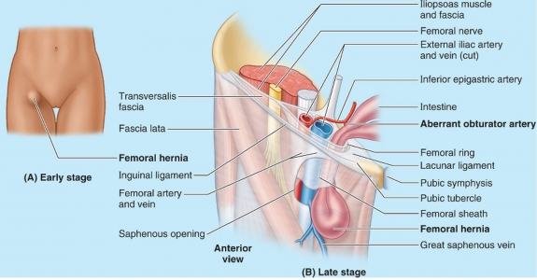
        - Nerve (femoral nerve)
        - Artery (femoral artery [continuation of external iliac artery below the inguinal ligament])
        - Vein (femoral vein [a little point below which will receive the greater saphenous vein in the saphenous ring])
        - Empty space = femoral canal (site of possible femoral hernia, however it has a TIGHT neck so that hernia contents are incarcerated/trapped)
        - Lymphatics (femoral lymph nodes; some group of nodes are called Cloquet’s nodes)
      - The borders are very annoying because of the orientation of the canal, but just remember that the anterior border is the inguinal ligament, medial border is lacunar ligament, the posterior wall is cooper’s ligament and laterally you have femoral VEIN.
- Classification of hernias
  - Based on location:
    - Inguinal (direct and indirect)
    - Femoral
    - Epigastric
    - Umbilical
    - Para-umbilical
    - Incisional
    - Lumbar
    - Obturator
  - Based on condition of hernia
    - Reducible hernia
      - Can be pushed back into orifice in which it originated
      - Either spontaneously while lying down, or by patient or by you
      - You should always ask if the patient can reduce it on their own or not
    - Irreducible hernia
      - Regardless of method, the hernia cannot be pushed back (it is a sign on P/E)
      - Increased risk of developing incarceration, obstruction and strangulation
    - Possible conditions of irreducible hernias:
      - Incarcerated (asymptomatic trapping)
      - Obstructed (patient develops S&S of SBO)
      - Strangulated (ischemia begins to develop)
    - Strangulated hernia (emergency)
      - A complicated incarcerated hernia, in which a clinical picture of SBO (2nd MCC) resulting from a closed loop obstruction progresses to ischemia and then necrosis of the bowel trapped in the hernia
Not all strangulated hernia must be obstructed. If it contains omentum it can strangulate alone (no obstruction). Or if this is a Richter’s hernia (strangulate without obstruction).
      - There is increased intraluminal pressure, impeding venous drainage and then arterial supply, resulting in bowel ischemia, which may lead to necrosis and perforation peritonitis sepsis and death
      - There is a clinical picture of an irreducible, severely painful hernia, with signs and symptoms of SBO/peritonitis (e.g. abdominal distention, vomiting, obstipation; abdominal tenderness, rigidity, guarding; bowel sounds turn from high pitched [obstructed] to absent [paralytic ileus]

- Hernia types and terminology
  - Hernial sac: the peritoneal reflection that contains the contents of the hernia
  - Contents of a hernial sac:
    - This is most commonly small intestinal loop
    - BUT it may also contain omentum, ovaries and fallopian tube, large bowel and various other structures as you will see below
  - Inguinal hernia: indirect or direct
  - Femoral hernia: in femoral canal
  - Pantaloon hernia: direct and indirect hernia at the same time
  - Sliding hernia: when hernial SAC contains part of the viscus
  - Spigelial hernia: hernia through the linea semilunaris of rectus abdominis muscle
  - Richter’s hernia:
    - Only PART of the wall of the involved viscus (e.g. small intestines) is within the hernia sac
    - May strangulate without obstruction (because you are killing one wall, but not blocking the whole viscus)
    - Occurs in femoral and obturator hernias
Diastasis recti is a big DDx of epigastric hernia, however classically seen in multiparous women or in neonates, there is midline ridge above the umbilicus that increases in prominence when abdomen contracted (raise chest above bed without arms). If it houses > 2 fingers, diastasis. Most of the time harmless.

Epigastric hernias are due to a weakning in the linea alba above the umbilicus.
  - Incisional hernia:
    - Hernia occurring at sites of previous abdominal incisions
  - Umbilical hernia:
    - Hernia through the umbilical ring
    - Usually congenital (Down syndrome, congenital hypothyroidism)
  - Paraumbilical hernia:
    - Hernia that occurs near the umbilicus (often above or below)
    - Usually occurring in adults in the cases of massive ascites, pregnancy/multiparity, obesity
  - Lumbar hernia:
    - Occurs in the posterior abdominal wall, in between muscles
    - Superior lumbar hernia occurs through triangle of Grynfeltt
    - Inferior lumbar hernia occurs through triangle of petit
  - Littre’s hernia:
    - Hernial sac contains meckel’s diverticulum (think little instead of littre)
  - Amyand’s hernia:
    - Inguinal hernia containing appendix
  - De Garengeot’s hernia:
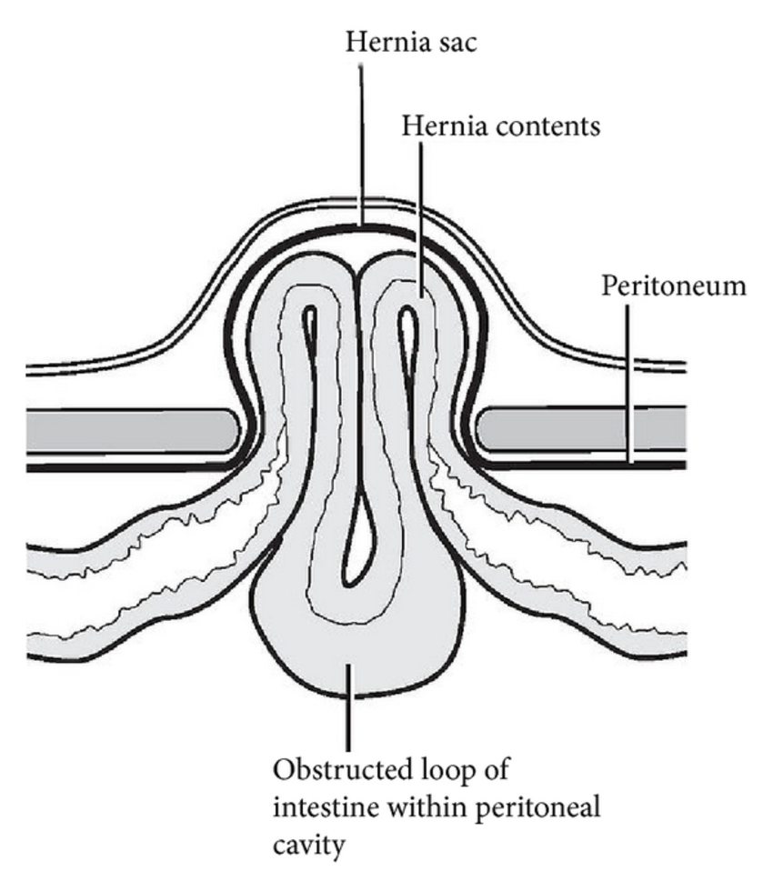
    - FEMORAL hernial sac contains appendix (which may be inflamed)
  - Maydl’s hernia:
    - W-shaped intestinal loop herniates
    - The part of this loop that remains within the abdominal cavity may have been strangulated and may be missed
  - Esophageal hiatal hernia:
    - Sliding type/type I (stomach cardia herniates above esophageal hiatus; can be treated medically [GERD symptoms], 15% surgical Rx = nissen fundoplication)
    - Rolling/paraesophageal hernia/type II (fundus goes up on the side, high risk of strangulation, needs surgical Rx)
    - Mixed type/type III (type I and II combined)
    - Advanced type/end-stage = intra-thoracic stomach
  - Congenital diaphragmatic hernia:
    - In utero herniation of abdominal contents through defect in diaphragm into the chest
    - Posterior = Bochdalek (MC); anterior = Morgagni (less common)

- History-taking of hernia (important to ask about):
  - Demographics
    - Age
    - Gender
    - Occupation
  - CC and duration (usually either lump +/- pain)
  - HOPI:
    - Onset, course, duration (OCD)
    - Pain: SOCRATES
    - Lump: some of the ‘S’s
      - Site (and any change?)
      - Size (and any change?)
      - Shape (may be difficult)
      - Skin overlying (red, painful, draining)
      - Special characters (increases with standing, coughing, straining, heavy lifting; aggravating and relieving factors; can he/she push it back in (i.e. reduce)?
      - ANY CHANGES in the above SINCE IT BEGAN
    - Associated symptoms of system involved:
      - GI: nausea, anorexia, vomiting, abdominal pain, diarrhea, constipation, passing flatus or not
      - May want to ask about respiratory, urinary Sx
    - Constitutional symptoms:
      - Weight loss, fever
    - History of trauma
    - Previous personal history of this condition
    - Course in the hospital
    - Ask questions related to possible DDx you have
  - PMH:
    - Medical conditions and their Rx
      - Ask about lung disease that may lead to chronic cough
      - Ask about chronic constipation, or BPH
      - Females pregnancies
      - You might want to ask about Hx of cryptorchidism or ectopic testes, if possible, but this may be delayed to scrotal examination
    - Previous operations (VERY IMPORTANT)
    - Medications, F&D allergy
  - FH:
    - Anybody with the same problem?
  - Social history:
    - Smoking, IVDU

- DDx:
  - It can be narrowed down by P/E, but let’s assume in the exam setting the doctor may ask you to give a DDx before P/E,
    - Ideally, you would need to do a P/E and also examine the scrotum in males to check if this is an inguinoscrotal swelling

  - DDx of inguinal mass/swelling:
    - Inguinal hernia (indirect, direct +/- femoral)
    - Superficial inguinal lymphadenopathy (LAD)
    - Lipoma
    - Sebaceous cyst
    - Hematoma/seroma
    - Cryptorchidism (undescended testis) or ectopic testes
    - Saphenous varix
    - Femoral artery aneurysm
    - Psoas abscess (it is a collection of pus from, most commonly, TB of a spine near the iliopsoas muscle; the pus drains down the psoas muscle and collects in the groin as a mass)
    - Sarcoma

  - DDx of scrotal swelling (meaning you can get above it in the scrotum = PURE scrotal swelling)
    - Epididymitis or orchitis or epididymo-orchitis or epididymal cyst
    - Hydrocele/hematocele/spermatocele
    - Testicular torsion or torsion of the appendix testes
    - Testicular cancer

  - DDx of inguinoscrotal swelling:
    - Indirect inguinal hernia (direct cannot enter here)
    - Testicular torsion
    - Varicocele (bag of worms feel)
    - Encysted hydrocele
    - Lipoma in cord
    - Undescended or ectopic testis
  - I can also imagine them asking about the DDx of lymphadenopathy:
    - Inflammation
      - Local infection (e.g. LL or perineum reactive LAD)
      - TB, sarcoidosis
    - Neoplasia
      - Lymphoma (HL and NHL)
    - Infiltration
      - Metastatic disease from primary lesion in LL, external genitalia or perianal area
      - Malignant melanoma
- P/E:
  - Introduce, ask for permission, wash hands, close curtains, check vitals from nurse chart
  - 1 = GENERAL EXAM
    - Patient is most commonly supine on his bed if in the wards
    - Stand at foot of bed, move to the right side
    - Comment on what you can see:
      - LOC (conscious, awake, oriented)
      - Well or unwell/toxic-looking/in obvious pain
      - Is in any distress or not?
STANDING POSITION IS A KEY EXAMINATION POINT THAT ALL EXAMINERS WANT TO SEE YOU DO OR AT LEAST SAY.

BUT when do I make a patient stand?

TWO OPTIONS:
1/Do abdominal examination then stand and do hernia and scrotal examination and tests.

2/Ask the patient to stand from the start, inspect and palpate and do tests for the hernia and scrotum, THEN ask patient to lie down and do abdominal examination.

      - Weight/built (obese, fit or underweight?)
      - Any obvious skin discoloration (e.g. pale, jaundiced?)
      - Attached to any lines and if so, what?
    - As a part of a pre-op exam, you may:
      - General inspection of upper limb for clubbing, capillary refill, and pulse, conjunctiva and sclera for pallor and jaundice, mouth for cyanosis, chest and cardiovascular exam (most important is auscultation for both)

  - 2 = ABDOMINAL EXAMINATION
    - EXPOSURE = 5th ICS to mid-thigh
      - People say from nipple because it is easier, however, nipple position varies
      - Why 5th ICS? Because the dome of diaphragm is that high, and we are examining the abdomen, which has contents up that high!
    - INSPECTION
      - Abdomen is distended, flat or scaphoid?
      - Type of breathing (abdominothoracic in males)
      - Hair distribution (and if it’s shaved, say it!)
      - Previous surgical scars
      - Flanks (whether they’re full or not)
Inguinal hernia:
Site: L or R? which quadrant, above or below groin crease, enlarged scrotum also?
Size: cm x cm
Shape: piriform (indirect), globular (direct), retort shape (femoral)
Surface/margin: smooth or well-demarcated
Skin overlying: erythematous, discharge

      - Look at scrotum (ideally also back of scrotum)
      - Obvious swellings (must be described with the ‘S’ including site, size, shape, skin overlying, special characters – see later)
      - COUGH test (ask the patient to cough when supine and look at all potential hernia sites or a site which already has a hernia = cough #1) –increase in bulging = inspection cough impulse
    - AUSCULTATION
How many times should you make the patient cough?
NOT MANY. 2-3 times MAX.

      - Check for bowel sounds: absent, high pitched, normal
      - Ideally, over the swelling (bowel sounds? Bruit?)
      - Ideally, over renal arteries for bruit
    - PALPATION & PERCUSSION
      - Ask for PAIN and leave the painful site or hernia site for the end
      - Superficial palpation is done first
      - You may ask the patient to raise his shoulders or to raise his LL in order to flex the abdominal muscles: if the swelling increases in size, it is superficial (e.g. lipoma); if it fades away, it is deep; if it stays the same size it may be a desmoid tumor of muscle
      - Deep palpation & organ palpation/percussion is not necessary, but may be done for the sake of a full abdominal examination (e.g. in the MD)
      - When palpating, always comment on warmth, tenderness, rebound tenderness, signs of rigidity/guarding, inspiratory arrest (Murphy)

      - Palpating the hernia & scrotum:
        - Warmth, tenderness
        - Shape and borders
So if the hernia is obvious in the supine position, you may not need to make him stand. If it isn’t (i.e. it is reduced), make them stand now.

Stand palpate the hernia site, check for cough impulse, palpate the scrotum and the scrotal neck to identify whether the hernia is complete (i.e. it has extended into the scrotum).

        - Consistency (soft & elastic gut; doughy and granular omentum; tense and tender strangulated)
        - Cough impulse (expansile)
        - Palpate the scrotum (index finger and thumb) and check if there is a scrotal mass and do a scrotal neck test (see if you can get above it or not)
        - Some percuss over the hernia (dull = omentum, resonant = enterocele)
      - DEEP RING OCCLUSION TEST = STANDING:
        - Patient is then asked to stand
        - Ask the patient to to reduce the hernia themselves OR you reduce it up to the DEEP INGUINAL RING (only if it is reducible)
This is when your anatomy kicks in. Where is the deep ring, doctor?
Midpoint of inguinal ligament, feel for ASIS and pubic tubercle, go in the middle, go up 1 inch.

How to know where the pubic tubercle is, doctor >:-) (evil doctor)?
Adduct thigh against resistance; follow up to its attachment.

        - Press over the deep inguinal ring and then ask the patient to cough (Cough #2/3)
        - ONE OF TWO OUTCOMES: the swelling will return (usually medial to your finger) = DIRECT inguinal hernia; the swelling does NOT return, but instead you feel a cough impulse beneath your finger = INDIRECT hernia
      - Other tests:
        - Finger invagination test (OUTDATED and INHUMANE)
        - Zeiman’s test (3 finger test: one finger over deep ring, another over superficial ring, and a third in femoral ring)
    - Cover the patient, thank him for his cooperation, tell the examiner (in case you did not do it) that ideally you need to do a/examine the:
Typical ending question:
The special ending tests above are used to clinically differentiate the type of inguinal hernia, but the question is, how do you CONFIRM THE TYPE OF INGUINAL HERNIA?
INTRA-OPERATIVELY! Does it herniate medial or lateral to inferior epigastric vessels?

      - Pelvic/scrotal exam (sometimes, in the exam, you will not examine the scrotum)
      - DRE
      - Back

- HERNIA:
  - 10% of the population get them, 3-4% of males have them
  - M>F (7:1!!!!!!!!!)
  - 2nd MCC of SBO
  - Age distribution:
    - Neonates (congenital)
    - Early adulthood (weight lifting)
    - Elderly (muscle wall weakness, smoking, other RF)
  - Most common types:
    - Indirect inguinal hernia (50%) – MC type in MALES AND females
    - Direct inguinal hernia (25%)
    - Femoral hernia (5%) – of all the people who have femoral hernia, MAJORITY are FEMALES (but it is NOT the MC hernia in females: 2nd MC)
  - Risk factors:
    - Old age (weak abdominal wall muscles)
    - Increased intra-abdominal pressure
      - Obesity
      - COPD (chronic cough)
      - Multiparity or pregnancy
      - Chronic constipation, CRC
      - BPH
      - Heavy lifting jobs or activities
      - Ascites, peritoneal dialysis
    - Previous surgical incisions (late post-op complication)
    - Smoking
    - Patent processus vaginalis (I don’t know if it is a risk factor, but it is definitely the cause of indirect inguinal hernia, but some doctors think weirdly and may expect you to say it here!)
  - COMMON QUESTION:
    - Are hernias through smaller defects better or worse?
      - WORSE!!!! More likely to get incarcerated!
MC content is small bowel, but it can be omentum (which can incarcerate but not obstruct = classical for omentocele or can be Richter’s hernia, which results in strangulation without obstruction). It can also be ovary and fallopian tube in females. Rarely can be sigmoid colon or part of a viscus (sliding hernia).
Majority of hernias in pediatric age group are incarcerated and strangulated (Dr. Fayza)
  - INGUINAL HERNIA
    - Indirect inguinal hernia
      - MC hernia in man
Inguinal hernias are more common on the right side (left testes descends earlier). Femoral hernia is MORE common than direct inguinal hernia in females. Femoral hernias are the most likely to strangulate. Indirect inguinal hernia can be incomplete (bubonocele = in cord; funicular = at external ring) or complete (in testes). If you find a testicular mass with expansile cough impulse, must be indirect.
      - Hernial contents go through deep +/- superficial inguinal ring +/- into scrotum (= “complete”)
      - CAUSE = PATENT PROCESSUS VAGINALIS (congenital problem)
      - 1/3rd of cases are BILATERAL
      - In pediatrics, the special sign felt is the silk-glove sign of thickened spermatic cord; and if this is felt in the contralateral side, it is sufficient enough for you to consider doing bilateral herniotomies (see peds)
      - Shape is usually pyriform/oblique
    - Direct inguinal hernia
      - Passes through hasselbach’s triangle (weak posterior inguinal canal wall) and through the superficial ring ONLY
Most direct inguinal hernias are irreducible, simply because the wall the weakened. Indirect inguinal hernias if not trapped can be reduced, because there is a hole to reduce it into.
      - Does NOT go into the scrotum
      - Has a WIDE neck (uncommon to strangulate)
      - Occurs almost exclusively in OLDER PATIENTS (usually male, and usually smokers)
      - Shape is usually globular; common to be bilateral
  - FEMORAL HERNIA
    - Arise in the femoral canal
      - Below inguinal crease/inguinal ligament
      - Medial in NAVEL usually (shape may be retort)
      - R>L
    - Tight “unforgiving” neck high risk of incarceration (1/3rd)
    - F>M (85% of patients are females)
      - But it is NOT the MC hernia in females
  - Umbilical hernia
    - In infants, it is often congenital, occurring in:
      - Down syndrome
      - Congenital hypothyroidism
      - Premature infants
    - Management is rarely needed as most of the time it spontaneously resolves by 2-3 years of age
    - If persistent, surgical Rx is done usually before entering school (>3 years old; 4- 5 years old is typical) or if:
      - Disfiguring
      - >2 cm or complicated

- Presentation:
  - Symptoms
    - Swelling (MC, defining character)
      - Usually intermittent and painless; may be persistent, if incarcerated
      - Increases with coughing, crying (infants), lifting heavy objects, standing, straining
      - Reduces either spontaneously when lying down
      - May be reduced manually by patient
    - Pain
      - Patients may have a dull, discomforting dragging pain at the site of the hernia
The most common to strangulate is femoral hernia, followed by a paraumbilical hernia in adults.
Patients who refuse surgery can try to have their hernia reduced en mass, which is done under sedation and icing, however the patient must be observed for signs of obstruction/strangulation, in which case emergency surgery should be done.
      - It is worse at the END of the day, relieved at NIGHT/when patient lies down or when reduced
    - Strangulation
      - Acute colicky abdominal pain, maximal at site of strangulated hernia, which does not reduce
      - Patient will have either symptoms of SBO (abdominal distention and pain, vomiting, obstipation) or even worse, features of peritonitis/perforation (shock, altered mental status, diffuse abdominal pain)
  - Signs:
    - Swelling with visible or palpable expansile cough impulse, increasing in size or appearing when standing, with reducibility
    - History of hernia with now irreducible swelling
    - History of hernia with unstable vitals and mental status, abdominal distention, tenderness, rebound tenderness, ridigity, involuntary guarding, irreducible swelling, overlying skin changes (tense, tender, erythematous, warm)
- Investigations
  - DIAGNOSIS IS CLINICAL
Virtually diagnostic if you find a groin mass that has an expansile cough impulse.
  - Radiological investigations are only done in special situations (e.g. when patient is obese, complications suspected)
  - Acute abdomen presentation acute abdomen lab & imaging
  - Standard pre-OP workup necessary
- Management:
  - 1= Rx underlying or precipitating causes, if any
    - If patient has an underlying cause/risk factor such as chronic lung disease, constipation, ascites, etc, you NEED TO TREAT THEM BEFORE TREATING THE HERNIAS, because then they will RECUR!

  - 2 = SURGICAL Rx

  - Principles:
    - Herniotomy = opening hernial sac
Although hernia repair is considered a clean surgery, use of a mesh warrants the administration of prophylactic antibiotics.
      - This is done with a GROIN INCISION
      - The layer of the abdominal wall incised include the skin, superficial and deep layers of superficial fascia, external oblique aponeurosis
      - The contents of the inguinal canal are identified and separated; the spermatic cord is opened up
Complications of hernia repair:
- Recurrence
- Mesh migration, infection
- Dysejaculation
- Testicular atrophy
- Ilio-inguinal nerve injury resulting in loss of sensation over area supplied
- Ilioinguinal nerve entrapment resulting in chronic pain
- Hemorrhage
      - The hernia sac is identified, freed, opened and its contents are studied
      - The contents are reduced into the abdominal cavity, the neck is ligated, the sac is reduced
      - High ligation herniotomy alone may be efficient (especially in pediatric cases)
    - Herniorraphy = using local structures to repair the abdominal wall defect (hernioplasty is superseding this)
Cooper’s repair is done for femoral hernias.
      - Tissue repair (that is tension-free) of posterior wall of inguinal canal and internal ring
      - E.g. Bassini’s repair (using incurved part of inguinal ligament)
Obstructed hernia presents with obstruction S&S.
Strangulated hernia = presents with local and then generalized peritonitis.
In either case, ABCs, IV analgesia, NPO, NGT decompression, IV antibiotics. Surgery is done over the hernia, to reveal it, drain any secretions, pull the bowel out to see it, assess bowel viability (and manage accordingly), reduction, herniotomy and close abdomen in layers.
      - E.g. Shouldice repair (double breasting of transversalis fascia)
      - E.g. Cooper’s/McVay repair (using cooper ligament)
    - Hernioplasty = using synthetic structures to repair the defect in the abdominal wall
      - Tension-free repair of posterior wall of canal and internal ring
      - Using sutured and/or plug (prosthetics)
      - Method of choice in modern day
      - Anterior approach (Lichtenstein’s repair), posterior approach
    - Laparoscopic methods
      - Totally extra-peritoneal (TEP)
      - Transabdominal pre-peritoneal (TAPP)
      - Indicated in the following cases:
        - Recurring
        - Bilateral
        - Needs rapid return to activity
  - What is the treatment of hernia?
    - 1= Rx underlying cause if any
    - 2 = Surgical Rx, which is:
      - In adults, herniotomy +/- hernioplasty and herniorraphy (“tension-free repair”)
      - In pediatrics/young, Herniotomy (high ligation)

- ACUTE APPENDICITIS
  - Anatomy of vermiform appendix:
    - Base of appendix is FIXED = McBurney’s point
      - It is 1/3rd the way from the right ASIS to the umbilicus
      - If you want to be a backwards fuck, 2/3rd the way from umbilicus to right ASIS
    - The appendix has various positions:
      - Retrocecal (44%) – MC position
      - Subcecal (24%) – 2nd MC position
      - Post-ileal (14%) – 3rd MC position
      - Pelvic (9%)
      - Paracecal (6%)
      - Pre-ileal
    - Some notes on the appendix:
      - The appendix has its own mesentery = mesoappendix
      - Appendicular artery is a branch of ileocolic artery of SMA and runs in the mesoappendix
      - It contains a good amount of lymphoid tissue and may have an immunological role
      - Size ranges from 6 – 9 cm! (very long!)
      - Luminal capacity <1 mL
  - Epidemiology
    - MCC of acute abdomen requiring surgery
    - Always on top of the differential of acute abdomen
    - 7% lifetime prevalence in USA
    - Peak age group: 10 – 30 years
      - Because of this, misdiagnosis occurs in the following populations: young children, pregnant women and elderly patients
    - M > F
    - Incidence of perforation ~ 12%
      - By 24 hours ~ 25%
      - By 36 hours ~ 50%
      - By 48 hours ~ 75%
      - Moral of the story = act quickly
  - Pathophysiology:
    - 1= luminal obstruction at the base of appendix
      - Young (most) patients ~ lymphoid hyperplasia
      - Older patients ~ fecalith, tumor, cancer (including carcinoid tumor and mucinous adenocarcinoma)
Remember, carcinoid tumor does not cause carcinoid syndrome unless it metastasizes to the liver. So a patient with carcinoid tumor can present with acute appendicitis (however, MC location is at the tip of the appendix, so in reality it is not a very common cause of appendicitis).
    - 2 = increased intraluminal secretions and pressure beyond this obstruction (with peristalsis against obstruction)
    - 3 = venous drainage impaired (why veins before artery? Because it is collapsible, has a low BP and a thin muscle wall)
    - 4 = arterial compromise mucosal THEN whole wall ischemia
    - 5 = wall edema, weakness, inflammation and invasion by luminal bacteria (gut anaerobes e.g. E. coli, B. fragalis)
      - What helps contain this infection? The omentum
      - In what age group can this “police man of the abdomen” be impaired? Pediatric age group
    - 6 = Complications
      - Necrosis perforation peritonitis sepsis death (mortality rate is ~ 5%)
      - “Appendicular mass” (phlegmon)
      - Appendicular abscess
  - Presentation
    - Symptoms:
      - ACUTE RLQ pain (usually comes <24 hours)
        - Represents localized irritation of parietal peritoneum by inflamed appendix
Sequence of pain and vomiting:

If pain precedes the vomiting, consider acute appendicitis.

If vomiting occurs first, then pain, consider gastroenteritis or other causes.
        - The pain is acute (rapid onset), localized, sharp, severe and steadily increasing
        - The pain is made worse by movement, coughing, family could say that bumpy road ride made him feel pain; patient likes to lie still
      - RECENT Hx of migration of pain from periumbilical region to the RLQ
        - Distention of the appendix refers the pain to the periumbilical area, which is thought to be due to its midgut origin
        - The pain is usually vague, not well-localized (discomfort or colicky and intermittent)
        - This begins <24hours before the RLQ pain
      - Nausea and vomiting
Don’t ever forget to ask about anorexia.

Hamburger sign = patient doesn’t feel like having a burger because of anorexia.
People say question the diagnosis if the patient doesn’t have anorexia.
      - Anorexia (most sensitive symptom)
      - Dysuria (inflamed pelvic appendix may irritate the bladder; pyuria may also be noted in urinalysis)
      - Constipation
      - Diarrhea (inflamed pelvic appendix may irritate the rectum)
      - Fever (may be low-grade to high-grade)
      - Ruptured appendicitis presents with diffuse abdominal pain and signs of peritonitis (the patient will be extremely unwell, toxic-looking and in pain)
    - Signs:
      - Patient appears to be in pain, lying still in the bed, fearful of examination
      - If unruptured, the patient is hemodynamically stable, awake, alert
      - +/- Fever, tachycardic
      - Cough test and pointing sign is to the RLQ or most specifically near McBurney’s point
        - Either tell the patient to point WITH ONE FINGER to the site of most pain
        - Or tell them to cough and then let them tell you
      - RLQ tenderness (most sensitive sign)
      - Rebound tenderness (NOT necessarily on McBurney)
        - This is a special sign that everyone remembers
        - On palpating over the RLQ, pain is felt on RELEASE of your finger
      - Special signs/tests:
        - Rovsing’s sign
          - Palpating the LLQ results in pain felt in the RLQ as a result of stretching the parietal pleura
        - Iliopsoas sign
          - Retrocecal appendix is adjacent to the iliopsoas muscle, principle is to stretch the muscle and see if it elicits pain, which may indicate an inflamed retrocecal appendix
          - Patient is prone or on left decubitus position, the thigh at the right hip joint is extended pain
        - Obturator sign
          - Pelvic appendix may come in contact with the obturator muscle
          - Internal rotation of the thigh at right hip joint results in pain
        - DRE exam (NOT routine, but should be done in ruptured cases)
          - Pain on DRE ~ pelvic appendicitis
Post-operative diarrhea and DRE tenderness might indicate spillage from surgery (intra-peritoneal pus/abscess)
          - It might also indicate a peritoneal abscess/fluid collection in pouch of douglas or recto-vesical pouch
      - Signs of peritonitis:
        - Unwell patient, toxic, in severe pain, might be hemodynamically unstable
        - Diffuse abdominal tenderness
        - Involuntary guarding and rigidity
        - Site of maximal tenderness (and rebound) is at RLQ
  - DDx of RLQ pain:
    - GI:
      - Acute appendicitis
      - Meckel’s diverticulitis
      - Crohn’s disease/terminal ileitis
      - Mesenteric adenitis
      - Gastroenteritis (especially Yersinia)
      - PERFORATED DU (Valentino’s sign)
      - Strangulated hernia
      - In older patients, CRC (right-sided)
      - Intussusception & cecal volvulus, typhoid fever
    - GU:
      - Testicular torsion in males
      - Females ruptured ectopic pregnancy, ovarian cyst torsion or hemorrhaging, PID, red necrosis of leiomyoma, mittelschmertz
      - Urolithiasis
      - Urinary tract infection

    - In your differential, you might want to include DDx of RIGHT SIDED abdominal pain, including:
      - Acute cholecystitis
      - Cholelithiasis
      - Right pyelonephritis
      - Right lower lobe pneumonia

  - Important points of history taking and P/E in acute appendicitis
    - Acute appendicitis is a CLINICAL diagnosis, so it is ESSENTIAL to R/O DDx with history and P/E
    - History taking
      - Demographics (age, school/work)
      - CC (pain + duration)
      - HOPI:
        - O, C, D
        - SOCRATES for pain
        - Ask about quality of pain (intermittent, steady, increasing) migration of pain, relationship to motion and coughing
        - Symptoms to related to systems involved:
          - GI: N&V, diarrhea, ANOREXIA
          - GU in males: scrotal symptoms like redness, warmth, swelling, pain, trauma
          - GU in females: ask if pregnant, PV bleeding, if menstruating or not
          - GU in general: urinary voiding, storage, irritative symptoms (dysuria, frequency, urgency)
        - Constitutional symptoms
          - Fever, weight loss
        - History of trauma, eating from outside (could this be GE?)
        - Previous Hx
        - Course in the hospital
      - PMH:
        - Does this patient have CD?
        - Does this patient have any known gynecological or GI problems?
        - Does this patient have any medical conditions that will put them at risk during surgery?
        - Previous operations and issues with anesthesia?
        - F&D allergies and medications
        - If you haven’t done so yet, in female take a quick gyne history

    - P/E in acute appendicitis
      - General exam
      - Abdominal exam (as usual)
        - Cough test, leave site of pain for the end
        - RLQ tenderness?
        - Rebound tenderness?
        - Guarding, rigidity?
        - SCROTAL EXAMINATION
        - Suspected? Do special tests: Rovsing, iliopsoas
        - Ideally do PV in females, DRE exam

  - Investigations:
    - Do you need investigations to diagnose acute appendicitis? NO!
      - CLINICAL DIAGNOSIS
      - We do investigations to help confirm the diagnosis and for pre-op assessment
    - LAB INVESTIGATIONS:
      - CBC (for leukocytosis) + BT + Cx
        - Left shift (PMN predominance)
        - >11,000 WBC count in acute appendicitis
        - >18, 000 WBC should raise your suspicion for perforation or abscess
      - Urinalysis (dipstick and microscopy)
        - Look for pyuria (it can occur in acute appendicitis, but also UTI)
        - Crystals & RBCs (urolithiasis)
      - Beta-hCG in all females
      - Electrolyte panel
      - If patient presents with acute abdomen, do acute abdomen labs
    - IMAGING:
      - Imaging is unnecessary and should not delay Rx
      - In the ER, the patient will most often have a AXR done, but this is NOT useful for appendicitis
Findings on graded compression US of acute appendicits:
Widened lumen
Closed loop
Edematous walls
Non-compressible (if compressible it is either ruptured or normal, so if compressible, inconclusive)
Aperistaltic
Surrounding fluid collection

A ruptured OR normal appendix is compressible, which leads to diagnostic confusion, requiring further imaging.
      - US may be done in women until pregnancy is ruled out
      - Ultrasound:
        - All women of childbearing age
        - No radiation, so if potentially pregnant no harm
        - You will be able to distinguish gynecological (e.g. torsion, cyst, ectopic) and appendicular disease
        - It may also be useful to R/O renal disease
      - CT scan:
        - CT is more sensitive than ultrasound
        - However, it is usually unnecessary unless there is diagnostic confusion
      - Plain erect AXR:
        - Possible findings:
          - Fecalith (<5%)
          - Scoliosis away from right side
          - Loss of psoas shadow
        - It may demonstrate a fecalith ONLY in < 5% (its presence is highly suggestive to acute appendicitis)
        - Fecaliths if radio-opaque, have a big DDx list, including:
          - Uroliths
          - Phleboliths
          - Mesenteric LN calcification
        - Although not the best tool for it, air under the diaphragm can be seen; as well as signs of bowel obstruction

  - Management of non-complicated acute appendicitis
    - Prerequisites:
      - NO P/E signs of peritonitis
      - NO imaging (if done) findings of advanced bowel obstruction, perforation (no air under diaphragm)
      - Patient presented within 24/48 hours (NOT delayed, e.g. after 4/5 days)
    - Steps:
      - Admit patient, insert IV lines to collect blood for investigations, give IV fluids
      - NPO
      - IV analgesics
      - IV pre-operative antibiotics
        - One dose, ½ to 1 hour before surgery +/- another dose after 6 hours
        - Usually metronidazole + cephalosporin
        - Antibiotics does not need to continue beyond the first post-OP day (e.g. <24 hours)
      - Urgent appendectomy
        - The risk of perforation in <24 hours ~ 25%!
        - They should be put in the next available slot for surgery on the SAME day
The appendix looks normal ?

A normal appearing appendix should still be removed unless the base is apparently affected by signs of CD; otherwise, appendectomy is done and the incision is expanded in order to look for OTHER causes such as CD/terminal ileitis and meckel’s diverticulum in the ileocecal area + mesentery for mesenteric adenitis, and the ovaries and tubes in females. Worst case scenario is looking for perforated DU.

If CD findings are apparent and the base of appendix is involved, do NOTHING, close up and plan for colonoscopic biopsy to confirm diagnosis (OLD SCHOOL).

        - Should not be delayed, especially in high risk populations (children, elderly, pregnant women)
        - It is a “contaminated” surgery
        - Operation is done under GA
        - May be done by open surgery or laparoscopy
        - A Gridiron (which is oblique) or Lanz (horizontal) incision is made in open surgery
        - Muscle splitting technique is practiced
        - The parietal peritoneum is opened
        - The cecum is identified, the tenia coli are followed until the base of the appendix
        - The appendix is FIRST grossly studied
        - The appendicular artery is ligated at the mesoappendix, then the base of the appendix is ligated and a clamp is placed distal to this
20% of appendectomies turn out to be NORMAL!!!!!
        - In between the ligated base and the clamp, the appendix is divided and removed
        - The stump is dealt with, the abdomen is closed in layers with sutures for primary intention
        - The appendix is sent for histopathological analysis in order to determine the potential cause
      - Post-OP care
        - Patient is continued on IV fluids and analgesics (w/ 24 hours antibiotic coverage)
        - The wound is dressed and left to heal
Is there any need to look at the wound for infection daily or within the first few days post-op?
No, because it takes about 5 – 7 days for wound infection to develop. Besides, the wound healing process is taking place, it is hard to assess whether it is an infection or normal healing process this early on.
        - The patient is NPO until passing gas and bowel sounds are heard (paralytic ileus is expected immediately post-OP), THEN he can start having clear liquids, then other liquids and then solid food
        - In most cases, the patient is discharged on the 2nd day post-OP and often also on the same day!
What are the complications of surgery?
Do not get stuck, reply with the standard answer:
We have complications related to anesthesia and those related surgery, and the ones related to surgery can be general (which is divided into immediate, early, late) and specific to the type of surgery done.
Complications of appendectomy to highlight in this case is SSI (MC), adhesion-related SBO, incisional hernia, damage to ilio-inguinal nerve, female infertility (adhesions), bleeding, and enterocutaneous fistula. Spillage can cause a pelvic abscess (watch for post-OP diarrhea and fever).
      - Follow up
        - If you wanted to inspect for SSI, it would be on the 5th day or later (the sutured is not removed yet, unless infection is noted)
        - After 10 days, the sutures are removed in the health center
        - A F/U appointment at the surgery clinic is necessary to discuss the results of the pathology report

- Appendicitis in special populations
  - There are 3 groups to worry about:
    - Pediatric age group (especially children)
    - Pregnant patients
    - Elderly (and immunocompromised) patients
  - Why worry about these groups?
    - They have atypical presentation and the diagnosis might be delayed
    - Faster rate of progression
    - The complication rate is high because of several factors
  - Pediatric age group
    - Have an underdeveloped omentum
    - Have difficulty to communicate symptoms
    - Low index of suspicion among physicians
    - Faster progression, in that, 80% of patients may present with features of perforation
  - Pregnant women
    - MC surgical emergency in pregnant women!
    - SAME frequency as in non-pregnant women!
    - The appendix is shifted to the RUQ due to the gravid uterus
    - Atypical presentation:
      - RUQ pain (instead of RLQ)
      - N&V may be normal symptoms of pregnancy
      - Other DDx are considered highly (e.g. ectopic, miscarriage)
      - Leukocytosis may be normal in pregnancy
    - US is the most helpful tool (MRI may be used if US fails)
    - Laparoscopic and open surgery are EQUALLY SAFE in 1st & 2nd trimester
    - Must we do surgery? YES! If it perforates, risk of MOTHER and FETUS mortality if perforates!!!
    - Note: increased risk of post-op preterm labor
  - Elderly patients
    - 50% of death from appendicitis occurs in the elderly age group
    - Factors include increased comorbidities and impaired immunity
    - Diagnosis is delayed because they are being investigated for other causes (especially since they may present with minimalized abdominal pain)

- Complications of appendicitis and their management
  - Complications:
    - Perforation (and resultant peritonitis)
    - Appendicular mass
    - Appendicular abscess

  - Perforated appendicitis with peritonitis
    - If a patient presents with signs of peritonitis and Hx & P/E findings suggestive of acute appendicitis as the probable cause, this is an indication for urgent appendectomy
      - Note that since we know the probable cause, there is no need for an exploratory laparotomy, but consent should be obtained for the possibility to convert to an open laparotomy
      - Investigations should not delay Rx
      - Mortality rate >5%
    - Rx:
      - ABCs (2 large IV bore needles to collect blood for investigations, IV fluids)
      - Pre-op IV antibiotics
      - IV analgesia
      - Surgery = NOW! You take the patient to the OT
        - Appendectomy (lap or open) +/- laparotomy
        - Peritoneal irrigation/toileting
        - A peritoneal drain can be placed
        - Wound is closed by secondary or tertiary intention (delayed primary) because of high risk of SSI
      - Post-OP antibiotics for up to 3- 7 days or more (IV, metro + cephalo)

  - Appendicular mass
    - Pathophysiology:
      - A ruptured appendix may be localized by the omentum
      - Represents the success of body to isolate the danger
      - This inflammatory mass may represent the phlegmon, which can either resolve or progress to an abscess
    - Presentation
      - Patient usually presents LATE (>4-5 days)
      - Symptoms of acute appendicitis have been present for days, but without evidence of life-threatening peritonitis (i.e. patient is stable)
      - A palpable mass is present in the RLQ, however the patient is clinically satisfactory and no features of an abscess is present
    - Management = OCHSNER-SHERREN REGIMEN
      - Non-operative program that is practiced because surgery may be technically difficult at this point in time due to adhesions with surrounding organs
      - Patient is admitted
      - IV fluids, IV antibiotics and IV analgesia are given
      - NPO (TPN if necessary)
      - Foley’s cath is inserted to monitor urine output
      - Mass is marked with a skin pencil in order to monitor changes in size
      - Patient’s vitals AND symptoms are monitored very regularly (Active surveillance)
      - Operate only if there is clinical deterioration or complications develop
      - Interval appendectomy is practiced 6 – 12 weeks later (because RR in first 6 months)

  - Appendicular abscess
    - Pathophysiology
      - Perforated appendix was localized by omentum and then an inflammatory mass developed
      - The initial non-specific inflammatory mass is known as phlegmon
      - Contained perforation phelgmon abscess
    - Presentation
      - Patient presents late, 4-5 days into symptoms
      - High, spiking fevers; tachycardic; sick-looking
      - RLQ enlarging, tender mass +/- overlying skin changes (redness, warmth, swelling)
      - An abscess is classically fluctuant
      - You may want to do a DRE, which may clinically indicate the presence of pus/abscess in the recto-uterine or recto-vesical pouch

    - Investigations
      - Ultrasound (or CT) shows an appendiceal abscess (echogenic mass)
      - You must image in order to determine the location, size of the abscess and look for any potential pockets (e.g. in the pelvis)
    - Management:
      - A, B, Cs (IV fluids)
      - IV antibiotics
      - IV analgesia
      - CT or US guided percutaneous drainage (ALL ABSCESSES NEED TO BE DRAINED, because antibiotics do not penetrate the wall well)
      - If percutaneous drainage is unfeasible, SURGICAL DRAINAGE
        - A drain may be left in place
        - The wound is left to heal by delayed primary intention
      - IV/PO antibiotics are continued for 10 – 14 days
        - IV until afebrile, patient status improving
        - Continue on oral ABx
      - Interval appendectomy in 6 – 12 weeks

- Additional topic:
  - Appendiceal tumors
    - Pathology:
      - 1 = mucinous adenocarcinoma (MC)
      - 2 = carcinoid tumor (2nd MC)
    - May present with acute appendicitis or SBO
    - Management depends mainly on SIZE and involvement of base of the appendix:
      - < 2 cm ~ appendectomy
      - > 2 cm OR involves base of appendix ~ right hemicolectomy

- Mesenteric ischemia
  - Key:
    - Arterial blockage is principally the same in the whole body (e.g. acute mesenteric ischemia is similar to acute ischemic limb in terms of causes and management)
    - When it comes to ischemia, you always have to wonder:
      - Is it acute or chronic?
      - Acute blockage = no time for collateral to develop, so ischemic changes occur quickly = severe pain
      - Chronic blockage = time for collateral to develop, so ischemic changes worsen over time = angina with exertion

  - ACUTE MESENTERIC ISCHEMIA
    - Usually affects SMA
    - Pathophysiology
      - Ischemia to the bowel results in necrosis because they are mostly end arteries
      - The mucosa is the first to get affected
      - Mucosal sloughing and bleeding occurs in 3 hours of ischemia
      - Infarction occurs in 6 hours of ischemia
    - Etiology:
      - Arterial:
        - Embolus (MCC) – 50%
          - MC = AF
          - Post-MI, SBE septic emboli, myxoma
        - Thrombosis – 15 – 25%
        - Vasospasm (non-occlusive AMI) – 20-30%
          - Occurs in hypovolemia or when using certain medications (vasopressors) or cocaine
      - Venous:
        - Hypercoagulable state (thrombosis)
          - Factor 5 leiden, protein C&S deficiency
    - Symptoms
      - Acute abdominal pain
        - Hallmark = OUT OF PROPORTION to P/E findings
        - Pain is diffuse, colicky; but may be epigastric or mid-abdominal
      - N&V, diarrhea
      - Make sure to ask about medical conditions in the history (e.g. CAD, MI, AF?)

    - Signs
      - Patient may be unstable (Tachycardic, tachypneic, dehydrated)
      - Pulse may be irregularly irregular (indicating AF)
      - Early abdominal tenderness
      - Late signs of peritonitis and SBO
    - Investigations
      - Acute abdomen lab and imaging
      - Electrolyte panel may show metabolic acidosis
        - Acute abdomen + metabolic acidosis = R/O acute mesenteric ischemia
      - If suspected clinically, the best initial investigation for AMI are:
        - 1 = CT angiography
        - 2 = mesenteric angiography (best tool, invasive, diagnostic and therapeutic)
    - Management
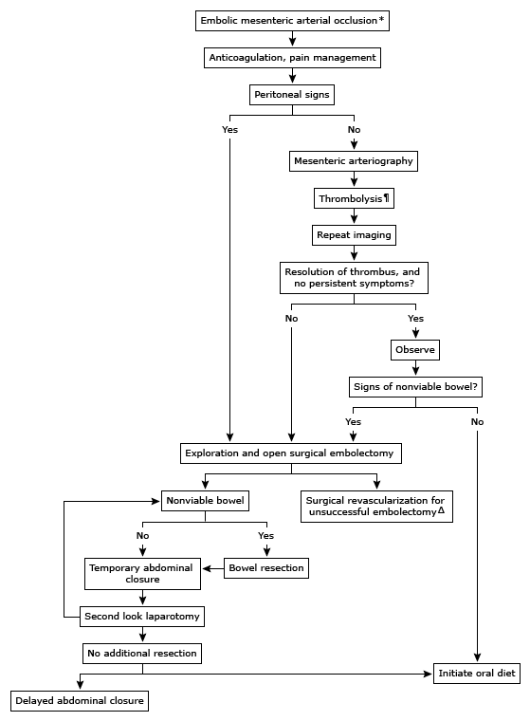
      - A, B, Cs (IV fluid resuscitation, correct acidosis and electrolyte imbalances)
      - NGT gastric decompression
      - IV antibiotics, IV PPI, IV analgesics
      - Heparin anti-coagulation (helps with venous thrombosis)
      - If signs of peritonitis or air under diaphragm noted on imaging = emergency exploratory laparotomy
        - Intra-operative embolectomy or thrombectomy
        - If fails, bypass or stenting techniques are tried
        - Once done, bowel is assessed for viability
        - If non-viable resect bowel
        - If unsure close and second look laparotomy
      - If no signs indicating need of emergency laparotomy in patient with suspected arterial disease:
        - Mesenteric angiography
        - If suspecting vasospasm Rx underlying cause; papaverine infusion (vasodilator)
        - If suspecting thrombosis catheter directed thrombolytic therapy
        - If suspecting embolism (AF patient) embolectomy
        - If this succeeds, but signs of bowel non-viability suspected, laparotomy needed
        - If this succeeds, percutaneous stenting may be tried in thrombosis
        - If this fails, proceed to laparotomy
    - Prognosis = poor (high MR in arterial disease)
  - CHRONIC MESENTERIC ISCHEMIA
    - Episodic intestinal hypoperfusion that does not lead to infarction, because enough time for collaterals to develop has elapsed
    - Etiology:
      - Arterial ischemia (MC)
        - Atherosclerosis
        - Low COP states (e.g. HF)
      - Venous thrombosis
      - Vasculitis
    - Risk factors:
      - Of atherosclerosis (modifiable & non-modifiable)
      - Smoking
      - Thrombophilias
      - Arcuate ligament syndrome
    - Symptoms:
      - Post-prandial abdominal pain (angina)
        - Pain is dull, crampy
        - Makes patient avoid eating
      - Weight loss (food aversion in fear of pain)
      - Big DDx is intra-abdominal malignancy
    - Signs:
      - None because it is episodic
    - Investigations:
      - For risk factors:
        - Lipid profile (LDL, HDL)
        - Coagulation profile
        - If DM: blood glucose, HbA1C
      - For the angina:
        - CT angiography
        - Mesenteric arteriography (gold standard, but invasive; also therapeutic)
    - Management:
      - Arterial disease revascularization
        - Endovascular techniques (percutaneous transluminal angiography)
        - Bypass grafting
      - Venous anticoagulation

- Small bowel Neoplasia
  - Benign
    - Adenoma (35%)
    - Most commonly found in the DUODENUM
    - MCC of adult intussusception (acts as a nidus)
    - Should be excised endoscopically
  - Malignant
    - Adenocarcinoma > Carcinoid > GIST > lymphoma
    - MC site for adenocarcinoma is DUODENUM
    - Rx involves wide en bloc resection of involved intestine +/- LN dissection
    - Duodenal lesions may require Whipple procedure
    - Carcinoid tumor
      - Malignant tumor
      - Appendix (tip) = MC site
      - Presentation:
        - Asymptomatic
        - SBO
        - Acute appendicitis
        - Metastatic to liver carcinoid syndrome (10%) ~ flushing, diarrhea, sweating, wheezing
        - Carcinoid syndrome = high serotonin metabolites which deprive the body of B₃/ niacin because all the tryptophan is used to make serotonin symptoms of pellagra
        - Metastasis to right heart valves and lung is possible
      - Investigations:
        - Urinary 5-HIAA (24 hour collection)
        - Plasma chromogranin A
      - Management:
        - Medical ~ serotonin antagonist (cyproheptadine), octreotide
        - Surgical: <2 cm = appendectomy alone
          - >2 cm = right hemicolectomy

- SHORT BOWEL SYNDROME
  - Definition
    - < 200 cm of small bowel present in patient resulting in symptoms secondary to low gut transit time
    - Usually secondary to bowel resection in the following:
      - Neonates & children ~ NEC, intestinal atresia, midgut volvulus, non-viable section of SBO/intussusception
      - Adults ~ CD, AMI, malignancy, strangulated hernia, non-viable SBO
    - Symptoms:
      - GI: diarrhea, flushing, sweating, dehydration
      - Malabsorption: malnutrition, vitamin deficiencies, anemia
    - Management:
      - Medical = increase bowel transit time
        - Temporary TPN
        - Anti-motility drugs
        - PPI
      - Surgical
        - Increase transit time: segmental reversal of small bowel, artificial small bowel valves, interposing colon
        - Increase length: longitudinal intestinal lengthening and tailoring
        - Transplantation

- Meckel’s diverticulum
  - Remnant of the vitelline duct (which connects the yolk sac to the midgut)
  - MC small bowel congenital anomaly (2% of population)
    - Present in the anti-mesenteric side, most often near terminal ileum
  - Rule of 2s:
    - 2% of population
    - Age of 2 years old MC presentation
    - 2x more common in males
    - 2 inches long
    - 2 feet away from ileocecal valve
    - 2% are symptomatic (MC = incidental/asymptomatic)
    - 2 types of heterotopic tissue: gastric (60%) and pancreatic
  - Presentations:
May be free or attached by fibrous band to the umbilicus. The free kind is more liable to cause intussusception, the fixed kind is more liable to cause volvulus.

MCC of painless lower GI bleeding in pediatrics. Consider juvenile polyp as a DDx.
    - Asymptomatic (incidental finding)
    - Diverticulitis
      - Ectopic gastric mucosa can secrete acid and irritate the adjacent intestine mucosa, leading to ulceration
      - Lower GI bleeding (usually painless)
      - Or RLQ PAIN mimicking acute appendicitis
    - SBO (MC)
      - Leadpoint for volvulus and intussusception
  - Investigations specific to it:
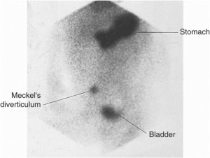
    - Meckel’s scan (technetium pertechnetate IV: scans for gastric mucosa)
      - A picture may invariably come in an OSCE
      - Don’t confuse the stomach (or bladder) uptake with the lower diverticular uptake
  - Management:
    - If symptomatic surgical resection with adjacent small bowel which usually contains the ulcer!
      - It goes without saying that you treat the presenting symptoms first (e.g. milk out intussusception)
- OSTOMIES AND FISTULAS
  - DEFINITION:
    - Fistula (FREQUENTLY ASKED QUESTION)
      - Abnormal connection between two epithelialized surfaces
      - Fistula is NOT the same as a sinus (connection to one epithelialized surface from a closed/blind sac)
    - Ostomy (stomas)
      - An unnatural connection to an epithelialized surface (basically a man-made fistula)
      - Most commonly the GIT to the skin or to another GIT lumen
      - May involve the use of artificial tubing (e.g. thoracostomy (intercostal chest tube/drain), gastrostomy (G tube) and jejunostomy (J tube)
  - Principle of fistulas
    - What keeps a fistula open?
      - “HIS FRIENDS”
      - High-output fistulas (>500 ml/day)
      - Intestinal destruction
      - Short fistulas (STAY OPEN LONGER)
      - Foreign bodies (this the principle of a G or J tube!)
      - Radiation
      - Infection (e.g. abscess or of the fistula)
      - Epithelialization (principle of stomas: we bring out the epithelium into another)
      - Neoplasia
      - Distal obstruction of the fistula
Types of fistulas
    - Clinical diseases that cause fistulas:
      - Diverticulitis (MC)
      - Crohn’s disease
      - CRC and other cancers
      - Radiation exposure (e.g. radiotherapy)
      - Cholecystitis (cholecystoenteric fistula)
    - The ones you need to be aware about in the GIT:
      - Colovesical (MC)
      - Enterocutaneous
      - Enteroenteric
      - Fistula-in-ano

    - Colovesical fistula (MC fistula type)
      - MCC is diverticulitis
      - Presentation?
        - Recurrent UTIs
        - Foul-smelling urine
        - Pneumaturia, fecaluria
        - Complications: renal failure/pyelonephritis
      - Investigations?
        - Cystoscopy
        - Barium enema
      - Management?
        - Surgical segmental colon resection and anatomosis

    - Enterocutaneous fistulas
      - Causes?
        - Anastomotic leak
        - Colon/bowel injury (e.g. diverticulitis or LB perforation)
        - CD
        - Abscess
      - How to identify source?
        - Need to do proper imaging (CT)
        - Fistulogram (use dye)
      - Complications?
        - High-output (>500 mL/day = high output)
        - Malnutrition
        - Skin irritation (develop 2nd SCC)
      - Management?
        - 1 = bowel rest (convert high-output to low)
          - NPO
          - TPN
          - 50% will close spontaneously
        - 2 = Rx underlying cause
          - Drain abscess if present, manage CD or cancer
          - Surgical resection of affected bowel segment
    - Other important fistulas:
      - ureterovaginal (iatrogenic in hysterectomy and other gynecological surgeries)
      - TEF in neonates
  - STOMAS TO BE AWARE OF
    - Gastrostomy and jejunostomy
      - In both cases, we use a tube to connect the organ to the skin
      - The tube elicits a foreign body reaction, keeping the connection patent
      - Removal of the tube connection will close in a matter of hours!
    - Colostomy and ileostomy
      - In general, a stoma seen on the right side is an ileostomy and one seen on the left side is a colostomy
      - End colostomy = proximal end of colon is brought to the skin
Stoma complications:
LOCAL:
- Skin irritation, rash
- Infection
- Ischemia
STRUCTURAL:
- Parastomal hernia
- Prolapse of stoma
- Stoma retraction
- Obstructed stoma
- Stoma stenosis
- Ischemia, necrosis
SYSTEMIC:
- Electrolyte disturbances, dehydration, malabsorption

      - Mucous fistula = distal end of colon brought up to skin (for decompression)
      - Hartmann’s pouch/procedure = end colostomy with the distal blind ended pouch left inside the body
      - Loop colostomy = large loop of colon is brought out, cut open, with both ends sewed to the skin (so you have two openings into the skin)
      - Ileal conduit = ileal segment is resected connected to the skin and both ureters (one type of ureter diversion after cystectomy)
      - Brooke ileostomy = ileostomy folded over it self

COLON

Worm-thing living in Fry’s colon: I AM THE MAYOR OF COLOGNE
Fry: you mean Colon?

- Key anatomy reminders:
  - Ascending and descending colon are RETROperitoneal
  - Transverse and sigmoid colon are intra-peritoneal (they have a mesentery)
  - Watershed areas
    - Splenic flexure (between SMA and IMA)
    - Rectosigmoid area (between IMA and superior rectal artery [from IAA])
  - Gross anatomy
    - Haustrations
      - Internally ~ semilunar folds
    - Tenia coli
    - Epiploic appendage
- DIVERTICULOSIS
  - Colonic diverticulosis:
    - Diverticulum = outpouching (plural = diverticula)
    - Diverticulosis = multiple diverticuli
    - Colonic diverticulosis is a condition in which multiple false diverticula form
    - Diverticulosis ≠ diverticulitis
      - Diverticulitis is a complication of diverticulosis
      - It represents inflammation of diverticula
  - Pathophysiology:
    - Increased intra-luminal pressure results in outpouching of the colonic mucosa & submucosa through the muscularis layer at the point of entry of the vasa recta (this area this considered to have a defect)
  - Risk factors:
    - Old age
    - Low fiber diet
    - Chronic constipation
  - Epidemiology:
    - OLD AGE (>70)
    - MC site = SIGMOID COLON
  - Presentation of DIVERTICULOSIS:
    - Asymptomatic (70-80%)
      - Diverticulosis alone is usually asymptomatic
      - Incidental finding on CT, barium enema, colonoscopy
    - Symptomatic:
      - Episodic LLQ pain
      - Bloating, flatulence, constipation, diarrhea
    - Of complications:
      - Painless rectal bleeding (5-15%)
        - Hematochezia
        - MCC of lower GI bleeding
        - 30 -50% of massive lower GI bleeding
        - DDx: CRC, angiodysplasia, massive/brisk upper GI bleeding, IBD, severe hemorrhoidal bleeding
      - Diverticulitis (15 – 25%)
        - See later
  - Investigations:
    - CLINICAL DIAGNOSIS that is CONFIRMED by imaging
    - Imaging techniques:
      - CT scan is preferred (especially if complicated)
      - Colonoscopy (CI in acute diverticulitis)
      - Barium enema (CI in acute diverticulitis)

  - Management of DIVERTICULOSIS:
    - Lifestyle changes
      - High fiber diet
      - Patient education about when to seek care (e.g. bleeding, symptoms of diverticulitis)

  - Management of diverticular bleeding:
    - A, B, Cs (O2, 2 large bore IV needles, IV fluids/blood)
    - Identify source of bleeding
      - Bleeding scan (slow bleeding)
      - Angiography or colonoscopy (both of which can be therapeutic)
      - If no response or unidentified source surgery (may require colectomy with ileostomy)

- DIVERTICULITIS
  - Complication of diverticulosis (15 – 25% of cases)
    - Inflammation of diverticuli
    - MC in left side in West
    - MC in right side in East
  - Pathogenesis:
    - Blockage of the diverticula results in increased pressure
      - Culprits: food particle, fecalith
    - This can result in wall inflammation, edema, ischemia and then necrosis
    - Outcomes:
      - Microperforation (contained by omentum) phlegmon, abscess, fistula
      - Macroperforation (free perforation) peritonitis
      - May develop recurrent attacks of acute diverticulitis (“chronic diverticulitis”) in which they develop strictures (leading to LBO)
  - Complications of diverticulitis
    - Perforation and peritonitis
    - Abscess formation
    - Fistulas (MCC of fistulas; colovesical fistula is MC fistula)
    - Strictures (and LBO) secondary to scarring
  - Presentation:
    - “Acute appendicitis, but on the LLQ”
    - Symptoms:
      - Acute onset of persistent LLQ pain (Hx of diverticulosis; steadily increasing)
      - Anorexia, N&V, change in bowel habits
      - Dysuria

    - Signs:
      - Fever
      - LLQ tenderness, rebound tenderness
      - Of complications:
        - Perforation peritoneal S&S
        - Abscess palpable, tender abdominal mass, spiking fevers
        - Fistula Hx of dysuria, fecouria
        - LBO abdominal distention, obstipation

  - DDx of severe LLQ pain:
    - GI:
      - Acute diverticulitis
      - CRC complication like perforation (biggest DDx, must be R/O after resolution)
      - Colitis (ulcerative colitis, ischemic colitis, pseudomembranous colitis)
      - Sigmoid volvulus
      - Strangulated inguinal hernia
    - GU causes in male and females
      - Given the age of the patient, some of these might be unlikely
      - Ovarian, testicular; UTI and ureteric colic;

  - Investigations
    - When suspecting diverticulitis, we investigate with:
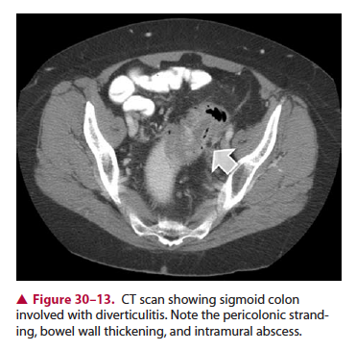
      - Lab:
        - CBC (leukocytosis) + BT+ Cx
      - Imaging:
        - CT abdo with IV contrast (TEST OF CHOICE)
          - High soft tissue density within pericolic fat/peri-colic fat stranding
          - Diverticula can be seen
          - Bowel wall thickening
          - Soft tissue masses (may represent pericolic fluid or abscess)
          - Free air (can be seen on CT!)

    - Colonoscopy and barium enema is CI during acute diverticulitis
      - However, they should be done in F/U to R/O malignancy (in 4 – 6 weeks)

  - Management:
    - Uncomplicated:
      - Can be managed as outpatient or inpatient (depending on patient state)
        - Cannot put down oral fluids (vomiting), or if he has comorbidities inpatient
      - OPD:
        - Oral fluids until symptomatic improvement
        - PO antibiotics (metronidazole) for 7-10 days
        - Non-opioid analgesics for pain
      - Inpatient:
        - IV fluids
        - NPO (bowel rest)
        - IV analgesic
        - IV antibiotics (ceftriaxone + metronidazole)

    - Complicated:
      - Classify based on the HINCHEY STAGING:
        - I = phlegmon/small abscess
          - Medical Rx (IV antibiotics, +/- drain)
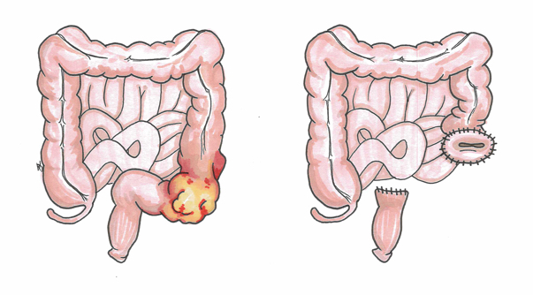
        - II = large abscess/fistula
          - CT/US guided percutaneous drainage + IV antibiotics
          - If non-accessible, surgical drainage
        - III = purulent peritonitis (ruptured abscess)
          - 6% MR!
          - Surgical Rx necessary
          - Hartmann procedure (sigmoid colectomy with proximal colostomy)
          - Colostomy reversal (re-anastomosis) in 3 – 6 months
        - IV = feculent peritonitis
          - 35% MR!
          - Surgical Rx necessary
          - Hartmann procedure with colostomy reversal in 3 – 6 months
      - Newer surgical practices for more stable patients with advanced disease:
        - End-to-end anastomosis with diverting ileostomy
      - Setting of surgery:
        - Elective surgery (“interval”)
        - Emergency surgery

      - Indications for surgery:
        - Unstable patient with signs of peritonitis or pneumoperitoneum
        - Hinchey stage III or IV (emergency)
        - Complicated cases (fistula, LBO, hemorrhage)
        - Immunocompromised patient
        - After several attacks (E.g. >3 attacks)
        - Failed medical Rx
        - Inability to R/O cancer
      - Complications of surgery:
        - Leakage from anastomosis
      - Prognosis:
        - High RR (up to 30% after 1 attack, up to 50% after second)
    - F/U appointment required in 4 – 6 weeks for colonoscopy to R/O cancer
      - Make sure you study the ENTIRE colon (not just the part affected)

- Large bowel obstruction (LBO)
  - Most common causes:
    - Adenocarcinoma (CRC) – MCC (65%!)
    - Diverticulitis (scarring stricture) – 20%
    - Sigmoid volvulus (5%)
  - Etiologies:
    - Mechanical:
      - Intraluminal:
        - Constipation/fecal impaction
        - Foreign body
      - Intramural:
        - Adenocarcinoma (MCC)
        - Diverticulitis scarring
        - IBD stricture
        - Radiation stricture
      - Extramural:
        - Volvulus
        - Adhesions
        - Hernias
    - Functional:
      - Ogilvie syndrome
      - Paralytic ileus

  - Clinical features:
    - Symptoms:
      - Abdominal pain (colicky)
      - Abdominal distention
      - N&V (less marked, late)
      - Obstipation (more marked, early)

    - Signs:
      - Abdominal distention
      - Hyperactive bowel sounds
      - DRE may show empty vault or impacted feces
      - More severe signs later
  - Investigations:
    - Acute abdomen labs
    - Imaging:
      - Supine and erect AXR
      - Erect AXR shows air-fluid levels, distended proximal colon, absent air in rectum
      - Supine AXR shows “picture-frame” appearance indicating large bowel distention
      - Coffee-bean sign is seen in sigmoid volvulus
  - Management:
    - General:
      - A, B, Cs
      - NGT for gastric decompression
      - IV broad spectrum antibiotics
    - Rx cause:
      - Steps for fecal disimpaction (e.g. enemas)
      - Surgical relief of obstruction (resect, remove, divert, reverse)
      - Volvulus management initially involves sigmoidoscopic decompression, and if fails, operative reduction
      - Intussusception involves air or hydrostatic enema which is diagnostic and therapeutic
- VOLVULUS
  - Rotation of a segment of the intestine around its mesenteric axis
    - Produces a CLOSED LOOP obstruction
  - Important volvuli to know about:
    - SIGMOID volvulus (75%)
    - Cecal volvulus (25%)
    - Midgut volvulus (pediatrics)
  - 3rd MCC of LBO
  - Risk factors:
    - Age > 70 (IMPORTANT)
    - High fiber diet (-_-)
    - Chronic constipation
    - Laxative abuse
    - Pregnancy
    - Institutionalized (psychiatric patients, in patients)
  - Presentation:
    - Typically an elderly patient with symptoms of LBO:
      - Colicky abdominal pain
      - Abdominal distention
      - Obstipation
      - N&V
  - Investigations:
    - AXR will show coffee-bean or omega loop sign (unmistakable on AXR)
    - Sigmoidoscopy has diagnostic and therapeutic role
  - Management:
    - Sigmoid volvulus
      - Non-operative reduction:
        - Sigmoidoscopic decompression
        - Followed by rectal tube insertion
        - However, high RR so plan for future elective surgery
      - Operative reduction:
        - Untwisting of involved segment
        - The involved segment is studied for viability
        - If non-viable, Hartmann procedure may be used
    - Cecal volvulus
      - Operative reduction is done
        - Untwist involved segment
        - Involved segment is studied for viability
        - If non-viable, right hemicolectomy and ileotransverse anastomosis may be required
- Ogilvie syndrome
  - Functional obstruction of the colon
    - It is not “fake!”
    - The colon is found to be massively dilated on imaging, however a mechanical cause is not identified
  - Typically occurs in bedridden or institutionalized patients
    - May be related to certain medications such as anti-cholinergics or opioids (which cause constipation)
  - Presentation:
    - Key factor is MARKED abdominal distention
    - However abdominal pain is milder
  - Investigation is as that of any LBO

  - Management:
    - ABC
    - NPO, NGT decompression
    - LGIT decompression by:
      - Rectal tube
      - Colonoscopy
      - Cholinergic drugs (neostigmine)
      - Surgery
- LOWER GI BLEEDING:
  - Bleeding originating from GI source BEYOND the ligament of Trietz
    - However, be aware that in general, we R/O upper GI sources before lower GI sources
    - Upper GI sources of bleeding usually present with melena or occult blood, however brisk UGI bleeding can present with hematochezia
  - Presentation
    - Hematochezia
      - Bright red blood per rectum
      - Usually indicates lower GI source of bleeding (or brisk UGI source)
    - Melena (not as often)
      - Right sided LGI bleeding may present with darker hematochezia or melena
    - Hemodynamic instability:
      - Anxious
      - Tachycardia
      - Orthostatic hypotension (>20 SBP drop on standing)
      - Hypotension, altered mental status/confused
  - Etiology:
    - Diverticulosis bleeding (MCC ~ 40%)
    - By group:
      - Anatomic
        - Diverticulosis
        - Acute hemorrhoidal bleeding & anal fissures
        - Intussusception (currant-Jelly stool)
        - Meckel’s diverticulum (painless)
      - Vascular
        - Angiodysplasia
        - Ischemic colitis (HF, shock patient, AAA repair)
        - Radiation induced
      - Inflammatory
        - Infectious colitis (e.g. pseudomembranous)
        - IBD (ulcerative colitis)
      - Neoplastic
        - CRC bleeding & polyp
  - Management & investigations:
    - ABCs (O₂, 2 large IV bore needle access, blood for lab: Hb + Hct + Cx + BT; IV resuscitation with bolus fluids NS or RL; may need blood transfusion if HCT <30%)
    - R/O and manage as preliminary UGIB if stable:
      - NGT to identify level of bleeding
      - If +ve, investigate for UGIB (endoscopy [also has role in unstable patients])
      - If –ve, investigate for LGIB (colonoscopy)
    - Investigate for LGIB if UGIB not identified OR directly if LGIB source suspected:
      - If patient stable, try to identify source:
        - Colonoscopy (often fails in massive bleeding, can be used to stop by diathermy or laser)
        - Tagged RBC scan
        - CT angiography
        - Mesenteric angiography (and embolization)
      - If patient unstable or above measures fail to control bleeding:
        - Emergency surgery to identify and control site of bleeding; surgical resection of affected segment
- Colon neoplasia:
  - Benign tumors (Polyps)
    - Gross morphology:
      - Sessile (flat) – more dangerous, more difficult to resect
      - Pedunculated (has a stalk)
    - Histological types:
      - Adenomatous (premalignant)
        - Tubular (75%)
        - Tubulovillous (15%)
        - Villous (10%) ~ most dangerous
      - Non-adenomatous (NO malignant potential)
        - Hyperplastic polyp (MC type overall)
        - Inflammatory polyp/pseudopolyps
        - Juvenile polyps (vascular; bleeds; can be syndromic)
        - Hamartomatous (e.g. Peutz-Jegher)

    - Malignant potential of a polyp is determined by?
      - SIZE (> 2 cm = more likely)
      - SHAPE (sessile/flat > pedunculated)
      - HISTOLOGY (Villous > tubulovillous > tubular)
      - ATYPIA (severe > moderate > mild)

    - So what is the worst kind of polyp?
      - Sessile, villous, adenomatous polyp with severe atypia, measuring > 2 cm
      - OR polyposis (thousands of polyps might indicate FAP, those individuals have 100% risk of developing cancer)
    - Presentation:
      - ASYMPTOMATIC (incidental finding)
      - Changes in bowel habits
      - Mucus discharge (with perianal discomfort)
      - LGIB (melena if on right; hematochezia on left)
    - Investigations:
      - Colonoscopy (diagnostic and therapeutic)
        - Study entire colon
        - Polypectomy
        - Send to histopathology lab
    - Management:
      - Polypectomy
      - F/U if found to be a adenomatous polyp (colonscopy in 3 years)
      - If FAP, offer prophylactic colectomy/annual screening

- COLORECTAL CANCER (CRC)
  - Epidemiology:
    - Classically:
      - 3rd MC cancer and cancer-related mortality in men and women (but I think now it’s the 2nd MC)
Most common site of COLON cancer?
SIGMOID colon > rectum > cecum > ascending and transverse colon
    - 6% lifetime risk
    - Age group:
      - Peak is 60 – 79 years
      - Risk begins to rise after age of 50
    - Screening:
      - For the AVERAGE person, screening is offered >50
        - Colonoscopy every 10 years
        - Sigmoidoscopy every 5 years
        - Fecal occult blood yearly
      - For those with 1st degree relatives affected with CRC, we offer screening at 40 OR 10 years younger than the age of diagnosis of the relative who developed it the earliest
      - Why 10 years?
        - It takes about 10 years for the adenoma-carcinoma sequence to occur

    - Risk factors:
      - Male gender
      - Age > 50 years old
      - Personal previous history of adenoma or CRC
      - Family history (1st degree relative)
      - Low fiber diet
      - Smoking
      - Inherited syndromes (FAP, Lynch syndrome, Gardner syndrome, Turcot’s syndrome)
      - Inflammatory bowel disease (UC > CD)
        - Screen UC in 8 – 10 years, unless has features of PSC, do it now!
  - Inherited syndromes:
    - Familial adenomatous polyposis (FAP)
      - AD disease
      - Adenomatous polyposis coli (APC) gene mutation
        - Tumor suppressor gene (TSG)
        - Located on chromosome 5
        - Codes for stuff related to E-cadherin, which is important for cell adhesion
        - Since it is a TSG, it must fulfill the 2 hit hypothesis (one inherited, the other during life)
        - Note that most APC mutation occur SPORADICALLY in patients without FAP
      - 100s-1000s of polyps develop (ALL are adenomatous) early in lifetime (late adolescence)
      - 100% risk of developing CRC
      - We offer them screening at age of 10 YEARS OLD
      - Prophylactic proctocolectomy with ileostomy or ileorectal anastomosis is offered

    - Gardner syndrome
      - AD
      - Adenomatous polyposis + osteomas + sebaceous cysts
      - Risk of developing CRC

    - Turcot’s syndrome
      - AD
      - Adenomatous polyposis + CNS tumors (glioblastomas, medullablastomas)

    - Lynch syndrome (Hereditary non-polyposis coli CRC or HNPCC)
      - Develops using microsatellite instability pathway (not adenoma-carcinoma sequence)
      - Lynch I: right sided colon cancer
      - Lynch II: colon cancer + risk of other cancers (endometrial, ovarian, breast cancer)

  - Peutz-Jegher syndrome
    - AD
    - Patient develops HAMARTOMATOUS polyps of ENTIRE GIT
    - Melanotic pigmentations of face, lips, oral mucosa and palm
    - High risk to develop cancer, but elsewhere

  - Pathogenesis:
    - The two important ones:
      - Adenoma-carcinoma sequence (MC ~ 80%)
      - Microsatellite instability pathway

    - Adenoma-carcinoma sequence

Normal
FAP (has 1 APC mutation already)
Sporadic APC mutation (1st hit)

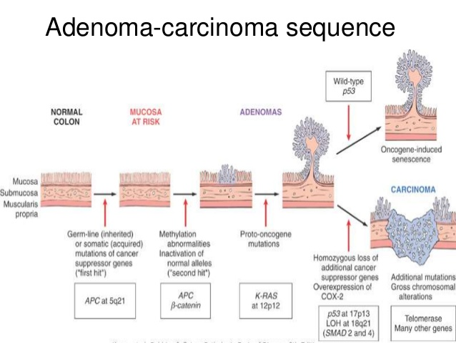
Mucosa at risk
Proto-oncogene mutation
KRAS mutation or loss of DCC gene
2 – 5 years

Uncontrolled proliferation
(Adenomatous polyps)
p53 loss (TSG 2nd hit)
2 – 5 years

Cancer
~ 10 years

    - Microsatellite instability pathway
      - Related to mismatch repair genes (hMSH2, hMLH1)
      - Increased number of short base repair repeats
      - Results in Lynch syndrome
      - 15% of sporadic cases of CRC

- Presentation:
  - Typically asymptomatic until late
    - That’s why we promote screening
    - That’s why it’s the 3rd MC cancer and death by cancer
  - Symptoms:
    - Constitutional symptoms (weight loss, anorexia)
    - Right-sided cancers BLEED
Microcytic anemia in elderly man or post-menopausal woman is CRC until proven otherwise.
      - Occult blood loss (leading to anemia)
      - Melena
      - Old patients with microcytic hypochromic anemia need to be investigated for occult blood loss in stool by doing stool guiaic test (most likely CRC or bleeding ulcer)
CRC is not a friend. It is a MONSTER. It is becomes large, bulky, friable and can bleed, obstruct, develop infections, produce an abscess, fistula and may perforate as well. It is very non-specific and easily fits with a broad range of differentials.
    - Left-sided cancers OBSTRUCT
      - Reduced stool caliber (pencil-shaped)
      - Change in bowel habits (constipation, encopresis)
      - LBO signs and symptoms
        - Abdominal distention, cramping abdominal pain, obstipation and then N&V
        - MCC of LBO is CRC
        - Big DDx of diverticulitis
    - Rectal cancer:
      - Hematochezia
      - Tenesmus
      - Rectal mass
TRIVIA:

Streptococcus bovis endocarditis should alert one to R/O CRC promptly.
Murmur + CRC = think S. bovis

They say to AVOID UNECESSARY PALPATION as it can increase the risk of spreading the cancer!
  - Signs:
    - Usually none, unless presents very late or with complications:
      - Right-sided hard abdominal mass (no signs of toxemia)
      - Hepatomegaly (MC site of metastasis is liver)
      - DRE mass fixed to sacrum

  - Complications of CRC:
    - Metastasis
      - LL, BB: liver [MC], lung, bone, brain
      - Local invasion: peritoneum with seeding
    - LBO (MCC)
    - LGIB & anemia
    - Fistula
    - Perforation, feculent peritonitis, sepsis

  - Investigations:
    - How is the diagnosis made?
      - As with all cancers, it is confirmed by BIOPSY

    - LAB:
You usually don’t suspect CRC in plain site. You either catch them by screening or incidentally when investigating patient for other symptoms or one of its complications (e.g. LGIB, LBO, diverticulitis)

You find it on stool guaiac screen, colonoscopy screen, anemia on CBC.

So I wouldn’t say occult blood in stool unless you find an elderly patient with anemia (on P/E and CBC).
      - CBC
        - Microcytic anemia in elderly man or post-menopausal woman is CRC until proven otherwise
      - RFTs (BUN, Cr)
      - LFTs (MC site of mets), coagulation profile
      - Tumor markers: CEA, CA 19-9
    - IMAGING:
      - Colonoscopy with biopsy
        - The entire colon is study well because lesions may be SYNCHRONOUS (present at different sites at the same time)
      - CT (for staging) of chest, abdomen and pelvis
      - Classically, barium enema (shows apple-core appearance)
      - Transrectal US for rectal cancer (or pelvic MRI)
        - Assess depth of invasion
      - Additional imaging is done based on suspected metastasis (E.g. develops neurologic deficits ~ head MRI)
  - STAGING of CRC:
    - TNM staging:
      - T:
        - T0 – no evidence
        - Tis – in situ cancer
        - T1 – submucosal involvement
        - T2 – muscularis involvement
        - T3 – serosa
        - T4 – adjacent organs or visceral peritoneum
      - N:
        - N0: none
        - N1: 1 – 3 local nodes
        - N2: 4 or more nodes
      - M:
        - M0: no evidence
        - M1: distant metastasis (LLBB in this order)
    - Dukes’ stages:
      - Stage I ~ T1 or T2 only (minimally invasive)
      - Stage II ~ T1 – T4 without N or M (locally invasive)
      - Stage III ~ with N1/N2 (with nodes)
      - Stage IV ~ with M1 (with metastasis)

  - Management:
    - Principles:
      - Surgical resection (w/ wide margins & LN dissection)
      - Radiotherapy
      - Chemotherapy
    - By stage:
      - Stage I and II ~ surgical resection with LN dissection
      - Rectal cancer ~ neoadjuvant radiotherapy, surgical resection (LAR or APR, TME)
      - Stage III ~ adjuvant chemotherapy, surgical resection with LN dissection
      - Stage IV ~ palliative care
    - Tumor markers may be used to assess response to therapy and recurrence
    - Surgical resection
      - 1 = remove involved segment(s) with WIDE MARGINS (e.g. 2 – 5 cm)
      - 2 = ≥ 12 LN removed
      - In the case of cecum & ascending colon – resect from distal ileum to mid-transverse colon
      - Vessel and mesentery should also be removed

    - Rectal cancer
      - Neoadjuvant (pre-OP) radiotherapy
        - May be preceded by 5-FU (radiosensitizer)
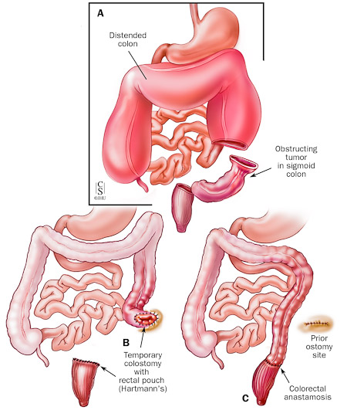
      - Surgical Rx:
        - Proximal cancers (>4 cm away from anal verge)
          - We do LAR + TME + colo-anal anastomosis
          - LAR = Low Anterior Resection
          - TME = Total meso-rectal excision
        - Distal cancers (<4 cm from anal verge)
          - Hard to get to it by LAR
          - So we do APR + TME + colostomy + closure of anus
          - APR = Abdomino-perineal resection
        - Complications:
          - Incontinence
          - Urinary dysfunction
          - Sexual dysfunction
          - Anastomotic leak
          - Stricture formation
    - Metastasis:
      - Liver
        - If < 4 sites in liver involved, a wedge resection or lobectomy can be performed

    - Follow-up
      - 80% of recurrences occur within 2 years
      - F/U plan:
        - Every 3 months for 2 years
        - Every 6 months for next 2 years
        - Annually thereon

      - F/U components:
        - Hx, P/E
        - CBC + CEA + stool guaiac
        - Colonoscopy (yearly at first)
  - Prevention:
    - Lifestyle changes (high fiber diet, exercise, no smoking)
    - Screening (> 50 years old, 10 year colonoscopy or 5 year sigmoidoscopy, yearly stool guaiac)

RECTUM & ANUS

- Anatomy
  - The dentate (pectinate) line
    - It is the division between the rectum and anal canal
    - It represents the transition between hindgut (endoderm) and ectoderm
      - Everything beyond has a different blood supply, innervation, lymphatic drainage and epithelium
      - Above this line, epithelium is simple columnar epithelium
      - Below this line, epithelium is stratified squamous non-keratinized epithelium
      - NOTE: the white line of Hilton, which is much lower, represents the anal verge (where the non-keratinized epithelium becomes keratinized)
  - RECTUM
    - Peritoneal lining:
      - Upper 1/3rd it is covered by peritoneum on 3 sides
      - Middle 1/3rd it is covered only anteriorly
      - Inferior 1/3rd is infra-peritoneal (No peritoneal covering)
    - The lower 1/3rd is attached to:
      - Anteriorly = Denonvillier’s fascia
      - Posteriorly = retrosacral fascia (Waldeyer’s fascia)
    - The rectum has a continuous layer of longitudinal muscle (tenia coli widens to cover the whole thing)
    - The rectum’s chief job is storage of feces, which means it has very high pressure and contains a lot of bacteria
    - The rectum has several curves produced by extraluminal structures (it follows the anterior curve of the sacrum, then a acute angle posteriorly because of the pelvic floor muscles) and intraluminal folds (3 of them)
      - These curves help keep feces in the rectum

  - ANUS
    - Runs from the pelvic floor/diaphragm to the anal verge
      - The pelvic floor includes the muscles of pelvic diaphragm, which includes the levator ani muscle:
        - Puborectalis
        - Pubococcygeus
        - Iliococcygeus
      - These muscles are somatic and help keep pelvic contents in their place (i.e. their weakness results in vaginal or rectal prolapse) and play a role in holding your shit in place before going to the toilet (continence)
    - Structures:
      - Anal columns of Morgagni (arise from the dentate line)
        - Between them are crypts that contain mucous glands
      - Anal sphincters:
        - Internal anal sphincter: rectal SMOOTH muscle (inner circular layer); involuntary (PS & S control); contribute 80% of the resting contraction pressure
        - External anal sphincter: 3 loops of voluntary STRIATED SKELETAL muscle that represent the continuation of the puborectalis; contribute 20% of the resting contraction pressure and 100% of the voluntary pressure
  - Blood supply:
    - Arterial:
      - Above line – superior rectal artery (From IMA)
      - Below line – middle & inferior rectal artery (from internal pudendal artery of internal iliac artery)
    - Venous:
      - Above line – superior rectal vein (to portal vein)
      - Below line – inferior rectal vein (to systemic circulation)
      - Both communicate through the internal and external hemorrhoidal plexuses
      - The internal plexus is above dentate line and is painless; external plexus is below line and is painful

  - Lymphatic supply:
    - Above line – to IM LN
    - Below line – to internal iliac LN
    - Below white line/anal verge – to superficial inguinal LN

  - Innervation:
    - Above line – sensation goes back with sympathetic; involuntary autonomic supply
      - Sympathetic promotes increased tone and reduction in peristalsis
      - PS (pelvic splanchnic nerves) promotes relaxation of tone and peristalsis
    - Below line – sensation goes back with PS fibers; somatic nerves supply sphincters (voluntary control) thru pudendal nerve

- Hemorrhoidal Disease
  - Definition:
    - Engorgement of the submucosal venous (“hemorrhoidal”) plexus in the anus or rectum
    - They may protrude into the lumen or prolapse downwards
  - Pathogenesis:
    - Deterioration of CT that anchor hemorrhoids
    - Abnormal dilation of plexus
    - Increased tone of internal anal sphincter (defecation pushes sphincter against vein)
  - Dr: Are hemorrhoids “normal”?
    - Well it depends on what you mean
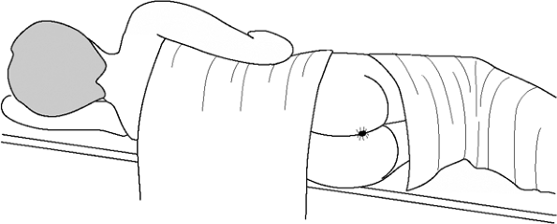
    - The venous plexuses are known as hemorrhoids, but when they become pathologically dilated they may be symptomatic, in which case we might use more appropriate terms like hemorrhoidal disease or piles
  - Common locations = anal cushion areas:
    - Right anterior (11:00)
    - Right posterior (7:00)
    - Left Lateral (3:00)
  - Classifications:
    - Internal (above dentate line, considered painless)
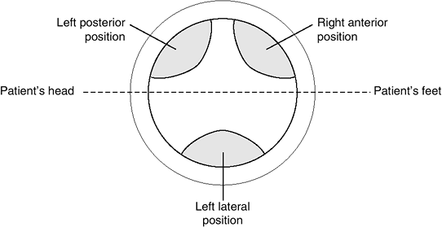
    - External (below dentate line, painful)
    - Mixed (both types)
  - Epidemiology
    - VERY COMMON CONDITION
    - M = F; more common in OLDER age
    - Risk factors:
      - Chronic constipation/straining
      - Pregnancy
      - Prolonged sitting
      - Increased pelvic pressure (e.g. ascites, tumors)
      - Portal HTN

  - Clinical manifestations:
    - ASYMPTOMATIC (40%)
    - Symptomatic (non-acute)
      - Hemorrhoidal bleeding (PR hematochezia)
        - Usually painless
        - Usually following bowel movements
        - Drips into toilet bowl or coats stool +/- tissue paper
        - RARELY develops anemia
      - Mucus discharge
        - Staining of underwear
        - Peri-anal pruritis and irritation
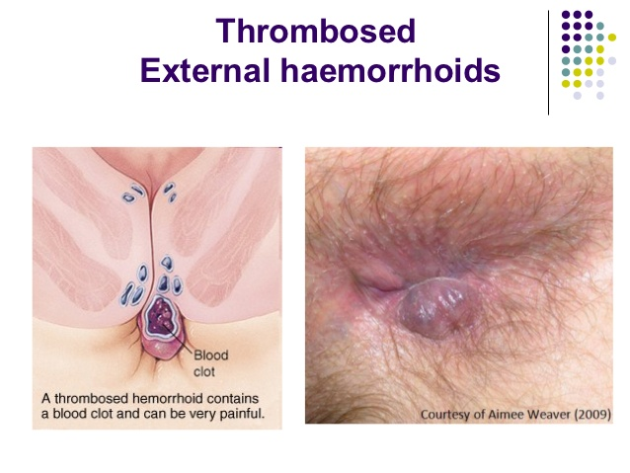
      - Sensation of fullness in perianal area (in prolapsed hemorrhoids)
      - Constipation
        - The patient will often complain of being constipated, but be aware that constipation is a cause and effect (the pain on defecation might discourage bowel movements)
    - Acute hemorrhoidal attack
      - Represents THROMBOSED external hemorrhoids
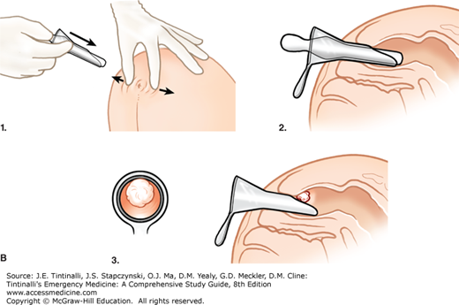
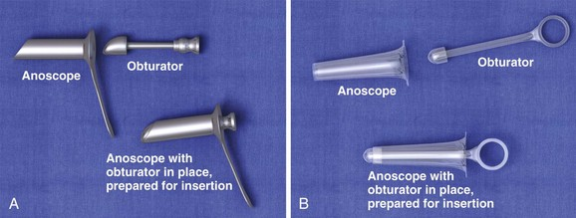
      - EXCRUCIATING peri-anal pain of acute onset for 2- 3 days
      - Patient unable to sit
      - There is a palpable & tender peri-anal lump
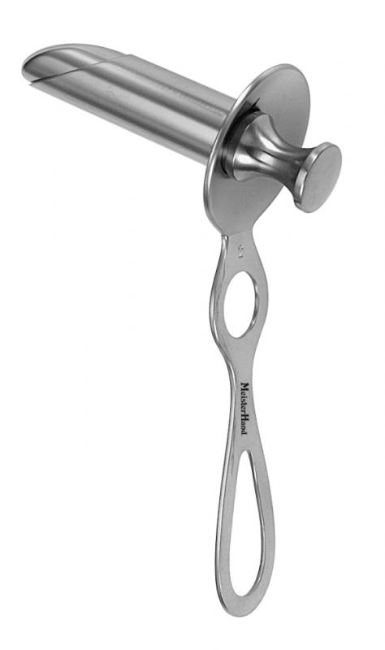
      - The swelling may last for weeks!
  - P/E:
    - Direct visualization:
      - By naked eye or thru ANOSCOPE
      - DRE MUST be done to R/O rectal cancer
    - INTERNAL hemorrhoids have DEGREES:
      - I = protrudes, but no prolapse; bleeds
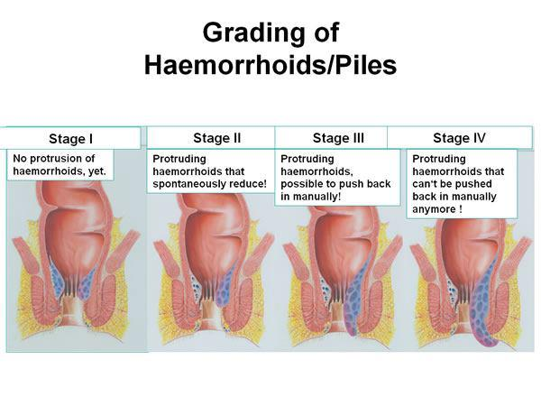
      - II = prolapses, only during straining; spontaneously reduces; bleeding, perceived prolapse
      - III = prolapses, requires manual reduction; same + mucosal soilage, pruritis
      - IV = prolapse and CANNOT be reduced; same + PAIN (if THROMBOSED)

  - DIAGNOSIS
    - CLINICAL Dx
Are uncomplicated hemorrhoids palpable? NO! They compress when pressed on DRE, but you gotta do a DRE to R/O differential causes.
      - DDx to consider in recurrent/persistent cases:
        - Crohn’s disease
        - Colon cancer (R/O in older patients)
        - Portal HTN
  - MANAGEMENT:
    - 1 = MEDICAL (95%)
      - Lifestyle changes:
COMPLICATIONS:
- Hemorrhage (BRBPR)
- Anemia (not common)
- Thrombosis
- Strangulation (which can ulcerate or necrose)
- Fibrosis (white)
- Infection
        - High fiber diet, hydration, avoid straining
        - Exercise
        - Anal hygiene
        - Sitz baths (principle is to add salts that will cause an osmotic shift to relieve swelling of veins)
      - Topic agents:
TRIVIA: NAPOLEON HAD PILES
Strangulation of prolapsed internal hemorrhoids by the strong anal sphincter can impede venous return, resulting in the hemorrhoid to become excessively tense & painful (like thrombosis).
It is believed that Napoleon missed out on the battle at Waterloo because he had a strangulated hemorrhoid; they lost at the battle, losing the war and then their empire
        - Steroids +/- lidocaine gels (procto-glyvenol)
      - Medications:
        - Stool softeners/laxatives
        - venoconstrictors (E.g. Daflon [flavins])
        - Analgesics (NSAIDs)
    - 2 = HEMORRHOIDECTOMY (rarely needed)
      - CLOSED (office-based procedures)
        - Rubber-band ligation
        - Infrared cauterization
        - Laser coagulation
        - Sclerotherapy
      - OPEN hemorrhoidectomy
        - Surgical excision (if large or refractory)
        - Requires 2 – 4 weeks of recovery!
      - Offered in severe cases (III, IV) or refractory cases or in ACUTE thrombosis (within 24-72 hours)
      - Complications of surgery:
        - Exsanguination (pooling of blood within)
        - Pelvic infection
        - Incontinence
        - Anal stricture
      - CI?
        - Crohn’s disease (CD)

  - FISSURE-IN-ANO (Anal Fissure)
    - Painful linear tears in anal mucosa BELOW dentate line
    - Causes:
      - Chronic constipation
      - Hyperactive sphincter (i.e. many bowel movements)
      - Crohn’s disease
      - Anal sex (in Homo AND Heterosexuals)
      - Childbirth
    - Locations:
      - MC = posterior midline (90%)
      - If NOT posterior midline, suspect CD
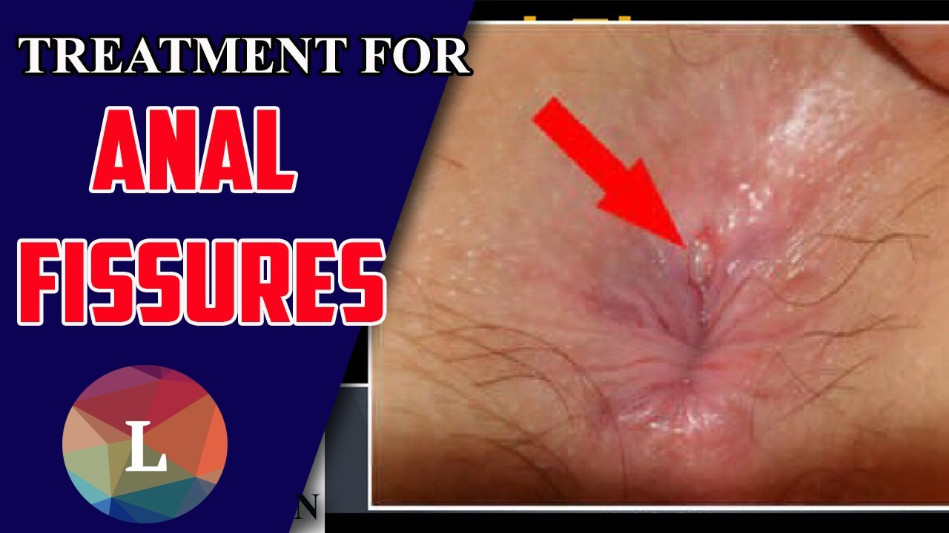
    - Presentation:
      - Symptoms:
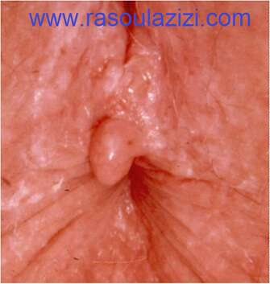
        - Painful bowel movements
        - Bright red blood on toilet paper (might also be seen in toilet)
      - Signs:
        - Inspection:
          - Fissure may be seen on external exam
          - Sentinel tag/pile represents chronic fissure (thickened skin at distal end of anal fissure)
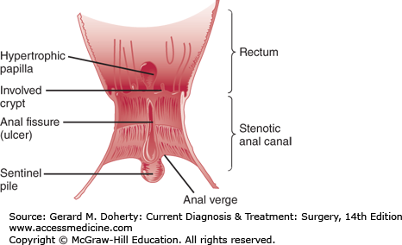
        - PAINFUL DRE (avoid DRE unless not sure)
        - Anoscopy (try to avoid if Dx obvious):
          - Shows fissure
          - Hypertrophic papilla (chronic fissuring)
      - TRIAD of CHRONIC FISSURE:
        - 1 = fissure
        - 2 = sentinel “pile” tag
        - 3 = hypertrophied papilla

    - Diagnosis = CLINICAL
      - You don’t need to do investigations unless you suspect a DDx;
      - DDx: hemorrhoids, early anal cancer, CD fissures
    - Management:
      - 1 = MEDICAL Rx
        - Lifestyle changes:
          - High fiber diet, hydration
          - Sitz bath & anal hygiene
        - Medications:
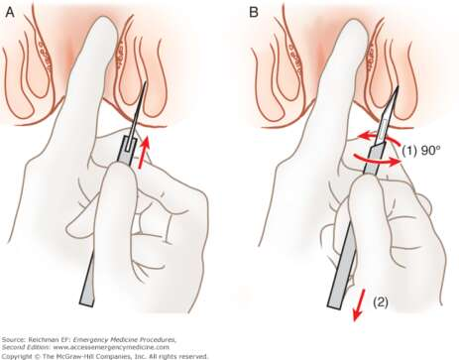
          - Goal is to relieve pressure (decrease tone + soften stool)
          - Stool softeners (e.g. docusate)
          - Topical CCBs (e.g. nefidipine) or GTN
      - 2 = SURGICAL Rx
        - Indication = chronic fissure refractory to conservative Rx
        - Lateral internal sphincterotomy (LIS)
          - Purpose is to relieve the pressure of sphincter tone (provides more perfusion and promotes healing)
      - RULE OF 90%:
        - 90% posteriorly
        - 90% respond to medical Rx
        - 90% of those who undergo LIS respond
  - Ano-rectal abscess
    - Results from infection of anal glands or skin glands
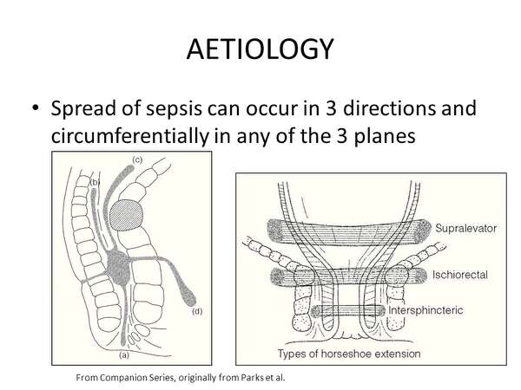
      - Anal glands exist in a plane between the internal and external anal sphincters and communicate by their ducts to the anal mucosa at the level of the dentate line
      - Infection of these glands (mostly G-ve enteric bacilli) leads to the formation of an intersphincteric abscess
      - This can spread:
        - Downwards peri-anal abscess (60%)
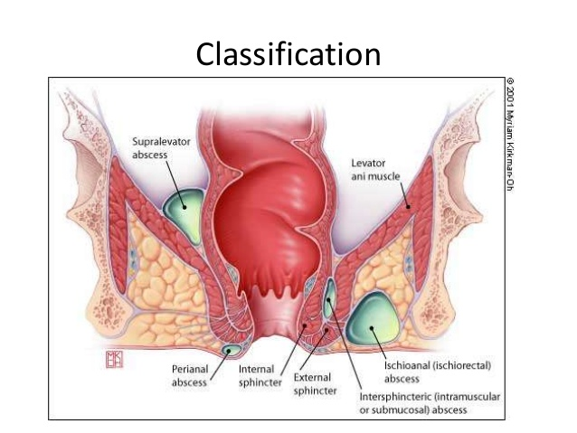
        - Outwards ischiorectal abscess (30%)
        - Inwards submucosal abscess (5%)
        - Upwards supralevator abscess (below peritoneal lining)
        - Note: above peritoneal lining pelvi-rectal abscess (originates from intra-peritoneal source)
      - The abscess may produce a fistula following these communications
      - Special problems = HORSE-SHOE ABSCESS
        - Leaving an abscess (especially ISCHIO-ANAL ABSCESS) untreated can make it spread in a plane around the anus/rectum in a horse-shoe pattern
      - Recurrent abscess? Consider:
        - CROHN’S DISEASE
        - TB
    - Presentation:
      - Symptoms:
        - Rectal pain (severe, THROBBING, unbearable, patient cannot sit down, CANNOT SLEEP)
        - Draining pus/foul-smelling discharge on underwear
        - They might tell you that it burst already and that the pain went away when the pus drained out
      - Signs:
        - Spiking fever, patient may be toxic
        - Tender swelling (depends on type/location of abscess):
          - Peri-anal ~ SQ, near orifice
          - Ischio-rectal ~ in ischio-rectal fat
          - Submucosal ~ nothing may be felt externally (you think FUO), but exquisitely painful DRE mass

    - Diagnosis is 100% clinical
      - Except for deep abscesses (need CT/MRI)
    - DO NOT WAIT FOR FLUCTUATION TO RX
      - The patient is in PAIN and he cannot sleep!
      - There is a very HIGH chance to develop fistula-in-ano
      - Complications:
        - Fistula-in-ano (abscess connects skin to anal mucosa: two epithelial lining)
        - Sinus formation (abscess to skin alone)
        - Deep pelvic infection, sepsis

    - Management:
      - SURGICAL Rx (all abscesses must be drained)
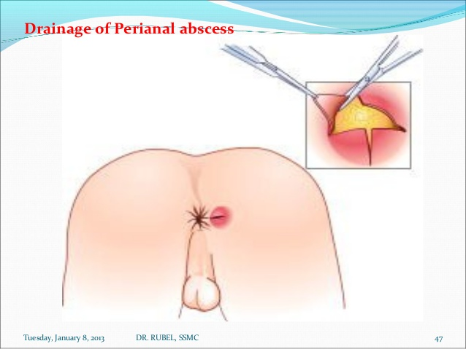
        - Incision & drainage
          - Done under LA/GA
          - EUA (examination under anesthesia) but DO NOT PROBE TO MUCH (might predispose to fistula)
          - Cruciate incision (Dr. Hamdi) to unroof, drain out all the pus (send for C&S)
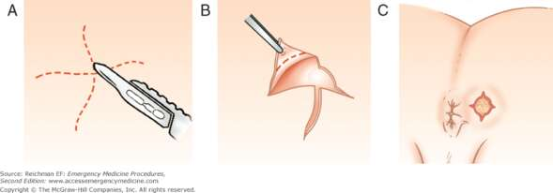
          - Many doctors use their fingers to drain every potential pocket of pus, because any remained contents can predispose to fistula formation
          - Wound is packed deep in but not tightly, daily dressing are arranged, healing is by tertiary intention (granulation tissue will slowly form)
        - If I&D not possible, SURGICAL drainage

      - IV/oral antibiotics in select cases:
        - Evidence of cellulitis
        - DM patient
        - Immunocompromised
        - Patients w/ prosthetic heart valves

      - Post-OP lifestyle changes:
        - Anal hygiene
        - Sitz bath
        - Stool softeners

FISTULA-IN-ANO
- Definition of fistula:
  - Connection (usually abnormal) between two epithelialized surfaces (unlike sinuses)
  - In anal fistula:
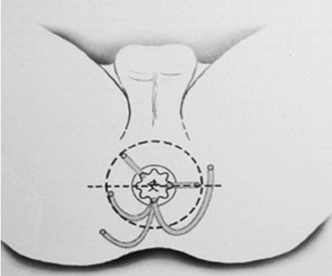
    - Between anal canal (usually) and skin
- Background:
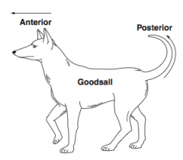
  - Develop as a complication of ano-rectal abscesses or in patients with CROHN’S DISEASE or TB or anal cancer
  - Other causes: iatrogenic, trauma, radiation, malignancy

  - GOODSALL’S RULE (HORZIONTAL RULE):
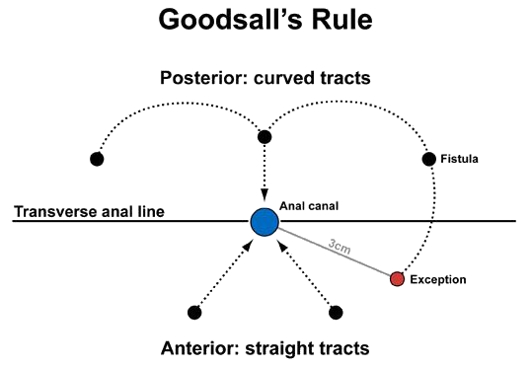
    - If we draw an imaginary line dividing the anal canal in the coronal plane
    - Fistulas ANTERIOR to this line follow a STRAIGHT course
    - Fistulas POSTERIOR to this line follow a CURVED course

  - PARK’S CLASSIFICATION (VERTICAL RULE):
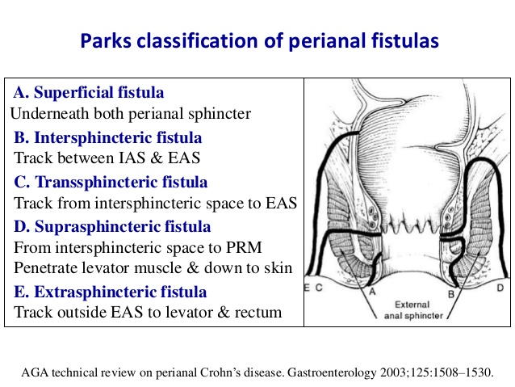
    - Type I = intersphincteric (MC)
      - Proximal opening = anal canal
      - Passes through internal sphincter and into the intersphincteric space and then goes downwards to exit into skin
    - Type II = Trans-sphincteric
      - Proximal opening = anal canal
      - Passes through both the internal and external sphincter, THEN goes down into skin
    - Type III = Supra-sphincteric
      - Proximal opening = anal canal
      - Passes through internal sphincter, goes UPWARDS above the level of the pelvic floor muscles and then comes back down THROUGH the pelvic floor muscles (yes! FUCKED UP!) and ischio-anal fossa to skin
    - Type IV = Extra-sphincteric
      - Proximal opening = rectum
      - Without passing through the anal sphincters, the fistula goes through the pelvic floor into the skin
    - Others:
      - Superficial (within the mucosa only)
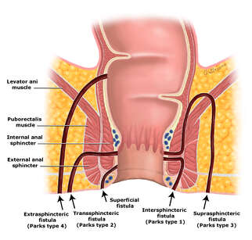
  - High VS low fistulas:
    - The OLDER classification (vague as to what it refers to)
    - Depends on the location of the internal opening:
      - HIGH = above anal sphincter
      - LOW = below anal sphincter
  - Presentation:
    - Symptoms:
      - Recurrent/persistent peri-anal foul-smelling discharge
      - Peri-anal pain = temporarily blocked fistula (when block removed, GUSH of fluid, soiling of underpants, pain resolved)
      - USUAL SCENARIO:
        - Patient with S&S/Hx of ano-rectal abscess that drained spontaneously relieving pain, but now has ON/OFF or persistent discharge
    - Signs:
      - P/E will show external opening of fistula
      - Internal opening of superficial fistulas may be seen as indurations (do not probe a lot)

  - Diagnosis is clinical
    - DRE or anoscopy may reveal internal opening
    - If unidentified, EUA is done (see later)
    - Make sure to R/O DDx (e.g. pilonidal sinus, draining abscess)
      - Recurrent fistulas are seen in:
        - CD
        - TB
        - Cancer
    - ALTHOUGH NOT USED, MRI is considered to be the gold standard imaging (if clinical and EUA fail)

  - Management:
    - SURGICAL Rx:
      - 1 = EUA (Examination under anesthesia)
        - DO NOT PROBE
        - Inject distilled H₂O₂ (hydrogen peroxide) from external opening and watch for bubbling in anal canal
        - Others use methylene blue or other dyes (but this can be messy)
      - 2 = Fistulotomy
        - Represents unroofing of the fistula tract
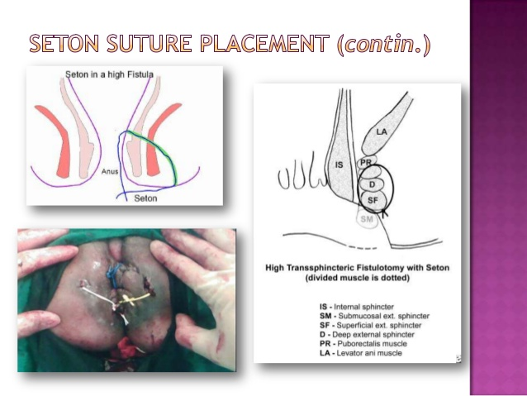
        - Can be used alone for intersphincteric fistulas without affecting continence
      - 3 = staged fistulotomy using CUTTING SETON SUTURE
        - Fistulas that involve the whole sphincter muscle (e.g. intersphincteric) should not be unroofed because it will result in incontinence
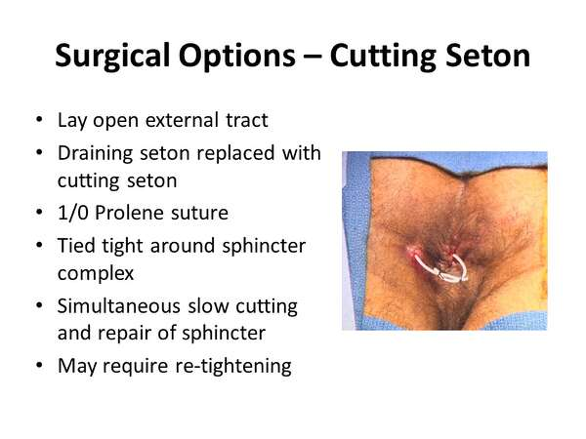
        - Instead, a “cutting” seton suture is placed through the fistula and left in place for about 2 – 3 months
        - This elicits a foreign body reaction that slowly allows the suture to be passed through the sphincter gradually producing an area of fibrosis in the tissue behind it, maintaining the capacity of continence
        - Needs to be intermittently tightened

- Pilonidal disease (PND)
  - It is not an anal disease but presents similarly to anal fistulas
  - It is an inflammatory condition with several postulations as to how it occurs (common in the Middle East)
  - MC location = cranial edge of the intergluteal cleft
  - Pathogenesis:
    - Acquired theory
      - Loose hair from the head or upper back falls onto the sacral area and because of several factors (e.g. by sitting, rolling, sweating, poor hygiene) the hair is drawn into the skin and into SQ tissue producing a cyst, which then becomes infected (this can develop into a sinus tract and drain pus into the skin)
      - Factors that favor this theory:
        - BARBERS get PND in between their fingers
        - The hair in it are found to be directed inwards
        - Repeated recurrences
  - Presentation:
    - Symptoms:
      - Recurrent foul smelling discharge on underwear
      - Local discomfort (pain, swelling, redness) with a mass felt below the opening or nearby it (represents the cyst)
    - Signs:
      - Draining sinus tract opening(s) seen in the high intergluteal area
      - Fluctuant like mass may be palpable
  - Diagnosis is CLINICAL
    - DDx: peri-anal abscess, anal fistula, dermoid cyst, sacrococcygeal teratoma (?)

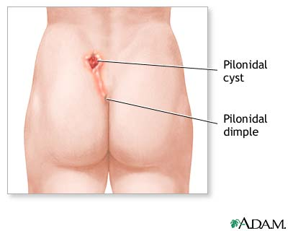
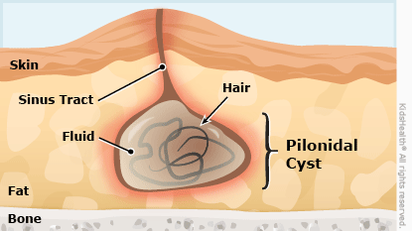
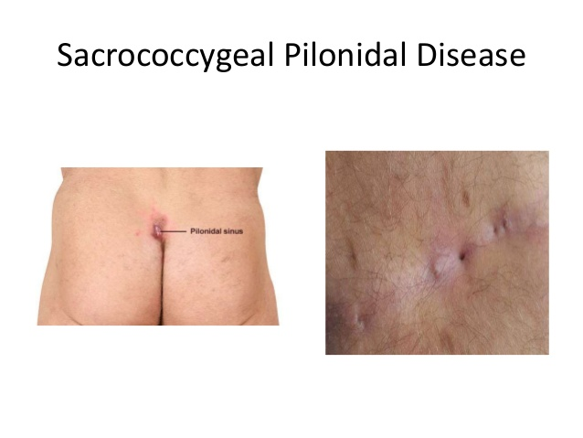

  - Management:
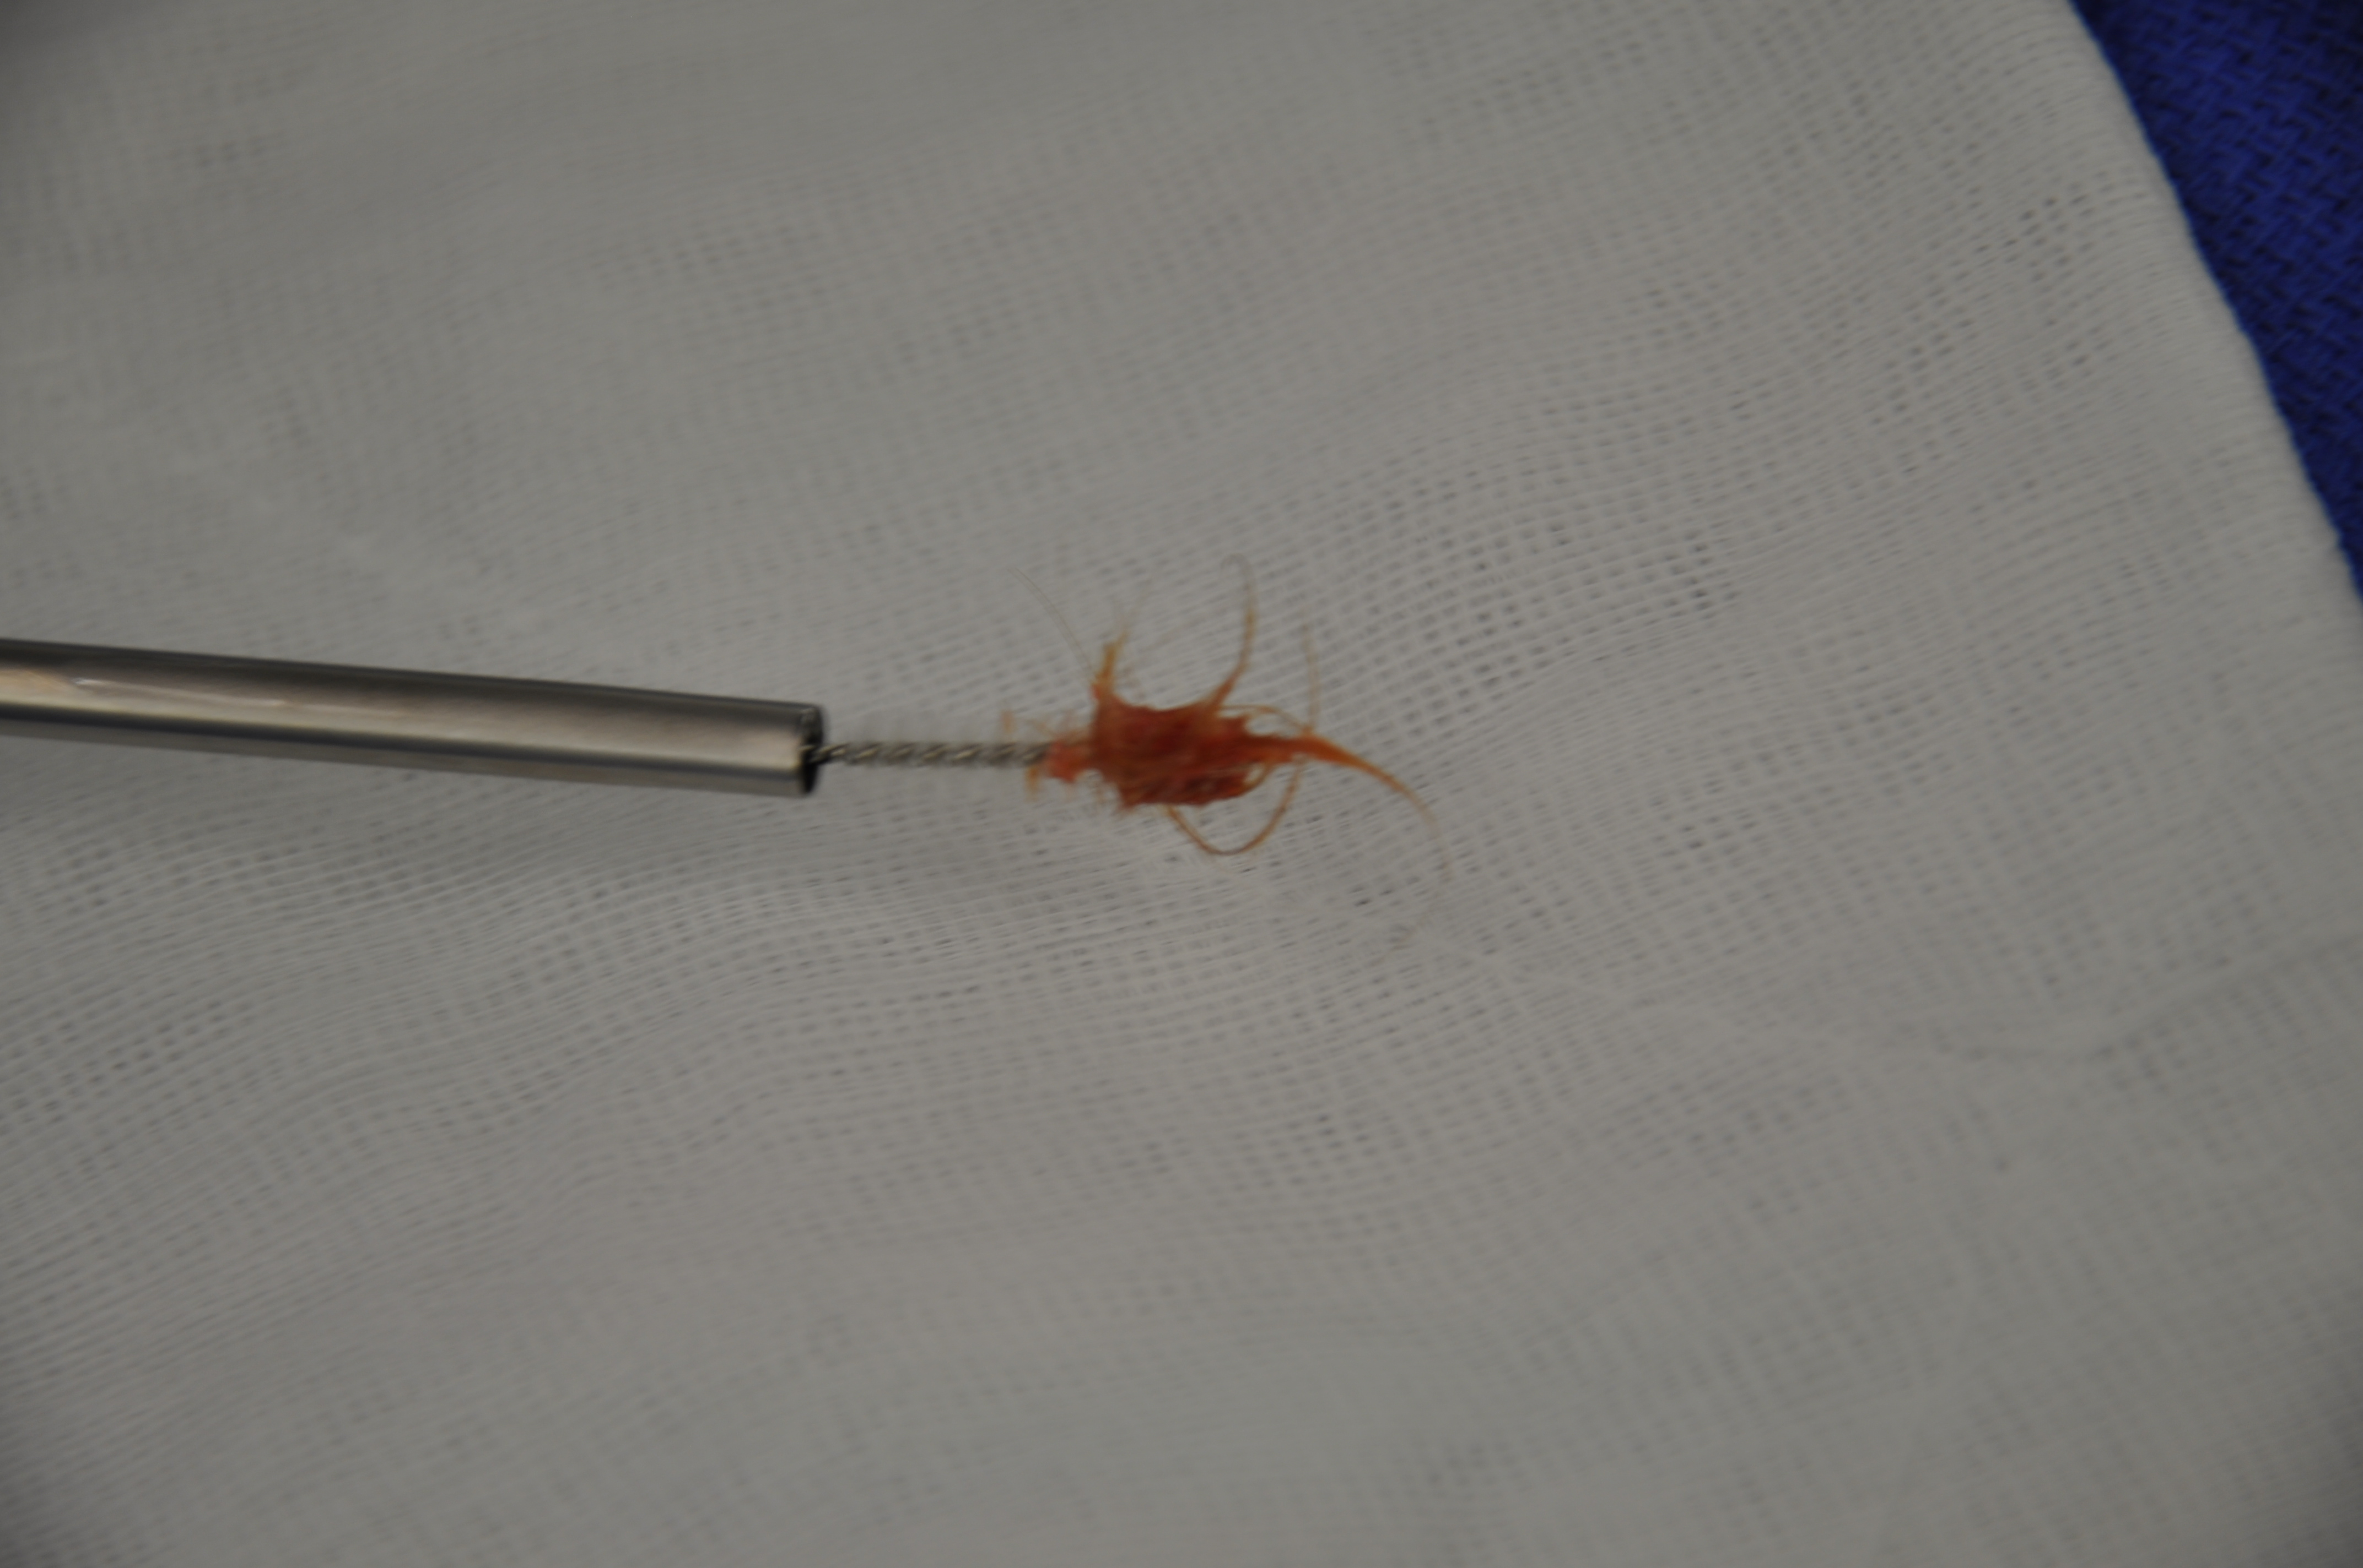
    - Pilonidal cyst infection (“abscess” or “acute” PND)
      - I&D, debride any involved hair, dressing
  - Management:
    - Recurrent PND (i.e. PN sinus or cysts that recur)
      - Excision of sinus and its tract (MOST CASES)
        - The wound is packed
        - The choice of wound closure is debatable as primary intention results in faster healing but higher RR while secondary/tertiary is slower but has a lower RR
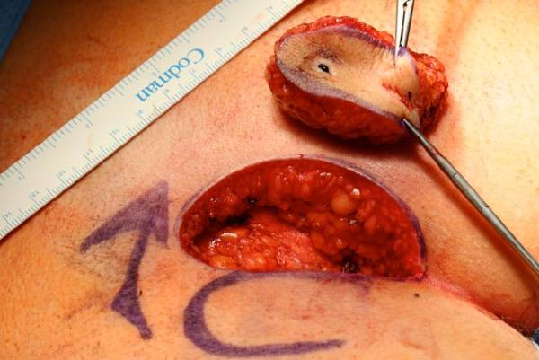
      - Marsupialization (laying open the tract and sinus)
      - In case of large skin deficits, doctors may practice reconstructive techniques using flaps
      - Antibiotics are only given in special populations:
        - Evidence of cellulitis
        - Prosthetic heart valves
        - High risk for endocarditis
        - Immunocompromised
        - Suspecting MRSA
- Anal cancer
  - Rare (1-2%)
  - More common in Western countries
  - Risk factors:
    - HPV infection
    - HIV
    - Cigarette smoking
    - Multiple sexual partners
    - Anal intercourse (homosexuals)
    - Immunocompromised
  - Carcinoma in situ
    - Paget’s disease (adenocarcinoma in situ)
    - Bowen’s disease (SCC in situ)
  - Types:
    - Anal margin tumors (can be seen)
      - SCC (MC type ~ 80%)
      - Adenocarcinoma
    - Anal canal tumors (may be missed)
  - Presentation:
    - Symptoms:
      - Anal bleeding (MC)
      - Local pain, swelling, mucus discharge and peri-anal pruritis (big DDx of hemorrhoids)
      - May be asymptomatic
    - Signs:
      - Mass may be obvious on gross inspection
      - You MUST examine for the local group of LN (e.g. superficial inguinal lymph nodes)
      - DRE exam and/or anoscopy might be necessary to inspect the anal canal (which can house a hiding tumor)
  - Investigations:
    - The importance of history is EXEMPLIFIED in anal cancer: if you don’t ask about the patient’s sexual history you may misdiagnose this as hemorrhoids or the like… Be considerate, everyone is different, so use your observation skills to understand what this patient has!
    - Diagnosis is confirmed by EXCISIONAL BIOPSY
    - Lab:
      - LFTs
    - Imaging/procedures (for staging):
      - CT scan of abdo/pelvis
      - CXR
      - Colonoscopy
  - Management:
    - Tumors & CIS ~ Excisional biopsy with wide local margins
    - If > 5 cm, we may also do:
      - Chemotherapy (5-FU, mitomycin C)
      - Radiotherapy (with post-radiation scar biopsy)
    - Prognosis:
      - Anal margin tumors have relatively good prognosis
      - Anal canal tumors have a poorer prognosis, especially if melanoma

HEPATOBILIARY SYSTEM

- LIVER ANATOMY
  - The liver is the LARGEST solid organ in the body
  - It fills the right hypochondrium and epigastric regions +/- left hypochondrium
  - Quick basics:
    - Parietal and visceral surfaces (the liver is very soft)
    - Parietal surface (superior and anterior):
      - Related to diaphragm mostly + part of anterior abdominal wall
      - Covered by visceral peritoneum except for the BARE AREA
        - This visceral peritoneum forms the liver capsule (AKA Glisson’s capsule)
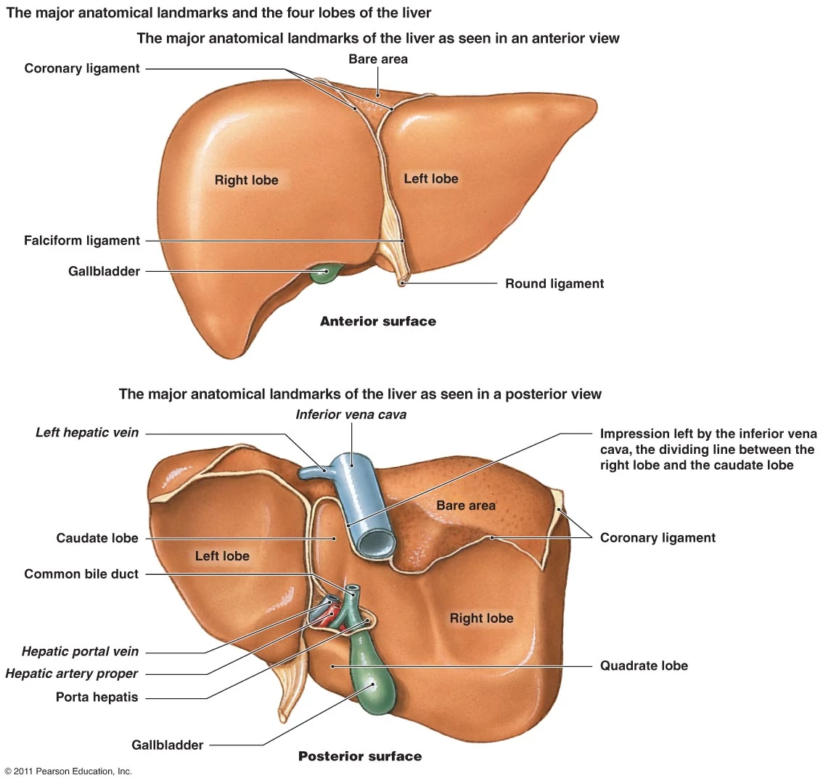
      - The visceral peritoneum reflects superiorly & anteriorly to produce a fold known as the falciform ligament, which attaches to the anterior abdominal wall
        - The ligamentum hepatis teres is contained in its lower free border; it attaches to the umbilicus and a part of the visceral surface of the liver
        - It represents the ligamentous remnant of the fetal umbilical vein
        - This ligament is surrounded by peri-umbilical veins that is normally non-significant
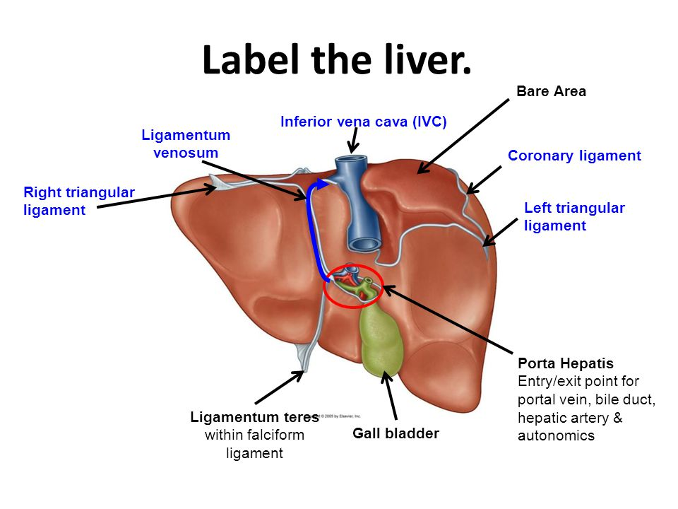
        - The falciform ligament divides the supra-hepatic space into right and left halves (the right communicates with the right para-colic gutter)
      - The visceral peritoneum at the dome of the liver divide to form the coronal ligament; laterally these condensations are known as the right and left triangular ligament
      - IVC lies posteriorly (retroperitoneal) and kind of hold the liver in suspension by the means of the hepatic vein

    - Visceral surface (inferior and posterior):
A remnant of the ductus venosus in the visceral surface is called the ligamentum venosum.
      - Left side anterior surface of stomach
      - Right side:
        - Gallbladder anteriorly (it has a fossa for it, and is normally adherent with adhesions)
          - Quadrate lobe is the one between the gallbladder and ligamentum teres
Quadrate or caudate lobe?
Think of cava for caudate, so the one posteriorly near the SVC is the caudate. The one anteriorly near the gallbladder is the quadrate.
          - The gallbladder and quadrate lobe are related to the 1st and 2nd part of the duodenum
          - The gallbladder lies anterior to the 1st part of the duodenum
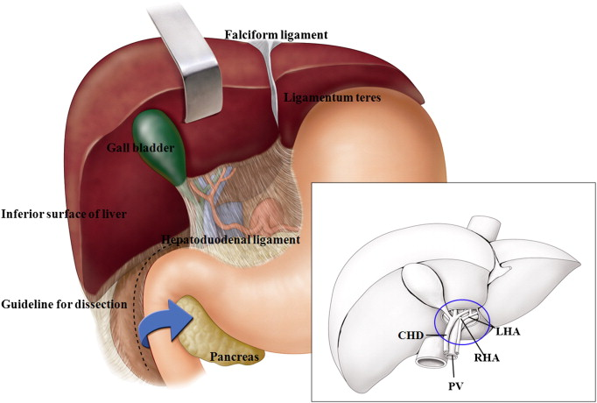
        - Right colonic flexure (“hepatic” flexure)
        - Right kidney
          - Hepatorenal (Morrison’s) pouch is a potential dependent space in the supine position
    - Hilum of the liver
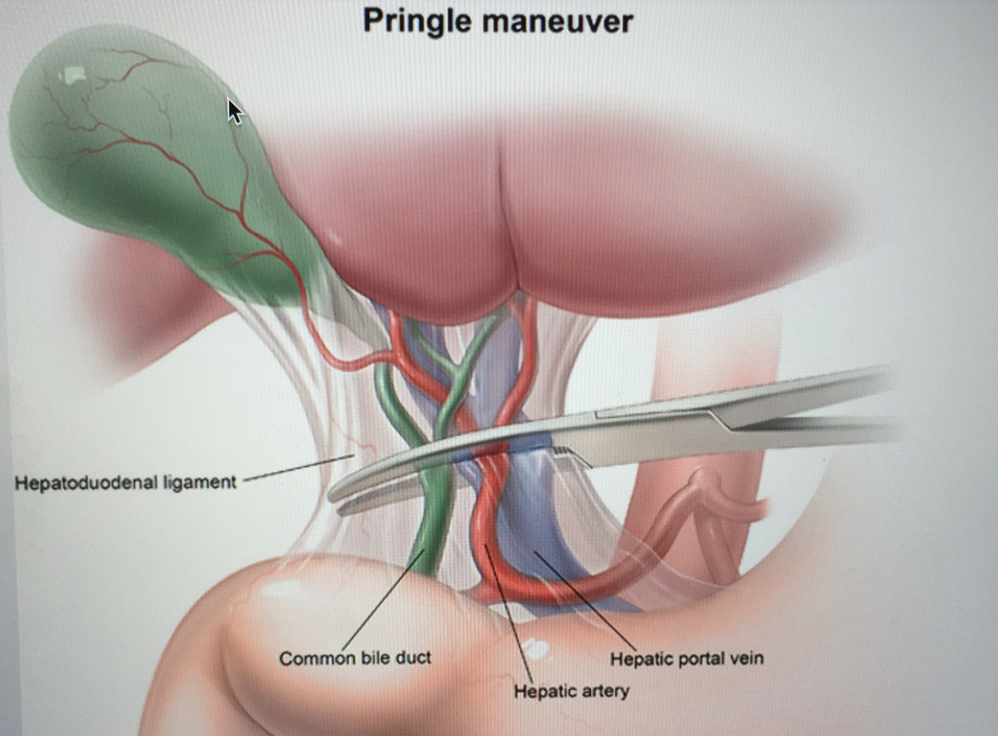
      - The portal triad runs in the hepatoduodenal ligament (the free border of the lesser omentum), behind of which is the foramen of Winslow that connects the greater peritoneal space to the lesser space
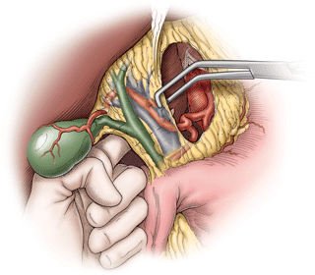
      - Importance = PRINGLE MANEUVER (clamp the hepatoduodenal ligament to stop bleeding in liver)
      - Portal triad includes:
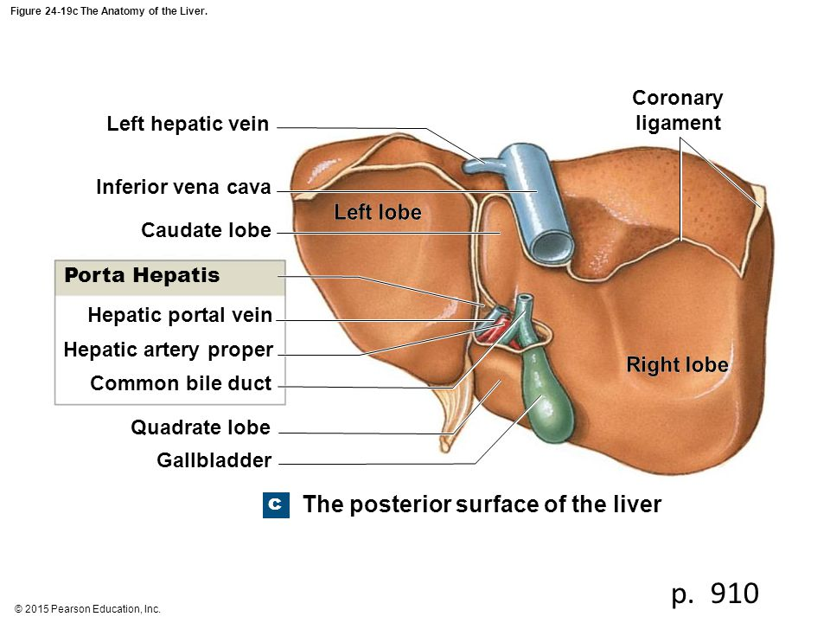
        - 1= Hepatic portal vein (the product of the splenic and the superior mesenteric vein meeting behind the neck of the pancreas)
        - 2 =Hepatic artery proper (HA) (from celiac trunk)
        - 3 = Common bile duct (CBD)
      - The arrangement is:
        - The LARGE portal vein posteriorly
        - The TINY CBD and HA anteriorly
        - The 3 of them divide into R & L branches when approaching the hilum
        - Their entry = PORTA HEPATIS
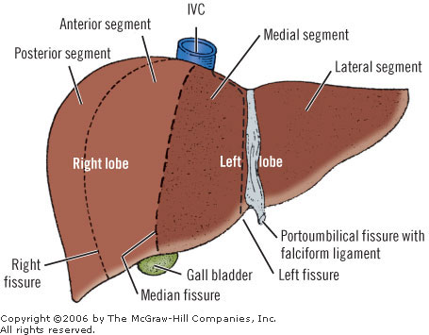
      - Hepatic blood supply vs oxygen:
        - 75% is from portal vein
          - Supplies 50% of O₂
        - 25% is from hepatic artery
          - Supplies 50% of O₂
        - Liver is drained into the HEPATIC VEIN (HV), which enters the IVC

    - Lobes of the liver
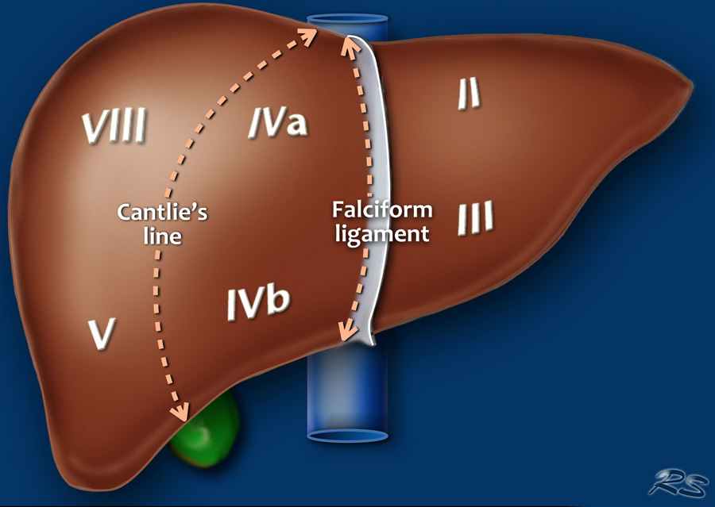
      - The liver can be divided into R & L lobes based on:
        - Blood supply
          - Cantlie line: imaginary vertical line at the level of the SVC and gallbladder (lies more to the right than the anatomical lobes)
        - Anatomy (the falciform ligament)
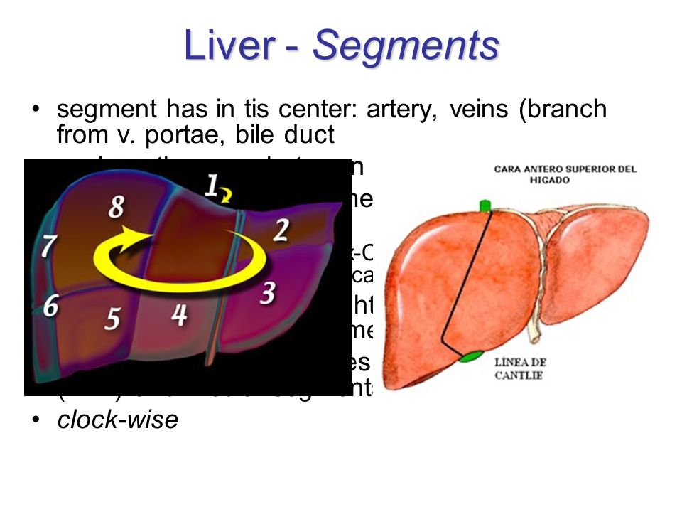
      - The liver can be further divided into SEGMENTS, it is best remembered by knowing that it arranged in a CLOCKWISE pattern from posterior to anterior (see picture)
        - Lobe 1 = caudate
        - Lobe 4 divided into A and B (A is higher up)
        - There are 8 lobes

- INVESTIGATIONS TO KNOW ABOUT:
  - Liver function tests (LFTs)
    - ALT & AST:
      - ALT = alanine aminotransferase = SGPT
      - AST = aspartate aminotransferase = SGOT
      - Enzymes found in hepatocytes that leak out into circulation when there is hepatic damage ACUTELY
      - Alcoholic steatohepatitis: AST:ALT ratio >2:1
      - ALT is the MOST specific for hepatocyte damage
      - How high is it?
        - 100s (cirrhosis or chronic hepatitis)
        - 1000s (viral or alcoholic hepatitis)
        - 10,000s (toxicity: e.g. acetaminophen or alcohol)
    - ALP & GGT:
      - ALP = alkaline phosphatase; GGT =gamma glutamyl transferase
      - High specificity for cholangiocyte injury/damage
  - Ultrasound
    - BEST imaging tool for GALLBLADDER visualization:
      - Most stones are cholesterol stones (visible on US)
      - Can look into the proximal CBD & cystic duct BUT NOT the part behind the duodenum
      - Can INDIRECTLY tell you about distal obstruction by seeing DILATED proximal ducts

  - Cholangiogram (visualizing bile duct)
    - Forms:
      - ERCP (see later)
      - T-tube cholangiogram (A tube is inserted intra-OP)
      - PTC (percutaneous transhepatic cholangiography; we pass a needle into the liver parenchyma and into the bile duct)
      - Intra-operative cholangiogram (IOC) w/o tube
    - The same routes may be used to drain bile ducts

  - HIDA scan:
    - Hepatobiliary iminodiacetic acid scan (in case any doctor is a jerk )
    - RBCs tagged with Technetium 99 is injected IV
      - This will be taken up by LIVER GALLBLADDER CBD spilled into duodenum
      - Timed radiographs (in minutes) are taken to see this sequence occurring
      - Absent uptake = DYSFUNCTION or BLOCKAGE
  - ERCP
    - Endoscopic retrograde cholangiopancreatography
    - Often done with sphincterotomy (papillotomy)
    - Diagnostic and therapeutic roles:
      - CBD stone removal (using basket/stent)
      - Cholangitis decompression
      - Choledochal cyst removal (type 3)
    - 1% risk of iatrogenic acute pancreatitis
    - MRCP is better and doesn’t expose to radiation; more $$$$
- ROLE OF BILE:
  - What is bile composed of? (Typical question)
    - 1 = Bile salts and acids (50%)
      - Important for fat emulsification to allow for more surface area to absorb in the small intestines in the form of micelles
      - ADEK = fat-soluble vitamins that need adequate bile for absorption
    - 2 = Phospholipids (40%)
      - Lecithin
    - 3= Bile pigments (Conjugated bilirubin, little)
    - 4= Cholesterol
  - Principles of bile stone
    - MC is cholesterol supersaturation and precipitation (cholesterol stones)
    - In patients with chronic hemolysis, supersaturation is with bilirubin (resulting in bilirubin or pigmented “black” stone)
    - If pigmented stones get infected, brown stones develop
    - In the case of CD, calcium oxalate stones develop
  - MOST BILE IS RE-ABSORBED in the terminal ileum (95%) = entero-hepatic circulation
  - Gallbladder contracts in response to CCK (cholecystokinin) which is released by duodenal cells (secondary to intra-luminal dietary fats and amino acids)
    - Contraction against a stone blocking the gallbladder outflow results in biliary colic

- Jaundice
  - Yellowish discoloration as a result of elevated bilirubin (typically > 2.5 g/dL)
  - The first location of jaundice = under the tongue
  - DDx:
    - Pre-hepatic (lemon-yellow):
      - Hemolysis and UDP-glucuronyltransferase enzyme deficiency (e.g. Gilbert, Criggler Najjar)
    - Hepatic (mixed):
      - Hepatitis, alcoholic cirrhosis, toxicity
    - Post-hepatic (olive green):
      - Cholestasis (“obstructive” jaundice)
      - Develops jaundice, pale stools, dark colored urine, pruritis, xanthomas, N&V
      - Causes: choledocholithiasis, PSC, PBC, choledochal cysts, cancer of head of pancreas
- Lobectomy:
  - Right hepatic lobectomy (usually removed until Cantlie line)
  - Left hepatic lobectomy (everything to the left of Cantlie line)
  - Right trisegmentectomy (until anatomic division)

LIVER

- LIVER INJURY
  - MC abdominal organ involved in penetrating trauma, 2nd MC organ involved in blunt trauma (after spleen!)
  - Can be detected on FAST or CT Abdomen
  - Management:
    - Penetrating = operative
    - Blunt = trial of observation if stable (if not, operative)
  - Operative principles:
    - Laparotomy
    - Direct pressure and packing
    - Pringle maneuver (but NOT for > 20 minutes)
    - Debridement, omental pedicle, drains
    - If too bloody damage control surgery (close and planned RE-OP in 24-36 hours)

- HEPATIC ABSCESS
  - Causes:
    - Pyogenic
    - Amebic
    - Fungal (rare)
  - Affects right lobe > left

  - Route of entry:
    - Direct spread (biliary tract infection/portal spread/site of trauma)
    - Systemic spread (hematogenous)

  - PYOGENIC (BACTERIAL) ABSCESS:
    - Common organisms:
      - Polymicrobial
      - G-ves: E. coli, proteus, klebsiella
    - Common sources:
      - Ascending cholangitis (MC)
      - Portal vein (diverticulitis, appendicitis)
      - Sepsis (IVDU, osteomyelitis, etc.)
      - They oven develop at liver cysts, hematomas, etc.
    - Presentation:
      - Signs of toxemia (fever, chills, septic-like picture)
      - Jaundice
      - RUQ pain and tenderness
      - Tender hepatomegaly
    - DDx of RUQ pain (include RLL pneumonia and right pleural effusion/empyema)
    - Investigation:
      - Lab:
        - CBC (leukocytosis)
        - CRP (elevated)
        - LFTs (elevated)
        - Hepatitis serology (R/O hepatitis)
        - Urinalysis, C&S (R/O right kidney problem)
      - Imaging:
        - RUQ US (good initial)
          - Liver and kidney examined
        - CT Abdo/chest (may show right sided pleural effusion that can be an effect of liver abscess)
      - Location of abscess:
        - Most are in right lobe, but beware of the position of abscess in left lobe (near pericardium) or near surface (risk of rupture into peritoneum)
    - Management:
      - A, B, Cs
      - IV broad spectrum antibiotics (ceftriaxone + metronidazole) for 4 – 6 weeks
Liver abscesses may produce local effect to the right lower pleura (e.g. chest symptoms may occur such as reduced chest expansion, reduced tactile fremitus, stony dullness (effusion), reduced breath sounds. It can be due a direct extension or reactive effect.
      - CT/US guided percutaneous drainage
        - Send drained pus for C&S
        - Change antibiotics to appropriate ones, PO
      - Operative drainage if above fails or if MULTIPLE
  - AMEBIC ABSCESS:
    - Cause?
      - Entamoeba histolytica
    - Source?
      - Feco-oral spread to GIT
      - Arrives from intestinal amebiasis (E. histolytica causes bloody diarrhea, flask-shaped intestinal ulcers, gain access to the portal circulation)
    - Risk factors?
      - Institutionalized
      - Male homosexuals
      - Immigrants
    - Presentation:
      - Symptoms:
        - RUQ pain
        - Fever (but not too high and no chills: patient not all too toxic)
        - Hx of diarrhea (may be bloody)
      - Signs:
        - Tender hepatomegaly
    - Investigations:
      - Same as above
      - SEROLOGY for E. histolytica
    - Management:
      - A, B, Cs (if appropriate)
      - IV metronidazole (DOC)
      - Percutaneous drainage ONLY IF:
        - Refractory to metronidazole
        - Peritoneal rupture risk
        - Co-infection
      - Drainage classically described to be achovy paste like (because it elicits liquefactive necrosis; it is sterile)

- HYDATID CYST
  - Etiology:
Hydatid is a VERY common, especially in small communities of Saudi Arabia.
A definite host is one where the male and female parasites sexually reproduce to form the eggs, which is excreted in the feces and infects water. Most of the time a sheep will get infected, and when it dies, a dog feeds on it and then the cycle repeats. Humans are accidental hosts when they ingest the EGGS. The cyst then forms in the human, reproducing asexually to create daughter cysts. These daughter cysts cannot theoretically infect other people, because you need to eat the egg!
    - Echinococcus granulosus or multilocaris
    - It is a parasite (tapeworm)
    - Source = infected animal feces (feco-oral)
      - Definitive host = dog (passed in dog stool)
      - Intermediate host = sheep
      - “Accidental” host = human
      - Ingestion of infected veggies with excreta
  - Risk factors:
    - Foreign travel (not RECENT, maybe years ago)
    - Exposure to infected animals
  - Presentation:
The cyst is formed by an ectocyst (body reaction) and endocyst (thin lamellar live membrane that produces the daughter cyst). Most common location for the cyst is the right lobe periphery (risk of rupture). It may rupture into the bile ducts, peritoneum (anaphylaxis), and pleura. THE GROWTH RATE IS SLOW, ABOUT 2-3 CM/YEAR, so a recent Hx of travel does not play a role.
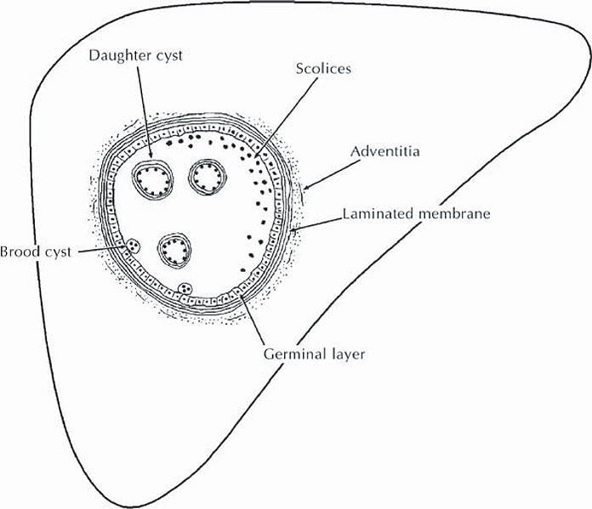
    - Asymptomatic (found incidentally on imaging)
    - Vague RUQ pain
    - Patients may have anaphylactoid symptoms (allergic symptoms)
    - However, complications of LIVER CYST:
      - Rupture (results in fatal anaphylaxis)
      - Cholangitis (cysts obstruct bile duct)
      - Secondary infection
    - Respiratory symptoms if has alveolar cysts in the lung
    - CNS symptoms if has a brain cyst
    - P/E findings:
      - Hepatomegaly
      - Hydatid thrill on palpation (vibration of daughter cells) is rare, but pathognomonic
  - Investigations:
    - Lab:
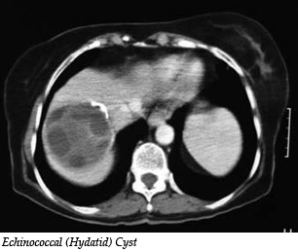
      - CBC (eosinophilia)
      - Serology (Anti-echinococcus IgG Ab)
      - LFTs
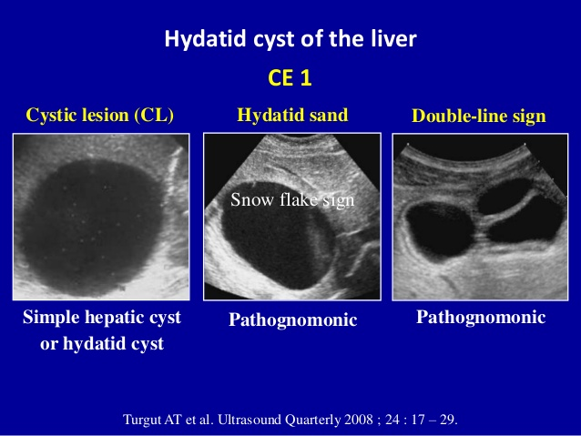
    - Imaging:
      - Liver US (virtually diagnostic):
        - Snowflake sign (hydatid “sand”)
        - Double-line sign (looks like chambers)
        - Outline is calcified (means dying)
      - CT scan (study anatomy, size, prepare for surgery)
    - Others:
      - Previously, a “Casoni” skin test was used
  - Management:
    - Surgical Rx:
      - Especially if risk of rupture imminent (location-wise)
Intra-OP, you need to be very careful to protect yourself and the patient’s body from dropping cysts, so we drape the body with hypertonic saline gauze, and we wear face shield too.
      - Peri-operative albendazole (monitor WBC &LFTs)
        - 7 days pre-OP
        - 28 days post-OP (just remember 1 month)
      - Our biggest concern is that any spillage during surgery can result in fatal anaphylaxis
      - Always have IV/IM epinephrine prepared during Rx just in case
      - Surgical resection
        - Need good visualization
        - Scolicidal agent is injected (20% hypertonic saline to kill daughter cyst)
        - Easily enucleated, usually clear
        - Risk of residual cysts implanting during surgery
      - “PAIR” = Puncture-Aspirate-Inject-Reaspiration
- LIVER TUMORS
  - BENIGN liver tumors:
    - Cavernous hemangioma
    - Focal nodular hyperplasia (FNH)
    - Hepatocellular adenoma
  - MALIGNANT liver tumors:
    - 1 = Metastatic (CRC > lung & breast)
    - 2 = PRIMARY tumors
      - Hepatoma/Hepatocellular cancer (HCC)
      - Angiosarcoma (Polyvinyl carbons use)
      - Hepatoblastoma
      - Cholangiocarcinoma (spread)

- BENIGN LIVER TUMORS

  - Cavernous hemangioma
    - MC benign liver tumor
    - Symptoms:
      - Asymptomatic
      - RUQ pain
    - Signs:
Pearls:
CAVERNOUS HEMANGIOMA
MC benign liver tumor

Bleeding, jaundice, infection, thrombocytopenia, rupture
Do not biopsy (fatal hemorrhage risk)
US or CT w/contrast
Surgical resection ONLY IF symptomatic (otherwise, serial imaging)
      - Hepatomegaly
      - RUQ bruit (bloody tumor!)
    - Complications:
      - Obstructive jaundice
      - Hemorrhage
      - Consumptive coagulopathy
        - Kasabach-Merritt syndrome (hemangioma + thrombocytopenia + fibrinogenemia)
      - Rupture
      - Infection
    - Investigations:
      - Lab
        - CBC (platelet levels)
        - LFTs
      - Imaging:
        - Liver US homogenous, hyperechoic mass
        - CT scan w/ contrast
    - What should you NOT do?
      - BIOPSY
      - It may result in fatal HEMORRHAGING
    - Management:
      - Asymptomatic monitoring (serial US imaging)
      - Symptomatic surgical resection

  - Hepatocellular adenoma
    - Benign proliferation of hepatocytes WITHOUT bile ducts
    - Risk factors:
      - OCP use
      - Anabolic steroids
      - Glycogen storage disease
    - Typical patient = women of childbearing age
Pearls:
Hepatocellular ADENOMA

Proliferation of liver cells
RF = OCP, anabolic steroids
Woman of childbearing age
If asymptomatic and small, stop OCPs and anabolic steroids; if large surgical resection
RISK OF CANCER
    - Symptoms: RUQ pain/fullness
    - Signs: RUQ tenderness/mass
    - Complications:
      - Can bleed into it
      - Risk of HCC
    - Investigations:
      - Lab: CBC, LFTs
      - Imaging:
        - Ultrasound solitary, well-demarcated, HETEROGENOUS mass
        - CT scan w/ contrast
    - Management:
      - In all cases, ask them to stop OCP and anabolic steroid
      - If asymptomatic and small (< 5 cm) monitor
      - If symptomatic or large (>5cm) surgical resection

  - Focal nodular hyperplasia (FNH)
    - Benign hepatic tumor composed of hepatocyte AND bile ducts
    - F > M; 40s
Pearls:
FNH:
No increased risk of cancer
Imaging shows a CENTRAL SCAR
    - Also associated with OCPs, but NOT as much as HC adenoma
    - Usually fed by a single artery source (important therapeutic principle)
    - Symptoms as for adenoma
    - Investigations:
      - Same
      - US and CT shows a CENTRAL SCAR
    - Management:
      - NO risk of developing cancer
      - Symptomatic surgical resection
      - Embolization of main feeding artery is a possibility

- Hepatocellular carcinoma (HCC)
  - AKA Hepatoma
  - MC primary malignant liver cancer
    - The most common malignancy in the liver overall is METASTATIC (MC source = CRC; followed by lung and breast)
  - M>F
  - 50s-60s
  - Risk factors:
    - Cirrhosis (only 5% develop HCC!)
      - Chronic viral hepatitis (hepatitis C, B)
      - Alcoholic cirrhosis
      - Hemochromatosis, A1AT deficiency, Wilson’s disease
    - Others
      - Smoking
      - Carbon tetrachlorides
      - Liver flukes (shistosoma)
      - Aflatoxins (aspergillus fumigatus)
  - Presentation
    - Symptoms:
      - RUQ pain
      - Weight loss
      - Symptoms of polycythemia (headache, vision disturbances)
    - Signs:
      - Signs of portal HTN/liver failure
      - Bruit may be heard because vascularity of tumor
      - Tender hepatomegaly (DDx of tender hepatomegaly)
      - Splenomegaly
  - Investigations
    - Diagnosis is made with BIOPSY
    - Lab:
      - CBC (polycythemia?)
      - LFT (albumin, coagulation profile/PT)
      - a-FP = tumor marker
    - Imaging:
      - Liver US (initial)
      - CT (plays a role in staging)
    - CT/US guided liver biopsy
  - Management:
    - If early and non-cirrhotic lobectomy with wide margins
    - Liver transplant is considered if:
      - Cirrhotic patient
      - Non-resection candidate
      - NO LN involvement
      - NO vascular involvement
      - Fulfills Milan criteria:
        - 1 site <5 cm
        - 3 sites, but <3 cm each
    - Unresectable tumors have a VERY POOR PROGNOSIS

BILIARY SYSTEM

- ANATOMY
  - Cystohepatic triangle vs Calot’s triangle
    - Cystohepatic triangle
      - Borders include the LIVER, cystic duct and common bile duct
      - The cystic artery crosses through this triangle
    - Calot’s triangle
      - It is a smaller part of the cystohepatic triangle
      - Its boundaries are the CBD (medially), cystic artery superiorly, cystic duct laterally
  - Gallbladder:
    - Parts:
      - Fundus
      - Infundibulum (Hartmann’s pouch)
        - Joins the cystic duct
    - Additional points:
      - Connects to the liver directly by the way of the Ducts of Lushka (receives bile components thru this)
  - Cystic duct joins the common hepatic duct (also referred to as common bile duct) to produce the common bile duct
    - Cystic duct contains spiral valves (of Heister)
  - Cystic artery arises from the hepatic artery
  - Surgical anatomy:
    - Surface anatomy of gallbladder:
      - Follow rectus abdominis muscle’s linea semilunaris up to where it meets the right lower most rib (9th)
      - OR go to the right subcostal border at the level of MCL
    - Laparoscopic “critical view of safety”
      - The gallbladder lies on the liver visceral surface, with the cystic artery and duct exposed (freed from adhesions)
      - Calot (Ludig) node lies in between the artery and duct
    - Laparoscopic ports/trochar sites:
      - First: infraumbilical (for camera)
      - Second: RUQ (for assistant, to hold gallbladder in place)
      - Third: LUQ (for surgeon)
    - Surgical incision = Kocher incision (right hypochondriac)
    - Steps of cholecystectomy:
      - Achieve critical view of safety (free the cystic duct, artery from adhesions and hold fundus of gallbladder)
      - Staple and then ligate the cystic artery and duct
      - Free gallbladder from liver bed
      - Pull the gallbladder out through the umbilical trochar
      - Highest likelihood of damage is to the RIGHT branch of the hepatic artery

- CHOLELITHIASIS
  - AKA gallstones
  - 10% of US population will develop it
  - Pathophysiology (often asked):
    - Imbalance between components of bile (supersaturation)
    - Biliary stasis
  - Types of stones:
    - Cholesterol stones (MC ~85%)
      - Non-pigmented stone
      - Bile supersaturation with cholesterol, especially in patients with obesity, having fatty rich meals, etc.
    - Bilirubin stones (15%)
      - Pigmented stones
      - Excessive conjugated bilirubin in gallbladder
      - Occurs in patients with hemolysis (E.g. HS, SCD) in which a lot of unconjugated bilirubin gets conjugated
      - Calcium bilirubinate = black stones
      - Infected bilirubin stones (biliary infection) = BROWN stones
      - 15% of these stones are calcified enough to appear on radiograph
    - Calcium oxalate stones (in CD patients)
  - Risk factors:
    - Female, Fat, Fertile, Forty, Flatulent (5Fs)
    - Obesity
    - Rapid weight loss
    - Hyperlipidemias
    - Hemolytic anemia (e.g. SCD)
    - Crohn’s disease
    - Terminal ileum resection (low enterohepatic circulation)
    - TPN
  - Presentation
    - ASYMPTOMATIC (risk of symptoms 1%/year)
      - MOST patients do NOT have symptoms
      - They are identified incidentally on imaging
    - SYMPTOMATIC GALLSTONES
      - “Biliary colic”
        - RUQ “colicky” pain that lasts for 1 – 3 hours
        - It is not a true colic (they have a persistent background pain that is accentuated from time to time)
        - The pain is usually steady, dull with episodes of increased severity
Very important to ask about timing (< or > 3/6 hours) and duration, relation to fatty meals, pain in other sites, previous Hx of same pain (rate: 3/month), N&V
        - Typically FOLLOWS FATTY MEALS (CCK secreted, causes gallbladder to contract against blockage)
      - Referred pain to the right shoulder or inferior scapula (“Boas” sign)
        - Irritation of diaphragm phrenic nerve
      - +/- N&V
    - COMPLICATED GALLSTONES:
      - These patients present to you with the complications that made you find gallstones in the gallbladder
If a patient has a classical biliary colic, stable and there is jaundice, it can only be CBD stone or Mirrizi syndrome. Otherwise, the picture is more severe (e.g. acute cholangitis, cholecystitis, pancreatitis)
      - Choledocholithiasis (obstructive jaundice)
      - Acute calculous cholecystitis
      - Ascending/Acute cholangitis
      - Acute pancreatitis (gallstone pancreatitis)
      - Hydrops gallbladder (complete cystic duct obstruction, leads to fluid filled gallbladder [not bile])
      - Mirrizi syndrome (external compression of CBD by large stone in the cystic duct jaundice)
      - SBO (gallstone ileus)
      - NOTE: they have higher risk of developing gallbladder cancer
  - Investigations
    - Lab:
      - CBC (cholecystitis or cholangitis?)
When taking history:
O, C, D
SOCRATES
Must ask about relation to meals and type of meals, weight loss, positioning
Shoulder and scapular pain
GI symptoms (history of PUD, reflux, N&V, bowel movements)
HB symptoms (itchiness, pale stools)
GU symptoms (dark urine, dysuria)
Chest (cough, cardio history)
Constitutional symptoms (e.g. fever, chills, weight loss)
Hx of travel, unusual activities, alcoholism, …
      - LFTs (hepatitis, cholestasis)
      - Amylase, lipase (acute pancreatitis?)
      - Urinalysis (R/O UTI/stone)
    - Imaging:
      - Gallbladder US (fasting patient, to fill gallbladder)
        - Acoustic SHADOW (“headlight”)
        - Gravity-dependent movement on patient repositioning
        - Must assess proximal CBD for stone (if distal blockage, the proximal CBD will be dilated)
      - CXR (R/O RLL pneumonia)
    - Others:
      - ECG (R/O inferior wall MI)
  - Management:
    - Asymptomatic regular patient? NONE
      - If they don’t have symptoms, don’t treat

    - Mildly symptomatic? Analgesia, lifestyle changes
    - Severely symptomatic or developed complications or is a high-risk patients?
      - Analgesia (based on WHO analgesic ladder; they say try to avoid morphine because it contracts Sphincter of Oddi, but studies are poor for this)
      - Pre-operative IV broad-spectrum antibiotic (clean-contaminated surgery)
      - Laparoscopic cholecystectomy (if not CI)

    - INDICATIONS FOR CHOLECYSTECTOMY IN PATIENTS WITH GALLSTONES? (Common trick question)
      - 1 = Only if severely symptomatic, OR
      - 2= Asymptomatic in SPECIAL POPULATIONS:
        - Chronic hemolytic anemias (e.g. SCD)
        - Pediatric patients
        - Immunocompromised
        - LARGE stone (> 2 cm)
        - Porcelain gallbladder also incidentally found
      - 3= COMPLICATIONS
        - Obstructive jaundice (choledocholithiasis)
        - Acute cholecystitis (either within 48/72 hours OR interval cholecystectomy in >6 weeks)
        - Acute cholangitis
        - Gallstone pancreatitis
        - Gallstone ileus

    - Are there any medications that can help dissolve stones?
      - Yes, ursodeoxycholic acid

- CHOLEDOCHOLITHIASIS
  - Stone in the CBD
  - Complication of gallstones
Cholestasis results in fat-soluble vitamin deficiency: vitamin K deficiency can cause a bleeding tendency. This has an important surgical impact.
  - Presentation:
    - Biliary colic symptoms
    - Cholestasis (obstructive jaundice, pale stools, dark urine, pruritis, bleeding tendency)
    - Complications (pancreatitis, cholangitis)
  - Investigations:
    - Lab:
      - CBC
      - LFTs
        - GGT, ALP will be elevated
        - High conjugated (direct) bilirubin

    - Imaging:
      - Ultrasound (may show more proximal stones and indirectly show distal stones)
      - ERCP (diagnostic and therapeutic)
      - CT
  - Management:
    - ERCP-guided sphincterotomy and basket retrieval of stone
    - If this fails, open surgery
      - CBD exploration, removal of stones
      - IOC and T-tube placement (to drain bile)
    - Interval cholecystectomy

- ACUTE CALCULOUS CHOLECYSTITIS
  - Inflammation of gallbladder (wall)
  - Due to obstruction of cystic duct or CBD by stone
  - Presentation:
    - Symptoms:
      - Steady, severe, sharp RUQ pain
        - Unlike colic, it lasts >3-6 hours
        - May have referred pain to shoulder or scapula
        - Increased with fatty meals
      - Fever
      - N&V
      - Hx of biliary colic (possibly for years)

    - Signs:
      - Fever and tachycardia (not as toxic as cholangitis)
      - RUQ tenderness (which may be rebound)
      - Murphy’s sign (inspiratory arrest when RUQ is palpated during inspiration)
      - Palpable tender gallbladder (33%)
  - DDx:
    - GI & HB:
      - Cholangitis
      - Pancreatitis
      - Hepatic abscess, hepatitis
      - Perforated duodenal ulcer
      - Acute appendicitis (yes! Sometimes, high retrocecal appendix)
    - GU:
      - Pyelonephritis or renal stone
    - Chest:
      - RLL pneumonia +/- inferior wall MI

  - Complications of acute cholecystitis:
    - Empyema of the gallbladder
    - Perforation bile peritonitis
    - Hepatic abscess
    - Cholecystoenteric fistula (repeated attacks) and gallstone ileus
    - Gangrenous cholecystitis
    - Emphysematous cholecystitis (DM elderly patients)
    - Hydrops gallbladder
    - Gallbladder cancer risk

  - Investigations:
    - Lab:
      - CBC (leukocytosis) +/-ESR
      - LFTs (if affected, consider cholangitis + cholecystitis)
      - Amylase/lipase (R/O pancreatitis)
      - Urinalysis (R/O pyelonephritis)
      - RFTs and electrolyte panel
    - Imaging:
      - CXR (R/O air under diaphragm)
      - RUQ ultrasound (Required for Dx)
        - Enlarged gallbladder (size and lumen)
        - Wall is thickened (> 4 mm)
        - Peri-cholecystic fluid
        - Stone in cystic duct
        - Sonographic murphy’s sign (painful US exam)
      - ECG
      - HIDA is helpful but NOT DONE because we have better tools like US that are easier and safer to use
        - Shows non-filling of gallbladder
  - Management:
    - ABCs (IV fluids, correct electrolyte disturbances)
    - NPO
    - IV antibiotics (contaminated)
Problems during cholecystectomy:
Tiny stones may be missed (“retained stone”) and enter the CBD (leading to post-op RUQ pain, obstructive jaundice and cholangitis, do LFT and look at direct bilirubin). Stone may also get lodged into ports when gallbladder is being removed, which results in a foreign body reaction (delaying wound healing, so always check wounds POST-OP). Also bile leakage. A bag is used to pull out the gallbladder. YOU MUST SEND THE GALLBLADDER for histopathology and talk about the results for the F/U surgery appointment, when you will also check the wound and remove the sutures.
    - IV analgesia
    - If presents within 48-72 hours:
      - Urgent laparoscopic cholecystectomy
      - If complicated, convert to open cholecystectomy
    - If presents >72 hours:
      - Continue conservative management with surveillance
      - Interval (delayed) cholecystectomy (>6 weeks)
      - Why?
        - The tissues will be very friable, very inflamed and adhesive, making surgery difficult after 72 hours
      - If patient deteriorates, do surgery in any case:
        - May perform cholecystectomy
        - If not feasible, debride and cholecystostomy for now
- ACALCULOUS CHOLECYSTITIS
  - Cholecystitis but on imaging, there are no stones (rarely, 10-15%)
  - Possible causes/risk factors:
    - Principle = biliary STASIS or HYPOPERFUSION
      - Hospitalization/ICU patient
      - NPO
      - On TPN
      - Dehydration
      - Prolonged post-OP stay
      - Trauma patient
  - Presentation and investigations are as acute calculous cholecystitis, however consider the above settings
  - US findings:
    - NO stone
    - BILIARY SLUDGE may be seen
  - Management:
    - A, B, Cs
    - Urgent cholecystectomy

- GALLSTONE ILEUS:
  - SBO at ileocecal valve by a gallstone received through the duodenum by a cholecystoenteric fistula
    - Size usually > 2 cm (2-3 cm)
  - Develops secondary to cholecystitis
  - Typical patient = woman > 70 years old
  - Patients with present as SBO (abdominal pain, distention, bilious vomiting and constipation)
  - Imaging:
    - Erect and supine AXR
      - Erect:
        - Air-fluid levels (step-ladder appearance)
        - Distal decompression beyond ileocecal valve
        - Pneumobilia (air in biliary tree)
      - Supine:
        - Air collected centrally
    - CT abdomen
      - Will show pneumobilia, the fistula and the stone (at transition point)
  - Management:
    - Exploratory laparotomy
      - Enterotomy, stone removal by milking
      - If the patient is stable, cholecystectomy may be done at this time (with fistulectomy)
      - If not, interval cholecystectomy may be done

- ACUTE CHOLANGITIS:
  - AKA ascending cholangitis
  - Bacterial infection of biliary tract proximal to an obstruction in the CBD by:
    - Intraluminal:
      - CBD stone/choledocholithiasis (MCC)
      - Biliary stenting
    - Intramural:
      - Strictures (Post-OP; Post-ERCP; PSC)
      - Cancer or choledochal cysts
    - Extra-luminal/compressive:
      - Mirrizi syndrome
      - Cancer of head of pancreas
      - Pancreatic pseudocyst
  - Bacterial causes:
    - E. coli (MCC)
    - Klebsiella
    - Proteus
    - Enterobacter
    - Pseudomonas
    - Enterococcus
    - Anaerobes (rarely)
    - Others
    - Remember: KEEPS (klebsiella, E coli, enterococcus, proteus, pseudomonas, serratia)
  - Presentation:
    - Symptoms:
      - RUQ pain
      - N&V
      - Fever (high grade), chills
      - Cholestasis-related (jaundice, dark urine, pale stool, pruritis)
    - Signs:
      - Unstable/toxic/shocked (tachycardia, high fever, low BP, dehydrated)
      - Jaundice
    - Charcot’s triad:
      - 1 = RUQ pain
      - 2 = Fever, chills
      - 3 = Jaundice

    - Reynold’s pentad:
      - Charcot’s triad AND
      - 4 = altered mental status
      - 5 = low BP

  - Investigations
    - It is done after patient is stabilized/ABC done
    - Lab:
      - CBC (leukocytosis in WBC count)
      - CRP (Raised)
      - Blood culture (septic picture: usually positive)
      - LFTs (elevated GGT, ALP, conjugated bilirubin)
      - Urinalysis, RFTs (R/O pyelonephritis; electrolyte panel)
      - Amylase/lipase (R/O pancreatitis)
    - Imaging:
      - RUQ ultrasound (best initial)
        - R/O extrinsic causes
        - Dilated CBD system (may also show obstruction)
        - Gallbladder may contain stones
      - ERCP (diagnostic, therapeutic, modality of choice)
        - If patient fulfills Charcot’s triad, you may do ERCP directly
        - Obstruction can be identified; pus may be seen oozing out of ampulla
        - May be suppurative (needs decompression) or non-suppurative
  - Management:
    - 1 = A,B,Cs (IV fluid resuscitation, blood drawn for investigations)
    - NPO
    - IV analgesics
    - IV antibiotics
      - 70 – 80% may respond to antibiotics, however, you need to Rx the underlying cause
      - Cephalosporin + metronidazole
    - 4 = Definitive Rx (early if suppurative or in shock)
      - ERCP-guided sphincterotomy and decompression with stone extraction, pus drainage +/- stent insertion
      - If above fails, percutaneous drainage (PTC)
      - If all else fails, surgery (CBD exploration, IOC, intra-operative T-tube insertion for drainage)
      - May need to do interval cholecystectomy
  - What is the mortality rate?
    - 50%!
- Gallbladder cancer
  - Most are ADENOCARCINOMA
  - Rare; occur in <1% of patient with gallstones
  - Age: >75 years old
  - Risk factors:
    - Gallstones
    - Cholecystoenteric fistulas
    - Porcelain gallbladder (MUST remove, 50% risk of cancer)
    - Typhoid carriers
  - MC site is gallbladder FUNDUS (60%)
  - Presentation:
    - ASYMPTOMATIC (until late)
    - Hepatobiliary symptoms
      - RUQ mass
      - RUQ pain
      - Jaundice (invasion of CBD)
    - Constitutional:
      - Weight loss
  - Metastasizes EARLY to the LIVER
  - Investigations:
    - Lab: CBC, LFTs
    - Imaging: US, ERCP
  - Management:
    - If it involves mucosa only OPEN cholecystectomy
    - Beyond mucosa OPEN radical cholecystectomy +/- chemo
      - Remove gallbladder, related liver lobes (4b, 5), LN dissection
    - DO NOT REMOVE IT LAPAROSCOPY (may result in tumor implants in the trochar site)
    - Prognosis is VERY POOR (<5% 5-year survival because most patients are diagnosed late when it is already metastatic or unresectable)

- Choledochal cyst (Quickly)
  - Maybe congenital or acquired
  - Increased risk to develop:
    - Cholangiocarcinoma (bad)
    - Cholangitis (bad)
  - Presentation:
    - Asymptomatic
    - Symptomatic
      - Cholestasis
      - Swelling (usually RUQ)
  - Classifications:
    - May involve intra-hepatic or extra-hepatic bile ducts or BOTH
    - I = fusiform dilation of extra-hepatic
    - II = saccular (side ways) dilation of extra-hepatic
    - III = dilation is near head of pancreas
    - IVa = multiple, intra and extrahepatic bile ducts involved
    - IVb = multiple, extra-hepatic bile ducts involved
    - V = multiple intrahepatic bile ducts (CAROLI disease)
  - Management depends on type:
    - Type 2 simple cyst excision
    - Type 3 Endoscopic resection
    - Type 5 (Caroli) Liver transplant
    - Other types may need extrahepatic bile duct resection with Roux-en-Y hepaticojejunostomy

- CHOLANGIOCARCINOMA
  - Adenocarcinoma of bile duct cells (cholangiocytes)
  - Typical location = bifurcation of hepatic ducts (proximal ducts)
  - Age ~ 55-65
  - RF:
    - Choledochal cysts
    - Primary sclerosing cholangitis
    - Liver flukes (e.g. clonorchiasis)
    - Agent Orange exposure
  - Presentation:
    - Cholestasis, cholangitis
    - Constitutional symptoms (weight loss)
  - Investigations:
    - US/CT
    - ERCP biopsy required
  - Bismuth classification:
    - You don’t really need to know it, Mohamed…
    - Just know that KLATSKIN tumor = involves bifurcation
  - Management:
    - Proximal resection + roux-en-Y anastomosis
    - Distal Whipple procedure
- Extra notes:
  - Complications of cholecystectomy
    - As always, say the general layout:
      - Anesthesia vs surgery (general [Immediate, early, late] or specific)
    - Of laparoscopy (e.g. introduction injury, air embolism, low BP)
    - Biliary leakage (leading to bile peritonitis)
    - Jaundice (stricture formation in CBD)
    - Post-cholecystectomy syndrome (still has some of the old pains after the surgery)
    - Residual pain also maybe retained stone; delayed wound healing (stone at SS)
PANCREAS

- Development
  - The pancreas develops from the foregut (endoderm) at the level of the duodenum
  - It first appears as a ventral and dorsal bud
    - Ventral bud mostly head of pancreas
    - Dorsal rest of it
  - The ventral bud then turns to fuse with the dorsal bud
    - The ventral bud gives rise to the proximal part of the main pancreatic duct
    - The dorsal bud gives rise to the rest of the pancreatic duct
  - Any deviation of this normal fusion result in congenital anomaly:
    - Pancreas divisum
      - Improper fusion resulting in the main pancreatic duct draining into the accessory duct, which is too small
      - It is the most common anomaly of the pancreas
      - May lead to chronic pancreatitis with acute on chronic episodes
    - Annular pancreas
      - Malrotation of the ventral bud resulting in a ring of pancreatic tissue around the duodenum
      - It is a cause of duodenal obstruction (DDx of duodenal atresia)
- Anatomy
  - Parts:
    - Head and uncinate process (behind SM vessels)
    - Neck
    - Body
    - Tail
  - The only part that is intraperitoneal is the tail (lies within splenorenal ligament); the rest of the pancreas is retroperitoneal
  - The tail is also abundant in islet cells of Langerhans
  - The SMA and SMV arise at the neck of the pancreas
    - The SMV joins the splenic vein here to produce the hepatic portal vein
  - The head contains the ampulla of vater (which is the entry point of both the common bile duct and main pancreatic duct) which enters the duodenum through the sphincter of Oddi
  - Blood supply:
    - Anterior and posterior superior pancreatoduodenal artery (from gastroduodenal artery)
    - Anterior and posterior inferior pancreatoduodenal artery (from SMA)
    - Splenic artery (Tortuous artery branching from the celiac trunk and running on the superior rim of the pancreas)
      - Gives rise to dorsal pancreatic artery
      - Also supply stomach thru the short gastric arteries and left gastroepiploic artery
    - Innervation:
      - Sympathetic: celiac plexus of nerves
      - Parasympathetic: secretory function thru Vagus nerve
  - Physiology:
    - Secretin (from duodenal cells) stimulates release of pancreatic HCO₃ from exocrine glands (centroacinar and ductal cells) making the intestinal contents less acidic, allowing the secreted enzymes to work appropriately
    - Acinar cells in pancreas secrete inactive enzymes (zymogens) that are activated by enterokinases present in duodenum
      - Includes chymotrypsinogen, trypsinogen, carboxypetidase, amylase, lipase

- ACUTE PANCREATITIS
  - Etiology:
    - Top 3:
      - 1 = Gallstones (in ME)
      - 2 = Alcohol ingestion (#1 in Western World)
        - Can occur in a long-term alcoholic patient or after an ACUTE episode of BINGING
      - 3 = Idiopathic
    - “I GET SMASHED”:
      - Idopathic
      - Gallstones
      - Ethanol (alcohol)
      - Trauma (accidental or intra-operatively)
In pediatric cases, consider pancreas divisum or annular pancreas as a cause; this warrants MRCP (better imaging).
      - Steroids
      - Mumps/viral (coxsackie virus) & Malignancy
      - Autoimmune
      - Scorpion sting
      - HyperTAG, hypercalcemia (think hyperparathyroidism)
      - ERCP (iatrogenic)
      - Drugs (NRTIs, valproate, INH, OCPs, cimetidine, sulfonamides, … so many drugs) and duodenal ulcer

  - Pathogenesis:
    - The above factors are thought to result in premature activation of pancreatic enzyme, which results in auto-digestion of the gland; access of these enzymes into the circulation may result in SIRS (see later)
    - Lipase breaks down fat in omentum and peritoneum, releasing FFA, which combines with calcium (resulting in hypocalcemia) causing fat saponification fat necrosis and chalky white spots on pancreas
    - The other enzymes may digest tissue, blood vessels and result in cytokine release leading to other complications
  - Presentation:
    - Symptoms:
      - Epigastric pain
        - Severe, constant, knife-like/boring pain
        - Radiates to the back
        - Worsens when supine
        - Patient prefers sitting upright/leaning forward
      - N&V
      - Anorexia
    - Signs:
      - Unstable vitals: tachycardia, tachypnea, low grade fever, low BP
      - Patient appears to be in pain, leaning forward/upright
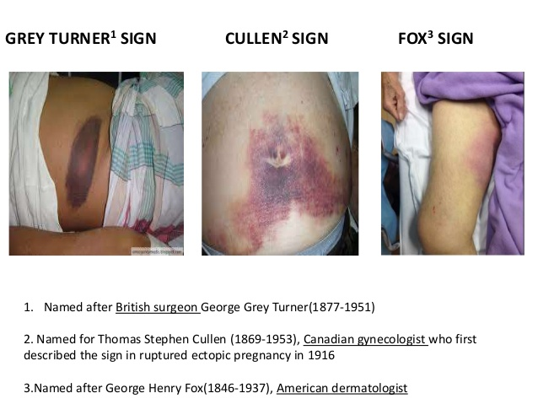
      - In hemorrhagic pancreatitis:
        - Cullen sign (internal blood collection near umbilicus)
        - Grey-Turner sign (on the flanks [think sides for turn for turner)
        - Fox’s sign (inguinal ligament and below)
      - Abdominal examination:
        - Absent bowel sounds (adynamic ileus)
        - Epigastric tenderness
        - May show signs of guarding

  - Differential Diagnosis (epigastric pain):
    - GI:
      - Perforated duodenal ulcer
      - Acute mesenteric ischemia
      - SBO
    - HB:
      - Acute pancreatitis
      - Cholangitis
      - Cholecystitis
      - Hepatic abscess
    - Vascular:
      - AAA rupture
    - Chest:
      - Inferior wall MI
      - +/- RLL pneumonia
  - Diagnosis:
    - The diagnosis of acute pancreatitis is CLINICAL
    - Investigations are done to R/O DDx, provide more evidence of diagnosis and to estimate degree of pancreatic damage
    - We do acute abdomen lab and imaging

  - Investigations:
    - Lab:
      - CBC + BT+ Cx (Hct, WBC count)
      - Serum amylase & lipase
Lipid profile (hyperlipidemia)
MRCP (pediatrics)
Biopsy to assess autoimmune etiology
Assess PTH levels/bone profile or do a neck US (and then a sestamibi scan) if you suspect a hyperparathyroidism
      - RFTs (BUN, Cr)
      - LFTs (AST, ALT, LDH, bilirubin)
      - Coagulation profile (DIC risk)
      - Electrolyte panel (Ca²⁺ levels, HCO₃)
      - Biochemistry (Glucose, lactate, ABG)
      - Cardiac enzymes
    - Imaging:
      - CXR
      - AXR (supine & erect if possible)
      - Abdominal US (if uncomplicated)
      - CT abdomen w/ contrast (if complicated)
    - Others:
      - ECG

  - FINDINGS IN ACUTE PANCREATITIS:
    - Remember, pancreatitis is a SPECTRUM
    - CBC: Leukocytosis +/- low Hb
      - >16,000 WBC count is in Ranson criteria
      - Hemorrhagic pancreatitis low Hb
    - High amylase and lipase
      - Both are elevated in acute pancreatitis
      - They must be elevated >3x normal limit
      - Lipase is MORE SPECIFIC, rises EARLIER, STAYS ELEVATED FOR LONGER
      - Neither is 100% specific to pancreas, but lipase has less false +ve
      - Amylase is found in saliva, may be elevated in perforated GI viscus, ruptured ectopic pregnancy, renal failure, and in DKA
    - Electrolyte panel: HYPOCALCEMIA, ACIDOSIS
    - BUN & Cr: high BUN
      - pre-renal AKI because of hypovolemic shock
    - Biochemistry & LFTs & ABG:
      - Glucose, LDH, AST may be elevated
      - Acidosis (from shock)

    - Imaging:
      - The best imaging tool for pancreatitis is CT w/ contrast
      - BUT we cannot assume that this is acute pancreatitis without doing basic acute abdomen imaging
      - AND if the patient is stable and there are no obvious complications, we may use abdominal US first (best initial imaging of acute pancreatitis)
      - So…
        - The best initial imaging for acute abdomen = AXR (supine, erect)
        - The best initial imaging modality for uncomplicated, stable patient with suspected acute pancreatitis = abdominal US
        - The best imaging tool for acute pancreatitis particularly those who are unstable or have complications = Abdominal CT scan w/ contrast
      - Findings in AXR:
        - Sentinel loop sign (the adjacent duodenum has adynamic ileus)
        - Colon cut-off sign (absent air in the splenic flexure where the pancreas lies)
        - Dilated stomach/gastric inflation
        - +/- gallstone
      - Findings in CT scan:
        - Edematous pancreas
        - Severe fat stranding around pancreas
        - Peri-pancreatic fluid collections
        - May see complications:
          - Phlegmon, abscess
          - Hemorrhage
          - Necrosis (lack of enhancement despite contrast)
          - Pseudocysts
      - Findings in US:
        - Gallstones (indicates that this might be the result of gallstone pancreatitis)
        - Dilation of biliary tree

  - Types of acute pancreatitis:
    - Edematous pancreatitis (MC)
    - Suppurative pancreatitis
    - Hemorrhagic necrotic pancreatitis
  - Complications:
    - Hypovolemic shock (3rd spacing, fluid sequestration in retroperitoneum)
    - Pancreatic necrosis (develops pancreatic failure)
    - Hypocalcemia (watch out for tetany, seizures!)
    - Phlegmon/abscess formation
    - ARDS (watch out for PaO₂ and chest!)
    - DIC (watch out for coagulation profile!)
    - Splenic vein thrombosis gastric varices (watch out for UGIB!)
    - Pancreatic ascites or pleural effusion
    - Pancreatic pseudocyst

  - PROGNOSTIC TOOL: Ranson’s Criteria
    - On admission = GA LAW
      - Glucose >200 mg/dL
      - AST > 250 IU/L
      - LDH >350 IU/L
      - Age > 55
      - WBC > 16,000
    - Initial 48 hours = C HOBBS
      - Hypocalcemia
      - Hematocrit drop (>10%)
      - PaO₂ < 60 ~ (Resp Failure)
      - BUN >5 mmol/L ~ (hypovolemic shock)
      - Base deficit (>4) ~ (MA)
      - Sequestration of >6L of fluid
    - 3 or more = ICU admission
    - 0 -2 ~ < 5% mortality
    - 3 – 4 ~ 15% mortality
    - 5 – 6 ~ 40% mortality
    - > 7 ~ 100% mortality

  - Management:
    - A, B, Cs
      - IV fluid resuscitation, O₂ support, may need blood
The management is essentially conservative: ALL patients need to be admitted, some will need ICU admission

      - Collect blood for investigations
      - Admit to ICU if unstable
    - NPO (rest the pancreas)
      - Feed by TPN or post-pyloric tube feeding
    - NGT decompression (if necessary)
7Rs:
- Relief of pain (opioids)
- Resuscitation (IV fluids, blood)
- Respiratory support (O₂)
- Rest the pancreas (NPO, NGT)
- Resist infection (antibiotics for necrosis/bloody)
- Removing obstruction (ERCP guided)
- Re-assessment (imaging, Rx underlying cause)

    - IV analgesia (OPIOIDS, but avoid morphine)
    - IV antibiotics ONLY IF hemorrhagic/necrosis
    - MONITORING (vitals, urine output/CVP)

    - CT scan:
      - When acute episode resolves, CT scan MUST be done in ALL patients (to look for complications)
      - If patient condition deteriorates or a complications develop, CT scan should be done
    - Rx underlying cause
      - If stone is the cause, and the patient has symptoms of cholangitis, this should be done immediately, otherwise it is done after the acute episode resolves
      - CBD stone distally ERCP-guided sphincterotomy, basket retrieval
      - Interval cholecystectomy (3 – 5 days later, because RR is high ~ 33%)
    - SURGERY IS INDICATED ONLY IF:
      - Hemorrhagic pancreatitis
      - Infected necrotizing pancreatitis (fever, unresolved pancreatitis symptoms, epigastric mass)
      - Complicated pseudocysts (i.e. rupture risk, hemorrhage, infection, gastric outlet obstruction)
- COMPLICATIONS
  - Pancreatic abscess
    - Persistent pain, fever +/- epigastric mass
    - Investigation = CT imaging, FNA for C&S
    - Cause: usually gram –ve (E. Coli, klebsiella, proteus)
    - Rx:
      - IV broad spectrum antibiotics
      - CT/US guided percutaneous drainage
      - If not possible, operative drainage

  - Pancreatic pseudocyst
    - Encapsulated collection of pancreatic fluid
    - NOT a true cyst (no epithelial lining, but instead a rim of inflammatory granulation tissue makes up the wall)
    - Types:
      - Communicating (with pancreatic duct)
      - Non-communicating
    - Cause:
      - Acute pancreatitis (10%; 2-3 weeks later)
      - Chronic pancreatitis
      - Trauma
    - Suspect pancreatic pseudocyst if a patient diagnosed with acute pancreatitis has:
      - Unresolved pain
      - Epigastric mass
      - Develops obstructive jaundice or cholestasis
      - Features of gastric outlet obstruction
    - DDx
      - Pancreatic abscess (has fever)
      - Tumors (cystadenoma or cystadenocarcinoma) – no Hx of acute pancreatitis?
    - Investigations:
      - CT or US
    - Management:
      - Watchful waiting
        - Wait 6 WEEKS before deciding to drain
        - By this time, the walls will become mature and strong enough to hold sutures
        - Also, 50% of pseudocysts resolve spontaneously
      - Drainage
        - When do you drain?
          - > 6 weeks
          - If > 5 cm
          - If symptomatic
        - How do you drain?
          - Percutaneously
          - Operatively (we join the cyst to nearby organ to drain):
            - Cystogastrostomy
            - Cystoduodenostomy
            - In tail, we resect it along with the cyst
        - Special situations:
          - If communicating we can use ERCP to insert a transpapillary stent
          - If infected, also give IV antibiotics
          - If hemorrhagic cyst, we may do angiogram embolization

- Chronic pancreatitis (quickly)
  - Chronic inflammation of pancreas resulting in irreversible parenchymal fibrosis, destruction, calcification and loss of exocrine and endocrine functions
  - Etiology:
    - Alcoholism (70%)
    - Idiopathic (20%)
    - Others:
      - Pancreatic anomalies (e.g. divisum)
      - Cystic fibrosis
  - Presentation:
    - Constant epigastric pain with episodes of peaking pain
      - Maybe confused with PUD, chronic mesenteric angina or angina pectoris
    - Steatorrhea (pale stools)
    - Weight loss (malabsorption)
      - Maybe confused with pancreatic cancer
    - Symptoms of DM (polyuria, polydipsia)

  - Complications:
    - Risk of pancreatic cancer (2%)
    - Malabsorption fractures, vision disturbances, bleeding tendency
    - IDDM
    - Splenic vein thrombosis gastric varices
    - Biliary obstruction and duct stones

  - Investigations:
    - Lab:
      - CBC
      - Amylase, lipase
      - LFTs
      - Random blood glucose/GTT
      - 72 hour fecal fat analysis
        - Qualitative (Fat globules, meat fibers)
        - Quantitative (Elastase-1)
      - Secretin stimulation test
    - Imaging:
      - CT scan
        - Atrophic pancreas
        - Calcifications
        - Pseudocysts
  - Management:
    - Medical Rx:
      - Alcohol control
      - Pain control (a lot of patients develop narcotic dependency and abuse)
      - DM control (insulin therapy)
      - Replace exocrine losses (pancreatic enzyme replacement: e.g. CREON, Viokace, pancreaze)
    - Surgical Rx:
      - Indicated in persistent pain, biliary obstruction, complicated pseudocysts
      - Celiac plexus block (for pain)
      - Principles:
        - Resective procedures
        - Ductal decompression
        - Ampullary procedures

- PANCREATIC CANCER:
  - Adenocarcinoma (MC) [from exocrine pancreas]
  - >60 years old
  - 2/3rd occurs in HEAD of pancreas
    - Better than tail of pancreas cancer, why?
      - They present EARLIER with signs of biliary obstruction
  - Risk factors:
    - Smoking
    - Alcohol abuse
    - Chronic pancreatitis
  - Presentation:
    - Weight loss (90%)
    - Chronic epigastric pain (75%)
    - Painless jaundice (70%)
    - Gastric outlet obstruction (non-bilious vomiting, early satiety)
    - Palpable painless gallbladder (Courvoisier’s sign) ~ 33%
      - Seen if it occurs in head of pancreas
    - Migratory thrombophlebitis (Trosseau syndrome)
    - May also develop Virchow’s node or Sister Mary Joseph nodule
    - Splenomegaly, ascites

  - DDx:
    - Other intra-abdominal malignancies (e.g. gastric, liver, etc.)
    - Chronic pancreatitis
    - Pancreatic pseudocyst

  - Investigations:
    - Lab:
      - CBC
      - BUN & Cr + electrolyte panel
      - Blood glucose
      - Amylase and lipase
      - Coagulation profile
      - Tumor markers: CEA and CA 19-9 (Carbohydrate antigen 19-9)
    - Imaging:
      - CT w/ contrast
        - Two views: coronal, transverse/cross-sectional
        - Double-duct sign
      - ERCP w/ biopsy if peri-ampullary

  - Management:
    - Most patients are diagnosed when the tumor is unresectable
    - Pain management
    - Localized tumors
      - Cancer of pancreatic head = WHIPPLE PROCEDURE
        - Pancreaticoduodenectomy (with duodenoduodenostomy)
      - Body/tail cancer = distal/near total pancreatectomy
      - POST-OP chemotherapy
    - Un-resectable cases:
      - What cases?
        - Vascular involvement (SMA, hepatic artery)
        - Liver metastasis
        - Peritoneal implants
        - Malignant ascites
        - Distal LN involvement
        - Distant metastasis
      - What to do?
        - Palliative care
        - Relieve biliary obstruction (ERCP stenting or surgery)
        - Relieve duodenal obstruction (Bypass procedure)
    - VERY POOR PROGNOSIS
      - If un-resectable <3% 5-year survival; expected to die in a matter of months
- Last point:
  - WHY DO YOU THINK ALL THESE CANCERS ARE SO BAD?
    - Non-specific symptoms
    - All the organs are close together (adding to the big list of DDx and easy spread)
    - No screening

- MEN = Multiple Endocrine Neoplasia
  - All are AD (“All men think they’re dominant”)
  - MEN 1:
    - Associated with MEN1 mutation (menin)
    - 3Ps: Pituitary, parathyroid, pancreas
      - Pancreatic tumors include:
        - Insulinoma (MC islet cell tumor)
        - Gastrinoma (Zollinger-Ellison)
        - VIPoma (WDHA syndrome)
        - Glucagonoma

  - MEN 2:
    - Both MEN2A and MEN2B are associated with RET mutation
    - MEN 2A:
      - 2Ps: Parathyroid, Pheochromocytoma
      - Medullary carcinoma of the thyroid
    - MEN 2B:
      - 1P: Pheochromocytoma
      - Medullary carcinoma of thyroid
      - Mucosal neuromas (e.g. in mouth)
      - MARFANOID HABITUS (DDx = MEN2B, homocystinuria, Marfan syndrome)

- Pearls of the major islet cell tumors (all CAN be associated with MEN1)
  - Insulinoma
    - MC islet cell tumor (Beta cells)
    - 90% are benign (vs other tumors, most are malignant)
    - Associated with MEN1 (<10% of cases)
    - Presentation:
      - Obese patient with hypoglycemia
      - Hypoglycemia:
        - Neuroglycopenic symptoms (altered mental status, confused, seizure, coma)
        - Sympathetic overstimulation symptoms (diaphoretic, anxious, tremors, tachycardia)
    - You may suspect surreptitious insulin intake to lose weight
    - Investigations:
      - Fasting hypoglycemia
      - High fasting insulin levels (should be low)
      - High C-peptide (vs. surreptitious intake)
      - CT abdo shows mass in liver
    - Whipple triad:
      - Symptoms of hypoglycemia when fasting
      - Evidence of low blood glucose (<50 mg/dL)
      - Improvement of symptoms after eating
    - Management
      - Surgical resection of tumor (90% curative)
      - Diazoxide (inhibits insulin release)

  - Gastrinoma (Zollinger-Ellison)
    - 2nd MC; 90% occur in gastrinoma triangle
    - Slow growing, but 60% are malignant
    - Presents as PUD refractory to standard Rx
    - On endoscopy, MULTIPLE ulcers seen in different sites (including distal duodenum, jejunum)
    - Investigations will show >1000 pg/mL gastrin level, increased gastrin upon using secretin stimulation test (should lower), octreotide scan can be helpful
    - Management = PPI, surgical resection, chemotherapy

  - VIPoma
    - VIP = vasoactive intestinal peptide
    - Most are malignant and metastasize early to LN
    - WDHA syndrome = watery diarrhea, hypokalemia, achlorhydria)
    - Hypokalemia constipation, polyuria, arrhythmias
    - Diagnosis high fasting VIP levels (>1800 pg/mL)
    - Rx surgical resection, chemotherapy, octreotide (symptomatic control)
  - Glucagonoma
    - a-cell tumor; most are MALIGNANT and usually metastasize to liver by time of diagnosis
    - Symptoms of:
      - Hyperglycemia
      - Weight LOSS (no glycogen build up)
      - NECROLYTIC MIGRATORY ERYTHEMA (psoriatic-like rash with serpiginous red borders over LL and trunk)
    - Diagnosis: high fasting glucagon level, skin biopsy for NME
    - Rx = resect, chemotherapy, octreotide

ENDOCRINE

ANATOMY OF NECK & THYROID GLAND

- Triangles of the neck
  - Divided into two large triangles by the SCM muscle:
    - Anterior triangle
      - Carotid triangle
      - Submandibular/digastric triangle
      - Submental triangle
      - Muscular triangle
    - Posterior triangle
      - Occipital triangle
      - Supraclavicular/subclavian triangle

  - Anterior triangle
    - Bounded by the SCM posteriorly, the mandible superiorly and the midline of the neck anteriorly
    - Carotid triangle
      - Part of the anterior triangle
      - Lies below the digastric muscle and above the omohyoid muscle (superior part)
      - Contains the carotid sheath, whose structure includes the carotid artery, IJV and vagus nerve
      - It also contains the ansa cervicalis (group of nerves that innervate the infrahyoid muscle except for the thyrohyoid)
    - Muscular triangle
      - Lies anterior to omohyoid muscle superior belly and posterior to the midline
      - Contains the infrahyoid muscle and deep to this is the thyroid gland
      - Both muscular triangle join to form a diamond shape when viewed from anteriorly
    - Submandibular triangle
      - It lies between the two bellies of the digastric muscle inferiorly and the mandible superiorly
      - It contains the submandibular salivary gland and LN
    - Submental triangle
      - Lies anterior to the digastric muscle and right to the side of the midline (both on each side of the neck meet to form a true triangle)
      - Contain submental LN and sublingual salivary gland

  - Posterior triangle
    - Bounded by the trapezius muscle posteriorly and SCM anteriorly; the clavicle inferiorly
    - The omohyoid’s inferior belly divides it into a large occipital triangle superiorly and a smaller subclavian triangle inferiorly
    - Occipital triangle
      - Contains a floor of muscles including the SCALENI muscle, through which the phrenic nerve passes and on top of which the accessory nerve (CN11) crosses transversely to supply the trapezius and SCM
      - The roof contains the EJV and above that is the platysma muscle (the most superficial muscle)
      - Contains posterior cervical lymph nodes
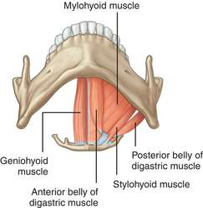
    - Subclavian triangle
      - Contains the 3rd part of the subclavian vessels (+ suprascapular and transverse cervical vessels)
      - Also houses the brachial plexus (before it passes underneath the clavicle) and supraclavicular lymph nodes
- Infrahyoid (“Strap”) muscles
  - Located in the muscular triangle in the anterior triangle
Suprahyoid muscles (FYI)
Digastric muscle
Stylohyoid (mouth diaphragm)
Mylohyoid
Geniohyoid

The submandibular salivary gland is half above the mylohoid and below it.
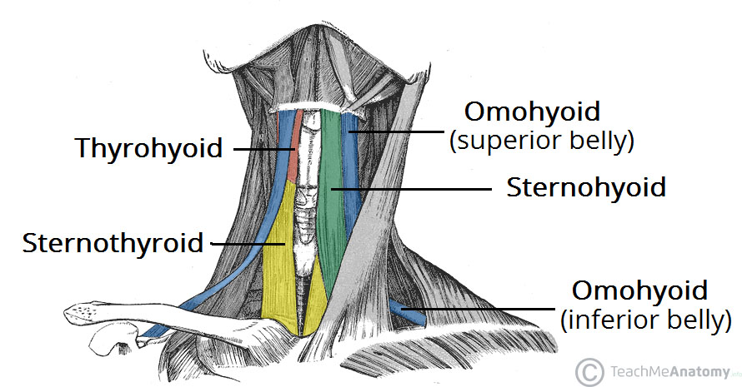
    - The structures deep to it are considered to be “anterior” in the neck (this includes the thyroid gland)
  - Components:
    - Sternohyoid
    - Sternothyroid
    - Thyrohyoid
    - Omohyoid
  - All except for the thyrohyoid muscle overly the thyroid gland (thyro part of the name means it is attached to the thyroid cartilage)
  - All except for thyrohyoid is supplied by nerves of ansa cervicalis

- Fascia of the neck (cervical fascia):
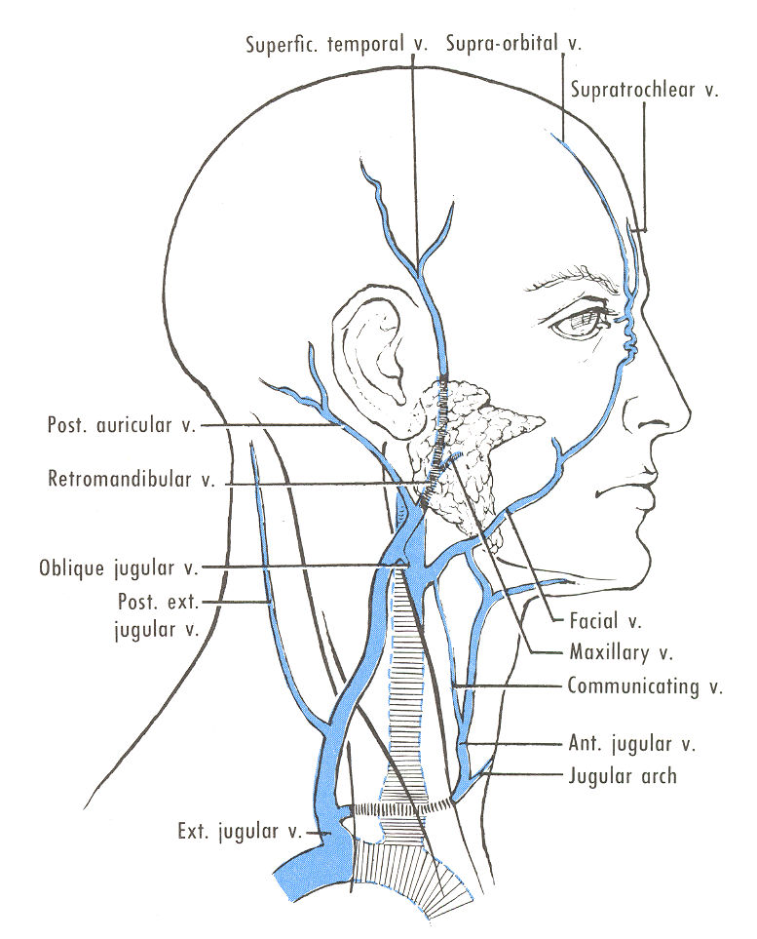
  - Superficial fascia
    - Contains platysma
    - When platysma is cut, the anterior jugular veins are visible (anteriorly)
    - Posteriorly, the external jugular veins are visible
  - Deep fascia
    - Investing layer of deep fascia (contains SCM and trapezius)
    - Pretracheal fascia
      - Contains the thyroid gland, trachea, esophagus and the RLN (in between the trachea and esophagus)
      - It is attached superiorly to the hyoid bone (limiting structures like the thyroid from extending above) but is continuous with the anterior mediastinum inferiorly (allowing a large thyroid to grow retrosternally, hence “retrosternal goiter”)
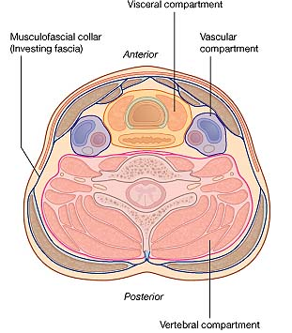
    - Carotid sheath
      - Contains the common carotid artery (and then the respective branches when it bifurcates), the internal jugular vein (IJV) and vagus nerve (CN10)
      - Basic principles to remember:
        - The right common carotid artery arises from the brachiocephalic artery on the right side, but the left common carotid artery arises from the aorta
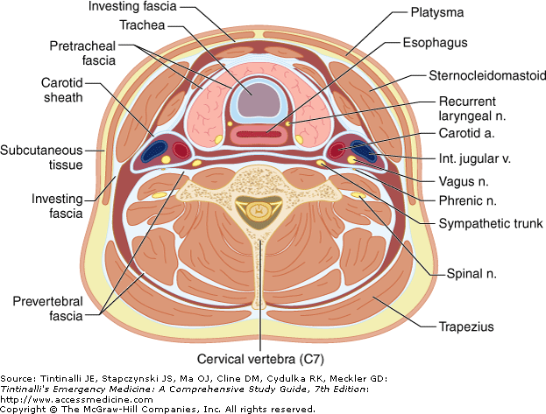
        - The IJV joins the subclavian veins to produce the brachiocephalic veins, the left one being the longer one that crosses to join the other to form the SVC
        - The vagus nerves arise from the medulla and descends down into the thorax, where on the left it gives off the left RLN which hooks around the ligamentum arteriosum and on the right it gives off the right RLN which hooks around the right subclavian artery
    - Prevertebral fascia:
      - This fascia encases the vertebra and the surrounding paravertebral muscles

- BRANCHIAL (PHARYNGEAL) ARCHES
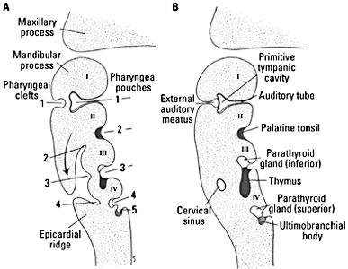
  - In embryological development, the 2nd branchial arch grows rapidly and around the 3rd arch and then attaches to the 4th, producing a branchial cleft
  - Normally, this obliterates
  - Its persistence = branchial cleft cyst (which can become a sinus)
  - It is usually located in the anterior neck (vs cystic hygroma)

- THYROID GLAND:
  - Embryology
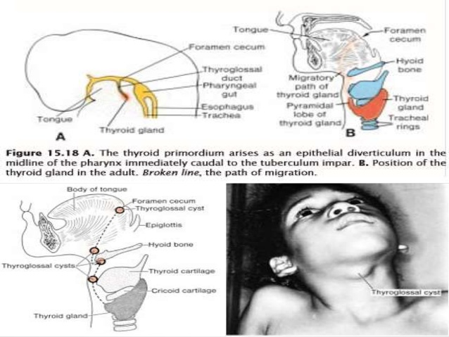
    - Develops from the FORAMEN CECUM (which is at the base of the tongue)
    - It then descends following a path in the anterior neck, passing anterior, through or posterior of the mid-anterior hyoid bone
    - It then rests in front of the cricoid cartilage and tracheal rings
    - Throughout its path, it is remains connected to the foramen cecum through the thyroglossal duct, which normally obliterates, however, its possible normal stigmata is the pyramidal lobe (also might have a fibrous band-like connection to the hyoid bone)

  - Thyroid gland structure
    - Parts:
      - Right and left lobes (that ascend up to the level of the thyroid cartilage; the most lateral part is known as the Tubercle of Zuckerkandl)
      - Isthmus (covering tracheal rings 3, 4, 5 and located on the midline of the neck)
      - Pyramidal lobe (50 – 80%)
    - The gland lies within the pretracheal fascia
      - It lies deep to the infrahyoid muscles in the MUSCULAR triangle
      - Clinically, the thyroid gland MOVES with DEGLUTITION (swallowing)
    - Blood supply
      - Arterial supply are:
        - Superior thyroid artery (STA) from the external carotid artery (it is the first branch of ECA)
Branches of the SCA:
“VITamin C&D”
Vertebral artery
Internal thoracic artery
Thyrocervical trunk (gives rise to inferior thyroid artery and suprascapular artery)
Costovertebral artery (gives rise to superior intercostal artery, deep cervical artery)
Dorsal scapular artery
          - Travels with superior laryngeal nerve (SLN) FAR away from the gland
          - To ligate it, ligate NEAR the gland (to avoid injuring SLN)
          - SLN injury = can’t speak in high pitched voice
        - Inferior thyroid artery (ITA) from the thyrocervical trunk (of subclavian artery)
          - Travels with the RLN NEAR the gland
          - To ligate the ITA, ligate FAR from the gland (avoid injuring the RLN)
          - Unilateral RLN injury hoarseness of voice; bilateral RLN injury impaired speech, difficulty in breathing
        - Thyroidea ima may be present (it is a branch directly from the arch of aorta or brachiocephalic artery)
      - Venous drainage:
        - Superior thyroid vein (drains into IJV)
        - Middle thyroid vein (also into IJV)
        - Inferior thyroid vein (directly into brachiocephalic vein)

    - Innervation
      - Sympathetic (vasomotor) from cervical sympathetic ganglion
      - Parasympathetic from RLN and SLN

  - Relation of the thyroid gland
    - Embedded in its capsule or in the gland itself posteriorly on either side of its lobes = 4 PARATHYROID GLANDS
      - Superior parathyroid comes from 4th POUCH
      - Inferior parathyroid comes from 3rd POUCH
    - Posteriorly trachea (attached thru ligaments of Berry)
      - The RLN runs near the posterior part of the gland (in the tracheosophageal groove)
      - Surgeons are careful to first IDENTIFY the RLN, and move it aside (its injury is a big medicolegal concern in thyroid surgery)
      - Remember that the RLN supplies all laryngeal muscles except for the cricothyroid muscle (supplied by ELN branch of SLN) and the laryngeal mucosa below the vocal folds (ILN supplies mucosa above vocal folds)
    - Posterolaterally carotid sheath

- IMPORTANT POINTS
  - Abnormalities in thyroid development
    - Failure to descend lingual thyroid
      - Posterior tongue mass identified
      - DO NOT excise mass before doing a THYROID SCAN (you have to make sure this isn’t their ONLY thyroid tissue)
    - Aberrant migration ectopic thyroid
    - Descends too far down retrosternal thyroid
    - Thyroid enlargement retrosternal goiter
      - Role in P/E
      - Also, DDx of anterior mediastinal mass:
        - Thyroid
        - Thymoma
        - Teratoma
        - Terrible lymphoma
    - Failure of thyroglossal duct to obliterate completely thyroglossal cyst or sinus

  - THYROGLOSSAL CYST
    - Failure to completely obliterate thyroglossal duct
    - Presentation:
      - Age ~ 5 years old
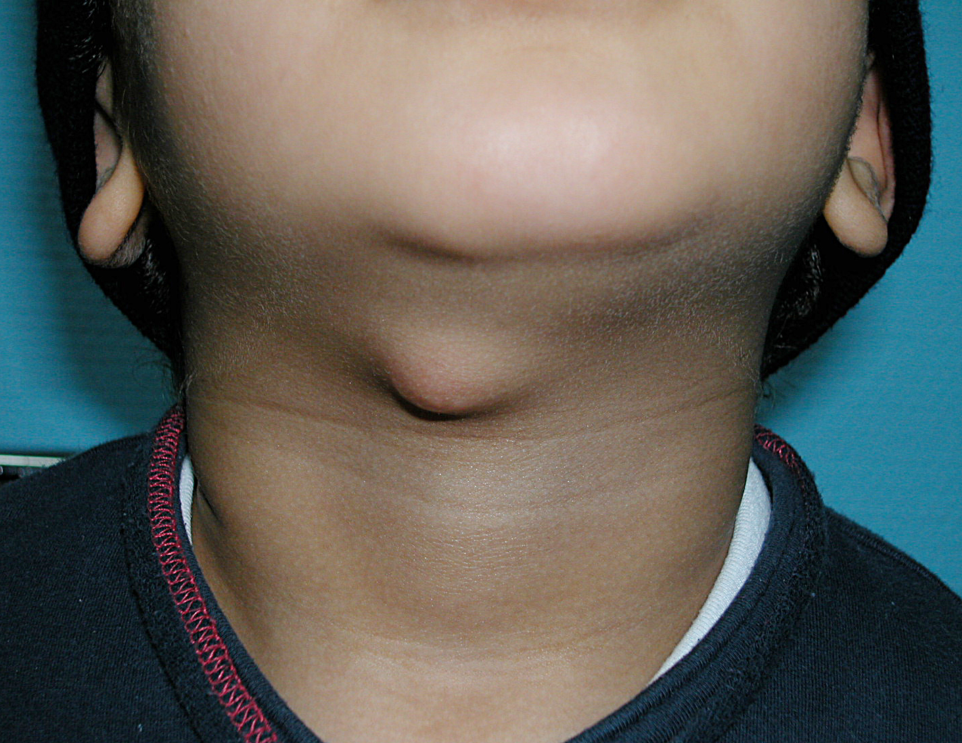
      - Midline neck lump
      - Moves with protrusion of the tongue (indicator that it is essentially attached to the back of tongue) and swallowing
    - It is usually also connected to the mid-portion of hyoid bone
    - Complications:
      - Mass effect (it may continue growing)
      - Infection
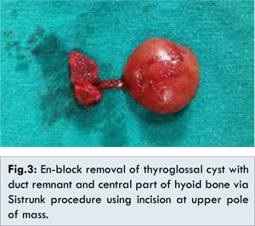
      - Fistula or sinus formation
    - Investigation:
      - Neck US (echogenic cystic mass)
    - Management:
      - Sistrunk operation (remove cyst + anterior-mid portion of hyoid bone + its tract)

  - Branchial cyst
    - Remnant of cervical sinus
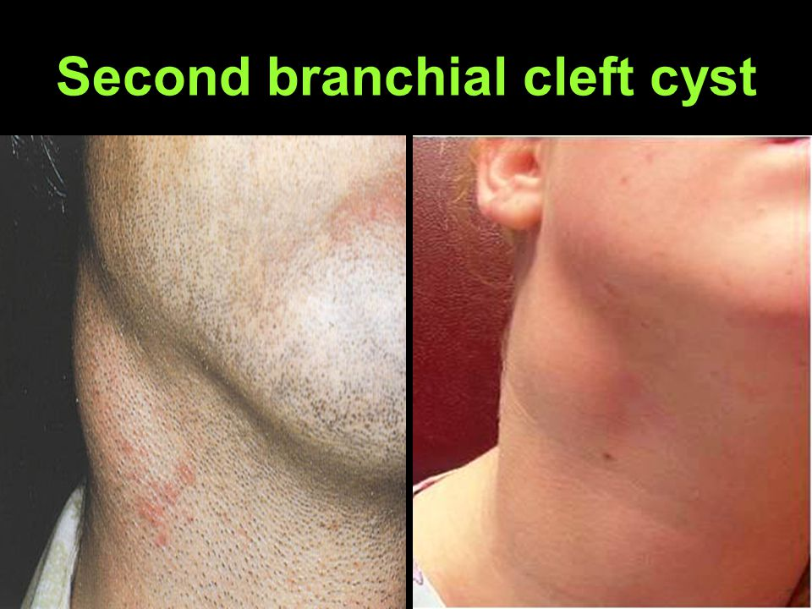
    - Presentation:
      - Late childhood
      - Anterior neck lump, lateral to midline (vs thyroid)
      - Usually protrudes from upper 1/3rd of SCM
      - Does not move with swallowing or tongue protrusion
      - Smooth, mobile and fluctuant mass
    - Complications:
      - Infection
      - Fistula (may be confused with tuberculous sinus; discharge is mucoid material, unless infected, may be pyogenic)
    - Investigations:
      - FNAB cholesterol crystals (classically rectangular with a missing edge)
    - Management:
      - Cyst excision through transverse neck incision
      - Fistula tract should also be excised

  - Cystic hygroma
    - Jugular lymph sac containing multiple large sacs and smaller vesicles (the larger ones are more superficial)
      - Contains clear lymph inside it
    - Common locations
      - Neck (posterior triangle)
      - Under mandible
      - Floor of mouth
      - Axilla
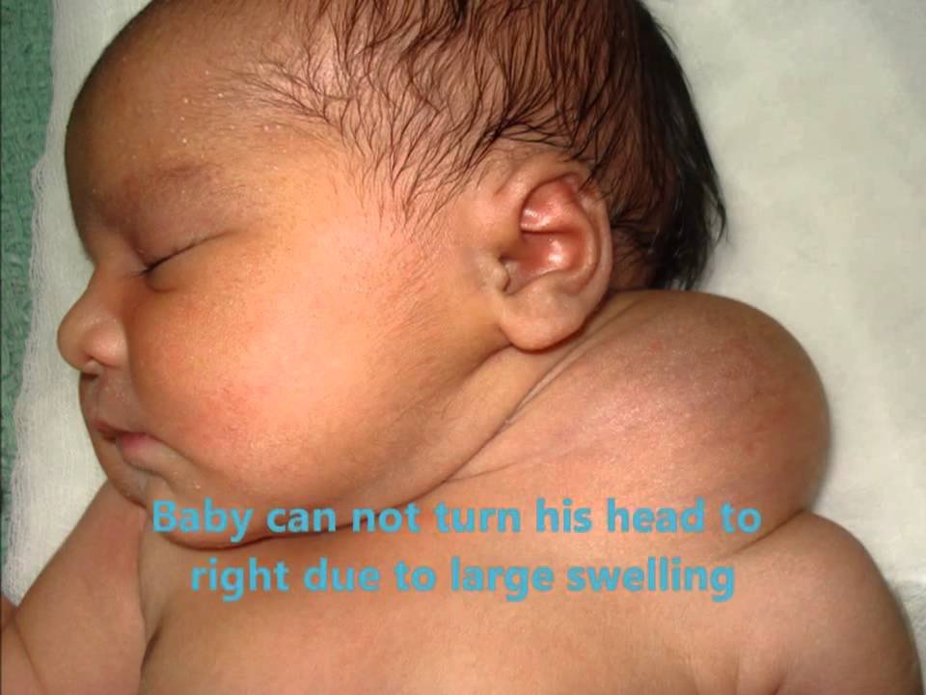
      - Thorax
    - Can occur in patients with Turner syndrome
    - Presentation:
      - Present at birth or in first few years of life
      - Painless neck mass in posterior triangle
      - Characteristically bluish tinge seen on skin surface
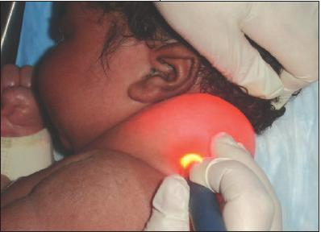
      - The mass is soft, easily compressible, with ill-defined borders
      - Transillumination +ve
    - Complications:
      - Rapid enlargement (may result in airway obstruction and difficulty in resection as it goes in between important neck structures)
      - Others (e.g. infection)
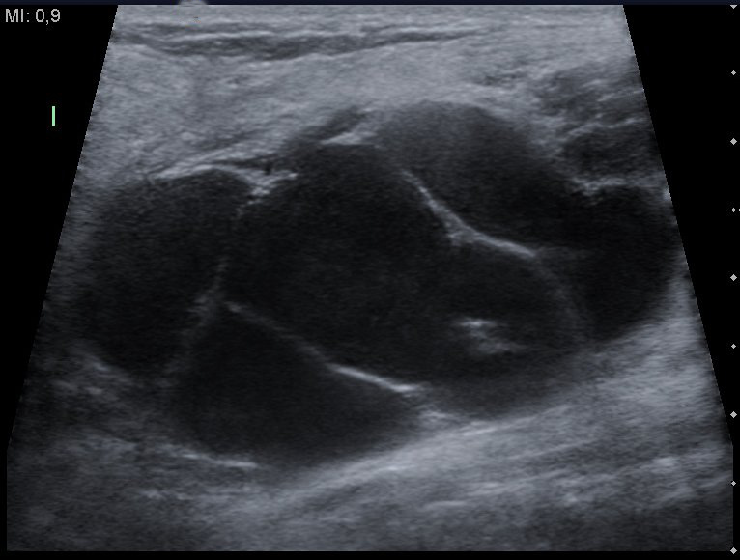
    - Investigations:
      - May diagnosed prenatally (fetal US)
      - Ultrasound and MRI may be used for imaging
    - Management:
      - A, B, Cs (make sure that airway is patent)
      - Early total surgical excision (it can grow rapidly and surgery can become more difficult), which may be preceded by injecting sclerosing agents

  - DDx of Neck lumps:

    - 1 = Lymph node enlargement (lymphadenopathy)
      - Inflammatory (lymphadenitis; scrofula)
        - Infectious
          - Bacterial
            - Local infections (e.g. dental, tonsil, cuts)
            - TB
          - Viral
            - EBV (mononucleosis posterior cervical lymphadenopathy)
            - CMV
            - HIV (generalized lymphadenopathy)
          - Fungal
        - Non-infectious (e.g. reactive hyperplasia)
      - Neoplastic
        - Primary = lymphoma (e.g. CLL!)
        - Secondary = metastatic (e.g. thyroid, lung, breast, GI)
      - Lymph nodes are located in specific distribution in the neck + it is typically oval in shape)
Dermoid cysts occur in the midline structures or lateral ends of eyebrows, it contains structures from the germ layers.

Sebaceous cyst is a misnomer. It is an epidermal cyst containing keratin not sebum; it is has a characteristic central punctum. It is FIRM, round, and a mobile nodule that can get infected, resulting in pain and pus drainage thru the punctum. Rx is excision of cyst.

Both of the cysts are INTRADERMAL meaning you can’t move overlying skin.

Lipomas and LN are SQ so they should be mobile (unless malignant invasion).
    - 2 = ANYWHERE
      - Lipomas (has a slippery edge, soft, SQ)
      - Sebaceous cyst (has a central punctum, firm)
      - Hematoma (which can be expanding, throbbing)

    - 3 = MIDLINE LUMPS
      - Dermoid cyst
      - Thyroglossal cyst (MC cervical cystic lump)
      - Thyroid mass:
        - Diffuse enlargement
          - Physiological goiter (pregnancy, puberty)
          - Endemic goiter (iodide deficiency)
          - Hyperthyroidism (e.g Graves)
          - Hypothyroidism (e.g. Thyroiditis)
        - Nodular enlargement
          - Solitary nodular (solitary adenoma, toxic adenoma, colloid cyst, cancer)
          - Multiple nodular goiter (Toxic or non-toxic)

    - 4 = ANTERIOR TRIANGLE LUMPS
      - Branchial cyst
      - Vascular-related (carotid aneurysm, carotid body tumors)
      - Laryngoceles (tuba players, worsens by blowing)

    - 5 = POSTERIOR TRIANGLE LUMPS
      - Cystic hygroma
      - Cervical ribs
PAROTID GLAND
The parotid is supplied by the GN (CN9) but it is passed by facial nerve (CN7), which within it divides into 5 motor branches: temporal, zygomatic, buccal, mandibular, cervical. The ECA also passes through the parotid gland; it divides into the maxillary artery and superficial temporal artery. Behind it is the retromandibular vein (drains into EJV). On its surface is the great auricular nerve. The parotid duct opens near the 2nd upper molar. Remember that we have 20 milk teeth and 32 mature teeth (16 above, 16 below). The parotid gland is mostly serous, and when moving more centrally, salivary glands (e.g. mandibular and sublingual) become more mucous. It is NOT the MC site for salivary gland stone (submandibular is).

    - 6 = SUBMANDIBULAR TRIANGLE/near the jaw
      - Lymphadenopathy
      - Salivary gland enlargement
        - Stone (sialoltihiasis) – MC in submandibular
        - Sialadenitis (inflammation/infection)
        - Tumor
      - Parotid gland enlargement
        - Infection (E.g. mumps)
        - Sjogren’s syndrome
SALIVARY GLAND STONES
Patient experiences pain when eating or thinking about food (salivation) and pain reproduced when seeing, sucking on lemon. Rx involves sucking on lemon, if in distal duct, removal thru mouth; if recurrent or proximal, gland excision may be necessary

PAROTID GLAND TUMOR
MC place for salivary gland tumor; MC is pleomorphic adenoma (benign); Warthin tumor = adenolymphoma (also benign). Malignant = mucoepidermoid cancer; CN7 involvement = malignant.

        - Parotid gland stone
        - Tumor (everts/raises earlobes)
        - Bulimics or alcoholics (recurrent vomiting)

- Thyroid (or neck) P/E
  - You should do a full exam, but here I want to highlight to you what you need to note
  - General inspection
    - Appearance (anxious/restless or somnolent)
    - Build (overweight or underweight)
  - General examination
    - Nails clubbing (Graves acropachy)
    - Tremors
    - Diaphoretic palms
    - Pulse tachycardic or bradycardic or AF
    - Face:
      - Loss of lateral 1/3rd of eyebrows (hypothyroidism)
      - Xanthelesma (hypothyroidism)
      - Eyes (Graves ophthalmopathy)
        - Anteriorly lid retraction, lid lag (ask them to look down)
        - Laterally (stand on side of patient) exophthalmos
        - Visual field examination
      - Mouth
        - Look for mass at back of tongue (lingual thyroid?)
  - Neck examination
    - Ask patient to sit on a chair (if present), if not, on the side of the bed, any position where you can maneuver yourself around, because the palpation is from the back of the patient
    - Inspection
      - Note any swelling, discoloration (e.g. erythema)
In real life, you don’t need to keep in mind these things now, you do a whole exam and then compile your idea about the mass. But sometimes doctor ask you questions like, what you can you say ON INSPECTION alone?
      - For swellings, keep in mind (on inspection):
        - Site
        - Size
        - Shape
        - Surface/skin overlying
        - Special characters (movement with swallowing, movement with tongue protrusion)
    - Palpation
      - Ask for pain, leave that area to the end
      - Stand behind the patient
      - Palpate from above below for normal anatomy (noting any swelling and leaving it for the end):
        - Occipital LN
        - Post-auricular and pre-auricular LN
        - Parotid LN and gland
        - Submandibular, submental LN
        - Posterior and anterior cervical LN
        - Follow the SCM down
        - Palpate supraclavicular LN
        - Then go back up to the thyroid prominence
        - Follow it down to the thyroid isthmus, then move laterally to feel the lateral lobes
        - Ask the patient to swallow to feel the thyroid move up
        - Comment on warmth, tenderness, swellings that were felt and go back up to there to assess
      - Palpating a swelling:
        - Site, size, shape, sides (margins), surface, consistency, mobility, tenderness and warmth
        - Ask them to swallow (feel it move)
        - Other characters:
          - Compressible?
          - Reducible? (not so much)
          - Indentable?
          - Fluctuating? (or Paget’s test)
          - Cough impulse
          - Pulsating? (expansile or transmitted)
          - Thrills?
          - Fixed? (Can you move overlying skin? Does it become more prominent when contracting neck muscles)
        - If it feels cystic, fluctuation testing or Paget’s testing (for smaller cysts) should be done
    - Percussion
      - Sternal percussion (for dullness ~ retrosternal goiter)
    - Auscultation
      - May auscultate over carotid artery and over mass to check for bruits (with BELL)
  - Ideally, you need to do:
    - Chest examination (cardiovascular)
    - Neurological examination (reflexes)
    - Pelvic examination in females (struma ovarii and trophoblastic disease can cause hyperthyroidism)
    - Lower limb examination (e.g. pretibial myxedema)

- HIGHLIGHTS OF THYROID HISTORY TAKING:
  - What should you not forget to ask about
  - Constitutional symptoms:
    - Fever
    - Weight loss or gain
    - Cold intolerance, warmth intolerance
    - Appetite
  - Systems involved:
    - Neck:
      - Swelling? pain? Dysphagia? Hoarseness of voice?
If you suspect cancer:
Age?
Occupation?
Radiation exposure?
Thyroid swelling or pain?
Local invasive symptoms? (dysphagia, hoarseness)
Thyroid symptoms (up, down)
Metastasis symptoms (cough? Bone pain? Fractures?)
FAMILY HISTORY
    - CNS:
      - Anxiety, insomnia, fatigued
      - Somnolent, lazy, tired, memory problems
      - Visual disturbances
    - CVS:
      - Palpitations (AF)
    - GIT:
      - Hyperdefecation/diarrhea or constipation
    - GU:
      - Amenorrhea (hyperthyroid) or menorrhagia (hypothyroid)
    - MSK & skin:
      - Weakness, fractures, osteoporosis Hx
      - Rashes anywhere?

- APPROACH TO A THYROID MASS
  - DDx of thyroid enlargement (again)?
    - Diffuse enlargement:
      - Physiological
      - Endemic
      - Hyperthyroid
      - Hypothyroid
    - Nodular enlargement:
      - Multiple nodules
        - MNG – toxic or not
      - Single nodule
        - MNG (dominant nodule) – toxic or not
MCC of pathological thyroid enlargement = MNG
MCC of hyperthyroidism is Graves disease
        - Adenoma (toxic or non-toxic)
        - Thyroid cyst (e.g. colloid cyst)
        - Thyroiditis
        - Thyroid cancer
        - Thyroid lymphoma
        - Parathyroid carcinoma
  - Approach to a suspicious thyroid nodule:
    - History
    - P/E
    - Investigations (Lab and imaging)

  - When to suspect a malignancy?
    - When on Hx, there is:
      - Young age
      - Local invasive features (vocal cord paralysis ~ change in voice, dysphagia)
      - Family history of thyroid cancer
      - History of radiation exposure (high risk jobs)
      - Rapid enlargement (over months)
    - When a nodule on P/E is:
      - Fixed
      - Solitary
      - Firm/hard
      - Irregular margins
      - Immobile (does not move with swallowing)
      - Local features (e.g. LAD)
  - Investigations
Suspicious thyroid nodule
(Hx & P/E)

Lab: TFTs (T₄, TSH), electrolytes (Ca²⁺)
Imaging: Ultrasound (best initial)
Cystic or solid mass?
Vascular?
Irregular wall shape?
Calcifications?
Septations?
LN involvement?
Complex cysts or solid masses are suspicious

FNAB results
Benign cysts: clear aspirate, complete disappearance of cyst, no reaccumulation of fluid, cytology is clear
Malignant cyst: aspirate is hemorrhagic, residual lump is present, rapid reaccumulation of fluid in cyst, cytology shows malignant cells

FNAB/C
(Is NOT able to differentiate follicular adenoma from carcinoma)

“Benign”
Colloid cyst or simple cyst
“Intermediate”
“Probable cancer”

Others
Follicular?
Thyroid Uptake Scan
Hot
(1% malignant)
Cold
(25% malignant)
F/U for 1 year (US)
If repeatedly comes back following aspiration or is complex, consider surgery
Lobectomy +/- total thyroidectomy if intra-operative biopsy shows follicular carcinoma (capsular invasion) +/- LN dissection

Total thyroidectomy +/- LN dissection
(excisional biopsy)

- Thyroid cancer
  - What to highlight in history (again)?
    - Age (young?)
    - Occupation (radiation exposure?)
    - Constitutional symptoms (weight loss)
    - Local invasion symptoms (dysphagia, hoarseness, swelling)
    - Family history of MEN2 or thyroid cancers/tumors
  - Types:
    - Papillary carcinoma (MCC) – 80%
    - Follicular carcinoma (2nd MC) – 10%
    - Medullary carcinoma – 5%
    - Hurthle cell carcinoma – 4%
    - Anaplastic carcinoma – 1%
  - General workup:
    - Lab: TFTs, Ca²⁺ /bone profile/calcitonin levels
    - Imaging: US +/- thyroid scan
    - FNAB
    - Staging: e.g. CXR, bone scan
    - Post-OP: TFT, Ca²⁺, scan, thyroglobulin, US (6 months)
  - Papillary carcinoma
    - MC thyroid cancer (Most Popular)
    - RF: radiation exposure
    - Average age: 30 – 40 years old
    - Spreads by lymphatics cervical lymphadenopathy
      - +ve LN does not affect the prognosis
      - “Laterally aberrant thyroid” is papillary cancer metastasized to the LN
    - MC distal site of metastasis Pulmonary
    - Good thyroid uptake!
    - Histologically psammoma bodies
    - 10-year survival rate ~ 95% (“best cancer to have”)
      - We use 10 year instead of 5!
    - Management:
      - Total thyroidectomy +/- LN dissection (preferred)
      - Some advocate that size <1.5 cm and no history of radiation exposure can warrant near total thyroidectomy
      - Post-OP thyroid scan (to look for residual tumors, because it can fall and seed during surgery)
      - If residual tumor found, starve the thyroid (do not replace T₄) and employ RAI
    - The Ps = Papillary:
      - Popular (80%), Psammoma bodies, Palpable LN, Positive uptake, Positive Prognosis, Post-OP uptake/RAI, Pulmonary mets
  - Follicular carcinoma
    - 10% of thyroid tumors
    - Nodule is typically rubbery, encapsulated
    - F > M
    - Hematogenous > lymphatic spread (but BOTH)
    - MC distal site of metastasis is BONE
    - Overall 10-year survival rate ~ 85%
    - Cannot be distinguished from follicular adenoma by FNAB
      - Needs tissue structure to identify capsular invasion
    - Management:
      - Total thyroidectomy
      - However, intra-operatively a lobectomy is done first and sent for histopathological analysis (frozen section is taken) to determine capsular invasion, and if so, then total thyroidectomy is done
      - Post-OP uptake scan +/- RAI

  - Medullary carcinoma
    - Rare ~ 5%
    - Risk factor:
      - MEN2A, 2B (RET mutation)
      - MOST are SPORADIC
      - Patients found to be MEN2 must have their family screen (it is AD) and offered prophylactic thyroidectomy
    - Histologically:
      - Amyloid deposit (due to calcitonin hypersecretion, because the cancer arise from parafollicular cells)
    - Route of spread is BOTH hematogenous & lymphatic
    - Lab = calcitonin levels
    - POOR THYROID UPTAKE
    - Prognosis:
      - 10-year survival is 80% w/o LN involvement
      - 45% if w/ LN involvement
    - Management:
      - Total thyroidectomy + LN dissection (medial LNs)
      - May need modified neck dissection if lateral LN are positive)

  - Anaplastic carcinoma
    - AKA: undifferentiated carcinoma
    - Thought to arise from one of the above carcinoma (MC = follicular carcinoma)
    - RAREST cancer
    - OLD AGE GROUP (>65)
    - POOR THYROID SCAN UPTAKE
    - Loves to spread directly to LOCAL STRUCTURES resulting in:
      - RLN palsy (hoarseness of voice)
      - Airway obstruction
      - Dysphagia
      - Resembles Reidel’s fibrosing thyroiditis (but this occurs in younger age group)
    - Prognosis is POOR (3% 5-year survival, most patients present late when it has already metastasized)
    - Management:
      - Confined to thyroid total thyroidectomy + chemotherapy
      - Airway compromise ABC, debulking surgery, tracheostomy, chemotherapy

- PRINCIPLES OF THYROIDECTOMY
  - Indications:
    - Hyperthyroidism
      - Refractory to 1-2 year medical therapy (or TSH fails to rise in 6 months)
      - CI to RAI (e.g. pregnant patient)
      - TMNG, simple nodular goiter, Graves
    - Thyroid neoplasia
      - Solitary adenoma ~ total lobectomy +/- proceed
      - Thyroid carcinoma ~ total thyroidectomy +/- LN dissection
  - Pre-OP preparation
    - Adequate consent for the possibility of complications, including:
      - RLN injury (resulting in change in voice or worse)
      - Hypoparathyroidism (MCC is iatrogenic)
      - Most patients will have temporary hoarseness of voice post-OP only because of the stress of surgery, not because RLN injury
    - Pre-OP thyroid control (try to make him euthyroid)
      - Medical Rx of hyperthyroidism as best can before surgery
      - To prevent risk of thyroid storm intra-OP, which can be fatal
    - Indirect laryngoscopy
      - To check pre-OP mobility of vocal folds and take pictures of it (for medicolegal reasons)
      - 3% have asymptomatic cord paralysis

  - Intra-OP keys
    - It is a CLEAN surgery (NO NEED for pre-OP antibiotics)
    - Laryngoscopy may be done multiple times to document changes in vocal folds (at least once before and after)
    - The RLN and parathyroid glands should be identified before thyroidectomy
    - The STA and ITA are ligated as well as the inferior thyroid vein (I guess to prevent spillage of thyroid hormone in the circulation)
    - Minimalize handling of the thyroid gland
  - Post-OP keys
    - Starve the thyroid (do not replace hormones immediately)
    - Perform a whole body thyroid uptake scan to look for residual tissue or mets (if present, RAI should be used)
    - Ca²⁺ (+/- PTH levels), TFTs and thyroglobulin levels are followed
    - Patients are routinely started on oral calcium carbonate for 2 weeks
    - Lifelong thyroid hormone replacement
  - Complications
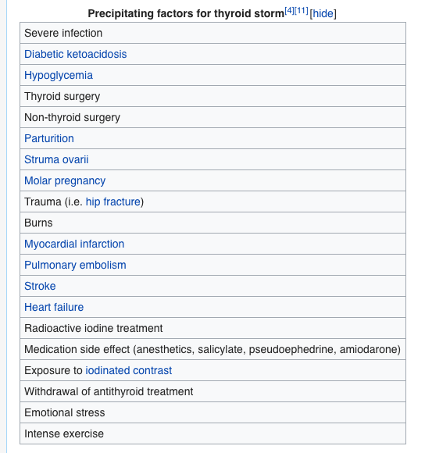
    - Intra-operative:
      - Thyroid storm (IV fluids, O₂, cooling blanket, adrenal support with steroid, Iodine [Wolff-Chaikoff effect], PTU and beta blockers)
    - Hemorrhage (expanding hematoma)
      - Slipped ligature bleeding in a closed cervical space airway compromise and carotid vessel compression
      - In text, bedside scissors are kept in case one suspects an expanding hematoma, in order to open the wound even before transferring to OT
    - Respiratory obstruction
      - Laryngeal edema (extensive manipulation of larynx intra-OP or due to ETT)
      - Expanding hematoma
      - Bilateral RLN injury
    - RLN paralysis
      - May be unilateral or bilateral; transient or permanent
      - Unilateral hoarseness of voice, dyspnea on exertion (this will improve in 6 months as the other cord adapts)
      - Bilateral injuries aphonia, respiratory obstruction
    - Hypocalcemia (hypoparathyroidism)
      - It may be temporary or permanent
      - Transient hypocalcemia occurs 24 – 48 hrs post-OP
      - If symptoms or severe hypocalcemia develops, IV calcium gluconate is given
- Parathyroid gland
  - Some basic physiology
    - PTG is usually in posterior thyroid (in ligament or capsule) but can also be in the carotid sheath, intravagally and in the thymus
    - PTG supplied by ITA
    - PTG contains chief cells that produce PTH
    - PTH:
      - Job is to increase net Ca²⁺ in blood
      - Calcium-sensing receptors (CaSR) in PTG will sense a drop in calcium and promote PTH release (it will not do this if Mg²⁺ is low)
      - Promote PO₄ excretion & Ca²⁺ reabsorption in kidney
      - Activates vitamin D₂ to D₃ (1,25-(OH)vit D₃/calcitriol) in the kidney by 1-a-hydroxylase enzyme
      - Vitamin D₃ promotes absorption of Ca²⁺ and PO₄ from the gut (and kidneys), which together can be deposited in bone
      - PTH initially stimulates osteoblasts in bone (RANKL), but the main job is osteoclast activation (by osteoblasts) in order to break down bone to release Ca₃(PO₄)₂, but the PO₄ is to be lost in urine, thus increasing net free Ca²⁺
    - Ionized calcium is the active form, however there is bound calcium (to albumin)
      - Total calcium = ionized Ca²⁺ + bound Ca²⁺
      - Corrected calcium is calculated if there is abnormal albumin levels (usually decreased levels)
      - Corrected Ca = Ca + [0.02 (40 – albumin)) if Albumin is in mg/dL (so 40s not 4)
      - Just FYI, corrected Na in hyperglycemia is calculated by Na + 1.6 (glucose-100/100)
      - Alkalosis decreased free calcium (more binds to available space on albumin, because the H⁺ bound to albumin leaves to neutralize the alkalinity)
      - Acidosis increased free calcium (more H⁺ bound to albumin, no room for Ca²⁺)

  - DDx of hypercalcemia
    - Medications (Ca²⁺, vitamin D [and A] supplements, thiazide diuretics)
    - Bone metastasis (breast, prostate, multiple myeloma, lung)
    - Paraneoplastic syndromes (e.g. PTH-rP in squamous cell carcinoma of lung)
    - PTG disease
      - PT adenoma
      - PT carcinoma
      - PT hyperplasia
      - Familial hypocalciuric hypercalcemia (FHH) ~ highly resistant CaSR
    - Others:
      - Hypercalcemia of immobility (e.g. POST-OP)
      - Sarcoidosis

  - Presentation of hypercalcemia
    - Asymptomatic
Hypercalcemia crisis is if >14 mg/dL and/or symptomatic
This requires immediate Rx.

Normal calcium is 8 – 10 mg/dL (varies by age…) or 2.2 – 2.6 mmol/L.
Don’t forget that citrate and EDTA is a calcium chelator (present in blood products)
    - Stones: urolithiasis, cholelithiasis, polyuria
    - Groans: constipation, acute pancreatitis, N&V, muscle pain, PUD, pseudogout
    - Bones: pathological fractures, subperiosteal resorption, bone pain
    - Psychiatric overtones: lethargy, confusion
    - Others: HTN (10%), palpitations (Reduced QT interval)

  - DDx of HYPOCALCEMIA
    - Iatrogenic (post-thyroidectomy)
    - Acute pancreatitis (saponification)
    - Medications (loop diuretics)
    - Hypomagnesemia
    - Hypoparathyroidism (e.g. DiGeorge)
    - Secondary hyperparathyroidism (CRF low calcium, but high PTH, PO₄, acids, etc.)
    - Pseudohypoparathyroidism (high PTH, but low Ca, high PO4, family history, normal RFTs, end-organ resistance to PTH)

  - PRESENTATION OF HYPOCALCEMIA
    - Numbness and tingling of peri-oral area, fingers and toes (first)
    - Altered mental state (anxiety, confusion)
    - Palpitations (high QT interval, heart block)
    - Trosseau sign (carpopedal spasm when inflating BP cuff)
    - Chvostek sign (tapping over facial nerve elicits facial muscle twitching)
    - Tetany and seizures

- Primary hyperparathyroidism
  - Causes: adenoma (90%), hyperplasia (~10%), carcinoma (<1%)
  - RF:
    - Hx of radiation exposure
    - Family history, MEN1, MEN2A

  - Presentation:
    - Hypercalcemia (stones, bones, groans, psychiatric overtones, polyuria, HTN)
    - Suspect carcinoma if there is a palpable neck mass +/- local symptoms (hoarseness of voice, dysphagia, neck pain)
    - Ask about lung, breast, prostate, bone symptoms (if applicable) to R/O cancers
  - Investigations:
    - Lab:
      - Bone profile:
        - Ca²⁺ ($↑$), PO₄ ($↓$), ALP ($↑$), PTH ($↑)$
      - Urine Ca²⁺ ($↑$,$↓$ if FHH)
      - PTH-rP if suspecting lung cancer
    - Imaging:
      - CXR (lung opacity? Subperiosteal bone resorption)
      - Neck US (initial)
      - May do uptake scan or CT/MRI for more accurate imaging
        - Sestamibi scan of PTG will show diffuse uptake in all 4 glands if hyperplasia; in one gland is adenoma or carcinoma
  - Management:
    - Rx hypercalcemia (if necessary)
      - IV fluids +/- loop diuretics (furosemide)
    - Surgical Rx
      - This is the standard treatment
      - Especially if suspicious, patient <50, hypercalcemia is >10 mg/dL, there are complications (e.g. osteoporosis)
    - Principles of surgical management:
      - After doing a scan, you may suspect hyperplasia or adenoma/carcinoma (you can’t tell which it is exactly)
      - Hyperplasia Rx = neck exploration, removal of all 4 PTG, implant a piece of one gland in the NON-DOMINANT forearm muscle in order to retain PTG function and to allow easy access if it recurs
      - Adenoma/carcinoma = excisional biopsy of affected gland, neck exploration for other glands, AND IF results show carcinoma, ipsilateral thyroidectomy with modified radical neck dissection for LN metastasis

- Secondary hyperparathyroidism
  - Usually due to CRF (remember that they have high PTH, the kidney is not functioning properly, so there is low Ca, high PO₄, high ALP, metabolic acidosis, low vit D3; eGFR is low
  - Rx underlying cause of RF; may need kidney transplant
- Adrenal gland
  - Layers:
    - “GFR” then medulla
      - Glomerulosa (mainly aldosterone)
      - Fasciculata (mainly glucocorticoids, +/- androgens)
      - Reticularis (mainly androgens)
      - Medulla (chromaffin cells which are modified post-ganglionic sympathetic cells, release epinephrine [and NE])
  - Vasculature
    - Arterial:
      - Superior adrenal artery (from inferior phrenic artery, which is a distal branch of the internal thoracic artery)
      - Middle adrenal artery (directly from aorta)
      - Inferior adrenal artery (from renal arteries)
Reminds you of what?
The left gonadal vein also drains into the left renal vein!

    - Venous:
      - Left adrenal vein drains into the left renal vein
      - Right adrenal vein drains directly into IVC

- Incidentalomas
  - Adrenal mass found incidentally on CT
  - Most commonly a non-functioning adenoma
  - However, how can one be certain it is not cancer?
  - Generally:
    - > 6 cm plan for removal (R/O pheochromocytoma first)
    - < 6 cm but enlarging remove
    - Hormonally active remove

- Cushing syndrome
  - It is an endocrine disorder resulting from elevated cortisol level in the blood (either endogenous or exogenously)
  - Etiology:
    - MCC overall = iatrogenic (steroid intake for whatever therapeutic cause)
    - MC pathological cause = Cushing DISEASE (pituitary adenoma)
    - Other causes:
      - Adrenal tumor (adenoma or carcinoma)
      - Paraneoplastic disorder (small cell carcinoma ectopic ACTH release)
  - Presentation:
    - Symptoms:
      - General: weight gain, memory loss
      - CNS: depression, mood disturbances
      - Head: hirsutism, acne, moon facies
      - Body/trunk: obesity, purplish striae, easy bruising
      - Extremities: muscle weakness and wasting (lemon on stick appearance), bone weakness and fractures (secondary to osteoporosis)
      - GU: impotence, decreased libido
    - Signs:
      - High BP, high fingerstick random glucose
      - Truncal obesity, moon facies, acne, hirsutism, supraclavicular fat pads, purplish striae, extremity muscle wasting
  - Investigations:
    - Initial lab:
      - CBC (lymphocytosis)
      - Blood glucose (elevated)
      - Electrolyte panel (high Na, low H⁺ and K⁺)
      - Serum and urinary cortisol (elevated)
    - Screening/diagnostic tests:
      - You need AT LEAST TWO tests done to confirm diagnosis
      - The tests:
        - 24 hr urinary free cortisol (GOLD STANDARD)
          - +ve result = >3x upper limit of normal
        - Overnight low dose dexamethasone suppression test
          - If cortisol still elevated and ACTH low, ACTH-independent disease
          - If cortisol still elevated and ATCH high, ATCH-dependent disease, which requires further testing to differentiate pituitary source from ectopic source
        - Midnight salivary cortisol
    - Further testing:
      - If ACTH-dependent high dose dexamethasone suppression test
        - At least 50% drop = Cushing disease (pituitary source)
        - No drop or <50% = consider ectopic ACTH
      - Alternative = inferior petrosal vein sampling for ACTH with CRH stimulation test
    - IMAGING:
      - Cushing disease? Pituitary MRI
      - Ectopic ACTH? CXR and proceed
      - Adrenal cushing? Adrenal CT or MRI

    - NOTE:
      - In Cushing disease, bilateral adrenal hyperplasia is expected
      - In Cushing syndrome of adrenal etiology, the contralateral adrenal gland is atrophic (this plays an important clinical role, as removal of the affected gland essentially puts the patient in a state of adrenal insufficiency)
OLD MANAGEMENT AND THEIR CONSEQUENCE
Previously they used to do bilateral adrenalectomy, which resulted in Nelson’s disease (further enlargement of the pituitary tumor, with secretion of more ACTH hyperpigmentation, mass effect with headaches, vision disturbances); Nelson’s disease is Rx with irradiation

  - Management:
    - Cushing disease:
      - Perioperative medical Rx (metyrapone, ketoconazole)
      - Transphenoidal resection of pituitary tumor
    - Adrenal Cushing:
      - Possibilities: adenoma or carcinoma
      - Adrenalectomy + sub-optimal glucocorticoid replacement (until contralateral atrophied gland recovers)
    - Ectopic Cushing:
      - Rx underlying cause
    - Exogenous Cushing:
      - DO NOT STOP INTAKE SUDDENLY (both glands are atrophic and it needs time for the HPA axis to recover; stopping it will result in adrenal insufficiency)
      - Gradual tapering of doses

- PHEOCHROMOCYTOMA
  - Chromaffin cell (neuroendocrine) tumor that secretes catecholamines
  - Locations:
    - Adrenal medulla (90%)
    - 10% are extra-adrenal:
      - Organ of Zuckerkandl (MC extra-adrenal source), which is the bifurcation of aorta after IMA branches out
      - Sympathetic chain ganglion
      - Mediastinum
      - Bladder (yes, they develop symptoms when urinating!)
  - Risk factors:
    - Family history
    - MEN2A, MEN2B (result in bilateral adrenal tumors)
    - VHL, NF
  - Presentation:
    - Symptoms:
      - Headache
Classic triad, typically
PAROXYSMAL or EPISODIC
      - Palpitations
      - Diaphoresis
      - Anxiety, tremors, weight loss
      - Hx of refractory HTN (not responding to meds)
      - Age group:
        - 90% in adults (40 – 60 Y)
        - 10% in children
    - Signs:
      - HTN
        - There is SUSTAINED HTN, but there are episodic acute elevations
  - DDx of HTN:
    - Primary HTN (MCC of HTN overall)
    - Secondary HTN
      - Renal parenchymal disease (e.g. renal failure)
        - MCC of secondary HTN
      - Renovascular disease (e.g. RAS)
        - This is the 2nd MCC of secondary HTN
      - Endocrine HTN
        - Hyperaldosteronism (MCC of endocrine HTN)
        - Pheochromocytoma
        - Cushing’s syndrome
        - Acromegaly
        - Hyperthyroidism
    - Iatrogenic (medications like NSAIDs, OCPs, steroids)
    - Others:
      - Obstructive sleep apnea

  - DDx of pheochromocytoma
    - Anxiety disorder with panic attacks
    - Hyperthyroidism
    - Migraine headaches
    - Carcinoid syndrome
    - Neuroblastoma
    - Peri-menopausal (climacteric)

  - Investigations:
    - Lab:
      - CBC
      - Glucose (hyperglycemia)
      - Electrolytes (check for hyperaldosteronism pattern)
      - TFTs (R/O hyperthyroidism)
      - RFTs (R/O secondary hyperaldosteronism/RF)
      - Urine and serum metanephrines (+/- HVA, VMAs and normetanephrines)
    - Imaging:
      - Adrenal MRI/CT
      - MIGB scan
    - Others: ECG!
    - Special tests
      - Clonidine test (results in LACK of suppression of plasma catecholamines)
  - RULE OF 10s:
    - 10% malignant
    - 10% familial (MEN2A, 2B)
    - 10% present in children
    - 10% bilateral
    - 10% extra-adrenal
    - 10% have multiple tumors
    - 10% malignant
  - Management:
    - Pre-operative alpha blockade
      - Achieved using phenoxybenzamine
      - Prevent development of hypertensive crisis intra-OP and to prevent the effects of unopposed a-receptors when giving beta blockers
      - NEVER GIVE BETA BLOCKERS WITHOUT giving alpha blockers first
    - Surgical Rx
      - BP monitoring
      - a-blockade
      - Clamp on VEIN FIRST (to prevent flooding during excision)
      - Tumor is excised WITH MINIMAL MANIPULATION (to prevent squeezing out more epinephrine)
    - If malignant, chemotherapy may be required

BREAST

- Anatomy
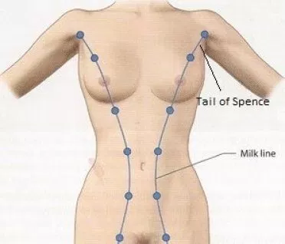
  - Embryologically derived from the mammary/milk lines
    - It is thus a modified sweat gland
    - This line stretches from the axilla across the chest, abdomen and into the perineum/groin
    - Any supernumerary breasts or nipples (polymastia or polythelia, respectively) can arise along this line
  - The breast is composed of 3 main tissues:
    - 1 = Glandular tissue (males DON’T have this)
    - 2 = Fibrous tissue (decreases as one ages – in younger age groups, these fibrous bands make mammographs more difficult to interpret)
    - 3 = Adipose tissue (increases as one ages – mammograms become more easy to interpret)
  - Breast tissue lies within the superficial pectoral fascia (anterior to the deep fascia of pectoralis major)
  - GLANDULAR TISSUE
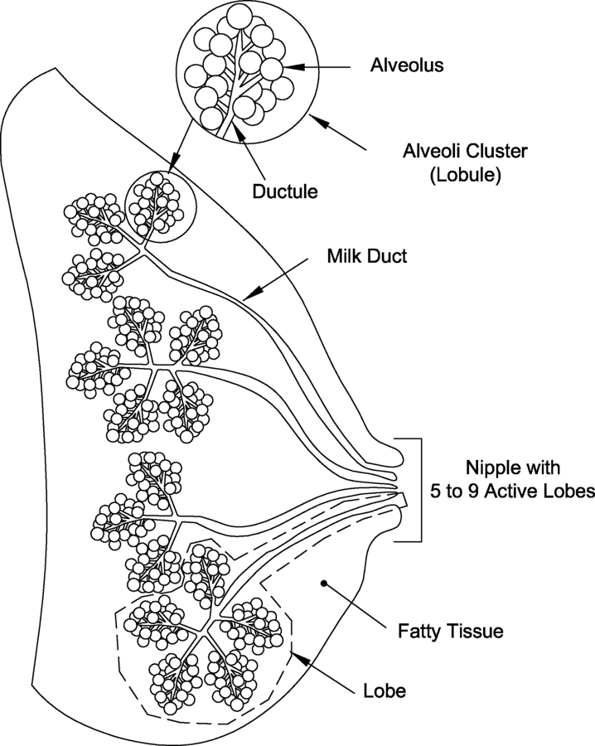
    - Prolactin stimulates milk production in alveoli, which spill out in the presence of oxytocin, which stimulates myoepithelial cells to contract the alveoli for milk let down
    - A group of alveoli forms a breast lobule, which collectively form a lobe, of which there are 15- 20
    - Each lobe drains into a lactiferous duct that reach underneath the nipple as a lactiferous sinus (this area is known as the nipple areolar complex or NAC)
    - Each lactiferous sinus opens into the nipple as pores (there are up to 20, but depends on activity of each lobe)
      - When a patient complains of nipple discharge, you need to know from which duct the discharge is coming from (you may use a clock numbering system)
    - NAC
      - Grossly, the nipple can be variable in its position, but we generally assume it to be at the level of 5th ICS (corresponding dermatome of T4)
      - The areola is hyperpigmented and contains montgomery’s tubercles
        - Palpating underneath the areola, a disc of tissue can be felt in women, which represents a portion of the glandular component of the breast
        - This should not be felt in males
        - This is the 2nd MC site of breast neoplasia
      - The center of the areola is raised to form the nipple
        - Some individuals NORMALLY have retracted nipples, so you must ask them about the retraction: is it NEW or has it always been like this?
        - A unilateral and NEW retracted nipple might be worrisome
        - Bilateral and long-standing retracted nipples can be normal
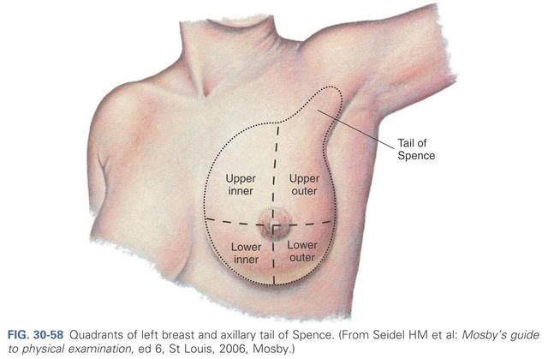
    - QUADRANTS OF THE BREAST
      - The breast tissue is divided into 4 main quadrants:
        - 1 = Upper-outer quadrant (50%)
          - It contains the lateral most extension of the breast, known as the tail of Spence, which enters the axilla
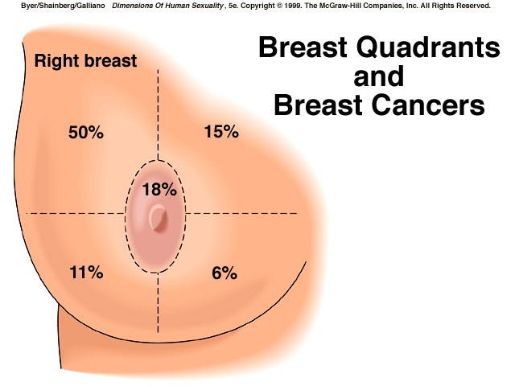
          - Because of this, it is the largest quadrant
          - 50% of masses in the breast occur here (it is the most common site of cancer)
        - 2 = Upper-inner quadrant (10%)
        - 3 = Lower-outer quadrant (10%)
        - 4 = Lower-inner quadrant (10%)
        - Subareolar (20%)
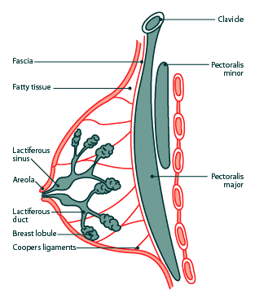
          - It is not considered a quadrant, but it is worthy to note that 20% of masses are found to be subareolar
      - It is also sometimes useful to consider the breast as a clock to describe location of a breast mass
  - FIBROUS TISSUE
    - The breast shape is supported by fibrous tissue condensations that stretch from the deep fascia to the superficial dermal fascia, called COOPER’S LIGAMENTS (or suspensory ligaments of the breast)
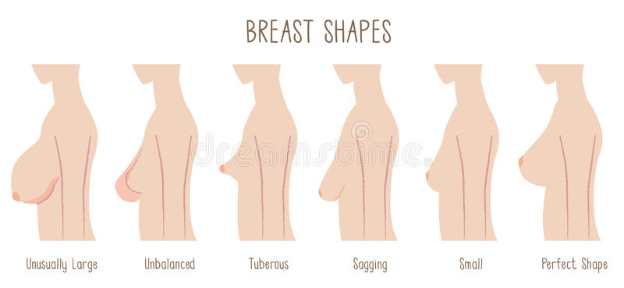
      - When cancer invades these fibrous tissues, they get fibrosed even further, resulting in classical symptoms and signs such as DIMPLING and NIPPLE RETRACTION
      - The breasts should be symmetrical in mature adult patients (asymmetrical breasts in adolescence may be considered normal)
      - Be aware that breasts come in many different shapes and sizes (e.g. tubular breasts), but the key is SYMMETRY
  - ADIPOSE TISSUE
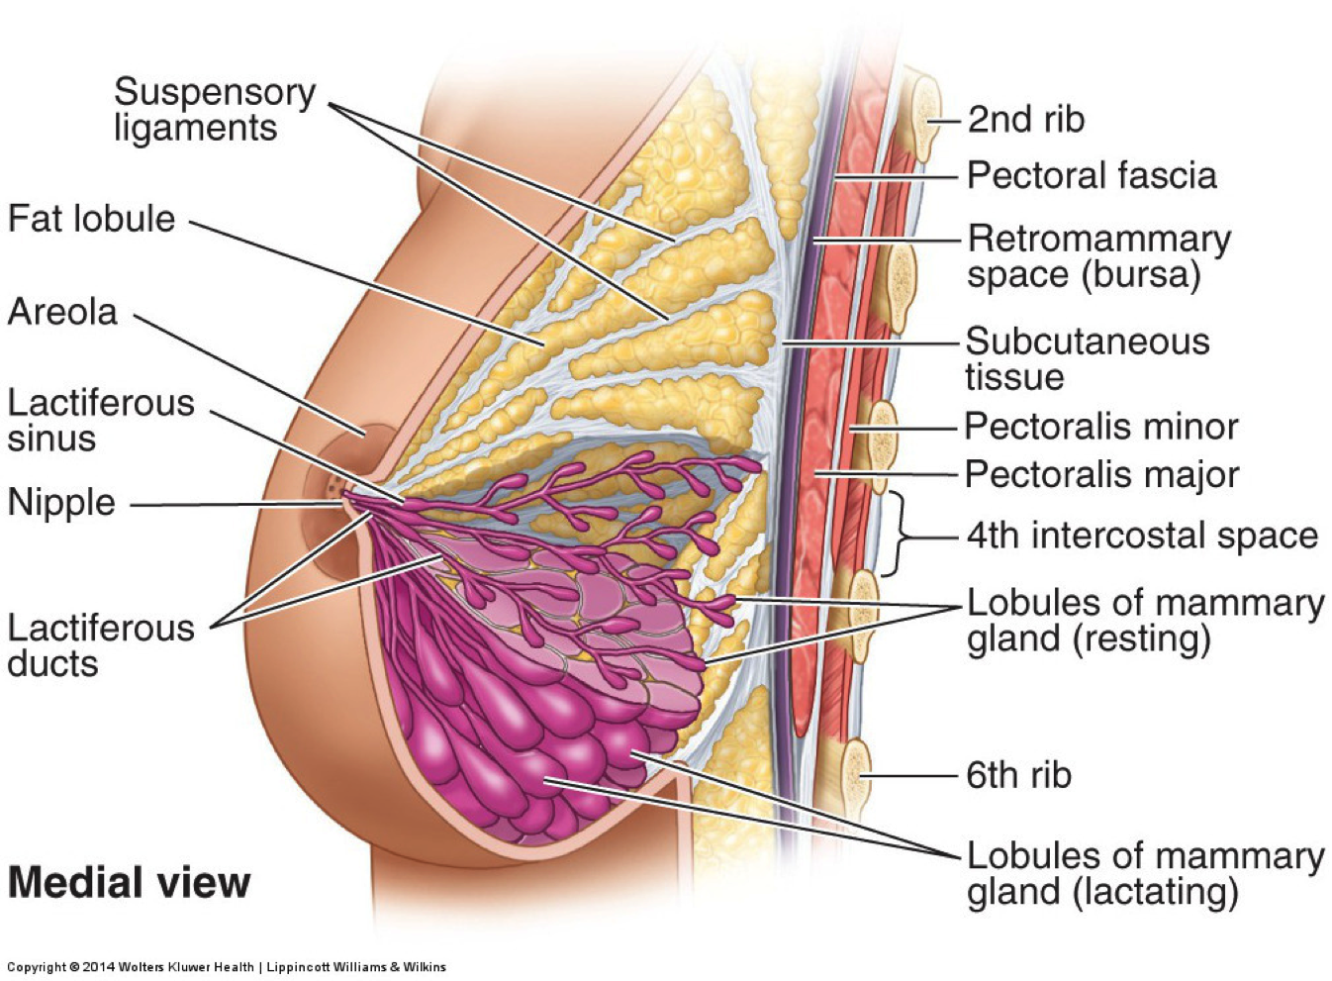
    - Interspersed between the fibrous and glandular tissue is the adipose tissue, which is the most abundant of all tissues

- NOTES:
  - Estrogen promotes DUCTAL development
  - Progesterone promotes LOBULAR development
  - Retromammary space
    - Space that lies in between the breast tissue and pectoralis muscle fascia
    - It allows the breast tissue to move somewhat freely over the pectoralis muscle
  - Blood supply:
    - Arterial:
      - Internal mammary (thoracic) artery (From SCA)
      - Lateral thoracic artery (from axillary artery)
      - Posterior and anterior intercostal arteries’ branches (e.g. lateral branches and perforating branches)
    - Venous:
      - The veins that correspond to the arterial supply
      - However, the majority drains into the axillary veins
      - Batson’s vertebral venous plexus is connected with the venous drainage of the breast: this is a gateway to spine metastasis in breast cancer
  - Lymphatic drainage:
    - Groups of LN you should be aware of:
      - Axillary LN (97% of drainage)
        - Groups:
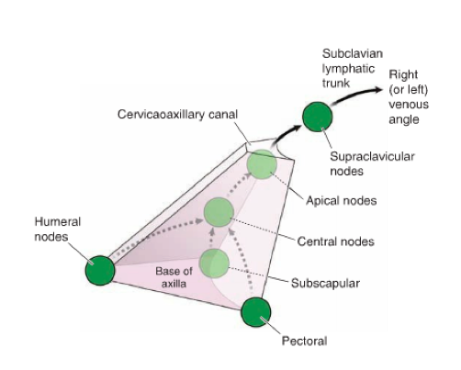
          - Anterior (pectoralis)
          - Posterior (subscapularis)
          - Lateral (humeral)
          - Central
          - Apical
        - The anterior, posterior and lateral group first drains into the CENTRAL group, which drains into the APICAL group
        - The apical group can drain into the:
          - Supra and infraclavicular lymph nodes
          - Right lymphatic duct or the thoracic duct (gateway for hematogenous mets)
          - +/- the cervical lymph nodes
        - They may drain to the CONTRALATERAL axillary lymph node too!

      - Internal thoracic LN (parasternal nodes)
        - We don’t like this! It is a bad sign and in TNM staging, involvement of these nodes (or the supra/infraclavicular LN) will be a N3

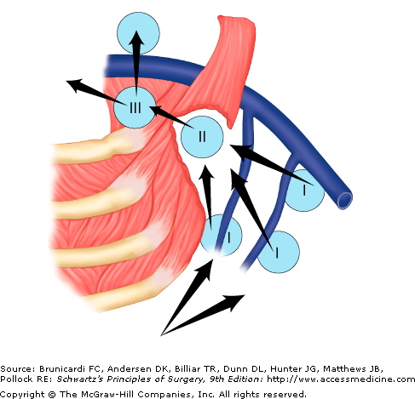
      - Rotter’s nodes
        - LN that lie in between the pectoralis major and minor muscle
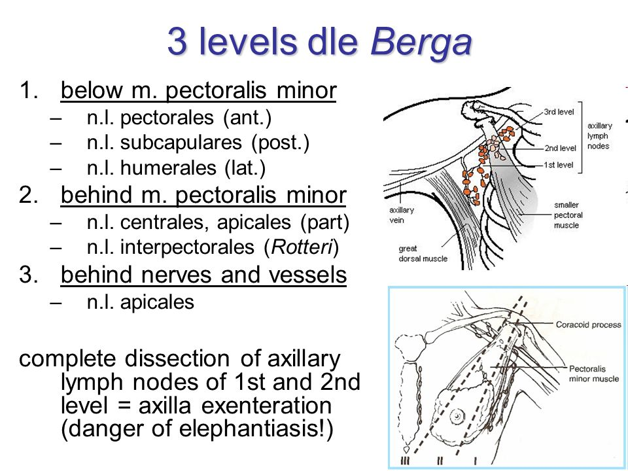
      - Subareolar lymphatic plexus
        - Drains the nipple, areola, some lobules into the axillary LN
    - SURGICAL LEVELS OF AXILLARY LYMPH NODES:
      - Classified from lateral to medial, in relation to the pectoralis minor muscle
      - I = lateral to the lateral border of the pectoralis minor (anterior, posterior, lateral LN)
      - II = deep to the pectoralis minor (central, apical LN)
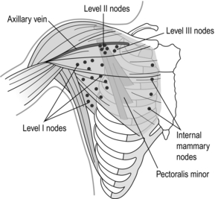
      - III = medial to the medial border of the pectoralis minor (supra and infraclavicular, internal thoracic LN)
      - I III = worse prognosis
      - However, keep in mind, the LEVEL is not as important as the NUMBER of LN involved
Axillary LN dissection, especially level I LN, as well as radiotherapy can result in lymphedema of the upper limb.
  - SURGICAL ANATOMY KEY
    - Boundaries
      - Mastectomy
        - Superior = clavicle
        - Inferior = inframammary fold
        - Medial = sternum
        - Lateral = latissimus dorsi
      - Axillary dissection
        - Superior = axillary vein
        - Anterior/medially = pectoralis minor (depending on surgical level)
        - Lateral = latissimus dorsi
        - Posterior = long thoracic nerve

    - NERVES to be AWARE OF in AXILLARY DISSECTION:
      - Long thoracic nerve
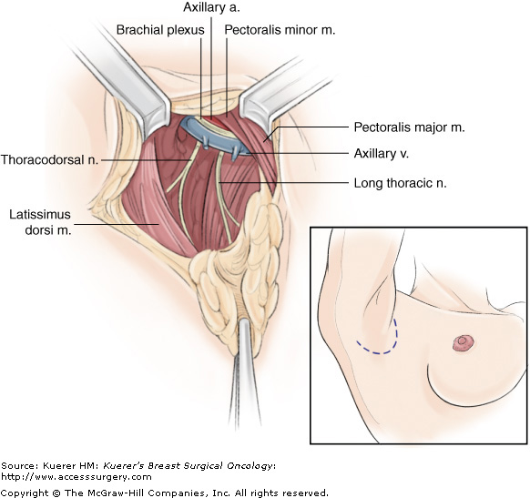
        - Supplies: serratus anterior
        - Source: C5, C6, C7 nerve roots
        - MCC of injury = during breast surgery (mastectomy, axillary dissection)
        - Injury: winging of the scapula
        - Clinically: ask patient to lay hands flat on wall with arm extended
      - Thoracodorsal nerve
        - Supplies: latissimus dorsi
        - Source: posterior cord of brachial plexus
        - Runs with: subscapular artery
        - Injury: can’t push self up from sitting position, can’t adduct upper limb properly
      - Medial pectoral nerve
        - Medial here means close to the brachial plexus vs the lateral pectoral nerve (but just remember it as from the MEDIAL cord)
        - Source: medial cord of brachial plexus
        - Supplies: pectoralis minor and major
      - Lateral pectoral nerve
        - Runs lateral to the medial pectoral nerve in relation to brachial plexus (just remember it as from the LATERAL cord)
        - Source: lateral cord of brachial plexus
        - Supplies: only pectoralis major
      - Others?
        - Intercostobrachial nerve
          - Cutaneous nerve that runs TRANSVERSELY across the axilla

    - According to the book, we do not paralyze patient during surgery so that we can identify major nerves by stimulating them and seeing the muscle contraction

- IMPORTANT THINGS TO KEEP IN MIND:

  - “TRIPLE ASSESSMENT” for suspicious breast mass:
    - 1 = Hx (for RF) + P/E
    - 2 = Imaging investigations (e.g. US, mammo)
    - 3 = Histological investigation (e.g. biopsy)

  - Things to highlight in the history:
    - Demographics
      - Age
    - CC:
      - Mass/swelling or pain
      - Discharge
      - Skin changes (dimpling, inverting nipple, eczematous nipple, swollen/red, ulceration)
      - Size changes (deviation of breast, asymmetry)
    - HOPI:
      - Hx of trauma, recent breastfeeding (if applicable)
      - Does BSE or goes for breast CA screening or not?
      - First time? Other breast fine?
      - If you suspect cancer with mets, ask about chest symptoms
    - Rest of history, goal = identify all RISK FACTORS of cancer
      - PMH:
        - HTN, DM
        - Previous history of breast cancer, other cancers
        - Breast procedures done
      - Medication history
        - OCPs/HRT
      - Menstrual/obstetric history:
        - Age of menarche (and menopause if applicable)
        - Current cycle status
        - Age of first pregnancy, parity
        - Breastfed?
      - Family history:
        - Breast cancer (especially 1st degree relatives)
      - Social history:
        - Smoking
      - Ideally, also FEARS, CONCERNS and EXPECTATIONS
        - Breast surgery may have a tremendous effect on a woman’s life, so ask about this

  - PHYSICAL EXAMINATION OF BREAST:
    - Standard steps are IMPORTANT
      - Introduce, ask for permission, ask for a CHAPERONE
      - Wash hands, close the curtains
      - I personally feel it is more appropriate to do a general exam before exposure for a breast exam
    - EXPOSURE and POSITION
      - Expose BOTH breasts down to the UMBILICUS
      - Initial position = seated on edge of the bed with hands on her lap
    - Inspection:
      - Breast shape and symmetry
        - Symmetrical shape
        - Normal breast contour
      - Nipple and areola
        - At the same level
        - Nipple is everted
        - No eczematous changes, obvious discharge and or inversion?
      - Skin changes
        - No erythema, obvious swelling, dimpling, ulceration
        - Inframammary folds should ideally also be inspected

      - Inspection (& palpation) in other positions:
        - Hands behind head or RAISING ARM
        - Hands on hips (to contract pectoralis major muscle to note fixation to muscle)
        - Leaning forward (to assess the breast as they are pendulous)
        - The first one helps make dimpling more obvious; the 2nd for muscle fixation; 3rd for symmetry
    - PALPATION
      - Let her lie down in the supine position, with a pillow behind the side you will palpate
Let her place her arm behind her head or above it.
      - One hand to support the breast (if necessary) and the other to palpate
      - ASK FOR PAIN and leave that site for the end
      - Feel the NORMAL breast first
      - Palpate with the tips of your finger, in a circular pattern, going clockwise from the areola outwards to the tail of Spence/axilla; GLIDE, do not keep removing your hand (because you might miss a spot!)
      - Go back and palpate the NAC (don’t forget this!)
      - Do the same for the other breast
Don’t forget to palpate for the axillary lymph nodes. Warn the patient that it might be uncomfortable. Feel for the groups of LN. Your left hand should palpate and your right hand to support her right arm.
      - I think here we ask her to compress her nipple to see for discharge IF she complains of breast discharge (don’t do it yourself, let her do it)
        - Try to figure out which duct is spilling
      - In general, comment on any site of tenderness, warmth and swelling/mass
      - Go back to any masses felt
      - COMMENTING ON A MASS:
        - SITE (UOQ or UIQ or LOQ or LIQ or use clock)
        - SIZE (estimate it)
        - SHAPE
        - MARGINS (and surface)
        - CONSISTENCY
          - Hard as forehead
          - Firm as nose
          - Soft as ear lobule
        - MOBILITY
          - Fixed (to skin or muscle?)
          - Mobile
        - TENDERNESS
        - OVERLYING SKIN CHANGES
          - dimpling, ulceration, peau d’orange
        - Special characters (e.g. fluctuation)
          - Dr Hamdi does not like it if you do this fluctuant test and indeed many books have abandoned trying to elicit fluctuation in suspected abscess because it is PAINFUL and does NOT really help
          - But for the sake of history, remember that big cystic swellings are fluctuated and smaller ones we use a test called Paget’s test

  - APPROACH TO A BREAST MASS
    - Always say the triple assessment
    - But II and III of triple assessment also have some funny approach business
Mastitis symptoms that do not clear up with antibiotics is concerning for inflammatory BC, because peau d’orange looks like mastitis
    - The only situations you DO NOT IMMEDIATELY WORRY:
      - Lactating women with focal erythematous warm swelling (MASTITIS)
      - CYCLIC changing painful mass in young woman with CLEAR aspirate

Solid (firm/hard) masses
Cystic-like mass

> 30 years old
Post-menopausal/old
You’re scared

< 30 years old
Non-suspicious

Highly suspicious on P/E
< 30 years old
Non-suspicious
Hx of cyclic nodular mass

US
(hypoechoic, well circumscribed)
Mammogram
> 30
< 30
May observe until next menstrual period

Mammogram
US
NOT OK
Biopsy
(can be core, or open)
FNAB
OK
OK
If steady, persistent or turns out to be non-cyclical, investigate as SUSPICIOUS
FNAB
NOT OK

Biopsy

STRAW-COLORED
or MILKY aspirate or CLEAR
BLOODY aspirate
RESIDUAL SOLID MASS after aspiration
SUMMARY:
Breast mass US if younger than 30/35, mammo if older, or BOTH FNAB, if not OK biopsy (either trucut core biopsy [closed] or open biopsy)

Recurs, concerning

Biopsy
Send fluid for cytology
& Mammogram
May observe

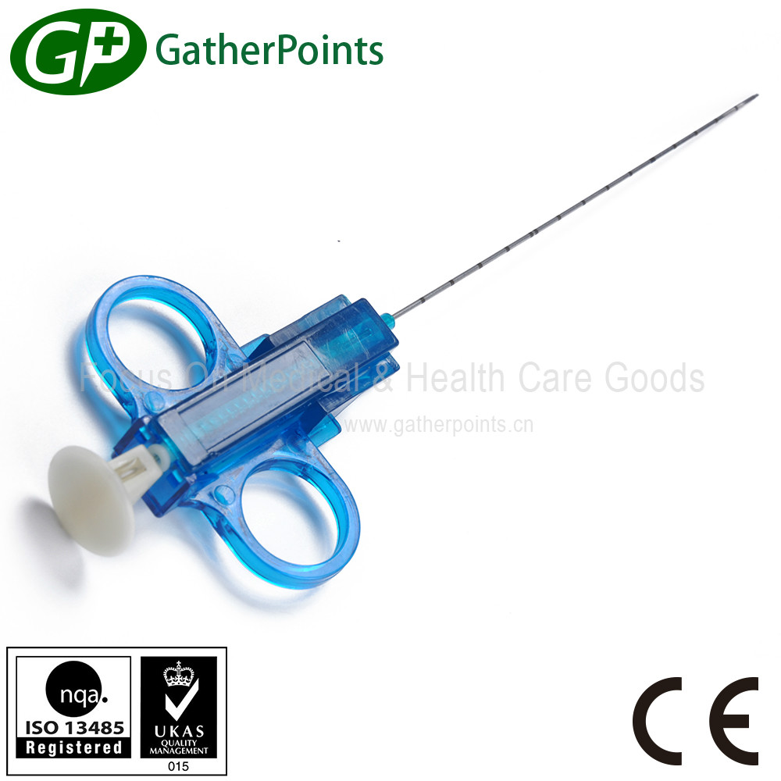
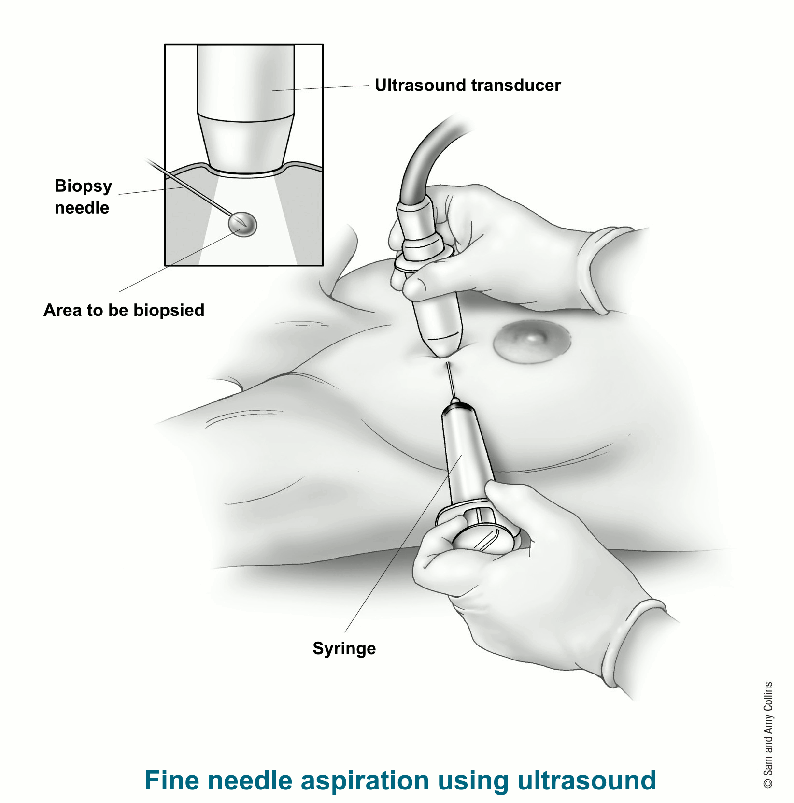
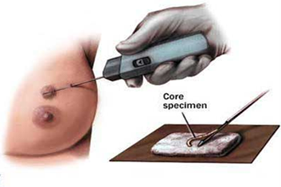
  - Types of biopsy:
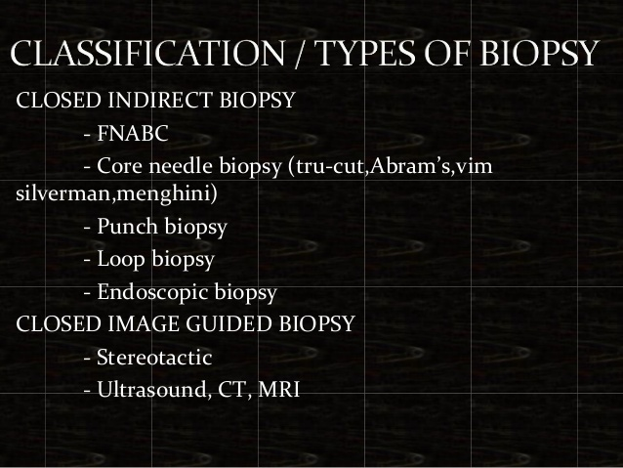
    - Closed biopsy
      - Fine needle aspiration cytology (FNAB/FNAC)
      - Truecut core needle biopsy
    - Open (surgical) biopsy with frozen section
      - Incisional biopsy (take part)
      - Excisional biopsy (take the whole thing)
        - +/- Proceed, because this is done intra-OP, meaning we send the frozen section to histopathology and wait for the result to proceed to further operative management (e.g. LN dissection)

- Some special notes:
  - Initial imaging:
    - Women older than 30 (35) mammogram > US
    - Women younger than 30 (35) US > mammogram
    - Reasoning:
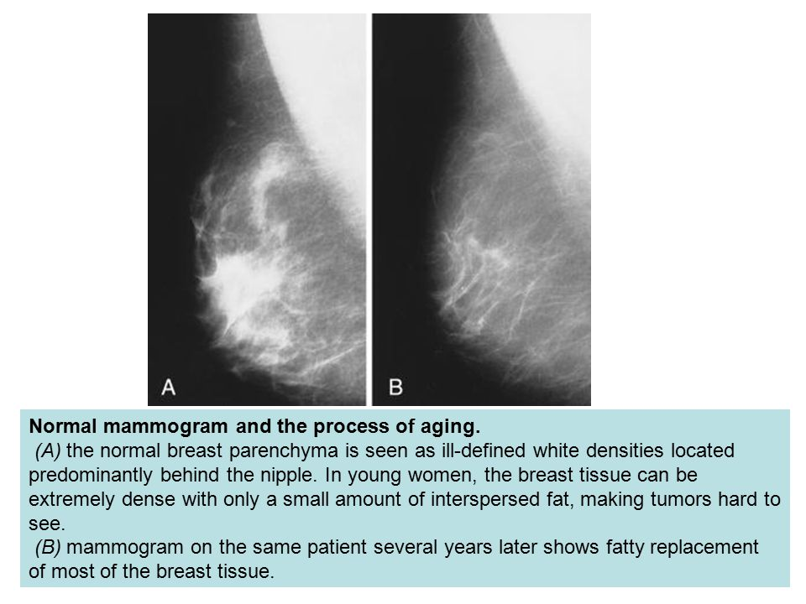
      - There is far more fibrous tissue in younger breasts, which distorts the mammogram (false positive)
    - In general, MAMMOGRAMS are STILL the BEST tool for SCREENING of breast cancer
      - Mammogram MUST be done BEFORE biopsies except for FNAB, because biopsies MAY ALTER mammogram findings
    - Important mammogram findings:
      - Spiculated mass/stellate mass
        - Indicative of possible invasive ductal carcinoma (IDC)
        - If with a central lucency = “radial scar”
      - Microcalcifications
        - Seen in DCIS
  - Indication for tissue biopsy?
    - Highly suspicious mass on P/E (solid mass, irregular borders, immobile, skin changes)
    - Highly suspicious mass in US/mammogram
    - Bloody aspirate
    - Residual mass following aspiration
    - Recurring clear cystic fluid
    - Bloody nipple discharge
    - Patient concern for persistent breast abnormality

- DDx of breast mass (EXCLUDING LIPOMA):
  - 1 = Neoplastic (first on list, because our biggest concern)
    - Benign
      - Fibroadenoma
      - Phyllodes tumor (can be malignant)
      - Intraductal papilloma (rarely felt, bloody discharge)
    - Pre-malignant (RARELY detectable)
      - DCIS
      - LCIS (you wish you could feel it!)
    - Malignant (when detected, usually already LN+ve or mets)
      - Invasive ductal carcinoma (IDC)
      - Invasive lobular carcinoma (ILC)
      - Other clinical entities (Paget’s disease of the nipple, inflammatory breast cancer)

  - 2 = Inflammatory
    - Fat necrosis of the breast
    - Mastitis (lactational, bacterial)
    - Breast abscess
    - Mondor’s disease (thrombophlebitis)

  - 3 = Fibrocystic changes (cyclic changes)

  - 4 = Mammary duct ectasia

- DDx of nipple discharge:
  - Physiological (BILATERAL, usually milky discharge/galactorrhea)
    - Excessive nipple stimulation
    - Stress
    - Pregnancy/lactation
  - Pathological (usually UNILATERAL)
    - Serosanguinous
      - Intraductal papilloma (MCC of bloody discharge)
      - Mammary duct ectasia (sticky, any color)
      - Fibrocystic changes (green, brown, straw-colored)
      - Breast cancer (anything)
    - Purulent discharge
      - Infectious mastitis/breast abscess
    - Galactorrhea (milky discharge)
      - Pituitary prolactinoma
      - Medication induced (e.g. antipsychotics)
      - Hypothyroidism

- INFLAMMATORY CONDITIONS OF THE BREAST
  - Acute mastitis
    - Etiology:
      - Staph aureus > streptococci
    - Occur in breastfeeding women
      - Improper breastfeeding technique nipple cracking bacteria in skin invade thru cracks
    - Presentation:
      - Lactating woman
      - Symptoms:
        - Breast pain, warmth, swelling, localized redness
      - Signs:
        - Breast erythema, swelling and warmth
        - Fever
    - Diagnosis is CLINICAL
    - Management:
      - Patient education
        - Tell them about the proper breastfeeding technique
Breast milk engorgement (whole breast seems swollen with dull aching pain)
$$↓$$
Acute mastitis
$$↓$$
Acute breast abscess

        - Continue breastfeeding using the UNAFFECTED breast
        - Decompress affected breast by using breast pump or by squeezing
      - Oral antibiotics (anti-staph antibiotics)
      - Simple oral analgesics
      - MUST F/U to R/O abscess, possible inflammatory breast cancer
        - If does not respond to oral antibiotics (persistence of local signs of inflammation), it could be an abscess

  - Breast abscess
    - Similar picture to mastitis, however, in addition:
      - Hx of diagnosis of mastitis, refractory to ABx
      - Hx of purulent nipple discharge (possibly)
      - Throbbing breast pain
      - High spiking fevers
      - Localized area of breast inflammation signs
      - Fluctuant, tender breast mass (however you don’t wait for this to diagnose)
    - Investigations
      - CBC
      - US

    - Management:
      - Incision and drainage (send pus for C&S) OR US guided percutaneous drainage (using needle aspiration)
      - Empirical oral antibiotics, 14 days (anti-staph)
      - Change antibiotics accordingly
      - F/U to R/O possibility of inflammatory breast cancer (especially in non-lactating or older women)
  - Fat necrosis
    - Occurs after breast trauma
      - 50% of patients DO NOT remember history of trauma, because it is TRIVIAL
      - In exams, however, the suspect is usually a sporty person (gymnast, boxer, etc) or was in a minor car accident
    - P/E firm, irregular breast mass +/- tenderness
      - This will be treated with fear, and most likely you will NOT KNOW that is fat necrosis until AFTER biopsy findings tell you that it is!
    - Investigations as for breast mass:
      - US/mammogram + FNAB/Biopsy
    - Rx = excision (usually done anyway)

  - Mammary duct ectasia
    - Dilated and inflamed duct secondary to OBSTRUCTION, usually occurs in the distal ducts, near the nipple
    - Presentation:
      - Non-cyclic, painful, subareolar mass/lump
      - STICKY NIPPLE DISCHARGE (2nd MCC of pathological nipple discharge)
      - You must identify WHICH DUCT is affected on P/E
    - Investigate as for breast mass
      - Mammogram will show dilated duct(s)
    - Management
      - Surgical excision of affected duct only

- Mondor’s disease (sorry, but no)

- Gynecomastia
  - Definition: enlarged male breast
  - Males CANNOT develop glandular tissue, so there will NOT be discharge
  - Causes:
    - Physiological (puberty, old age, neonates)
    - Pathological
      - Iatrogenic/medications (antipsychotics, spironolactone)
      - Liver failure (high estrogen)
      - Prolactinoma
  - Presentation:
    - Male breasts (MOOBS)
    - Subareolar disc of tissue (maybe palpated as a mass)
  - DDx
    - In older males, don’t forget about MALE BREAST CANCER
  - Management:
    - If physiological reassurance
    - If pathological Rx underlying cause
    - Cosmetic surgery is an option

- BENIGN BREAST CONDITIONS

  - FIBROADENOMA
    - Proliferation of fibrous stroma and duct epithelium
    - It is a benign tumor that is well-encapsulated
      - It is estrogen sensitive
      - Size and tenderness may increase during pregnancy
    - Most common breast lesion in adolescence and young females (15- 30 years old)
    - Presentation:
      - Symptoms: breast lump
      - Signs or P/E:
        - Smooth, firm, well circumscribed, round, very mobile breast mass
        - May be solitary or multiple
        - Described to be “mouse of the breast” because it is difficult to get it under your finger
    - Investigations:
      - Imaging: US
      - FNAB (if suspicious) no fluid, pathology will be evident
    - Management:
      - Close observation if patient is young (<30) and < 2 cm
      - Surgical excision if patient is old and/or if >2cm
      - In general, surgical excision is preferred to confirm the pathological diagnosis
    - Note: subset of patients develop juveline giant fibroadenoma, which occurs in teenagers, grows very fast, distorts the normal development of the breast and that MUST be surgically excised to ensure normal breast development
  - PHYLLODES TUMOR (CYSTOSARCOMA PHYLLODES)
    - Fibroadenoma variant
    - Presents at 30s – 40s (much later than fibroadenoma)
    - Can be:
      - Benign (MC)
      - Intermediate
      - Malignant (<10%)
    - Presentation:
      - Hx of rapid growth of breast mass
      - LARGE, freely movable breast mass that distorts the breast shape
      - When very large, it is unmistakable
    - Investigation
      - Triple assessment
      - May need core biopsy
    - Management
      - Surgical excision with >1 cm margins
        - Why margins? Because it tends to recur and more aggressively
        - There may also be a risk to develop cancer
      - If very large simple mastectomy may be offered

  - FIBROCYSTIC CHANGES (FCC)
    - Age group: 30s – 50s
    - Common condition
      - Only 10% develop CLINICALLY apparent FCC, however majority of woman have SOME form of FCC
      - Estrogen responsiveness (related to cycles)
    - As the name implies, the changes involve fibrous tissue and cyst formation, however in more detail we have:
      - Adenosis
      - Epitheliosis (atypical epithelial hyperplasia is associated with higher possibility of developing cancer)
      - Fibrosis (sclerosing adenosis resembles cancer)
      - Cyst formation
    - Presentation
      - Symptoms
        - Painful, nodular swelling(s) of the breast
        - This is especially marked in the perimenstrual period (cyclic breast pain and swelling)
        - May have nipple discharge that is clear, yellow or even brown/green in color

      - Signs
        - Multiple, tender breast nodularities (one can be predominant and felt alone)
        - Often BILATERAL
        - MC location is UOQ
    - Investigations:
      - US/mammogram
      - FNAB of dominant cyst (if possible)
        - Straw-colored fluid/green fluid is typical
        - If biopsy shows atypia or lobular/ductal hyperplasia, there is a possible risk of developing cancer (must excise)
    - Management:
      - If <30, non-bloody aspirate, no residual mass and does not recur in 2 weeks surveillance
        - Patient education about SBE
        - Avoidance of caffeine
        - Pain control
        - Some role of danazol/OCPs in reducing pain
        - F/U visit to proceed
      - If bloody aspirate, recurrence, or suspicious case (older age group, or biopsy with atypia) open excisional biopsy
      - Patients found to have atypia on biopsy should be instructed to do BSE

  - INTRA-DUCTAL PAPILLOMA
    - Benign local proliferation of subareolar duct epithelial cells
    - Presentation:
      - Symptoms
        - Bloody or blood-stained nipple discharge (MCC)
      - Signs:
        - Subareolar breast mass +/- bloody nipple discharge
        - Radical breast compression to identify which duct expresses the fluid
    - Investigation:
      - Triple assessment (try to R/O breast cancer)
      - Excisional biopsy of the affected duct is also therapeutic
    - Management:
      - Excision of the affected duct

- PREMALIGNANT DISEASE
  - AKA carcinoma in situ
  - We are concerned with:
    - Ductal carcinoma in situ (DCIS)
    - Lobular carcinoma in situ (LCIS)

  - DCIS:
    - Inner layer of duct epithelial cells proliferate
    - They spread along the ducts but not beyond the BM
    - Older age group (>50s)
      - 50% of patients found to have DCIS are post-menopausal
    - CAN occur in males (LCIS cannot, because they don’t have glands!)
    - Presentation:
      - Almost always ASYMPTOMATIC
      - Discovered incidentially on mamography screening
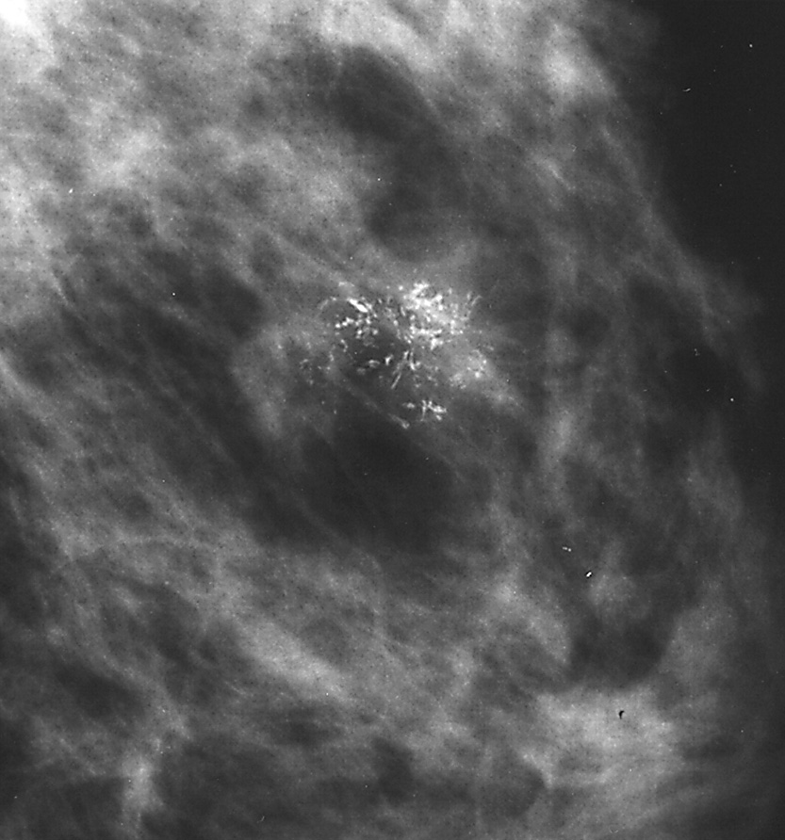
      - It MAY present with a palpable mass
    - Investigations:
      - Mammography MICROCALCIFICATIONS
      - Biopsy malignant cells within ducts, but not invading BM
    - Interpretation:
      - Anatomic precursor of IDC
      - Typically will occur in the ipsilateral breast and same quadrant (vs LCIS)
    - Management:
      - < 2 cm lumpectomy + XRT
      - > 2 cm lumpectomy with 1 cm margin + XRT
      - Diffuse/CI to XRT simple mastectomy
      - ER +ve Tamoxifen
        - For 5 years, shown to lower risk of breast cancer from developing (however at the stake of potentially developing endometrial cancer and thrombosis)
  - LCIS:
    - Arise from cells in terminal duct + lobular unit
      - Proliferation of acinar and duct cells
    - MC in premenopausal age group
    - NEVER in males
    - Considered a MARKER of impending cancer, but it in itself is NOT precancerous!
      - EITHER breast is at risk (30% in 20 years to come)
      - 75% will develop IDC (YES, IDC, not ILC!)
      - It is usually found to be BILATERAL (50% you’ll find LCIS in the other breast)
    - Presentation
      - Pre-menopausal woman
      - ASYMPTOMATIC
      - Almost NEVER presents with a palpable mass
    - Investigations
      - NOT detectable on mammography!
      - Incidental finding on biopsy!!
    - Management:
      - High risk patients are offered prophylactic bilateral mastectomy
      - If patient refuses, intensive/close F/U is done
      - If ER +ve tamoxifen can help reduce risk of cancer

- BREAST CANCER
  - Epidemiology
    - 1 in 8 women will develop breast cancer in her lifetime
    - 12% lifetime risk in USA
It is the MC cancer diagnosed in females (excluding skin cancer); 2nd MCC of cancer-related mortality (after lung cancer).
    - 75% have NO KNOWN risk factors
    - 99% are woman; 1% man
    - Distribution:
      - 50% UOQ
      - 20% subareolar
      - 10% UIQ; 10% LOQ, 10% LIQ
  - Screening
    - 3 methods of “screening” of breast cancer:
      - Breast self-exam (BSE)
      - Clinical breast exam
      - Mammography

    - Monthly breast self-exam (BSE)
      - Patients are encouraged to do this
      - Once a month
      - 1 week after menses
      - Starting at age of 20

    - Yearly clinical breast exam
      - Offered to patients >40 years old, done YEARLY
      - When cancers are felt as masses on clinical exam, it is already too late!
      - The goal of screening is to identify risk of cancer before the cancer develops clinically

    - Yearly mammography (still the best we got)
      - LOW radiation dose
Mammography views:
CC = cranicaudal
MLO = mediolateral oblique
      - Offered to patients >40 (45) years old YEARLY (or now every other year)
      - If nothing is found by age of 55, the mammograms can be done every other year
      - Patients with FAMILY HISTORY of breast cancer at YOUNG AGE (<45 years old) should be screened 5-10 years EARLIER than the youngest relative to develop it
      - A mammogram should be done NOW if you find a clinical mass
  - Risk factors:
    - Gender (obvious: females)
    - Old age (> 50)
    - Personal history of:
      - Breast cancer
Remember, in the majority of women, there are no identifiable risk factors (besides being female)
      - Breast procedures done (e.g. biopsy)
      - Abnormal biopsy (LCIS, DCIS, atypia)
    - Family history (1st degree relative)
      - Especially if premenopausal or bilateral
    - Menstrual history
      - Early menarche (<12)
      - Late menopause (>55)
    - Obstetric history
      - Nulliparity
      - Late first pregnancy (>30)
      - Lack of breastfeeding
    - Genetic predisposition/hereditary factors:
      - Only in 5 – 10%
      - BRCA1: 17q, 60% lifetime risk, also increased risk of ovarian cancer; tumor suppressor gene
      - BRCA2: 13q, 60% lifetime risk, male breast cancer associated; tumor suppressor gene
      - P53 mutation (and Li-Fraumeni syndrome)
      - Others (Peutz-Jeghr, Lynch syndrome)
      - We offer +ve patients with prophylactic bilateral simple mastectomies
    - Lifestyle
      - Obesity (more fat, more estrogen)
      - HTN and DM
      - Smoking
      - Radiation exposure
      - OCP/HRT (debatable)
  - HISTOLOGICAL TYPES:

    - Invasive DUCTAL carcinoma (IDC) and NOS
      - MC type (80%)
      - MC in peri and post-menopausal women
      - Subtypes:
        - Comedo IDC
        - Scirrhous IDC
        - Medullary IDC (associated with BRCA1)
        - Papillary IDC
        - Tubular IDC
      - Prefers to metastasize to:
        - Bone
        - Lung
        - Liver
        - Brain
        - LN
        - So basically, LLBB (like colon cancer, but not same order)
      - We must include investigations to R/O mets to the above sites
        - Except for CNS, we only do it when neurological symptoms are present

    - Invasive LOBULAR carcinoma (ILC)
      - 10% of breast cancers (2nd MC type)
      - Has high likelihood of being BILATERAL
      - For common knowledge purposes, you don’t really need to know the exact sites it prefers to metastasize, but it includes lymph nodes, serosal surfaces, meninges
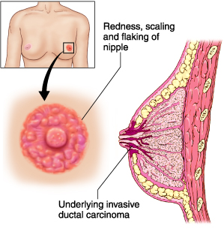
    - Clinical types:
      - Paget’s disease of the nipple
        - Usually 2nd to underlying IDC (or LCIS extending thru duct and invading nipple and areola)
        - The cancer cells climb up the ducts and into the areola, resulting in a weeping NAC
        - Presentation:
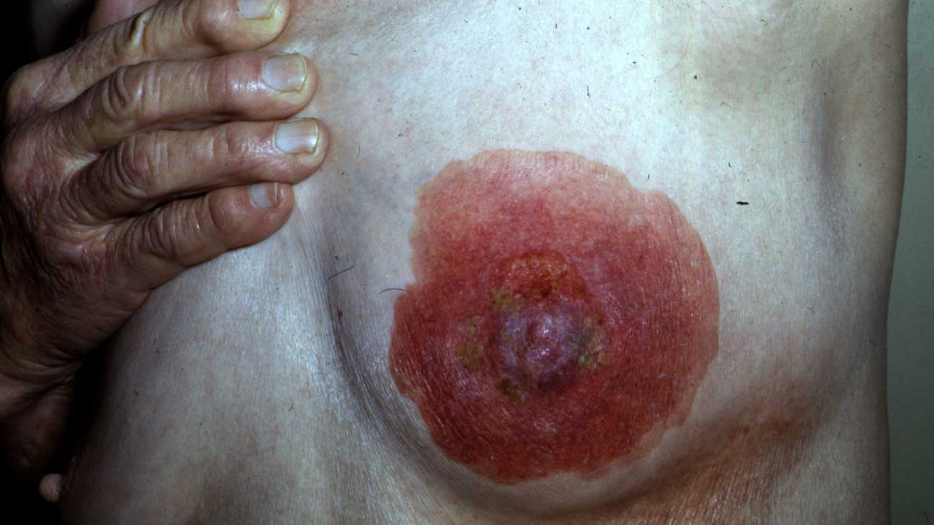
          - Pruritic, tender, eczematous (“weeping”) nipple
          - The NAC can completely DESTROYED
          - +/- subareolar mass
        - Investigations
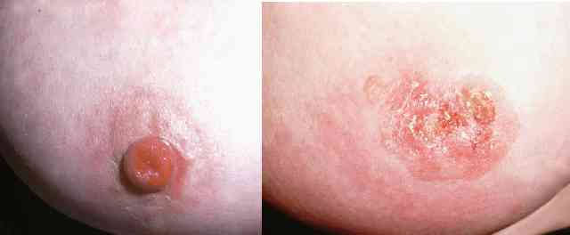
          - Skin biopsy shows Paget cells
      - Inflammatory carcinoma (2-3%)
        - Rare, but aggressive
        - Most lethal form of breast cancer
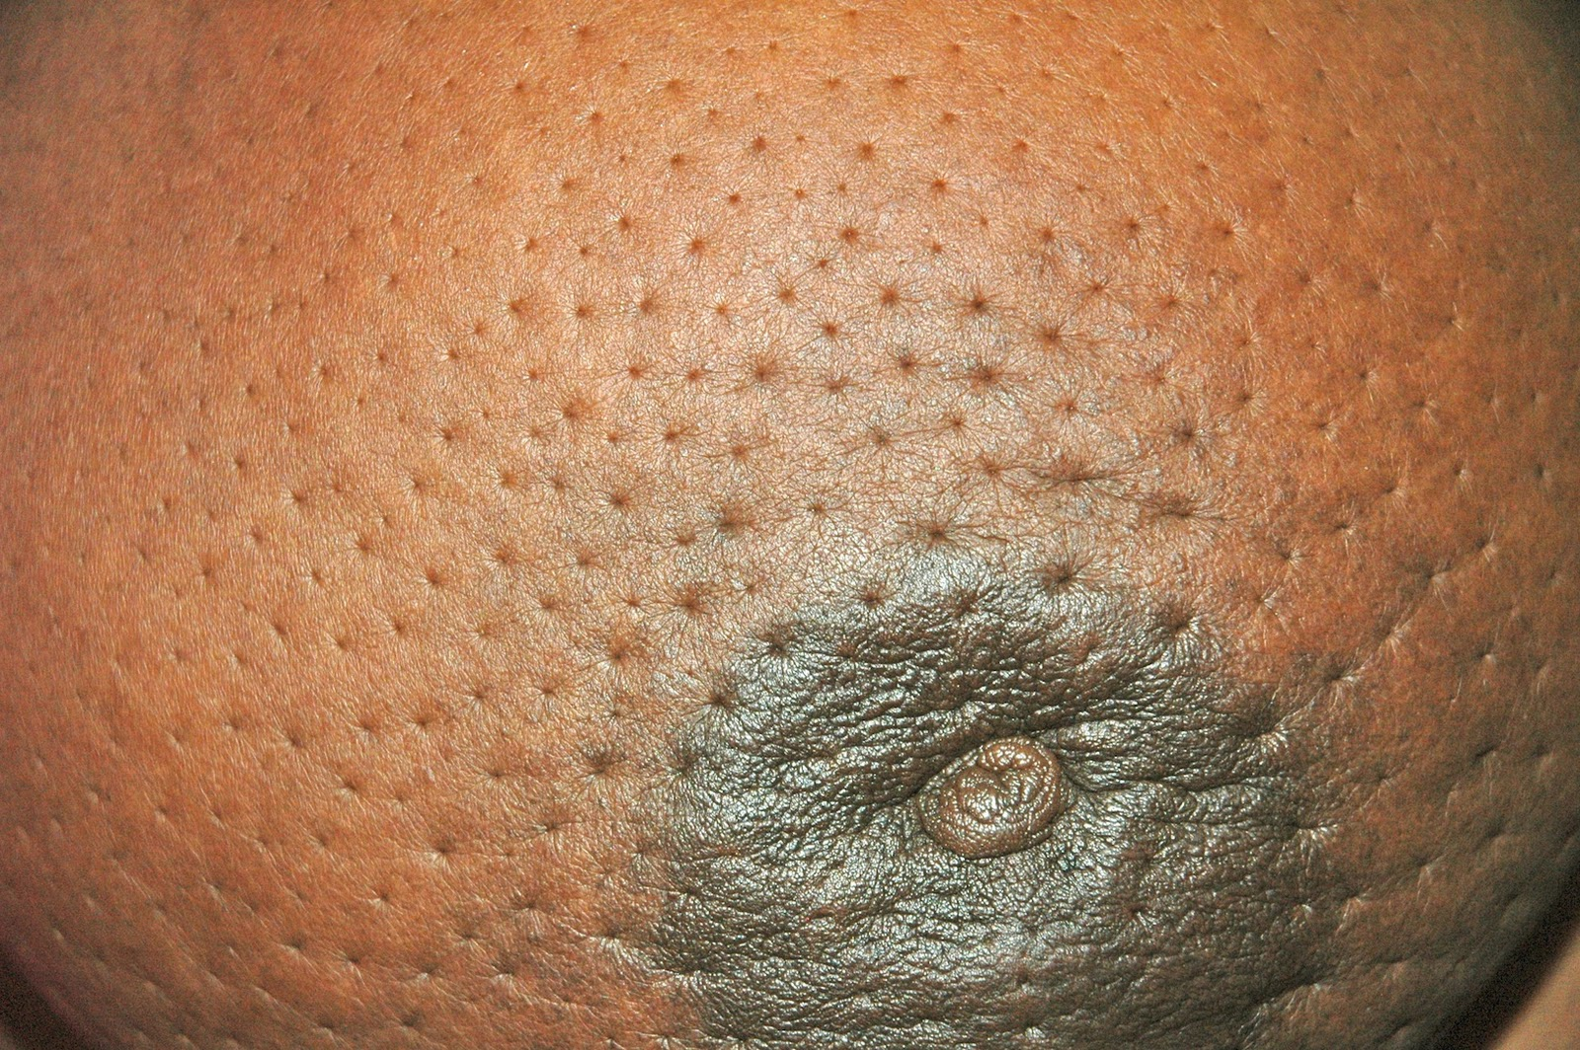
        - 75% have metastasis at diagnosis
        - Invasion of breast lymphatic system results in edema of breast, while the sebaceous gland ducts remain pitted peau d’orange
        - Presentation:
          - Classical Hx: patient Dx as mastitis unresponsive to antibiotics
          - Inflammatory S&S: redness, swelling, pain
          - On P/E:
            - Erythema, swelling, tenderness and warmth
            - Peau d’orange
            - Nipple retraction
        - Investigation:
          - Biopsy will show dermal lymphatic invasion
        - It is one of the breast cancers that we use neoadjuvant CHEMOTHERAPY (see later)

  - Presentation:
    - Symptoms:
      - Asymptomatic (until metastatic)
      - Painless breast mass
      - Nipple discharge
      - Skin changes:
        - Nipple retraction (unilateral, new)
        - Nipple eczema
        - Skin dimpling
        - Ulceration
        - Inflammatory features (e.g. peau d’orange)
      - Breast shape changes (everted, asymmetry)
      - Of metastasis (bone pain, fractures, CNS symptoms, liver symptoms, etc.)
    - P/E:
      - Asymmetrical breast shape/contour
      - Palpable breast mass
        - Usually non-tender
        - Hard/firm
        - Irregular shape, surface, margins
        - Fixed (to skin or muscle)
      - Nipple discharge (any color, but serosanguinous)
      - Skin changes (as above)
      - Lymphadenopathy (axillary, supra and infraclavicular, and maybe cervical and contralateral axillary)

  - What is your next step or approach to a suspicious breast mass?
    - Using the TRIPLE ASSESSMENT, we continue with imaging and biopsy
    - If the 3 components are suggestive of cancer, diagnosis is sufficient to proceed to staging investigation
    - If the 3 are not met sufficiently, an open biopsy procedure is done (e.g. excisional biopsy)

  - INVESTIGATIONS
    - Following the standard investigations
      - Imaging: bilateral mammography
        - Findings of radial scar/stellate or spiculated opacity; may see microcalcifications
      - Biopsy: closed or open
        - Check for ER, PR, HER2/NEU receptors by immunohistochemistry (other minors: E-cadherin, beta-catenin)
    - Pre-OP staging workup
      - Lab:
        - CBC
Cytology report in breast cancer following FNAB or trucut core biopsy:
C1 = unsatisfactory
C2 = benign
C3 = atypical, probably benign
C4 = suspicious (needs re-evaluation)
C5 = malignant

If C4 must do core biopsy if did FNAB; if did core already, repeat it.
        - Bone profile (Ca²⁺, PO₄, Mg, ALP)
          - Breast cancer bone mets can be osteolytic or osteoblastic
        - LFTs (Liver mets)
        - RFTs (BUN, Cr, GFR, electrolytes)
      - Imaging:
        - CXR (lung mets)
        - Abdominal CT (liver mets)
        - If bone profile shows abnormality bone scan
Triple negative = BAD
Triple positive = GOOD
ER +ve, PR +ve = good
In ER, PR +ve we can use tamoxifen (breast is hormonally responsive) and in HER2/NEU +ve we can use trastuzimab/Herceptin
Classically, HER2/NEU +ve is bad (but if +ve in triple, considered good because we have tamoxifen)
    - Intra-OP staging
      - Frozen section excisional biopsy will be done initially if closed biopsies were not sufficient
        - This is sent immediately for histopathology analysis for histology, ER, PR, HER2/NEU
      - Sentinel LN biopsy (if no palpable LN were detected on P/E or seen on imaging)
        - Aim: try to find the primary draining LN, excise it, send it for pathology to see if it is invaded
        - How: injecting blue dye or technetium labeled sulfur colloid into lymphatic use special gamma probe OR see the blue color drain
        - The FIRST LN it drains to = sentinel node
        - If sentinel node is +ve = proceed with axillary dissection
        - If sentinel node is –ve = no need to proceed with axillary dissection
      - Once all the necessary components of staging are collected, the patient can be staged
  - STAGING
    - TNM staging
      - The nodal component is the MOST important for prognosis (also, the NUMBER of LN affected)
There is a clinical staging (cTNM) and pathological (pTNM) staging which is done after appropriate biopsy is taken.
      - Staging is more important than histological type
    - T = tumor size
      - Tis = in situ
      - T0 = no evidence
      - T1 = <2 cm
      - T2 = 2 – 5 cm
      - T3 = > 5cm
      - T4 = any size + skin involvement (ulceration, nodule, peau d’orange, not dimpling) OR fixed to muscle
    - N = nodal involvement
      - N0 = none
      - N1 = ipsilateral level I & II axillary LN + MOBILE
      - N2 = ipsilateral I & II + FIXED
      - N3 = WEIRD/FAR NODES
        - Involves supraclavicular or infraclavicular LN
        - Involves parasternal/IMA nodes
        - Involves contralateral LN?
      - If it is not obvious clinically, radiologically, then you need to do a sentinel node biopsy
    - M = metastasis
      - M0 = no
      - M1 = yes (radiologically, clinically, or histologically)

    - Numerical staging:
      - Stage I
        - T1, N0, M0
        - Tumor is < 2 cm, NO nodes
      - Stage II
        - 2A = T1 + N1 or T2 + N0
        - 2B = T2 + N1 or T3 + N0
        - basically, big size + movable nodes
      - Stage III
        - 3A = T3 + N1 OR any size + N2 (fixed node)
        - 3B = T4 (fixed to skin or muscle)
        - 3C = N3 (went to far node)
      - Stage IV
        - M1 (any T, any N, but M1)
    - Examples:
      - Patient with 4 cm mass, 2 palpable mobile axillary LN, no evidence of skin involvement or muscle or mets
        - 4 cm = T2
        - mobile LN = N1
        - No mets = M0
        - T2 + N1 + M0
        - Stage 2 (2B to be exact, get it? To be, 2B… haha)

      - Patient with 5.2 cm mass, 1 fixed ipsilateral axillary LN, no metastasis, but it is fixed to muscle
        - 5.2 cm = T3, BUT has fixed to muscle, so T4
        - Fixed node = N2
        - M0
        - But since T4, we jump directly to? Stage 3 (3B to be exact)

  - PRINCIPLES OF MANAGEMENT
    - Modalities:
      - Surgical Rx (e.g. modified radical mastectomy, lumpectomy)
      - Radiotherapy (e.g. in breast conservative surgery)
      - Chemotherapy (e.g. “CMF”/”CAF”)
      - Hormonal therapy (e.g. tamoxifen)
      - Targeted receptor therapy (e.g. trastuzimab/Herceptin)

    - SURGICAL Rx
      - Done in almost all cases
        - In advanced cancers where palliative care is done (E.g. inflammatory BC or stage 4), we do palliative surgery or debulking because the cancer can become large, bleed, fungate, cause chronic pain, get infected, etc.
      - Usually surgical Rx +/- reconstruction (offered to patients for cosmetic reasons)
      - Types of surgery:
        - Breast conservation surgery/therapy
          - Lumpectomy (+ post-op XRT)
          - Quadrantectomy
        - Mastectomy
          - Simple mastectomy
          - Modified radical mastectomy
          - Classical (but not done anymore) = radical mastectomy

      - Breast conservative therapy (BCT)
        - At the risk of recurrence, eligible patients are given the option to conserve their breast
Watch out for satellite tumors near the main tumor. These satellite tumors need to be removed as well. We use wide margins for lumpectomy to ensure we cover them.
        - Lumpectomy +/- LN dissection AND post-OP radiotherapy
        - LN dissection if sentinel node biopsy is +ve
        - Eligibility is ONLY for:
          - Stage I & II breast cancer
        - Contraindicated in:
          - Pregnancy (can’t do XRT)
          - Previous radiation exposure
          - Collagen vascular disease (scleroderma)
          - Diffuse disease (e.g. extensive DCIS)
          - Small breasts (no advantage)

      - Simple Mastectomy
        - Removal of ALL breast tissue
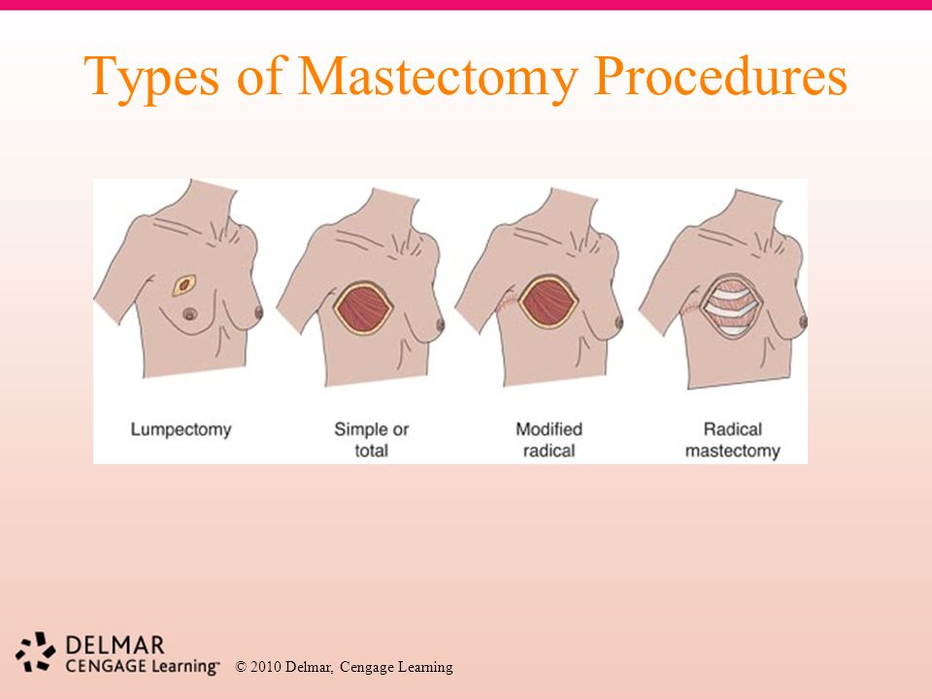
        - Done for/offered in:
          - Diffuse DCIS
          - LCIS (bilateral mastectomies)
          - BRCA1 +ve patients (bilateral)

      - Modified radical mastectomy (MRM)
        - Removal of all breast tissue + NAC
        - Level I & II axillary LN dissection
        - Axillary drain
          - Inserted to drain lymph because of lymphedema risk
          - Kept for 14 days or until <30 cc drainage
        - Complications:
          - Cosmetic/disfiguring
          - Lymphedema of arm
          - Long thoracic nerve injury winged scapula
Careful, careful
If the doctor asks you the complications of MRM, don’t jump to this: remember what we said…
Anesthesia and surgery: general and specific (as this) and for general: immediate, early, late

Prolonged lymphedema increases the risk of developing infection and malignancy (Stewart-Treves syndrome).
          - Infection, skin graft necrosis, hematoma, phantom breast syndrome
          - Note: lymphedema can occur secondary to XRT too
      - Breast reconstruction
        - Can be done during initial surgery or later
        - Methods:
          - Implants
            - Autologous
            - Prosthetic (saline or silicone)
          - TRAM flap
            - Transverse rectus abdominis myocutaneous flap
          - Latissimus dorsi flap
  - Other notes:
    - Chemotherapy
      - Neoadjuvant chemotherapy
      - CMF = cyclophosphamide, methotrexate, 5-FU
      - CAF = same, but A = Adriamycin
      - Typically done if:
        - LN +ve
        - Metastatic cancer
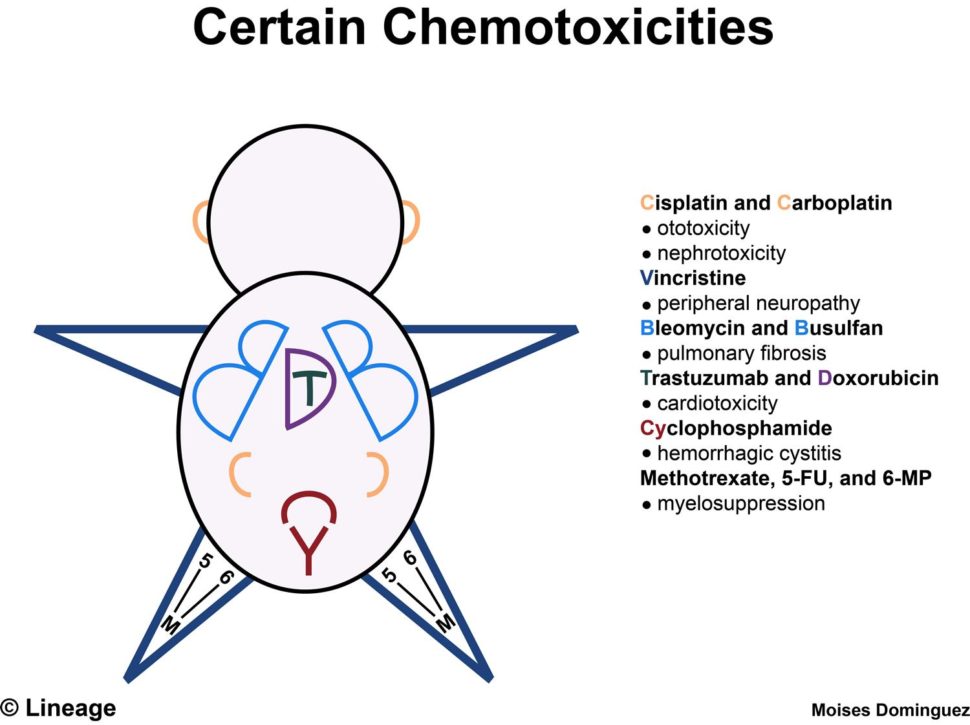
        - High risk patient
        - Inflammatory breast cancer
      - Complications:
        - A lot, but remember, BM suppression and risk of developing secondary non-solid tumors (leukemias, lymphomas)
      - Who is a high-risk patient?
        - > 2 cm
        - ER/PR –ve
        - Lymphatic or vascular invasion
        - High nuclear grade
        - HER2/NEU +ve

    - Hormonal therapy
      - ER/PR +ve:
        - Aromatase inhibitors (anastrazole)
        - Selective estrogen receptor modulators (SERM)
          - Tamoxifen (-ve breast, +ve bone, +ve endometrium)
          - Raloxifen (-ve breast, +ve bone, -ve endometrium; but not enough studies, not used even though sounds good!)
        - ADR of tamoxifen = high estrogen
          - Endometrial cancer risk (must screen while on therapy)
          - DVTs/PE (thrombosis risk)
          - Hot flashes, diaphoresis, mood swings (mimics menopause)
          - N&V (very common)
    - Targeted Therapy
      - Trastuzamab (Herceptin)
        - Targets HER2/NEU receptors
        - Notorious ADR = HEART FAILURE

    - TREATMENT DECISIONS
      - Stage I & II (“early invasive”)
        - Breast conservative therapy
        - Lumpectomy +/- LN dissection AND Post-OP XRT (adjuvant)
        - +/- tamoxifen (hormonal) if ER/PR +ve
        - +/- targeted (trastuzimab) if HER2/NEU +ve
        - +/- adjuvant chemotherapy (if LN +ve or high risk)
      - Stage III (“locally advanced”)
        - Modified radical mastectomy + axillary LN dissection (with drain)
        - XRT or chemotherapy because high risk
        - +/- hormonal therapy if ER/PR +ve
      - Stage IV (metastatic)
        - Systemic and palliative care
        - Poor prognosis (median survival is ~ 2 years)
        - May need mastectomy for palliation (severe pain, discharge)
      - Inflammatory breast cancer
        - Neoadjuvant chemotherapy
        - Palliative care (e.g. surgery)
    - Prognosis
      - 5-10% local recurrence within 10 years
      - 5-year survival
        - Stage 1 ~ 95%
        - Stage 2 ~ 75%
        - Stage 3 ~ 50%
        - Stage 4 ~ 18% (just say 20%)

- Breast cancer in special populations
  - Pregnant women
    - Same steps in diagnosis (triple assessment)
    - Mammography can be done if SHIELDED
    - No XRT is done during pregnancy, however
      - If Dx is in 3rd trimester and it is stage I, II can do lumpectomy now and XRT post-partum
    - 2nd trimester MRM
      - Chemotherapy should NOT be done in 1st trimester

  - Male breast cancer
    - IDC (never ILC)
    - Usually diagnosed LATER (because not suspected) when the tumor already invaded chest wall
    - Risk factors:
      - Klinefelter syndrome
      - Estrogen therapy
      - Previous radiation exposure

PEDIATRIC SURGERY

- Esophageal atresia
  - Types:
    - Type A = pure esophageal atresia (8%)
    - Type B = esophageal atresia + proximal TEF (1%)
      - Absent air in stomach
      - Aspiration pneumonia/chemical pneumonitis
    - Type C = esophageal atresia + distal TEF (85%) – MC type
      - Excessive stomach bubble
      - Gastric acid may enter airways from below and because of atresia, food can enter airway from above (aspiration pneumonia/chemical pneumonitis)
    - Type D = esophageal atresia with proximal & distal TEF (2%)
    - Type E (“H”) = no esophageal atresia, but TEF, producing an H shape
  - Point of entry of the TEF is usually at the level of the CARINA
  - 50% of patients have associated anomalies such as:
    - VACTERL association
      - Vertebral anomalies
      - Ano-rectal abnormalities
      - Cardiac abnormalities
      - TE fistula
      - Renal malformation
      - Limb deformities
  - Presentation:
    - Antepartum
      - Polyhydroamnios, maybe identified on US
    - Neonatal symptoms
      - Hypersalivation (MC)
      - Choking following first feed
      - Vomiting milk contents (spit up)
      - Respiratory distress/recurrent cough/pneumonia
    - Signs:
      - NGT fails to pass through esophagus
      - Signs of aspiration pneumonia
      - Gastric distention (if distal TEF)
      - May need to check for VACTERL:
        - Heart defects (cardio exam)
        - Renal abnormalities (abdo exam)
        - Ano-rectal abnormalities (inspect anus)
        - Vertebral anomalies (check back)
  - Investigations:
    - Antenatal US
    - Post-natal:
      - CXR:
        - Coiling of NGT in esophagus (indicates atresia)
        - Signs of pneumonia
        - Increased or absent air in stomach
      - Renal US
      - Echo and ECG
  - Management:
    - ABC (stabilize patient)
    - Upright seat
    - NGT suctioning
    - NPO
    - IV prophylactic antibiotics
    - When stable Surgical repair
      - If not a wide gap fistulectomy, end-to-end esophageal anastomosis
      - If wide gap ( ≥ 3 vertebral levels):
        - May create temporary cervical esophagostomy and gastrostomy
        - Alternative methods can be used many years later when patient more mature (e.g. interposing a bowel loop)
      - Complications:
        - Leaking of esophageal contents (mediastinitis)
        - Stricture formation
        - GERD (70%)

Skin cancers
Marjoline ulcers (SCC on burns and other sites of skin irritation)
Instruments
Biliary atresia
Spleen
Renal cancer
Parotid disease
Central venous line indications, veins used, complications,…
Soft tissue tumors
Type of incision for bone biopsy = longitudinal

