**EMERGENCY MEDICINE**

**PATIENT ASSESSMENT**

1. ***Primary survey***
   1. **ABCDEFG**
      * Airway (and C-spine protection/immobilization)
      * Breathing
      * Circulation
      * Disability
      * Exposure and environment (temperature control)
      * Foreign body (do NOT remove)
      * Go back to ABCs (repeat to monitor)
   2. **General information:**
      * MCC of fatal injury in Bahrain is RTA
      * **Trimodal death distribution** in trauma:
        1. **Immediate (50%)** – patient fatality when trauma occurs (usually result of a fatal injury causing massive airway obstruction, massive brain injury or a high neck injury disrupting the c-spine)
        2. **Within an hour (30%)** – the **GOLDEN hour** (can be a result of inadequate emergency management)
        3. **Within a week (20%)** – result of **secondary problems** such as **sepsis** and **multiple organ failure**
      * In all cases, always practice universal precautions, especially if bloody:
        1. Wear gloves, goggles, plastic gowns and face mask when necessary
      * AVPU can be done quickly (instead of GCS) to help guide the extent of injury:
        1. AVPU = alert/verbal/pain response/unresponsive (unconscious)
        2. GCS 8 or less = comatosed/unconscious
      * The vitals (including SPO2) and IV access is usually done by others at the same time as the primary survey!
   3. **AIRWAY**
      * First priority in all cases is **secure airway** (so that the patient can breathe or if unconscious be provided oxygenation and ensure a patent airway)
      * Inspection of the patient when arriving can give you a clue as to the extent of damage to the airways:
        1. Patient is conscious but has **noisy breathing or stridor** (obstructed airway)
        2. **Patient is unconscious**, has risk of obstruction by swallowing tongue or insidious injuries (so we generally need to do definitive airway in these patients)
        3. Patient coming from a **fire/smoke** and might have inhalational injuries or chemical injuries
        4. Patient has obvious **trauma to face** and **neck** that might result in **blockage of airway** or **damage to the c-spine** causing damage to phrenic nerve (C3, C4, C5 keep the diaphragm alive 🡪 stops breathing) or respiratory centers in the medulla
      * **Assume C-spine injury in any major trauma cause** (e.g. RTA)
      * **INITIAL STEPS:**
        1. **BASIC AIRWAY:**
           1. **C-spine immobilization**

Hold head in **neutral position** by both hands

Apply a **HARD cervical collar** of the appropriate size (based on distance from **angle of mandible to shoulder**: 4 sizes) W/O moving head/neck

Other measures: **sandbags**

This is done until c-spine injury is ruled out ideally by CT > radiographs (need many views, might need swimmer view)

* + - * 1. **Jaw thrust > head-tilt chin lift** (the latter is CI if suspecting c-spine injury)
        2. **Insert airway devices**

If **not major**: **oropharyngeal airway** (CI if has a gag reflex or jaw injury/dislocation) or **nasopharyngeal airway** (CI if suspecting basal skull fracture: look for battle sign and raccoon eyes and CSF leakage)

**Laryngeal mask airway** (LMA): quick, easy to insert, but does NOT prevent aspiration – done if definitive airway is difficult

If definitive airway not needed, bag and mask ventilation (ampu bag) can be used over these airways

* + - * 1. If has indications for **definitive airway,** proceed to **ETI or surgical airway**

Patient unable to protect airway because **unconscious** (GCS <8, U in AVPU) or **major trauma** (the other indications of intubation will not be available in an immediate emergency setting

**Definitive airway = tube in the trachea WITH cuff inflated**: ETI with cuff or surgical airway with cuff

For ETI, RSI w/o moving c-spine is done

Surgical airway = cricothyrotomy, tracheostomy

**Do LMA if difficult** (to buy time)

FYI: there is orotracheal intubation and nasotracheal intubation

Drugs given through ETT: **NAVEL** (**n**aloxone, **a**tropine, **v**entolin, **e**pinephrine, **l**idocaine)

* + - 1. **BREATHING**
         1. Goal is to R/O the condition that affects the chest that can be easily diagnosed clinically, managed w/o invasive procedures and that w/o immediate management can cause death rapidly

**Tension pneumothorax**

**Massive hemothorax**

**Open pneumothorax**

**Flail chest**

**Cardiac tamponade can be assessed, but it’s mostly in circulation**

* + - * 1. Steps involve:

**INSPECTION** (from up to down)

**Mental status:** anxious, agitated = airway obstructed or shocked; unconscious?)

**Signs of respiratory distress** (nasal flaring, gasping for air, tachypneic, supraclavicular and suprasternal retractions and in kids, also intercostal and subcostal retractions)

**Distended neck veins**

Obvious chest wounds, **SUCKING chest wound**, **obvious flail chest** (multiple rib fractures at two points that protrude during inspiration and sink during expiration)

**Paradoxical chest movements** (thoracoabdominal in males is abnormal!)

**PALPATION & PERCUSSION**

**Tracheal deviation**, chest wall crepitus or SQ emphysema, sucking chest wound and flail chest

**Percuss** for **hyper-resonance or dullness**

**AUSCULTATION**

Watch out for stridor, **absent breath sounds**, asymmetrical air entry and **muffled heart sounds** (difficult to assess in emergencies)

Absent breath sounds: is it hemothorax or pneumothorax?

* + - * 1. What to do?

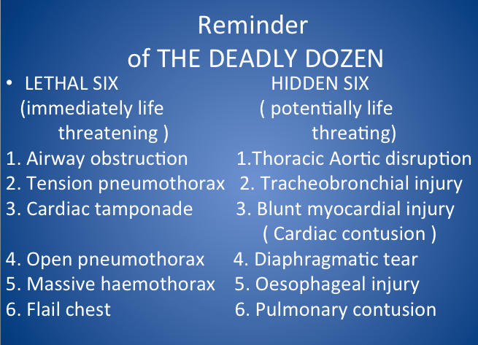You **manage each one immediately once you find it,** don’t wait!

**Tension pneumothorax:**

Tracheal deviation, distended neck vein, paradoxical chest movement, hyper-resonance on percussion, absent breath sound over affected side; low BP, tachycardia; YOU DO NOT NEED TO DO ANY IMAGING TO CONFIRM, IT IS A ***CLINICAL DIAGNOSIS***

Connection between airway and pleura results in air entering the pleura when breathing in, but being trapped when breathing out, compressing the adjacent lung tissue and deviating the mediastinum to the opposite side, resulting in low VR and low COP

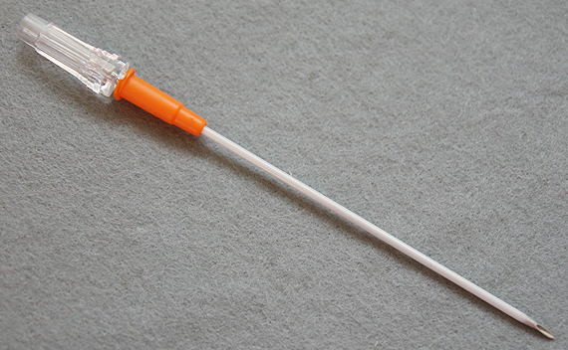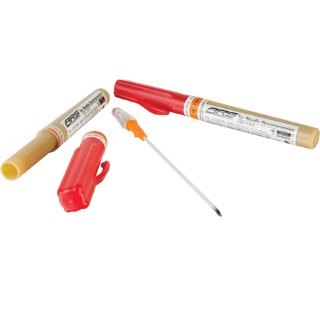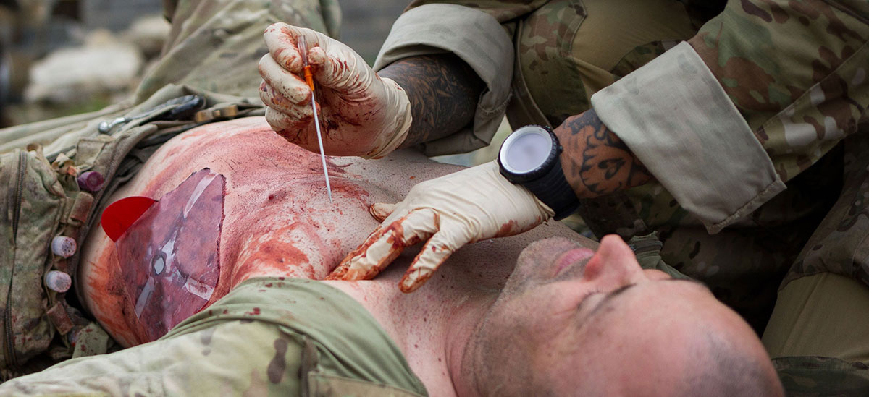FIRST THING TO DO IS ALWAYS immediate **needle decompression in 2nd ICS, MCL** using a **14 G IV needle** (a hissing sound will be heard!) – this buys you time to get to the definitive Rx and lets you move on with the primary survey

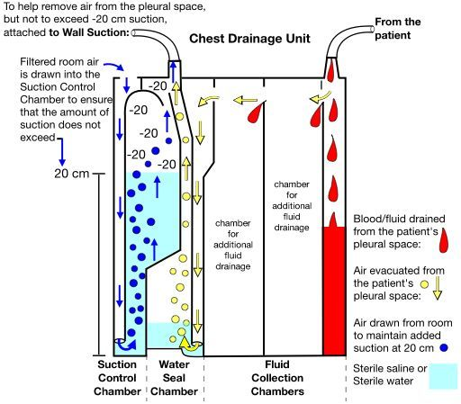**Thoracostomy** (**intercostal chest tube insertion**) into the **4/5th ICS mid-axillary line, above the rib** (to avoid injuring neurovascular structures that run below the rib), with an **underwater seal** (in hospitals now, we use a **chest tube drainage system** that has **3 chambers**: a large fluid collection chamber, a water seal chamber and a suction control chamber) – it has to be below the level of the patient and do not clamp it unless you’re gonna move the patient

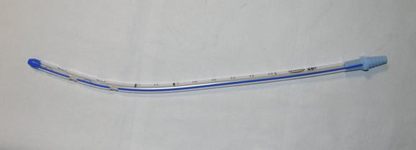The IC chest tube can be inserted within a trochar (sharp object) that helps put it in within the chest

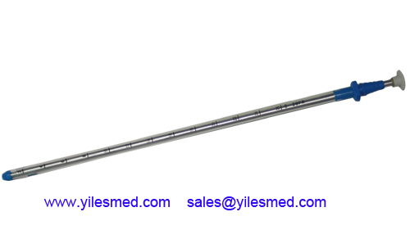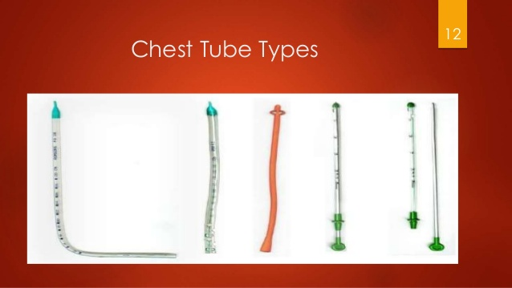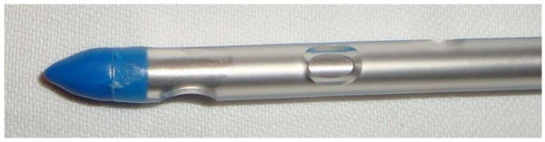**Massive Hemothorax**

If it occurs with pneumothorax = hemopneumothorax (on CXR there will be air-fluid level)

Can be a result of **blunt or penetrating trauma** or secondary to **rib fracture**, **lung contusions**, **cardiac rupture, venous and arterial damage** (major: aorta; minor: IC or internal mammary artery) during trauma

Vitals are important to note (low BP might be a major bleeding source)

A non-massive hemothorax might go undiagnosed until imaging of the chest is done, however, blunting of costophrenic angle on CXR is only seen when >400/500 mL of blood has accumulated; FAST US can also detect it quickly now

Massive hemothorax can be detected clinically and does not need imaging to be diagnosed: there is reduced chest expansion, +/- tracheal deviation, dullness to percussion and absent breath sounds on the affected side

**Management = fluid management + tube thoracostomy (IC chest tube) with an underwater seal (initially)**

IF the **drained blood is A LOT or FAST** (>1.5 L or >20 ml/kg) or the patient is (persistently) hemodynamically unstable, you may need to do an **emergency thoracotomy (surgery)**

**Does it clot?** YES, if it overwhelms the pleura’s capability to prevent it from clotting: this results in retained hemothorax, blocking of the chest tube and fibrothorax; chest tube must be periodically assessed, cleared when blocked!

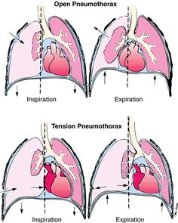

**Open pneumothorax**

Sucking chest wound is obvious (penetrating trauma to chest, with the wound **moving in and out**)

A large one that is >2/3rd the size of the trachea can allow more air to enter through the wound than from the URT and this is dangerous

The air enters and escapes freely through the wound

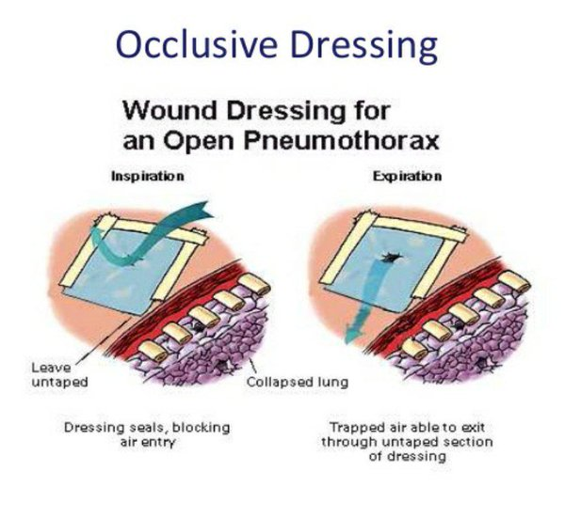**THE BIGGEST MISTAKE YOU CAN MAKE IS TO COVER THE WOUND COMPLETELY** = you are converting an open pneumothorax to a tension pneumothorax

If you need to put a dressing, put a **3-SIDED FLUTTER VALVE DRESSING** (that is closed from 3 sides only): this allows the air to escape on expiration and minimalizes air entry during inspiration (sucking)

**A chest tube should then be inserted**

**Flail chest**

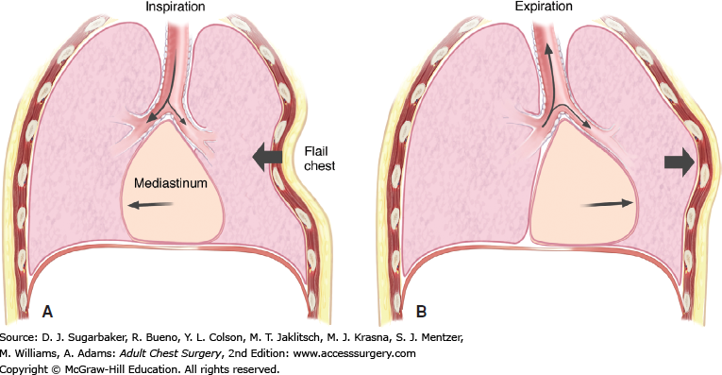**Free floating segment** of chest wall due to **3 or more rib fractures at 2 sites** so that they rise and sink in conjunction to chest wall pressure (breathing in? moves in instead of expands with rest of chest… breathing out? Moves out instead of moving in with rest of chest)

P/E: **paradoxical movement of flail segments**, palpable crepitus over affected ribs, decreased air entry on affected side

**Diagnosis is essentially clinical** but **confirmed on CXR** (there is usually an associated lung contusion)

Management is **conservative** + **positive pressure ventilation** (+/- ETI; whole idea is to increase the pressure of breathing in)

**DO NOT TRY TO IMMOBILIZE, REDUCE OR FIX THE FRACTURES!** They will **heal on their own** in about 3 weeks (a callus will form in around 10 days)

**+/- cardiac tamponade**

Clinical signs include **beck’s triad**: distended neck veins, muffled heart sounds, hypotension; **kussmaul sign**: JVP increases on inspiration instead of decreasing; **pulsus paradoxus** (not a paradox: it is an exaggerated decrease in BP [>10 mm Hg] or pulse on inspiration); tachycardia and tachypnea

Usually detected on **FAST in secondary survey**

In ACUTE cardiac tamponade, even MINIMAL amount of blood/fluid in the pericardium can be life-threatening vs in chronic cardiac tamponade (malignant, infectious, CRF) the pericardium can accommodate very large volumes without major compromise in cardiac output!

**Management = fluids + pericardiocentesis** (xiphisternal approach pointing to left shoulder) +/- **open pericardiotomy (pericardial window)**

* 1. **CIRCULATION**
     + Here we are concerned about **shock** (primarily **hemorrhagic** shock)
       1. ***Definition of shock*** (popular question)
          1. **Inadequate tissue perfusion** (low oxygen supply to meet their metabolic demands)
          2. Different kinds of shock: hypovolemic (hemorrhagic), distributive (septic, neurogenic, anaphylactic), cardiogenic shock and obstructive shock (as in PE, cardiac tamponade, constrictive pericarditis and tension pneumothorax)
          3. **What occurs in hemorrhagic shock?** Blood loss results in **sympathetic activation** (**anxiety, tachycardia, tachypnea, raised BP**: basically increased blood flow to vital organs and decreased blood flow to kidneys, brain, skin 🡪 low urine output, altered mental status and decreased capillary refill
          4. Decreased blood volume, inadequate tissue perfusion, increased metabolites of anaerobic respiration, retention of acids from kidney all result in acidosis
       2. **DO NOT DEFINE IT BY LOW BLOOD PRESSURE!**
          1. **BP may be normal or initially raised** in early stages of shock
          2. Fall in BP only occurs if **>30% blood loss (stage 3 shock)**
          3. THE FIRST BEST SIGN OF SHOCK IS **TACHYCARDIA**
       3. **STAGES OF HEMORRHAGIC SHOCK:**
          1. **STAGE I** (**<15%** ~<1L blood loss; patient is **anxious**)
          2. **STAGE II** (**15 – 30%** ~ 1 – 1.5 L blood loss; **tachycardia**, **tachypnea**; **delayed capillary refill** and **oliguric**)
          3. **STAGE III** (**30 – 40%** ~ 1.5 – 2 L blood loss; as stage II but more severe, patient is **CONFUSED** AND **low BP** [generally SBP <90 or DBP <60 is bad])
          4. **STAGE IV** (**>40%** ~ **>2 L**; as stage III, but **anuric** and patient is **UNCONSCIOUS**, potentially irreversible)
          5. SO early signs are anxiety, tachycardia, tachypnea and reduced capillary refill
          6. LATE signs are **low BP, altered mental state** (confused, unconscious), **reduced to absent urine output**
       4. QUESTIONS YOU WANT TO ANSWER:
          1. **HOW MUCH?** (For fluid replacement)
          2. **FROM WHERE?** (For compression/control and Rx)
     + **Management of hemorrhagic shock:**
       1. Apply **DIRECT EXTERNAL pressure** over the source of bleeding if identified
          1. **DO NOT apply a tourniquet**, it **INCREASES bleeding** because it BLOCKS VENOUS RETURN!
       2. Insert **TWO LARGE IV BORE NEEDLE CANNULA**/**LINES in LARGE veins (Brachial/cephalic veins)**
          1. **Collect blood for important lab investigations** including:

**CBC (Hct), BT and Cx** (THIS IS THE LEAST THING YOU SHOULD DO IN ALL PATIENTS!)

**RFTs** (BUN, Cr, electrolytes)

**Biochemistry** (**lactate,** random blood glucose)

**Coagulation profile**

**Amylase**

**BETA-HCG IN ALL WOMEN!**

* + - 1. **Give IV fluids**
         1. General rule:

**1:3 ratio of blood:IV fluids**

**1:1 is for colloids** (including blood and gelatins)

* + - * 1. The fluid type of choice in shock therapy (2ndry to blood loss, trauma and burns) is **RINGER’S LACTATE**

AKA **Hartmann solution**

Useful when given in large amounts/boluses to help raise BP; the **lactate** in it is **converted to bicarbonate** in the **liver**, which **reverses the acidosis**

Its **osmolarity and pH resemble that of blood**

It is **“isotonic and isoelectric”**

**NS is avoided** because it has a **low pH** and **high Cl content**, which means repeated boluses can result in **HYPERCHLOREMIC METABOLIC ACIDOSIS**

**AVOID USING DEXTROSE solutions** (causes **hyperglycemia**, then **osmotic diuresis**)

RL might not be the best thing in lactic acidosis (because their liver cannot convert the lactate to bicarbonate!)

**How much fluid?**

Trauma patient, confused, HR 140, BP <90, anuric

Stage III/IV ~ let’s say 2 L loss

1:3 🡪 2 L blood loss = 6 L fluids!

OR use a general amount: 20 ml/kg in kids, 1L/30 mins or 1 hour and repeat until responds

* + - * 1. **If the patient responds**

Response means the **vitals are all picking up** (not just BP, but also reduced RR, HR, improved mental status, urine output occurs) and there is **adequate urine output/CVP**

Move to **deficit and maintenance therapy** with forms of **NS (usually 1/2 NS or ¼ NS in pediatrics)**

Maintenance rules is **4-2-1 if in HOURS** (4 ml/kg/hr for first 10 kg, 2 ml/kg/hr for next 10 kg, 1 ml/kg/hr for any additional kg above 20 kg)

**100-50-20 rule if in 24 HOURS**: first 10 kg ~ 100 ml/kg; 2nd 10 kg ~ 50 ml/kg; additional kg above 20 kg ~ 20 ml/kg

Deficit and maintenance are **divided over 24 hours** as **8 and 16 hours** (1/2 of deficit + 1/3rd of maintenance over 8 hours; other 1/2 of deficit and 2/3rd of maintenance over 16 hours) along with **electrolytes (20 mEq/L KCL)**

**We use ¼ NS in kids** because their kidneys have decreased ability to concentrate urine

**Dextrose may be given in maintenance fluid** (also post-op) to **prevent muscle breakdown**

Best way to assess fluid status is **urine output** (but if has cardiac or renal failure, **CVP is better**)

**Minimum urine output in adult is 0.5 ml-1/kg/hr** (below this is oliguric, below 0.1 ml/kg is nearly anuric)

Note if patients have hyponatremia or hypernatremia, we correct for over 48 hours with max 10 mEq/L/day (prevent CPM and cerebral edema, respectively)

* + - * 1. If the patient doesn’t respond, worsening hemodynamic instability

**REPEAT GIVING FLUID BOLUSES**

**USE COLLOIDS**

* + - * 1. **COLLOIDS IN UNRESPONSIVE OR SEVERE SHOCK**

**Gelatin/Gelofusin**

**Volume expander** (1:1 ratio!)

Problem with **renal dysfunction**/failure + **anaphylactic reaction + hypocoagulability** (dilutes them)

**PRBC blood transfusion**

THERE IS NO TIME TO WAIT FOR TYPE SPECIFIC BLOOD MATCH (**takes 30 minutes for Cx to come**!)

Use **O-ve blood type**

**Warm the blood** (cold blood from the blood bank can **promote hemolysis**)

Depending on the type of shock there are other things you can do (e.g. vasopressors, IABP, etc.)

* 1. **DISABILITY**
     + If you haven’t done so, assess **LOC using GCS or AVPU**
       1. GCS: components EVM (eye opening (4), verbal (5), motor (6)): max score 15, **minimal score 3, comatosed 8 or less**
     + **Check pupils** for size, symmetry, reactivity to light
       1. Unilateral dilated pupil can indicate a intracranial hematoma
       2. Bilateral pinpoint pupil may indicate opioid overdose
  2. **EXPOSURE AND ENVIRONMENT**
     + **Uncover the patient whole** (should be naked) BUT cover with blanket to prevent hypothermia
     + This is important for **secondary survey** (head to toe exam including all orifices, including a DRE exam) and inserting lines and putting them under monitors
     + Patient may need to have NG tube for gastric decompression (CI if has maxillofacial fracture: instead use a orogastric tube) and foley’s catheter inserted to monitor urine output and bladder decompression (CI if bleeding at urethral meatus, suspected urethral injury with bruising in perineum and free floating/ballotable prostate 🡪 RUG)
  3. **FOREIGN BODY**
     + Patients with a penetrating foreign body (e.g. knife, hook, etc.) **should NOT have them removed in the field**!
     + Trying to remove a sharp object can result in **REVERSE cutting**
     + They are **removed in the OT!**
  4. **G for GO BACK AND REASSES ABCS!**
     + Hemodynamics can change rapidly over time so you must repeat ABC repeatedly

**SECONDARY SURVEY**

* Done AFTER the primary survey when potentially caught acute life-threatening conditions are found and Rx
* Goal is to take a HISTORY (if possible), and do FULL PHYSICAL EXAMINATION and RAPID IMAGING
  + **SAMPLE history** (our biggest concerns):
    - **S**igns and symptoms
    - **A**llergies
    - **M**edications
    - **P**ast medical history
    - **L**ast meal
    - **E**vents related to the injury
  + **P/E:**
    - **Head and neck** (including ears and nose!)
    - **Chest exam**
    - **Abdominal exam with DRE and pelvic exam**
    - **Neurological exam & MSK**
    - **EXAMINE THE BACK!**
  + **INITIAL IMAGING:**
    - These include:
      * If stable: c-spine, chest, abdominal and pelvic CT scans (may replace chest and abdominal CT with CXR, AXR)
        + **C-spine lateral, odontoid view, AP view** 🡪 CT scan (or swimmer’s view) if cannot see **C7-T1**
        + CXR and AXR (look for widened mediastinum among other chest problems + free air under diaphragm)
      * If **unstable** OR **stable after blunt abdominal trauma** 🡪 **FAST, DPL**
    - **FAST = focused assessment with sonography in trauma**
      * Done in stable and unstable patients, guides further imaging and management
        + **Diagnostic test of choice for evaluation of unstable patients with blunt abdominal trauma**
        + If the patient is unstable and has clear signs of peritonitis (or CXR or CT was done and you see free air), you DO NOT do it and GO DIRECTLY TO EMERGENCY LAPAROTOMY
      * US is done quickly to **assess potential source of bleeding/free fluid** around organs or body cavities, particularly:
        + **Pericardium**
        + **Spleen**
        + **Hepatorenal area**
        + **Rectouterine/rectovesical pouch of Douglas**
        + **Extended = add pleura** to above list
      * Views:
        + **Pericardial window** (+/- chest)
        + **LUQ** (spleen)
        + **RUQ** (hepatorenal space)
        + **Pelvic** (pouch of douglas)
      * Interpretation:
        + If patient is stable or unstable but had a **blunt** trauma, do a **FAST exam**
        + **If stable pt 🡪 FAST**

**+ve 🡪 CT**

-ve 🡪 observe

* + - * + If **unstable pt 🡪 FAST**

**+ve 🡪 laparotomy**

**-ve 🡪 DPL 🡪 +ve** 🡪 **laparotomy**

* + - **DPL = diagnostic peritoneal lavage**
      * Catheter is placed **below the umbilicus** (or **above it if had pelvic fracture**) into peritoneal cavity
      * **Aspirate**:
        + If little blood (< 10 mL) or whatever comes out 🡪 infuse 1 L saline and drain and then analyze
        + If **> 10 mL blood aspirate = +ve DPL**
        + If **enteric contents aspirated = +ve DPL**
        + If on analysis there is high **RBC, WBC, bile, feces, vegetable matter, etc. = +ve DPL**
        + **+ve DPL = laparotomy** (control bleeding site)
    - NOTE: penetrating injuries to the abdomen are observed closely unless clear signs of shock and peritoneal irritation or positive DPL is noted 🡪 laparotomy
    - **NOTE: both the above methods may miss RETROPERITONEAL injuries**
* **CHEST INJURIES DETECTED ON SECONDARY SURVEY:**
  + **Pulmonary contusion** (CXR: **opacity in lung within 6 hours of trauma**)
  + **Ruptured diaphragm** (R>L 🡪 repaired in surgery)
  + **Esophageal injury/rupture**
  + **Aortic tear** (**most die at scene**; MC site is post-left SCA)
    - CXR findings include depressed left main bronchus, pleural cap, **widened mediastinum (best; >6 cm),** left hemothorax, **indistinct aortic knuckle**, **NG tube and tracheal deviation to right**
    - Best imaging is CT angio
  + **Blunt myocardial injury** (e.g. myocardial contusion) – biggest problem is ARRHYTHMIAS
  + **Tracheobronchial injury**

**TRAUMA**

* Repeated information from above:
  + MCC of fatal injury in Bahrain is RTA
  + Trimodal death distribution in trauma:
    - Immediate (50%) – patient fatality when trauma occurs (usually result of a fatal injury causing massive airway obstruction, massive brain injury or a high neck injury disrupting the c-spine)
    - Within hour(s) (30%) – the GOLDEN hour(s) (can be a result of inadequate emergency management)
    - Within a week (20%) – result of secondary problems such as sepsis and multiple organ failure
  + In all cases, always practice universal precautions, especially if bloody:
    - Wear gloves, goggles, plastic gowns and face mask when necessary
* **TYPES OF INJURY:**
  + **Blunt injury (MC)**
    - RTA, getting hit by a car, motorcycle collision, fall, kicking/assaulted, sports tackling injuries
  + **Penetrating injury**
    - Stab wounds, gun shots
  + Things to consider:
    - Understanding the mechanism of injury
      * You can’t stab someone with a butcher knife!
      * Also to understand what possible organs or structures can be injured
      * If fallen: how many stories high? Vertical or horizontal landing position
      * Is it a head-on collision or lateral collision or rear-end collision (whiplash injury)
    - Understand the situation the patient was in (under the influence of alcohol or drugs, seizing, syncope, suicidal attempt)
    - Ask about symptoms related to body part injured, if not all over
      * i.e. if head blunt trauma, ask about LOC, headache, vomiting, seizures and amnesia
* **Head injuries:**
  + Specific injuries to know about:
    - **Skull fractures**
      * **Vault fractures** (**linear** [which can be depressed or not] over temporal bone, where MMA runs, resulting in epidural hematoma)
      * **Basal skull fracture** (signs include battle sign [mastoid bruise], hemotympanum, raccoon eyes, CSF otorrhea or rhinorrhea that stains with a halo) - **clinical diagnosis is sufficient**
    - **Brain injury**
      * Focal injuries include brain contusions (coup and contrecoup) and ICH (epidural, subdural, intracerebral)
      * Diffuse injuries include diffuse axonal injury (patient is comatosed) or concussion (transient LOC, confusion and post-traumatic amnesia for <24 hours)
  + **C-spine injury**
    - **Assume in any patient with polytrauma** until it can be cleared out
      * In text, we assume it when there is distracting pain elsewhere (e.g. trauma), **midline injuries and neck pain**, LOC, intoxication, P/E showing altered mental status, **neurological deficits and tenderness in neck**
      * In this case, we do the **3 XR views (lateral, odontoid view and AP view) and if you cannot see C7-T1 or you need better imaging, CT scan is done** (alternative is an additional swimmer’s view)
      * If abnormal, keep the c-spine immobilized and manage accordingly (evaluate ABC again for possible neurogenic shock, diaphragm paralysis [need ventilator])
      * If you suspect a spinal cord injury (neurological exam findings), MRI should be done
* **INJURY TO NECK:**
  + **Zones of the neck**
    - From **down to up is I, II, III**
    - **Zone I**: below cricoid cartilage (base of neck)
    - **Zone II**: cricoid cartilage to angle of mandible (midportion)
    - **Zone III**: superior neck (above angle of mandible)
  + **Penetrating neck injury (anywhere)**
    - If it **surpasses the platysma = penetrating** = must intervene somehow
      * Symptoms include **expanding or pulsatile hematoma**, **airway compromise** and **hoarseness of voice**, **dysphagia**, **SQ emphysema**
    - If pt unstable or uncontrolled hemorrhage 🡪 surgical exploration
    - If **pt stable and symptomatic**:
      * **Zone I 🡪 Chest CTA** (if appropriate esophagram, bronchoscopy)
      * **Zone II 🡪 SURGICAL EXPLORATION**
      * **Zone III 🡪 angiography +/- embolization**
    - If **pt stable and asymptomatic**
      * Zone I 🡪 imaging (Chest CT) and observation
      * Zone II 🡪 imaging (CT) and observation
      * Zone III 🡪 imaging and observation
    - **KEY POINTS:**
      * **Zone II injuries are the most dangerous** and are always explored surgically if patient is symptomatic but stable OR unstable
      * Zone I and III injuries are surgically explored if patient is unstable
      * Patients with zone I injuries who are stable but symptomatic require CTA to guide further management (otherwise if unstable, patient needs emergency thoracotomy)
      * Patients with zone III injuries who are stable are now preferably taken to an interventional radiologist for endovascular procedures
      * The surgical incision for zone II is called a **J-shaped or hockey incision** and it done medial to the sternocleidomastoid muscle
* **ABDOMINAL INJURY**
  + Type of injury
    - **Blunt injuries**
      * **MC organ injured = spleen**; **2nd MCC = liver**
    - **Penetrating injuries**
      * **MC organ injured = liver**
  + **Blunt trauma**
    - May result in intra-abdominal AND/OR retroperitoneal hemorrhage (can be missed with some rapid assessment tools)
    - P/E can be deceiving
      * Make sure you note special signs such as **seat-belt sign** (**small bowel perforation**, **retroperitoneal duodenal injury** 🡪 gastric outlet obstruction, **lumbar spine injury** [**Chance fracture**])
      * Auscultate for bruits, high pitched bowel sounds
      * PALPATE 🡪 signs of tenderness, peritoneal irritation (rigidity, involuntary guarding, rebound tenderness)
      * DRE should be done to assess anal tone, ballotable prostate and possibly bleeding or bone fragments
    - **Investigations:**
      * None if signs of peritoneal irritation 🡪 emergency laparotomy
      * **Trauma labs** (CBC, RFTs, LFT, coagulation profile, amylase & lipase, b-HCG, biochemistry & electrolytes)
      * Imaging/procedures (initial FAST or DPL)
      * Imaging to R/O fractures or for unidentified causes of hypotension/instability
    - Management:
      * A,B,Cs
      * Patient must be monitored for 24 hours
      * If warranted 🡪 laparotomy
  + **Penetrating abdominal injuries**
    - Problem is **perforation and sepsis**
    - Source: stabbing, gun shot
    - **Gunshot wounds are surgically explored**
    - **Stab wounds:**
      * **1/3rd don’t penetrate peritoneal cavity**
      * **1/3rd penetrate but are harmless**
      * **1/3rd cause injury requiring surgery**
      * If patient has peritoneal signs, heavy bleeding or is unstable, exploratory laparotomy
      * If not, **observation or local wound exploration**
    - **Laparotomy is indicated if:**
      * **Shocked with an unknown cause but hx of blunt** **abdominal trauma**
      * **Signs of peritonitis**
      * **Free air in abdomen**
* **Other injuries**
  + **GU injuries** (See GU notes)
    - **Bladder rupture** 
      * **Intraperitoneal** (trauma to abdomen with full bladder resulting in dome of diaphragm to rupture 🡪 peritoneal signs)
      * **Extraperitoneal** (pelvic fracture, no urine output)
    - Urethral injury (posterior or anterior injury)
  + Orthopedic injuries (see orthopedic notes)

**BURNS**

* What is a burn?
  + Injury to the skin (or other organic tissue) that result from:
    - Heat (Thermal burn)
      * Think about it as either hot liquid, smoke, solid
      * Scald burn = hot liquids (MC)
      * Flame burns = fire, explosions/flash
      * Contact burns
      * Steam burns (inhalational injury/hot smoke)
    - Radiation
    - Electricity (electrical burns)
    - Chemicals (chemical burns)
      * Acids
      * Alkali
* What is severity of burn determined by?
  + Body surface area (BSA) involved
  + Depth of burn (i.e. degree)
  + Location of burns (e.g. face, perineum, feet, toes)
  + Type of burn (e.g. electrical)
  + Patient condition (i.e. comorbidities)
* Jackson theory of thermal burns?
  + There are 3 zones of burn:
    - Coagulation zone (center point, dead)
    - Zone of stasis (ischemic blood vessels, imminent danger)
    - Zone of hyperemia (inflamed, reactive hyperemic area)
* Types of burns:
  + 1st degree burn or superficial thickness burn
    - Involves epidermis only
    - Skin is hyperemic and painful
    - Does NOT need BSA calculation or Parkland fluid calculation
    - Resolves spontaneously in 3 – 5 days w/o scarring
  + 2nd degree burn or partial thickness burn
    - Superficial partial thickness
      * Involves epidermis and part of the dermis
      * Characterized by bullae and vesicle formation, weeping and very erythematous skin lesion (that blanches)
      * It is extremely painful, swollen and mottled
    - Deep partial thickness
      * Involves the epidermis and dermis
      * Pain is less marked, but still present
      * There is also bullae (but not as much)
    - This needs management in the hospital if >20% BSA
  + 3rd degree burn (full thickness burn)
    - The dermis and epidermis is completely burned, exposing the underlying SQ tissue
    - The affected area is PAINLESS (the nerve endings are burned), the center is leathery, chalky white to black, and dry
    - The area surrounding it is very painful (2nd degree)
    - This needs management in hospital if >5% BSA involved, will definitely require some sort of split thickness skin graft (STSG)
  + 4th degree burn
    - This exposes the bone or muscle
    - This will need reconstructive surgery and grafting
* RULE OF NINES
* CRITERIA OF ADMISSION INTO BURN UNIT
* PARKLAND FORMULA
* MANAGEMENT OF BURNS:
  + Pre-hospital
  + Hospital
  + Post-op care (wound infection)
* Special cases
  + CIRCUMFERENTIAL BURNS
  + ELECTRICAL BURNS
  + CHEMICAL BURNS